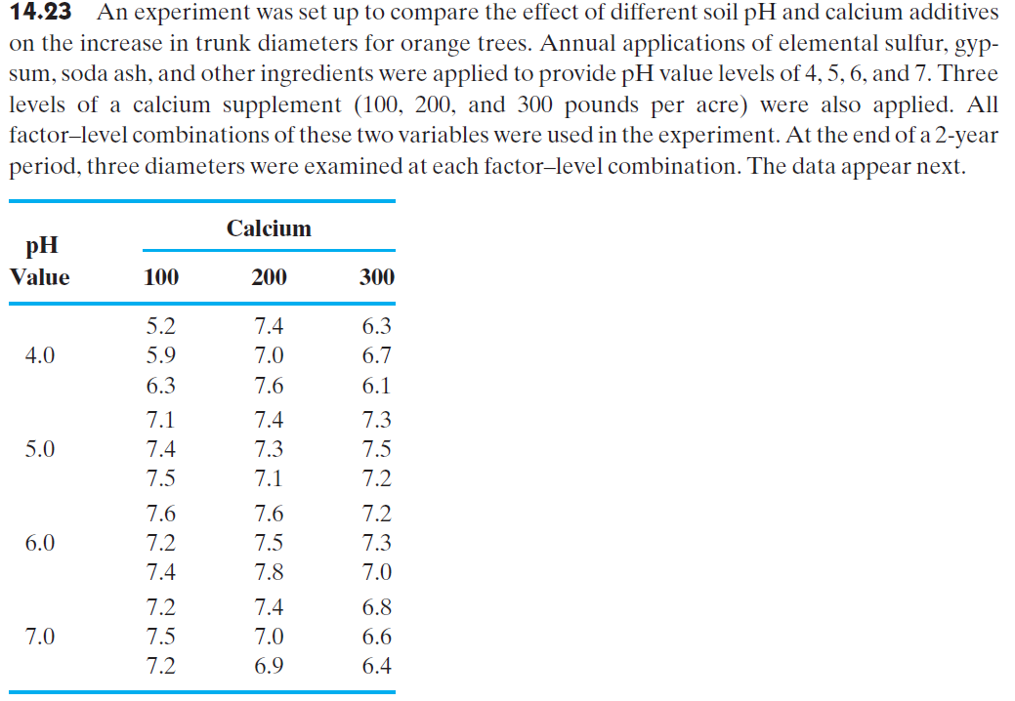

1. Construct a profile plot. What do the data suggest?
2. Write an appropriate statistical model.
3. Perform an analysis of variance and identify the experimental design. Use α=.05.
4. Use the computer output given here to test for interactions and main effects. Use α=.05.
5. Estimate the parameters in the model.
6. Write a linear contrast statement combining Calcium level 100 & 200 and compare against the 300 cohort.
7. What can you conclude about the effects of pH and calcium on the increase in the mean trunk diameters for orange trees?

**Data:**

|  |  |  |  |
| --- | --- | --- | --- |
|  |  | Calcium |  |
| PH | 100 | 200 | 300 |
| 4 | 5.2 | 7.4 | 6.3 |
| 4 | 5.9 | 7 | 6.7 |
| 4 | 6.3 | 7.6 | 6.1 |
| 5 | 7.1 | 7.4 | 7.3 |
| 5 | 7.4 | 7.3 | 7.5 |
| 5 | 7.5 | 7.1 | 7.2 |
| 6 | 7.6 | 7.6 | 7.2 |
| 6 | 7.2 | 7.5 | 7.3 |
| 6 | 7.4 | 7.8 | 7 |
| 7 | 7.2 | 7.4 | 6.8 |
| 7 | 7.5 | 7 | 6.6 |
| 7 | 7.2 | 6.9 | 6.4 |

**In class practice**

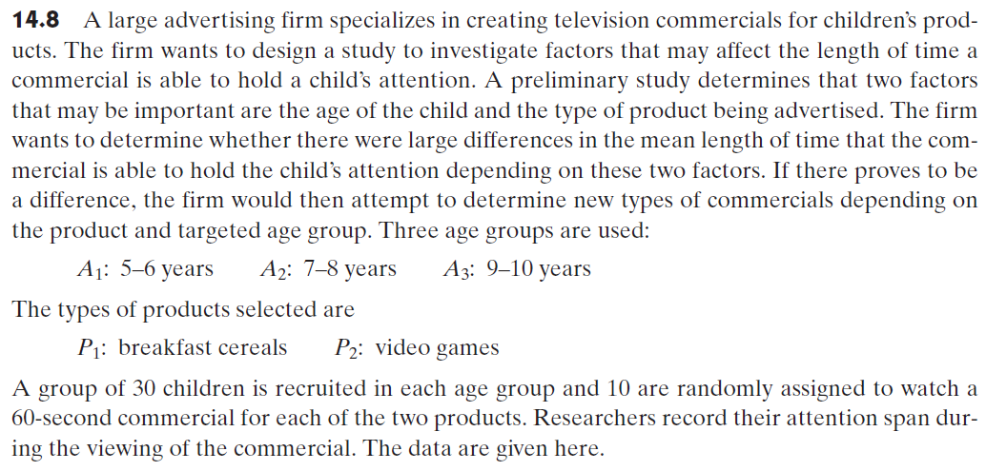

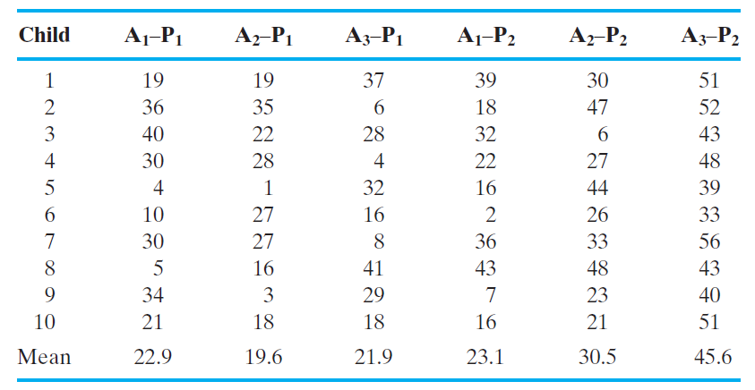

1. Identify the design.
2. Write a model for this situation, identifying all the terms in the model
3. Estimate the parameters in the model
4. Compute the sum of squares for the data and summarize the information in an ANOVA table.
5. Draw a profile plot for the two factors, age and product type.
6. Perform appropriate F tests and draw conclusions from these tests concerning the effect of age and product type on the mean attention span of the children.

**Data:**

Child A1P1 A2P1 A3P1 A1P2 A2P2 A3P2;

1 19 19 37 39 30 51

2 36 35 6 18 47 52

3 40 22 28 32 6 43

4 30 28 4 22 27 48

5 4 1 32 16 44 39

6 10 27 16 2 26 33

7 30 27 8 36 33 56

8 5 16 41 43 48 43

9 34 3 29 7 23 40

10 21 18 18 16 21 51