**SAS lecture 4 – Chapter 16 The Analysis of Covariance**

An experiment was conducted where twenty bags of ten oysters each were placed across 5 locations within the cooling water runoff of a power-generation plant (i.e. 4 bags / location). Each location is considered a treatment:

* TRT1: cool-bottom
* TRT2: cool-surface
* TRT3: hot bottom,
* TRT4: hot-surface
* TRT5: control (i.e. mid-depth and mid-temperature)

Each bag of ten oysters is considered to be one experimental unit. The oysters were

cleaned and weighed at the beginning of the experiment and then again about one month

later. The dataset consists of the initial weight and final weight for each of the twenty

bags.

The goals of this experiment were:

**1.** To determine if exposure to artificially-heated water affects growth

**2.** To determine if position in the water column (surface vs. bottom) affects growth

Trt Rep Initial Final

1 1 27.2 32.6

1 2 32.0 36.6

1 3 33.0 37.7

1 4 26.8 31.0

2 1 28.6 33.8

2 2 26.8 31.7

2 3 26.5 30.7

2 4 26.8 30.4

3 1 28.6 35.2

3 2 22.4 29.1

3 3 23.2 28.9

3 4 24.4 30.2

4 1 29.3 35.0

4 2 21.8 27.0

4 3 30.3 36.4

4 4 24.3 30.5

5 1 20.4 24.6

5 2 19.6 23.4

5 3 25.1 30.3

5 4 18.1 21.8

a). Create the dataset in SAS; plot the data (yaxis= final weight and xaxis=initial weight) for each treatment (overlay in one plot).

b). Fit one way ANOVA, a simple regression model and an ANCOVA model to this dataset.

c). Use the result in b) to test whether the initial weight provides a significant reduction in experiment error?

d). Compute the observed and adjusted treatment means for all 5 treatment groups.

e). Give the linear regression equations for the control treatment and hot surface treatment.

f). Does there appear to be a significant difference between 5 treatments after adjusting for the initial weight?

g). Type III SS vs. Type I SS.

f). Please write contrast statement to compare

* Control vs. Treatment
* Bottom vs. Top
* Cool vs. Hot
* Interactions Depth*Temp

g). Test for heterogeneity of slopes.

h). Check for the model assumption.

Hint:

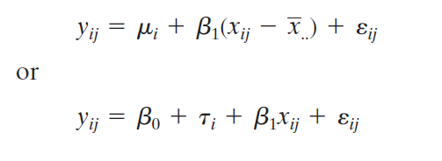

I). Increase in precision due to covariance

|  |  |  |
| --- | --- | --- |
|  | ANOVA | ANCOVA |
| MSE |  |  |
| DF |  |  |