**STAT6305_1**

**HW#2**

**Nikta Farsai**

**Shruti Natekar**

14.5

A.

H0: µA=µB=µC = µD

Ha:at least one of the incentive plan means is different from the others

B.

The P-value is 0.1181 > α = 0.05. Therefore, we fail to reject the Null Hypothesis since there is no evidence that there is a difference between the means of incentive plans A, B, C and D.

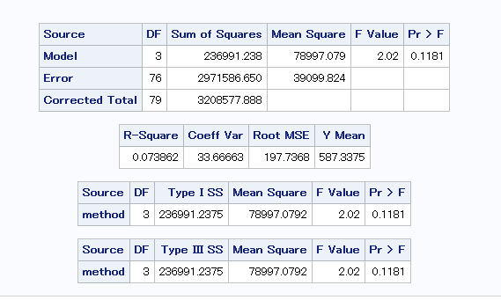

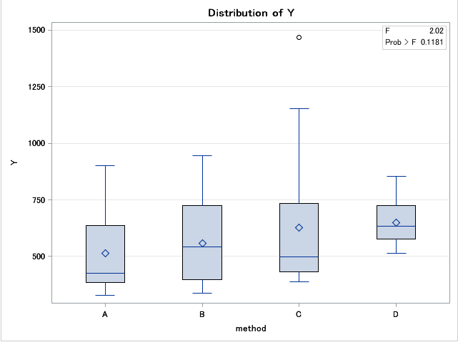

C.

Based on the result from SAS, it shows the means of incentive plans are not significantly different from each other which also supports part B that we failed to reject the null hypothesis of having equal means.

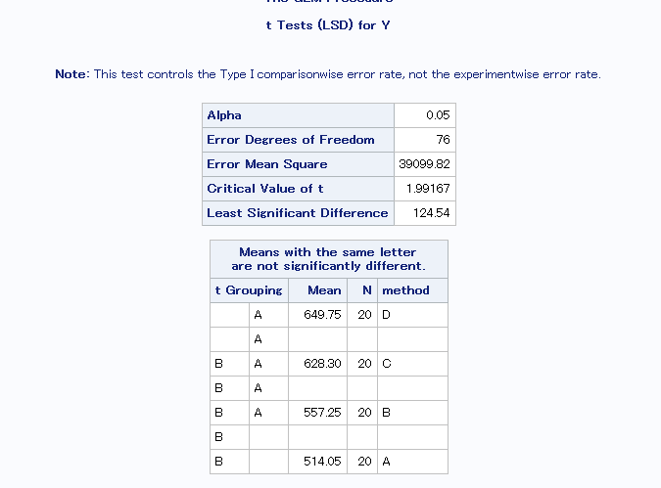

14.6

A. H0: Residuals follow a Normal Distribution

Ha: Residuals do not follow a Normal Distribution

The P-value is 0.0001 which is less than the α = 0.05. Therefore we reject the null hypothesis and conclude that the residuals do not follow a Normal Distribution. We could also see that the residuals do not follow a Normal plot and its skewed.

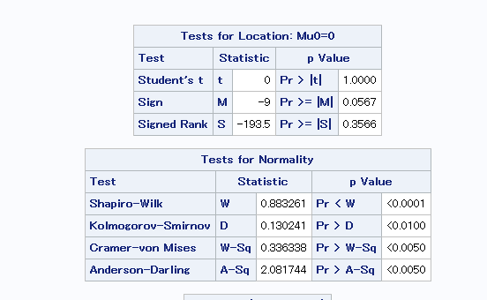

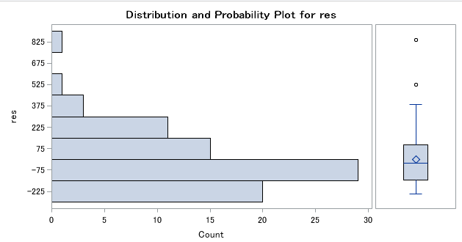

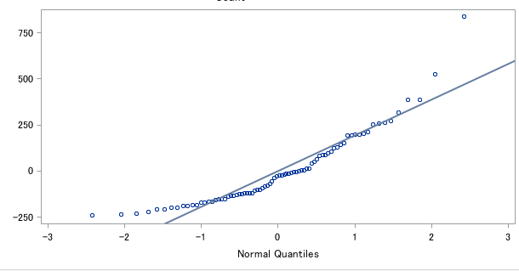

B.

H0: Variances of residuals are equal

Ha: At least one of the variances differ from the rest

Due to the P-value =0.0519 > α = 0.05 and the F-value = 2.69 < critical F-value (df1=3, df2=76, α = 0.05) = 2.724 , we fail to reject the null hypothesis of equal variances assumption. Therefore, we conclude that we have equal variances between the residuals.

