Exercise 1
Two devices have been proposed to reduce the air pollution resulting from the emission
of carbon monoxide (CO) from the exhaust of automobiles. To evaluate the effectiveness of the devices, 48 cars of varying age and mechanical condition were selected for the study. The amount of carbon monoxide in the exhaust (in ppm) was measured prior to installing the device on each of the cars. Because there were considerable differences in the mechanical condition of the cars, the cars were paired based on the level of CO in their exhaust. The two devices were then randomly assigned to the cars within each pair of cars. Five months after installation, the amount of CO in the exhaust was again measured on each of the cars. The reduction in carbon monoxide from the initial measurements are given here.

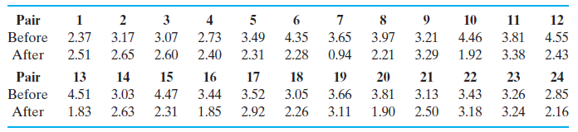

a. Does the device appear to reduce the average amount of CO in the exhaust of the
cars? Use α= .05.

b. Compute the relative efficiency of the randomized complete block design (blocking
on car) relative to a completely randomized design in which the 48 cars would have
been randomly assigned to the two devices without regard to any pairing. Interpret
the value of the relative efficiency.

c. Based on the relative efficiency computed in part (b), would you recommend pairing
the cars in future studies?

d. In Chapter 6, we introduced the paired t-test. Analyze the above data using this test
statistic.

e. Show that the paired t-test is equivalent to the F-test from the randomized block design.

Data:
Pair | Before | After
1 | 2.37 | 2.51
2 | 3.17 | 2.65
3 | 3.07 | 2.60
4 | 2.73 | 2.40
5 | 3.49 | 2.31
6 | 4.35 | 2.28
7 | 3.65 | 0.94
8 | 3.97 | 2.21
9 | 3.21 | 3.29
10 | 4.46 | 1.92
11 | 3.81 | 3.38
12 | 4.55 | 2.43
13 | 4.51 | 1.83
14 | 3.03 | 2.63
15 | 4.47 | 2.31
16 | 3.44 | 1.85
17 | 3.52 | 2.92
18 | 3.05 | 2.26
19 | 3.66 | 3.11
20 | 3.81 | 1.90
21 | 3.13 | 2.50
22 | 3.43 | 3.18
23 | 3.26 | 3.24
24 | 2.85 | 2.16

Exercise 2.

A petroleum company was interested in comparing the miles per gallon achieved by four different gasoline blends (A, B, C, and D). Because there can be considerable variability due to differences in driving characteristics and car models, these two extraneous sources of variability were included as ‘‘blocking’’ variables in the study. The researcher selected four different brands of cars and four different drivers. The drivers and brands of cars were assigned to blends in the manner displayed in the following table. The mileage (in mpg) obtained over each test run was recorded as follows.

Driver Model 1 Model 2 Model 3 Model 4
1 A(15.5) B(33.8) C(13.7) D(29.2)
2 B(16.3) C(26.4) D(19.1) A(22.5)
3 C(10.5) D(31.5) A(17.5) B(30.1)
4 D(14.0) A(34.5) B(19.7) C(21.6)

- Write a model for this experimental setting.

- Estimate the parameters in the model.

- Conduct an analysis of variance. Use α= .05.

- What conclusions can you draw concerning the best gasoline blend?

- Validate the model assumptions.
In Class Exercise
Textbook page1008
15.35

