- Researchers conducted an experiment to determine the content uniformity of film coated tablets produced for a cardiovascular drug used to lower blood pressure. They obtained a random sample of three batches from each of two blending sites; within each batch they assayed a random sample of five tablets to determine content uniformity. The data are shown here:

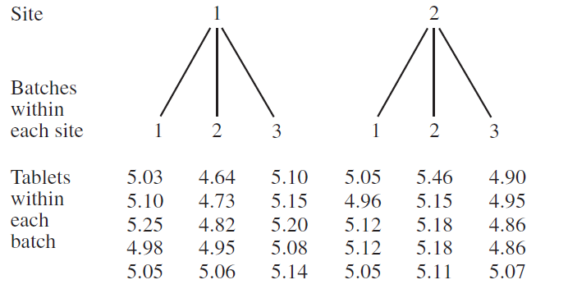

- Run an analysis of variance. Use α=.05.

b. Is there evidence to indicate batch-to-batch variability in content uniformity? Does the F test run depend on whether we assume batches are fixed or random?

c. Draw conclusions about batch.

Data for tablet:

5.03
5.10
5.25
4.98
5.05
4.64
4.73
4.82
4.95
5.06
5.10
5.15
5.20
5.08
5.14
5.05
4.96
5.12
5.12
5.05
5.46
5.15
5.18
5.18
5.11
4.90
4.95
4.86
4.86
5.07
2. The following example is from Fundamental Concepts in the Design of Experiments (C. Hicks). In a training course, the members of the class were engineers and were assigned a final problem. Each engineer went into the manufacturing plant and designed an experiment. One engineer studied the strain (stress) of glass cathode supports on the production machines:
- There were 5 production machines (fixed or random effect?).
- Each machine has 4 components called `heads' which produces the glass. The heads represent a random sample from a population of heads (random effect).
- She took 4 samples from each. Data collection of the 5x4x4 = 80 measurements was completely randomized. The data is presented in the table below:

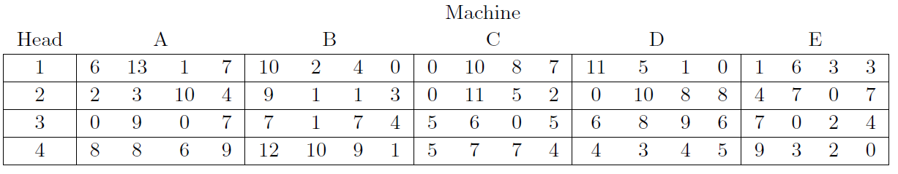

- She analyzed the data as a two-factor factorial design. Is this correct?

- Run an analysis of variance under appropriate design. Use α=.05.

Data:
6 13 1 7 10 2 4 0 0 10 8 7 11 5 1 0 1 6 3 3
2 3 10 4 9 1 1 3 0 11 5 2 0 10 8 8 4 7 0 7
0 9 0 7 7 1 7 4 5 6 0 5 6 8 9 6 7 0 2 4
8 8 6 9 12 10 9 1 5 7 7 4 4 3 4 5 9 3 2 0
Answer:
- To be a two-factor factorial design, the same 4 heads must be used in each of the 5 machines. This was not the case. The 4 heads in Machine A are different from the 4 heads in Machine B, and so on. 20 different heads were used in this experiment (not 4).

- Therefore, we do not have a factorial experiment. When the levels of a factor are unique to the levels of one or more other factors, we have a nested factor. In this experiment, we say the heads are nested within machines".

