System Requirements Document
Rahbar — AI-Assisted Career Discovery Platform for Pakistani Teenagers

Field | Value
Version | 1.0
Status | Draft — for hackathon MVP build
Date | August 12, 2026
Companion document | PRD_Rahbar_Career_Guidance_Platform.docx
Build window | 2–3 days

1. System Overview
This document specifies the technical implementation of the product described in the companion PRD. The system collects behavioral and open-text responses through six in-app activities, computes a fixed-schema trait vector from them, uses a locally-trained classifier to rank career clusters, and uses Gemini only for two narrow, bounded tasks: scoring open-text responses against an explicit rubric, and converting the model's numeric output into natural-language explanation text. Gemini never receives raw, unscored responses and is never asked to choose or rank a career.

2. Architecture
Frontend: React + Vite + Tailwind CSS, Framer Motion for the swipe/card interactions, Recharts for the trait radar chart, deployed to Firebase Hosting. Backend: a Python FastAPI service deployed to Render (or a comparable free-tier host — Railway, Fly.io, etc.), exposing three endpoints (/predict, /score, /explain). Data: Firebase Firestore for all session/response/result storage, Firebase Authentication (anonymous by default) for identity. The trained classifier is a joblib artifact committed to the repo and loaded from local disk at startup, so no separate cloud storage service is required. Gemini is called server-side from FastAPI using the Google Gen AI SDK, never from the client, so the API key never reaches the browser.
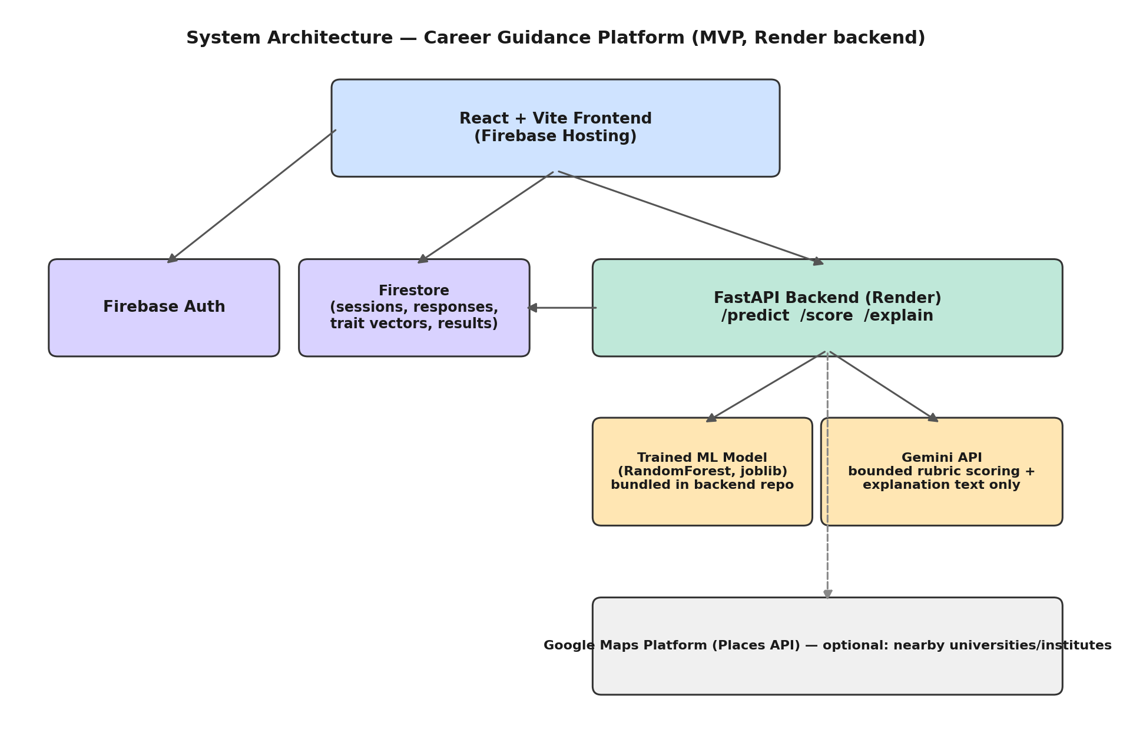

2.1 Component responsibilities
Component | Technology | Responsibility
Frontend | React + Vite + Tailwind, Framer Motion, Recharts | Renders activities, captures responses, shows results; writes to Firestore directly for low-latency UX
Auth | Firebase Authentication | Anonymous session identity; upgradeable to Google sign-in for return visits
Data store | Firestore | Sessions, raw responses, computed trait vectors, interpretation flags, recommendation results
Backend API | FastAPI on Render (or another free-tier host) | Hosts /predict, /score, /explain; the only component allowed to call Gemini or load the ML model
ML model | scikit-learn RandomForestClassifier (or XGBoost), joblib artifact bundled in the backend repo | Maps a trait vector to a ranked probability distribution over career clusters
Gemini API | Google Gen AI SDK (Gemini Developer API or Vertex AI) | (a) bounded rubric scoring of open-text responses, (b) explanation-text generation from numeric results only
Google Maps Platform | Places API (optional) | Surfaces nearby universities/institutes for the top-matched cluster

3. Data Model (Firestore)
Firestore is document/collection based rather than strictly relational; the schema below is denormalized accordingly. All timestamps are ISO 8601.

3.1 users/{userId}
Field | Type | Notes
age | number | 12–20
age_band | string | "12-14" | "15-17" | "18-20", derived
region | string | optional, free text or city
language | string | "en" | "ur"
created_at | timestamp

3.2 sessions/{sessionId}
Field | Type | Notes
user_id | ref
start_time / end_time | timestamp
completion_status | string | "in_progress" | "complete" | "abandoned"
activities_completed | array<string> | activity ids, in the order actually served

3.3 responses/{responseId}
Field | Type | Notes
session_id | ref
activity_id | string | e.g. "pattern_hunter"
raw_response | map | activity-specific payload
is_correct | boolean | for deterministic items only
latency_ms | number
attempt_number | number
rubric_scores | map | populated only for Activities 3 and 5, via /score

3.4 trait_vectors/{sessionId}
The canonical fixed-schema feature vector computed from all responses in a session. Field list:
Field | Source activity | Range
R, I, A, S, E, C | Instinct Swipe | 0.0–1.0 each
decisiveness | Instinct Swipe | 0.0–1.0
numerical_reasoning, logical_reasoning | Pattern Hunter | 0.0–1.0
data_interpretation, analytical_thinking | Data Detective | 0.0–1.0
creativity, flexibility, communication, originality | Creative Problem Solver (Gemini rubric) | 0.0–1.0
risk_tolerance, decision_making, planning, leadership | Decision Lab | 0.0–1.0
domain_exposure | Career Simulation (Gemini rubric) | 0.0–1.0
version and computed_at fields allow a user to retake the sequence without overwriting prior history.

3.5 interpretations/{sessionId}
Field | Type | Notes
flags | array<map> | {type, field, note, source_activity}
confidence_modifier | number | 0.8–1.0, from decisiveness

3.6 recommendations/{sessionId}
Field | Type | Notes
ranked_clusters | array<map> | {cluster_id, confidence}, top 5
explanation_text | map | per-cluster, Gemini-generated
model_version | string | joblib artifact version tag
generated_at | timestamp

3.7 careers (reference collection)
Field | Type | Notes
cluster_id | string | e.g. "software_engineering"
title | string
riasec_vector | map | for the fallback similarity method, Section 6.3
education_path | string | e.g. "ECAT → BE/BS Engineering"
description | string

4. Functional Requirements
ID | Requirement
FR-1 | The system shall present Instinct Swipe first in every session and compute an initial R/I/A/S/E/C + decisiveness vector before any other activity is served.
FR-2 | The system shall select each subsequent activity using the adaptive rule in Section 5.1, not a fixed order.
FR-3 | For deterministic activities (Pattern Hunter, Decision Lab, the prediction part of Data Detective), scoring shall be computed client-side or in a Cloud Function with zero external API calls.
FR-4 | For open-text activities (Creative Problem Solver, Career Simulation, and the optional Data Detective reasoning field), the system shall call POST /score with the response text and a fixed rubric, and shall reject/retry if the response is not valid JSON matching the rubric schema.
FR-5 | The system shall call POST /predict with the complete trait vector once all required activities are complete, and shall receive a ranked list of career clusters with confidence scores.
FR-6 | The system shall run the interpretation engine (Section 5.2) on the trait vector and model output before rendering results.
FR-7 | The system shall call POST /explain with only the numeric ranked-cluster output (never raw response text) to generate the explanation shown per top match.
FR-8 | The results screen shall always show at least 3 and at most 5 ranked clusters with confidence, never a single deterministic answer.
FR-9 | Every interpretation flag shown to the user shall cite the activity that produced it.
FR-10 | If the Gemini call in FR-4 or FR-7 fails or times out, the system shall degrade gracefully: use a deterministic fallback score for FR-4, and a templated (non-LLM) explanation string for FR-7, rather than blocking the flow.

5. Algorithms

5.1 Adaptive next-activity selection (rule-based)
After Instinct Swipe and one baseline activity, maintain a confidence score per skill dimension. Each remaining activity is scored by how much it would reduce the largest current confidence gap, and the highest-scoring one is served next.
def select_next_activity(confidence: dict, completed: set, catalog: list) -> str:
remaining = [a for a in catalog if a.id not in completed]
if not remaining:
return None
def gap_closed(activity):
# sum of (1 - confidence[skill]) for each skill this activity measures
return sum(1 - confidence.get(skill, 0.0) for skill in activity.skills)
return max(remaining, key=gap_closed).id
This is intentionally simple for the MVP — a per-skill threshold check plus a greedy "biggest gap" choice, not a trained policy. The architecture should keep this function isolated so it can be replaced by a contextual bandit later without touching the rest of the pipeline (see Section 8).

5.2 Interpretation engine
Runs once the trait vector and model output are both available; produces labeled flags, each traceable to a source activity.
def interpret(signals: dict) -> dict:
flags = []
if signals['I'] > 0.7 and signals['numerical_reasoning'] < 0.4:
flags.append({'type': 'unexplored_interest', 'field': 'Investigative',
'note': 'High interest, low demonstrated aptitude — likely unexposed, not unsuited',
'source_activity': 'instinct_swipe + pattern_hunter'})
if signals.get('spatial', 0) > 0.75 and signals['R'] < 0.4:
flags.append({'type': 'hidden_strength', 'field': 'Realistic',
'note': 'Strong mechanical/spatial aptitude with no stated interest — worth surfacing',
'source_activity': 'pattern_hunter'})
if signals['domain_exposure'] < 0.3 and signals['top_cluster_confidence'] > 0.7:
flags.append({'type': 'low_exposure',
'note': 'Top match has minimal domain exposure — recommend beginner resources',
'source_activity': 'career_simulation'})
confidence_modifier = 1.0 if signals['decisiveness'] > 0.6 else 0.8
return {'flags': flags, 'confidence_modifier': confidence_modifier}

5.3 Career cluster prediction (primary method)
Trained offline, served at inference time. Training data: the Open Psychometrics public RIASEC response dataset (~145k rows) merged with a hand-labeled career-cluster mapping; 15–20 target clusters (Appendix, PRD).
# train.py — offline, run once in a notebook
from sklearn.ensemble import RandomForestClassifier
from sklearn.model_selection import train_test_split
import pandas as pd, joblib
df = pd.read_csv('riasec_career_dataset.csv')
FEATURES = ['R','I','A','S','E','C','numerical_reasoning','analytical_thinking',
'creativity','communication','risk_tolerance','domain_exposure']
X, y = df[FEATURES], df['career_cluster']
X_train, X_test, y_train, y_test = train_test_split(X, y, test_size=0.2, random_state=42)
clf = RandomForestClassifier(n_estimators=300, max_depth=12, random_state=42)
clf.fit(X_train, y_train)
print('Test accuracy:', clf.score(X_test, y_test)) # 70%+ is sufficient for the MVP demo
joblib.dump(clf, 'career_model.joblib')

5.3.1 Fallback method (if training data or time runs out)
Cosine similarity between the trait vector and each career's hand-set RIASEC vector in the careers reference collection (Section 3.7). Lower quality than a trained classifier but needs zero training data and can ship in under an hour — use this as a day-1 placeholder behind the same /predict interface, and swap in the trained model once it's ready, so the rest of the system never has to change.

6. API Specification

POST /predict
Request:
{ "trait_vector": { "R": 0.8, "I": 0.6, ..., "domain_exposure": 0.4 } }
Response:
{ "ranked_clusters": [
{"cluster_id": "software_engineering", "confidence": 0.71},
{"cluster_id": "data_science", "confidence": 0.19}, ... ],
"model_version": "rf_v1" }

POST /score
Used for Activities 3 and 5 (open text). Server-side call to Gemini with a strict, dimension-bounded rubric prompt; output must be valid JSON matching the requested dimensions or the call is retried once, then falls back to a neutral default score (FR-10).
Request:
{ "activity_id": "creative_problem_solver",
"response_text": "...",
"rubric": ["creativity", "flexibility", "communication", "originality"] }
Response:
{ "creativity": 0.7, "flexibility": 0.6, "communication": 0.8, "originality": 0.65 }

POST /explain
Receives only the numeric ranked_clusters output — never raw response text — and returns natural-language explanation strings.
Request:
{ "ranked_clusters": [ {"cluster_id": "software_engineering", "confidence": 0.71} ],
"language": "en", "age_band": "15-17" }
Response:
{ "explanations": { "software_engineering":
"Your evidence points strongly toward Software Engineering — ..." } }

7. Third-Party Integrations
Service | Purpose | Notes
Firebase Authentication | Anonymous session identity | Upgrade path to Google sign-in for returning users
Firestore | All persistent app data | Security rules must restrict each user to reading/writing only their own documents
Render (or Railway/Fly.io) | Hosts the FastAPI backend | Free tier is sufficient for a hackathon demo; the joblib model file ships inside the repo, so no separate storage service is needed
Gemini API (Gemini Developer API or Vertex AI, via the Google Gen AI SDK) | Bounded rubric scoring + explanation text only | Called server-side from FastAPI; API key never reaches the client
Google Maps Platform — Places API | Nearby universities/institutes for the top match | Optional; scope to the student's stated region
Firebase Hosting | Frontend deployment | One-command deploy

8. Non-Functional Requirements

8.1 Performance
- POST /predict shall respond within 2 seconds under demo-day load.
- POST /score and /explain shall respond within 5 seconds; the frontend shall show a loading state, never a blank screen, while waiting.

8.2 Security & privacy
- No API keys (Gemini, Maps) shall ever be embedded in client-side code; all external calls to paid/keyed services go through the FastAPI backend.
- Firestore security rules shall restrict read/write access to the authenticated user's own documents.
- Collect the minimum data necessary: age band rather than birthdate, no name required to use the product, no data resale or third-party sharing.
- Because users may be minors, avoid any UI pattern that pressures continued engagement (streak-shaming, fake urgency, etc.).

8.3 Reliability
- Every external call (Gemini, Maps) has a defined fallback per FR-10; the core flow (activities → prediction → results) must never hard-fail due to a third-party outage.

8.4 Scalability
- Not a hard requirement for the hackathon build, but Render + Firestore impose no redesign cost if usage grows; if free-tier limits become a problem later, the FastAPI service is a plain container and can move to Cloud Run, Railway, or Fly.io without any code change.

9. Testing & Acceptance Criteria
Check | Pass condition
Full flow | A fresh anonymous session can complete all 6 activities and reach a results screen without manual intervention
Adaptive selection | Two sessions with deliberately different early answers are served a different activity order
/predict | Returns 3–5 ranked clusters summing to ≤ 1.0 confidence for any valid trait vector
/score | Rejects and retries on non-JSON Gemini output; falls back to a neutral score after one retry
/explain | Never receives a payload containing raw response text — verify via request logging
Interpretation engine | Each of the three flag types triggers correctly on a hand-constructed boundary-condition trait vector
Offline resilience | Activity responses queued locally survive a simulated network drop and sync once connectivity returns

10. Build Plan (2–3 Days)
- Day 1 AM — clean the RIASEC dataset, train the RandomForest classifier, confirm 70%+ test accuracy, export via joblib.
- Day 1 PM — stand up FastAPI, deploy /predict to Render, confirm it's callable with a hand-built trait vector.
- Day 2 — build Instinct Swipe + Pattern Hunter + Decision Lab (the three fully-deterministic activities); wire Firestore writes; this alone is demoable.
- Day 2 evening — connect the results screen (Recharts radar + ranked clusters) to /predict; add /explain.
- Day 3 AM — build Data Detective and Creative Problem Solver (adds /score and the Gemini rubric path); add the interpretation engine.
- Day 3 PM — Career Simulation, adaptive selection logic, Maps stretch feature if time remains, polish, and pitch prep.

11. Future Technical Roadmap (Phase 2/3 — not in MVP scope)
Subsystem | MVP approach (this document) | Future upgrade
Activity selection | Rule-based greedy confidence-gap selection (5.1) | Contextual bandit (e.g. Thompson Sampling) jointly optimizing information gain and engagement
Ability/trait scoring | Direct weighted scoring per activity | Bayesian Item Response Theory (2PL/4PL) with age-normed percentile scoring
Career matching | Trained RandomForest/XGBoost classifier | Hybrid content + collaborative recommender trained on real outcome feedback, once usage data exists
Trait structure | RIASEC assumed as-is from Western literature | Factor analysis / clustering on local user data to check whether RIASEC's structure replicates in this population
None of the right-hand column is required to ship the hackathon MVP; it exists here so the architecture (isolated scoring functions, versioned trait vectors, a swappable /predict interface) doesn't need to be rebuilt to support it later.

