Expression

An expression is an arbitrarily complex combination of operands (variables, constants, literals, operators, function invocations, and placeholders) and operators.

The simplest expression is a single variable.

The PL/SQL compiler determines the data type of an expression from the types of the operands and operators that comprise the expression. Every time the expression is evaluated, a single value of that type results.

**Topics**

* [Syntax](https://docs.oracle.com/database/121/LNPLS/expression.htm#GUID-D4700B45-F2C8-443E-AEE7-2BD20FFD45B8__CJAFDIBJ)
* [Semantics](https://docs.oracle.com/database/121/LNPLS/expression.htm#GUID-D4700B45-F2C8-443E-AEE7-2BD20FFD45B8__CJACBJEH)
* [Examples](https://docs.oracle.com/database/121/LNPLS/expression.htm#GUID-D4700B45-F2C8-443E-AEE7-2BD20FFD45B8__I36868)
* [Related Topics](https://docs.oracle.com/database/121/LNPLS/expression.htm#GUID-D4700B45-F2C8-443E-AEE7-2BD20FFD45B8__CJAEEEDA)

**Syntax**

***expression* ::=**

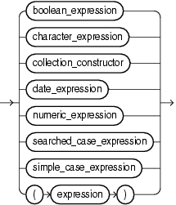  
[Description of the illustration expression.eps](https://docs.oracle.com/database/121/LNPLS/img_text/expression.htm)

See:

* "[boolean\_expression ::=](https://docs.oracle.com/database/121/LNPLS/expression.htm" \l "GUID-D4700B45-F2C8-443E-AEE7-2BD20FFD45B8__CHDDGEFH)"
* "[character\_expression ::=](https://docs.oracle.com/database/121/LNPLS/expression.htm" \l "GUID-D4700B45-F2C8-443E-AEE7-2BD20FFD45B8__CHDGJCJE)"
* "[collection\_constructor ::=](https://docs.oracle.com/database/121/LNPLS/expression.htm" \l "GUID-D4700B45-F2C8-443E-AEE7-2BD20FFD45B8__CJACBCAB)"
* "[date\_expression ::=](https://docs.oracle.com/database/121/LNPLS/expression.htm" \l "GUID-D4700B45-F2C8-443E-AEE7-2BD20FFD45B8__CHDIAFJD)"
* "[numeric\_expression ::=](https://docs.oracle.com/database/121/LNPLS/expression.htm" \l "GUID-D4700B45-F2C8-443E-AEE7-2BD20FFD45B8__CHDIEJAI)"
* "[searched\_case\_expression ::=](https://docs.oracle.com/database/121/LNPLS/expression.htm" \l "GUID-D4700B45-F2C8-443E-AEE7-2BD20FFD45B8__CHDGJEJJ)"
* "[simple\_case\_expression ::=](https://docs.oracle.com/database/121/LNPLS/expression.htm" \l "GUID-D4700B45-F2C8-443E-AEE7-2BD20FFD45B8__CHDIFFCB)"

***boolean\_expression* ::=**

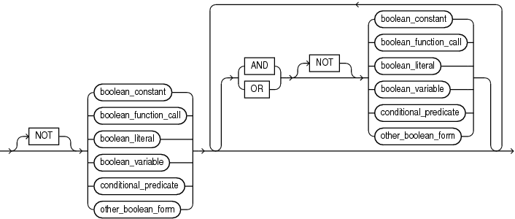  
[Description of the illustration boolean\_expression.eps](https://docs.oracle.com/database/121/LNPLS/img_text/boolean_expression.htm)

See "[function\_call ::=](https://docs.oracle.com/database/121/LNPLS/expression.htm" \l "GUID-D4700B45-F2C8-443E-AEE7-2BD20FFD45B8__CHDBCJGE)".

***boolean\_literal* ::=**

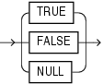  
[Description of the illustration boolean\_literal.eps](https://docs.oracle.com/database/121/LNPLS/img_text/boolean_literal.htm)

***conditional\_predicate* ::=**

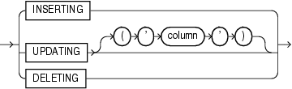  
[Description of the illustration conditional\_predicate.eps](https://docs.oracle.com/database/121/LNPLS/img_text/conditional_predicate.htm)

***other\_boolean\_form* ::=**

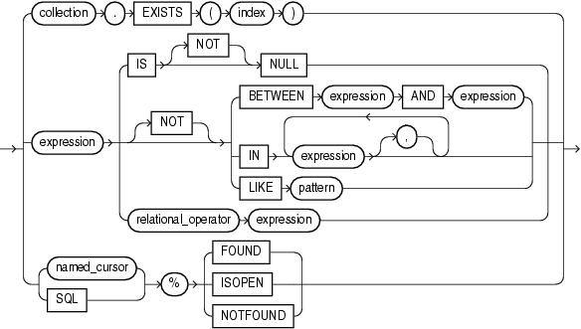  
[Description of the illustration other\_boolean\_form.eps](https://docs.oracle.com/database/121/LNPLS/img_text/other_boolean_form.htm)

See:

* "[expression ::=](https://docs.oracle.com/database/121/LNPLS/expression.htm#GUID-D4700B45-F2C8-443E-AEE7-2BD20FFD45B8__CHDHFDEA)"
* "[named\_cursor ::=](https://docs.oracle.com/database/121/LNPLS/named_cursor_attribute.htm" \l "GUID-CD8D8415-FF19-4D81-99BA-7825FD40CC96__CJABJCCH)"

***character\_expression* ::=**

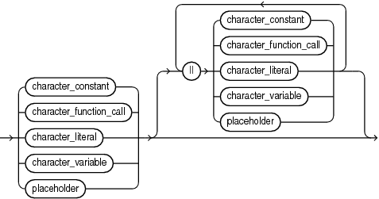  
[Description of the illustration character\_expression.eps](https://docs.oracle.com/database/121/LNPLS/img_text/character_expression.htm)

See:

* "[function\_call ::=](https://docs.oracle.com/database/121/LNPLS/expression.htm" \l "GUID-D4700B45-F2C8-443E-AEE7-2BD20FFD45B8__CHDBCJGE)"
* "[placeholder ::=](https://docs.oracle.com/database/121/LNPLS/assignment_statement.htm#GUID-4C3BEFDF-3FFA-4E9D-96D0-4C5E13E08643__CHDJCGHJ)"

***collection\_constructor* ::=**

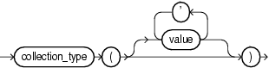  
[Description of the illustration collection\_constructor.eps](https://docs.oracle.com/database/121/LNPLS/img_text/collection_constructor.htm)

***date\_expression* ::=**

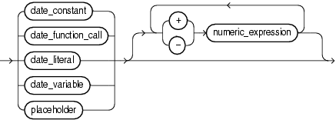  
[Description of the illustration date\_expression.eps](https://docs.oracle.com/database/121/LNPLS/img_text/date_expression.htm)

See:

* "[function\_call ::=](https://docs.oracle.com/database/121/LNPLS/expression.htm" \l "GUID-D4700B45-F2C8-443E-AEE7-2BD20FFD45B8__CHDBCJGE)"
* "[placeholder ::=](https://docs.oracle.com/database/121/LNPLS/assignment_statement.htm#GUID-4C3BEFDF-3FFA-4E9D-96D0-4C5E13E08643__CHDJCGHJ)"

***numeric\_expression* ::=**

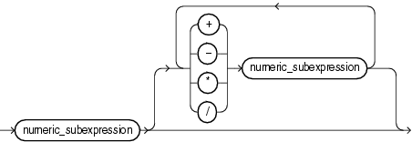  
[Description of the illustration numeric\_expression.eps](https://docs.oracle.com/database/121/LNPLS/img_text/numeric_expression.htm)

***numeric\_subexpression* ::=**

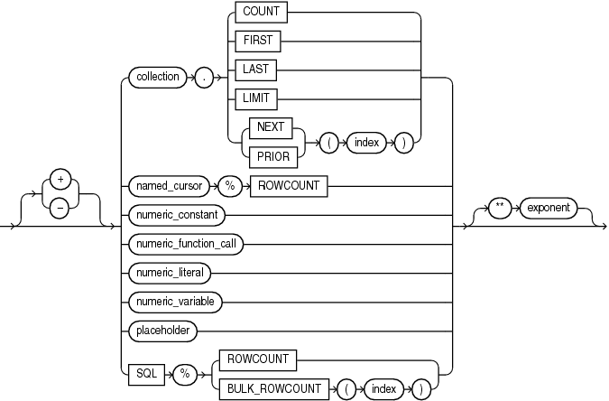  
[Description of the illustration numeric\_subexpression.eps](https://docs.oracle.com/database/121/LNPLS/img_text/numeric_subexpression.htm)

See:

* "[function\_call ::=](https://docs.oracle.com/database/121/LNPLS/expression.htm" \l "GUID-D4700B45-F2C8-443E-AEE7-2BD20FFD45B8__CHDBCJGE)"
* "[named\_cursor ::=](https://docs.oracle.com/database/121/LNPLS/named_cursor_attribute.htm" \l "GUID-CD8D8415-FF19-4D81-99BA-7825FD40CC96__CJABJCCH)"
* "[placeholder ::=](https://docs.oracle.com/database/121/LNPLS/assignment_statement.htm#GUID-4C3BEFDF-3FFA-4E9D-96D0-4C5E13E08643__CHDJCGHJ)"

***function\_call* ::=**

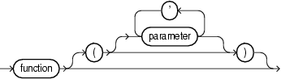  
[Description of the illustration function\_call.eps](https://docs.oracle.com/database/121/LNPLS/img_text/function_call.htm)

***searched\_case\_expression* ::=**

Description of searched_case_expression.eps follows  
[Description of the illustration searched\_case\_expression.eps](https://docs.oracle.com/database/121/LNPLS/img_text/searched_case_expression.htm)

See "[boolean\_expression ::=](https://docs.oracle.com/database/121/LNPLS/expression.htm" \l "GUID-D4700B45-F2C8-443E-AEE7-2BD20FFD45B8__CHDDGEFH)".

***simple\_case\_expression* ::=**

Description of simple_case_expression.eps follows  
[Description of the illustration simple\_case\_expression.eps](https://docs.oracle.com/database/121/LNPLS/img_text/simple_case_expression.htm)

**Semantics**

***expression***

***boolean\_expression***

Expression whose value is TRUE, FALSE, or NULL. For more information, see "[BOOLEAN Expressions](https://docs.oracle.com/database/121/LNPLS/fundamentals.htm#GUID-E277B6FF-866F-486A-BCB1-58235C0AFC69)".

**Restriction on *boolean\_expression***

Because SQL has no data type equivalent to BOOLEAN, you cannot:

* Assign a BOOLEAN value to a database table column
* Select or fetch the value of a database table column into a BOOLEAN variable
* Use a BOOLEAN value in a SQL function

(However, a SQL query can invoke a PL/SQL function that has a BOOLEAN parameter, as in [Example 3-3](https://docs.oracle.com/database/121/LNPLS/datatypes.htm#GUID-02AEA63C-9A27-43F4-80B7-4781343445D0__CJAJAJIC).)

* Use a BOOLEAN expression in a SQL statement, except as an argument to a PL/SQL function invoked in a SQL query, or in a PL/SQL anonymous block.

**Note:**

An argument to a PL/SQL function invoked in a static SQL query cannot be a BOOLEAN literal. The workaround is to assign the literal to a variable and then pass the variable to the function, as in [Example 3-3](https://docs.oracle.com/database/121/LNPLS/datatypes.htm#GUID-02AEA63C-9A27-43F4-80B7-4781343445D0__CJAJAJIC).

**NOT, AND, OR**

See "[Logical Operators](https://docs.oracle.com/database/121/LNPLS/fundamentals.htm#GUID-9D19FEBB-A397-47F5-A4EC-D71B0DE91738)".

***boolean\_constant***

Name of a constant of type BOOLEAN.

***boolean\_function\_call***

Invocation of a previously defined function that returns a BOOLEAN value. For more semantic information, see "[function\_call](https://docs.oracle.com/database/121/LNPLS/expression.htm" \l "GUID-D4700B45-F2C8-443E-AEE7-2BD20FFD45B8__CHDEBDGB)".

***boolean\_variable***

Name of a variable of type BOOLEAN.

***conditional\_predicate***

See "[Conditional Predicates for Detecting Triggering DML Statement](https://docs.oracle.com/database/121/LNPLS/triggers.htm#GUID-EC6A8FA1-9E60-4374-9905-639F4F100D83)".

***other\_boolean\_form***

***collection***

Name of a collection variable.

**EXISTS**

Collection method (function) that returns TRUE if the *index*th element of *collection* exists and FALSEotherwise. For more information, see "[EXISTS Collection Method](https://docs.oracle.com/database/121/LNPLS/composites.htm#GUID-31E27176-042B-4BA8-8FBC-14CCEDC33095)".

**Restriction on EXISTS**

You cannot use EXISTS if *collection* is an associative array.

***index***

Numeric expression whose data type either is PLS\_INTEGER or can be implicitly converted to PLS\_INTEGER (for information about the latter, see "[Predefined PLS\_INTEGER Subtypes](https://docs.oracle.com/database/121/LNPLS/datatypes.htm#GUID-00859F04-85FC-422D-B35B-93F5B5F4B912)").

**IS [NOT] NULL**

See "[IS [NOT] NULL Operator](https://docs.oracle.com/database/121/LNPLS/fundamentals.htm#GUID-D02FA4D0-0074-4227-9624-F01E3D219BAB)".

**BETWEEN *expression* AND *expression***

See "[BETWEEN Operator](https://docs.oracle.com/database/121/LNPLS/fundamentals.htm#GUID-B748E382-B068-48EC-B809-4FAB1F8D7C6B)".

**IN *expression* [, *expression* ]...**

See "[IN Operator](https://docs.oracle.com/database/121/LNPLS/fundamentals.htm#GUID-3E3F4260-9773-41E8-BA10-069CFE1F0A6D)".

**LIKE *pattern***

See "[LIKE Operator](https://docs.oracle.com/database/121/LNPLS/fundamentals.htm#GUID-C3921F3A-52B3-473D-A93F-D198DED21BA9)".

***relational\_operator***

See "[Relational Operators](https://docs.oracle.com/database/121/LNPLS/fundamentals.htm#GUID-2EB964C8-9B36-4009-A45F-B340F44EE2A2)".

**SQL**

Implicit cursor associated with the most recently run SELECT or DML statement. For more information, see "[Implicit Cursors](https://docs.oracle.com/database/121/LNPLS/static.htm#GUID-596C1961-5A94-40ED-9920-668BB05632C5)".

**%FOUND, %ISOPEN, %NOTFOUND**

Cursor attributes explained in "[Implicit Cursor Attribute](https://docs.oracle.com/database/121/LNPLS/implicit_cursor_attribute.htm#GUID-5A938EE7-E8D2-468C-B60F-81898F110BE1)" and "[Named Cursor Attribute](https://docs.oracle.com/database/121/LNPLS/named_cursor_attribute.htm#GUID-CD8D8415-FF19-4D81-99BA-7825FD40CC96)".

***character\_expression***

Expression whose value has a character data type (that is, a data type in the CHAR family, described in "[CHAR Data Type Family](https://docs.oracle.com/database/121/LNPLS/predefined.htm#GUID-1D28B7B6-15AE-454A-8134-F8724551AE8B__CDFIHAGE)").

***character\_constant***

Name of a constant that has a character data type.

***character\_function\_call***

Invocation of a previously defined function that returns a value that either has a character data type or can be implicitly converted to a character data type. For more semantic information, see "[function\_call](https://docs.oracle.com/database/121/LNPLS/expression.htm" \l "GUID-D4700B45-F2C8-443E-AEE7-2BD20FFD45B8__CHDEBDGB)".

***character\_literal***

Literal of a character data type.

***character\_variable***

Name of a variable that has a character data type.

||

Concatenation operator, which appends one string operand to another. For more information, see "[Concatenation Operator](https://docs.oracle.com/database/121/LNPLS/fundamentals.htm#GUID-4792284C-D82B-4F6A-8554-45CF1BFAE6EB)".

***collection\_constructor***

Constructs a collection of the specified type with elements that have the specified values.

For more information, see "[Collection Constructors](https://docs.oracle.com/database/121/LNPLS/composites.htm#GUID-92967CC1-481E-472A-BB4C-90C60F75296D)".

***collection\_type***

Name of a previously declared nested table type or VARRAY type (not an associative array type).

***value***

Valid value for an element of a collection of *collection\_type*.

If *collection\_type* is a varray type, then it has a maximum size, which the number of values cannot exceed. If *collection\_type* is a nested table type, then it has no maximum size.

If you specify no values, then the constructed collection is empty but not null (for the difference between *empty*and *null*, see "[Collection Types](https://docs.oracle.com/database/121/LNPLS/composites.htm#GUID-7E9034D5-0D33-43A1-9012-918350FE148C)").

***date\_expression***

Expression whose value has a date data type (that is, a data type in the DATE family, described in "[DATE Data Type Family](https://docs.oracle.com/database/121/LNPLS/predefined.htm#GUID-1D28B7B6-15AE-454A-8134-F8724551AE8B__CDFICIEE)").

***date\_constant***

Name of a constant that has a date data type.

***date\_function\_call***

Invocation of a previously defined function that returns a value that either has a date data type or can be implicitly converted to a date data type. For more semantic information, see "[function\_call](https://docs.oracle.com/database/121/LNPLS/expression.htm" \l "GUID-D4700B45-F2C8-443E-AEE7-2BD20FFD45B8__CHDEBDGB)".

***date\_literal***

Literal whose value either has a date data type or can be implicitly converted to a date data type.

***date\_variable***

Name of a variable that has a date data type.

**+, -**

Addition and subtraction operators.

***numeric\_expression***

Expression whose value has a date numeric type (that is, a data type in the DATE family, described in "[NUMBER Data Type Family](https://docs.oracle.com/database/121/LNPLS/predefined.htm#GUID-1D28B7B6-15AE-454A-8134-F8724551AE8B__CDFJEBIF)").

**+, -, /, \*, \*\***

Addition, subtraction, division, multiplication, and exponentiation operators.

***numeric\_subexpression***

***collection***

Name of a collection variable.

**COUNT, FIRST, LAST, LIMIT, NEXT, PRIOR**

Collection methods explained in "[Collection Method Invocation](https://docs.oracle.com/database/121/LNPLS/collection_method.htm#GUID-7AF1A3C4-D04B-4F91-9D7B-C92C75E3A300)".

***named\_cursor*%ROWCOUNT**

See "[Named Cursor Attribute](https://docs.oracle.com/database/121/LNPLS/named_cursor_attribute.htm#GUID-CD8D8415-FF19-4D81-99BA-7825FD40CC96)".

***numeric\_constant***

Name of a constant that has a numeric data type.

***numeric\_function\_call***

Invocation of a previously defined function that returns a value that either has a numeric data type or can be implicitly converted to a numeric data type. For more semantic information, see "[function\_call](https://docs.oracle.com/database/121/LNPLS/expression.htm" \l "GUID-D4700B45-F2C8-443E-AEE7-2BD20FFD45B8__CHDEBDGB)".

***numeric\_literal***

Literal of a numeric data type.

***numeric\_variable***

Name of variable that has a numeric data type.

**SQL%ROWCOUNT**

Cursor attribute explained in "[Implicit Cursor Attribute](https://docs.oracle.com/database/121/LNPLS/implicit_cursor_attribute.htm#GUID-5A938EE7-E8D2-468C-B60F-81898F110BE1)".

**SQL%BULK\_ROWCOUNT]**

Cursor attribute explained in "[SQL%BULK\_ROWCOUNT](https://docs.oracle.com/database/121/LNPLS/implicit_cursor_attribute.htm#GUID-5A938EE7-E8D2-468C-B60F-81898F110BE1__CJAGCIJA)".

***exponent***

Numeric expression.

***function\_call***

***function***

Name of a previously defined function.

***parameter* [, *parameter* ]...**

List of actual parameters for the function being called. The data type of each actual parameter must be compatible with the data type of the corresponding formal parameter. The mode of the formal parameter determines what the actual parameter can be:

| **Formal Parameter Mode** | **Actual Parameter** |
| --- | --- |
| IN | Constant, initialized variable, literal, or expression |
| OUT | Variable whose data type is not defined as NOT NULL |
| IN OUT | Variable (typically, it is a string buffer or numeric accumulator) |

If the function specifies a default value for a parameter, you can omit that parameter from the parameter list. If the function has no parameters, or specifies a default value for every parameter, you can either omit the parameter list or specify an empty parameter list.

**See Also:**

"[Positional, Named, and Mixed Notation for Actual Parameters](https://docs.oracle.com/database/121/LNPLS/subprograms.htm#GUID-A5DA8CF5-1BCC-4ABE-9B68-DB593FF1D2CC)"

***searched\_case\_expression***

**WHEN *boolean\_expression* THEN *result***

The *boolean\_expression*s are evaluated sequentially. If a *boolean\_expression* has the value TRUE, then the *result* associated with that *boolean\_expression* is returned. Subsequent *boolean\_expression*s are not evaluated.

**ELSE *result***

The *result* is returned if and only if no *boolean\_expression* has the value TRUE.

If you omit the ELSE clause, the searched case expression returns NULL.

**See Also:**

"[Searched CASE Statement](https://docs.oracle.com/database/121/LNPLS/controlstatements.htm#GUID-C7CBBE66-5E51-444E-BE92-C23ED662FE4D)"

***simple\_case\_expression***

***selector***

An expression of any PL/SQL type except BLOB, BFILE, or a user-defined type. The *selector* is evaluated once.

**WHEN *selector\_value* THEN *result***

The *selector\_value*s are evaluated sequentially. If a *selector\_value* is the value of *selector*, then the *result* associated with that *selector\_value* is returned. Subsequent *selector\_value*s are not evaluated.

A *selector\_value* can be of any PL/SQL type except BLOB, BFILE, an ADT, a PL/SQL record, an associative array, a varray, or a nested table.

**ELSE *result***

The *result* is returned if and only if no *selector\_value* has the same value as *selector*.

If you omit the ELSE clause, the simple case expression returns NULL.