1) Test Instagram API

2) Inspiration link on single blog change size on hover

3) Popular stories in side bar

a) bind with MySQL

b) make sorting by visits

c) set counter

4) No Pin on firefox(only in my Firefox)

a) check opera –safary;

5) in-page links *discarded*

6) About me page create

7) Advices in tags

a) Make active advice tab

b) add record to DB

8) Login page;

a) generate random hash using md5(salt)

9) Admin panel;

a) add delete and edit options

b) make markup of page

c) if no choose img -> not update

10) Adjust Contacts;

a) interface to load busy days

b) calendar not worked on any firefox;

c) load from JSON

11) Share buttons make layout;

a)Check vkontacte share

b) counter of like/share

c)make layout of like/share

12) Vkontacte comments appear when FB not logged but VC is;

13) Discuss format of date;

14) separate small preview and large;

15) split text to 1000 symbols and add … if more

16) add data sorting for preview fetch

New tasks

1. Ask for 6-8 wedings grouped like:

Preview small –/preview/S_name

Preview big -/preview/L_name

Photography set - /name of set/N_name

1. Put website to free web hosting
2. Discuss follow tag (delete put language bar instead)
3. Make 2 language
4. Choose button for switcher
5. Enable cookies for session
6. Adjust admin panel;
7. Put to WP?
8. Clean code from errors ,make more readable
9. Popular story center preview photo(will be 280 x 280)
10. Share link to VK has bad view
11. Optimization(Mobile version):
    1. Add viewport to all pages
    2. Use flex
    3. Lazyload of img
    4. Srink img gulp
    5. Compile css, js
    6. Start css from script
    7. Htconf enable catching
    8. Try to reduce queries()
12. Add form for mailing
    1. Datapicker has bad layout
13. Add response of customers;
    1. Create new tab to admin panel to add response;
    2. Feedback page ask and perform layout;
14. Make user set links to words in description.
15. Remove names of php files in the links(Htaccess);

Discussion with Olya 23.10.2015

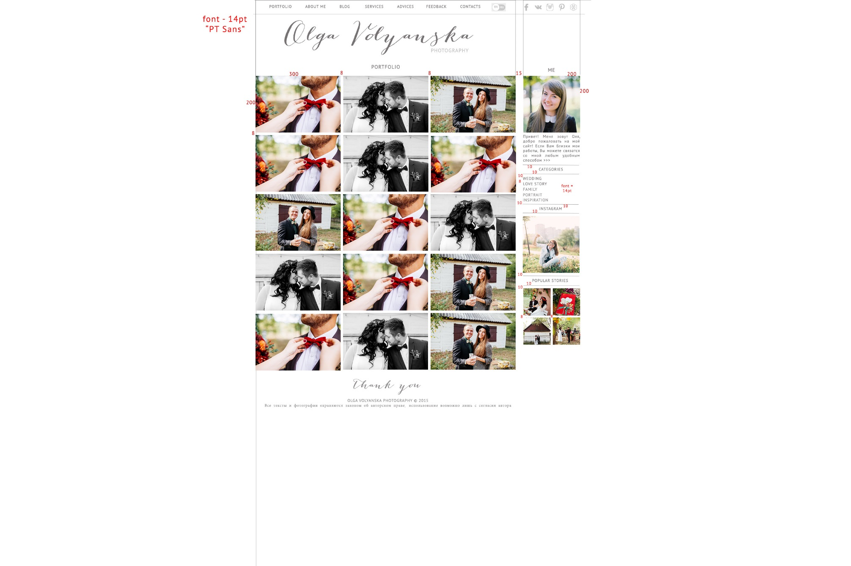

Portfolio:

1. Resize to 1131px(924+206)
2. Change header:
   1. Drop logo;
   2. Adjust language button;
   3. Add new items;
3. Change logo to temp(SVG)
4. Portfolio and Me on top
5. Change div 308 x 208
6. Change 200x200 logo and text about me;
7. Edit “preview” photo not change (cache or something)!
8. Change font to PT Sans
9. Instagram photo compress
10. Enable caching of insta-photo
11. Name conflict for folder;

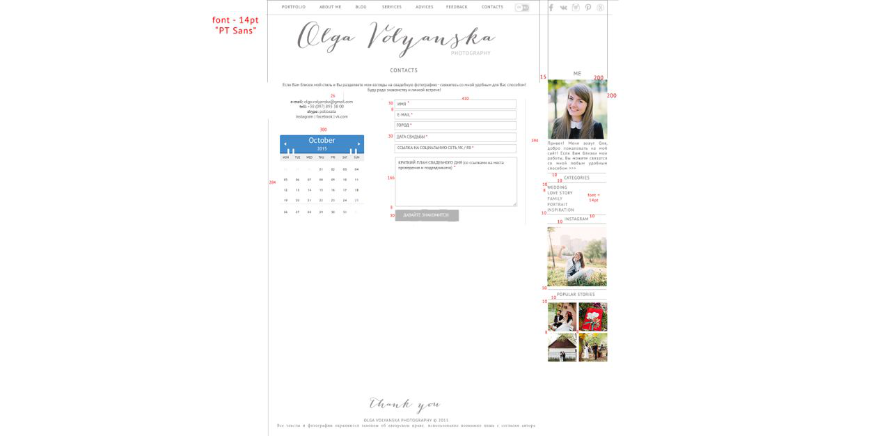

Contacts

1. Datepicker make according layout
2. Make check of filled fields.
3. Put mailsender server
4. Links to social networks

Blog

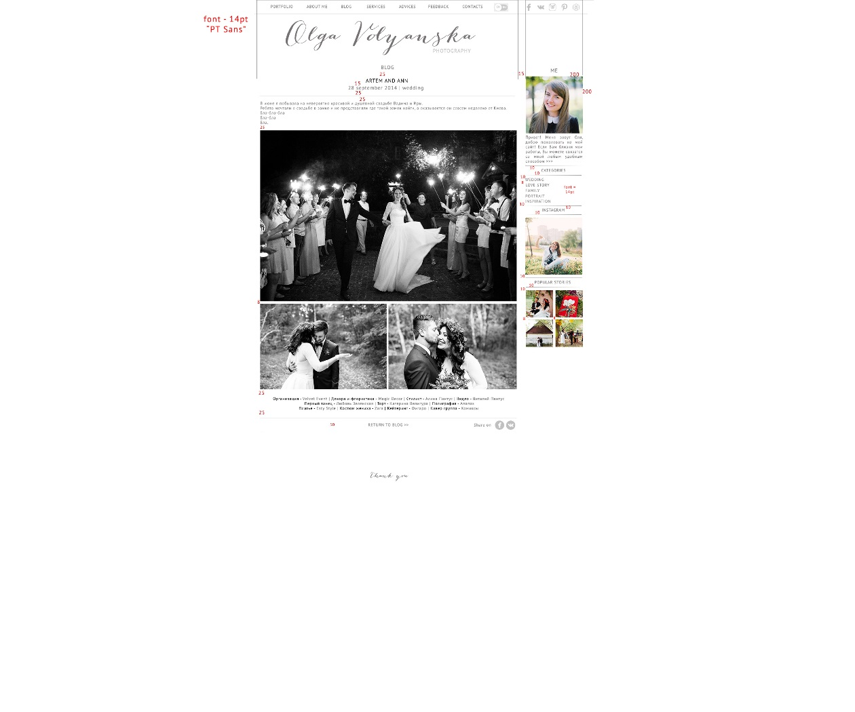

1. Add subcontractor (wedding specialist)
2. Организация – [Velvet Event](http://www.w3schools.com/cssref/pr_border.asp) | Декор и Флористика – [Magic Décor](http://www.w3schools.com/cssref/pr_border.asp) | Платье – [Esty Style](http://www.w3schools.com/cssref/pr_border.asp) | Костюм жениха – [Zara](http://www.w3schools.com/cssref/pr_border.asp) | Стилист – [Алина Пантус](http://www.w3schools.com/cssref/pr_border.asp) | Видео – [Виталий Пантус](http://www.w3schools.com/cssref/pr_border.asp) | Кейтеринг – [Фигаро](http://www.w3schools.com/cssref/pr_border.asp) | Полиграфия – [Ananas](http://www.w3schools.com/cssref/pr_border.asp) | Торт – [Катерина Велигура](http://www.w3schools.com/cssref/pr_border.asp) | Кавер группа - [Комиксы](http://www.w3schools.com/cssref/pr_border.asp)
3. 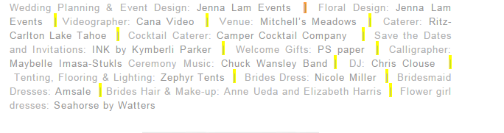

a)add into admin panel to add subcontractor

4) about me out of div fix

5) panel should be scrollable

6) edit Admin bar to get prev data

7) map edit Admin for subcontractors

Feedbacks

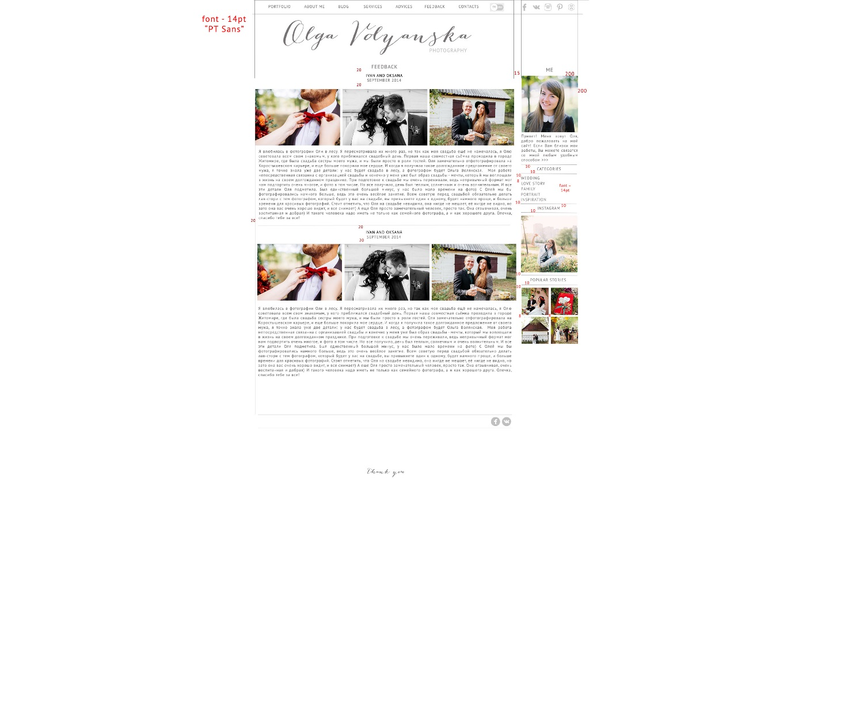

Update php.ini

To post_max_size 100mb

And max_file_uploads to 200