Pattern Library

Depth- Number of regions (colors) used.
Difficulty- This is opinion based, A is the easiest.

Beige cells = Important
Pink cells = Very Important
Red crossed cells = Mines resulting from pattern
Lime crossed cells = Safe cells resulting from pattern

The “Document Outline” feature on the left of the page is pretty much required in order to browse properly.

Holes

1 D-Pattern / 221-Hole

1.1 D-Pattern Classic
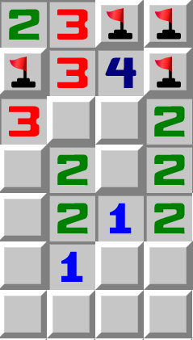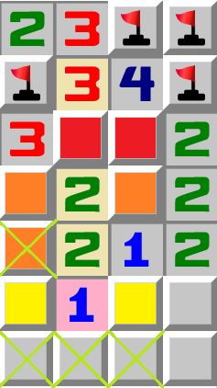
Depth: 3
Difficulty: A
The red cells contain one mine
The orange cells contain one mine
The yellow cells contain one mine
The 1 sees the yellow cells, so the lime crossed cells are safe

1.2 D Pattern / Start-Extension / 23-221
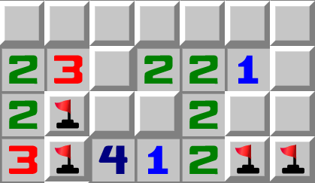
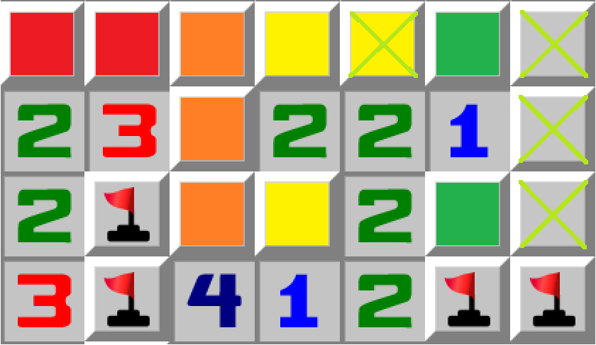
Depth: 4
Difficulty: A
The red cells contain one mine
The orange cells contain one mine
The yellow cells contain one mine
The green cells contain one mine
The 1 sees the green cells, so the lime crossed cells are safe.
-This pattern is very common in Evil NG, due to it being one of the more simple patterns to generate.
-This pattern also exists vertically

1.3 D-Pattern End-Extension / 24-322-2
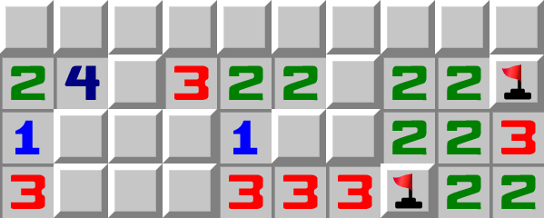
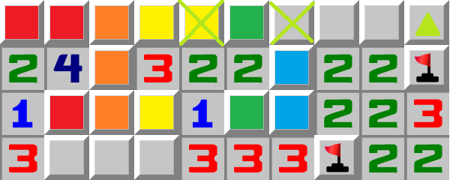
Depth: 5
Difficulty: B
The red cells contain two mines
The orange cells contain two mines
The yellow cells contain one mine
The green cells contain one mine
The cyan cells contain one mine

The 2 sees both the green cells and cyan cells, so the lime crossed cells are safe

-In this example the green triangle cell is also safe, this is unrelated to the pattern though.

2 O-Pattern / 222-Hole

2.1 O-Pattern Classic
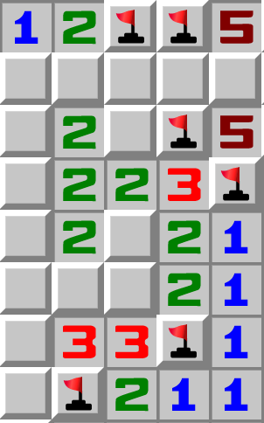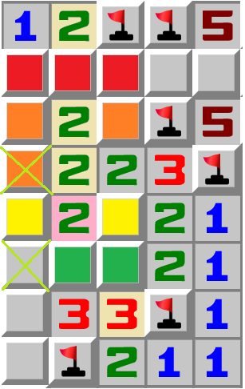
Depth: 4
Difficulty: A
The red cells contain one mine
The orange cells contain one mine
The yellow cells contain one mine
The green cells contain one mine
The 2 sees both the yellow and green cells, so the lime crossed cells are safe.

2.2 O-Pattern Pure

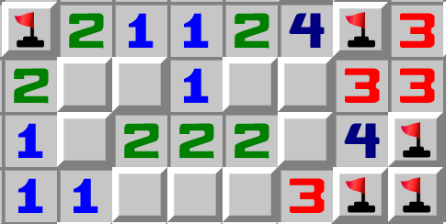
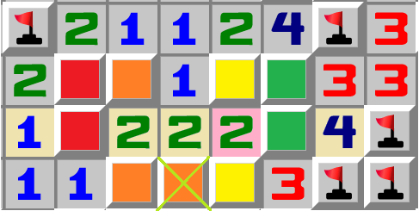
Depth: 4
Difficulty: A
The red cells contain one mine
The orange cells contain one mine
The yellow cells contain one mine
The green cells contain one mine
The 2 sees both the yellow and green cells, so the lime crossed cell is safe.

2.3 O-Pattern Reduction
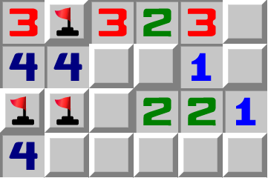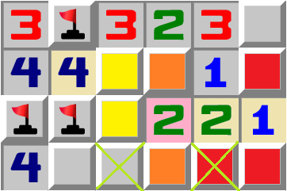
Depth: 3
Difficulty: A
The red cells contain one mine
The orange cells contain one mine
The yellow cells contain one mine
The 2 sees both the orange and yellow cells, so the lime crossed cells are safe.

-not a D-Pattern, it shares more characteristics to the O-Pattern

2.4 O-Pattern Reduction Advanced
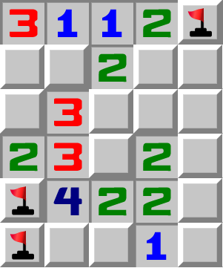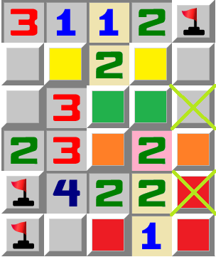
Depth: 4
Difficulty: B
The red cells contain one mine
The orange cells contain one mine
The yellow cells contain one mine
The green cells contain one mine
The 2 sees both the orange and green cells, so the lime crossed cells are safe.

-not a D-Pattern, it shares more characteristics to the O-Pattern

3 P-Pattern / 422-Hole
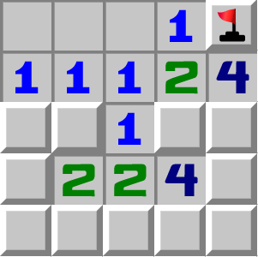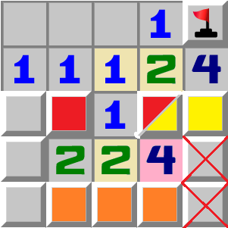
Depth: 4
Difficulty: A
The red cells contain one mine
The orange cells contain one mine
The yellow cells contain one mine
The 4 gets only two mines from the orange and yellow cells, so the red crossed cells contain mines
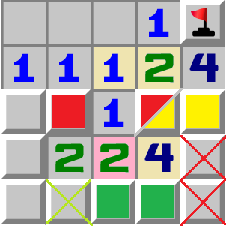
The red cells contain one mine
The yellow cells contain one mine
The green cells contain one mine
The 2 sees both the red and green cells, so the lime crossed cell is safe

4 T-Pattern / 23X-Hole
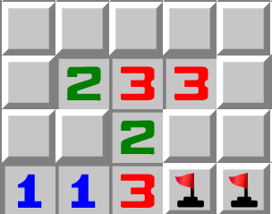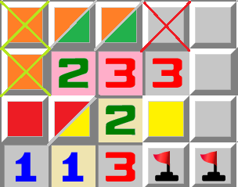
Depth: 4
Difficulty: B
The red cells contain one mine
The orange cells contain one mine
The yellow cells contain one mine
The 3 has one mine in the yellow cells and one in the green cells, so the red crossed cell is a mine.
The green cells contain one mine
The 2 sees both the red and green cells, so the lime crossed cells are safe.

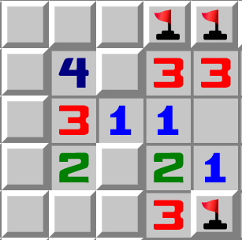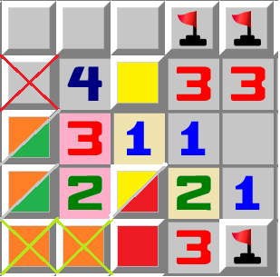
Depth: 4
Difficulty: B
The red cells contain one mine
The orange cells contain one mine
The yellow cells contain one mine
The 3 has one mine in the yellow cells and one in the green cells, so the red crossed cell is a mine.
The green cells contain one mine
The 2 sees both the red and green cells, so the lime crossed cells are safe.

5 J-Pattern / 322-Hole
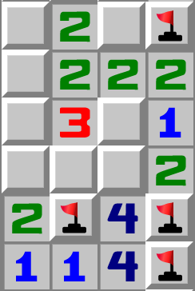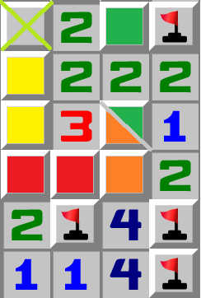
Depth: 4
Difficulty: A
The red cells contain one mine
The orange cells contain one mine
The yellow cells contain one mine
The green cells contain one mine

The 2 sees both the yellow cells and green cells, so the lime crossed cell is safe

6 B-Pattern / 332-Hole
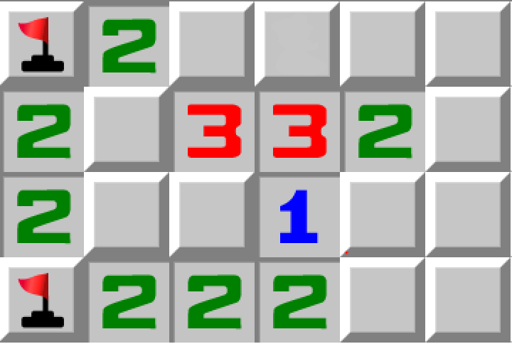
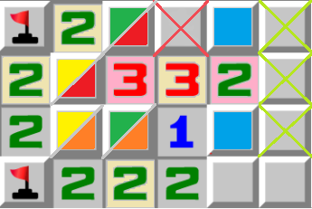
Depth: 5
Difficulty: B

The red cells contain one mine
The orange cells contain one mine
The 3 sees the red and orange cells, so the third mine goes into the red crossed cell
The yellow cells contain one mine
The green cells contain one mine
The cyan cells contain one mine
The 2 sees both the red crossed cell and the cyan cells, therefore the lime crossed cells are safe.

7 U-Pattern / 32X-Hole
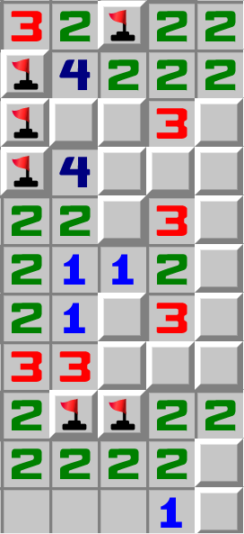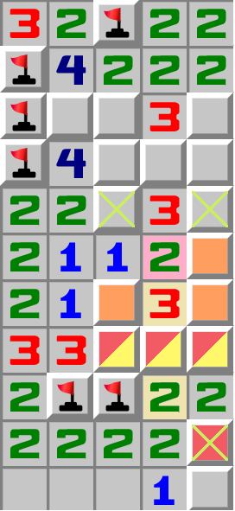
Depth: 3
Difficulty: A
The red cells contain one mine
The orange cells contain two mines
The 2 sees the orange cells, so the lime crossed cells are safe.
The yellow cells contain one mine
The 2 sees the yellow cells, so the lime crossed cell is safe.

Holes+

8 C-Pattern / 1>2-2-2-Corner Pattern
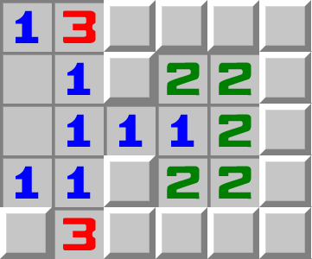
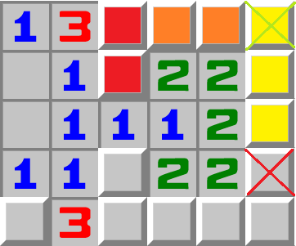
Depth: 3
Difficulty: A
The red cells contain one mine
The orange cells contain one mine
The yellow cells contain one mine
The red crossed cell contains a mine
Then, the 2 sees both the 2 yellow cells and the orange cells, so the lime crossed cell is safe.

9 Dependency Chain

9.1 Dependency Chain A Variation
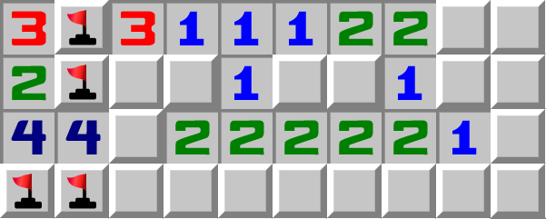
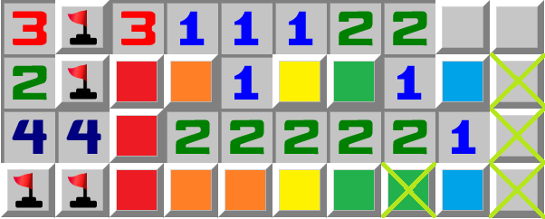
Depth: 5
Difficulty: B
The red cells contain one mine
The orange cells contain one mine
The yellow cells contain one mine
The green cells contain one mine
The cyan cells contain one mine
The 1 sees the cyan cells, so the lime crossed cells are safe.

-Dependency chain patterns usually make for
the patterns with the highest depth.

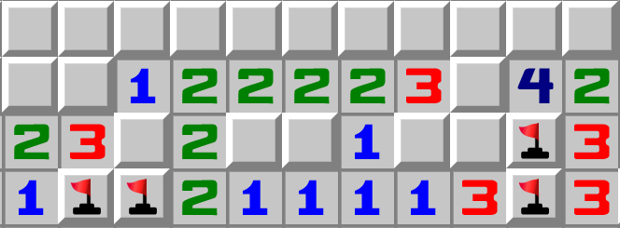
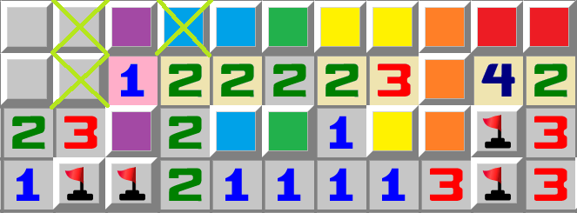
Depth: 6
Difficulty: B
The red cells contain one mine
The orange cells contain two mines
The yellow cells contain one mine
The green cells contain one mine
The cyan cells contain one mine
The purple cells contain one mine
The 1 sees the purple cells, so the lime crossed cells are safe.

-Dependency chain patterns usually make for
the patterns with the highest depth.

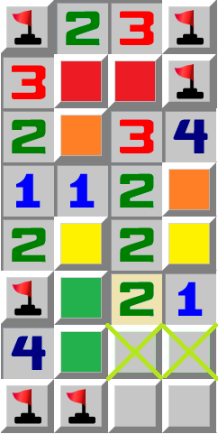
10 Z-Pattern
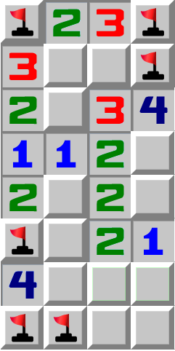
Depth: 4
Difficulty: B

The red cells contain one mine
The orange cells contain one mine
The yellow cells contain one mine
The green cells contain one mine
The 2 sees both the yellow and green cells, hence the lime crossed cells are safe.

11 G-Pattern

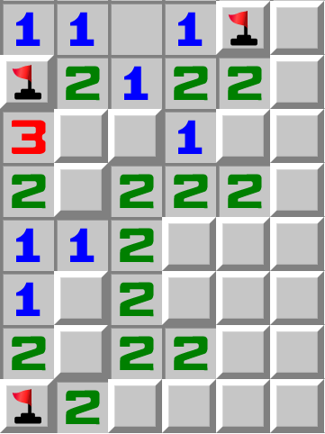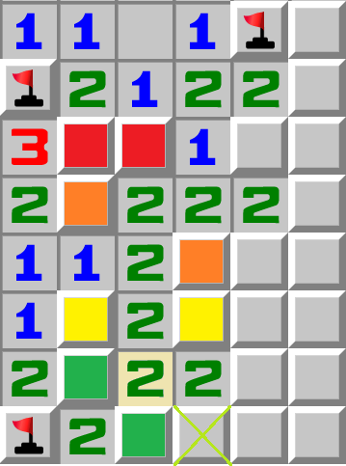
Depth: 4
Difficulty: B
The red cells contain one mine
The orange cells contain one mine
The yellow cells contain one mine
The green cells contain one mine
The 2 sees both the yellow cells and green cells, therefore the lime crosses cell is safe

-Similiar to the Z-Pattern, this pattern is more common though

High Complexity

12 Y-Pattern
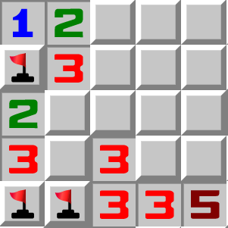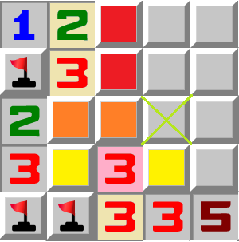
Depth: 3
Difficulty: A
The red cells contain one mine
The orange cells contain one mine
The yellow cells contain one mine
The 3 sees both the orange and yellow cells, so the lime crossed cell is safe.

13 L-Pattern
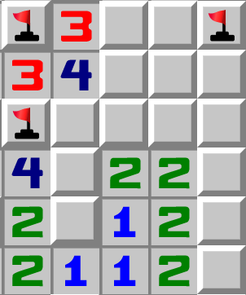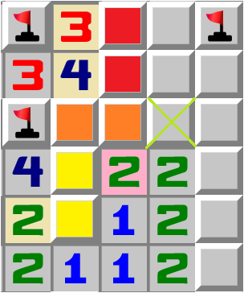
Depth: 3
Difficulty: A
The red cells contain one mine
The orange cells contain one mine
The yellow cells contain one mine
The 2 sees both the orange and yellow cells, so the lime crossed cell is safe.

Higher Complexity (Simple Outward Chains/Box Logic)

14 Basic Box Pattern
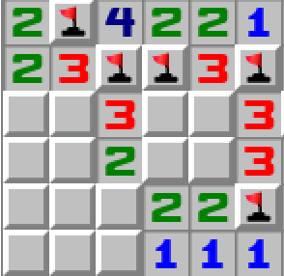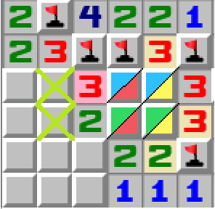
Pattern found by: Unknown
Pattern provided by: Not Anon
Depth: 4
Difficulty: B

The blue cells contain one mine
The green cells contain one mine

The “box” contains a total of two mines

One of these mines is in the yellow cells
The other mine goes into the red cells
The 3 sees the red cells, so the lime crossed cells are safe.

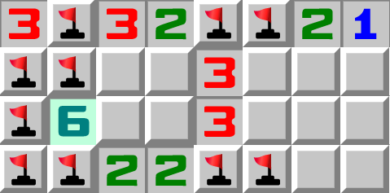
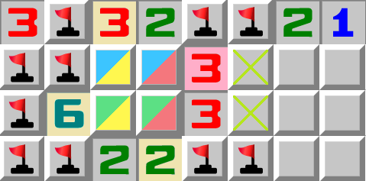
Depth: 4
Difficulty: B
The blue cells contain one mine
The green cells contain one mine

The “box” contains a total of two mines

One of these mines is in the yellow cells
The other mine goes into the red cells
The 3 sees the red cells, so the lime crossed cells are safe.

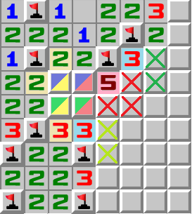
14b Basic Box Pattern Upper Bound

The blue cells contain one mine
The green cells contain one mine
The 2x2 box contains 2 mines in total

One of these mines is in the yellow cells
The remaining mine is therefore in the red cells

The 5 needs four mines, one is in the red cells. The three other mines must go into the three red-crossed cells

The 3 sees a red crossed cell, and the green cells, so the lime crossed cells are safe

The 3 sees a red crossed cell, so the green crossed cells are safe

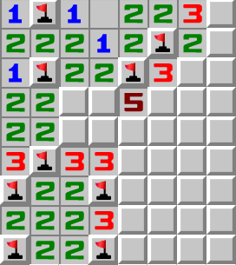

The first and currently only upper bound (proves mines rather than cells) that i’ve found

Broader Image: 1nAK52c

Full game: See “Game Records of Rare Patterns”

Another interesting thing about this example is the amount of resulting safe cells, 4 is quite high

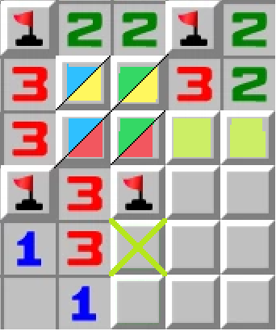
15 Input Box Pattern
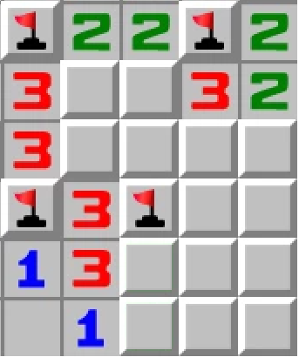
Pattern found by: Unknown
Pattern provided by: Not Anon
Depth: 5
Difficulty: C
The blue cells contain one mine
The lime cells contain one mine
The green cells contain one mine

The “box” contains a total of two mines

One of these mines is in the yellow cells
The other mine goes into the red cells
The 3 sees the red cells, so the lime crossed cells are safe.

16 Output Box Pattern
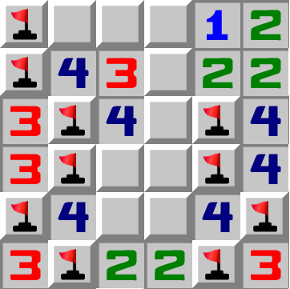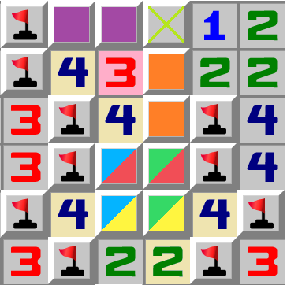
Depth: 6
Difficulty: C
The blue cells contain one mine
The green cells contain one mine

The “box” contains a total of two mines

One of these mines is in the yellow cells
The other mine goes into the red cells

The orange cells contain one mine
The purple cells contain one mine
The 3 sees both the orange and purple cells, so the lime crossed cell is safe

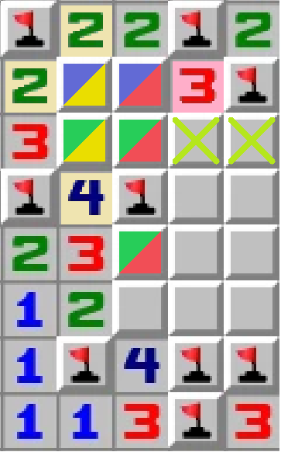
17 Bounded Box Pattern
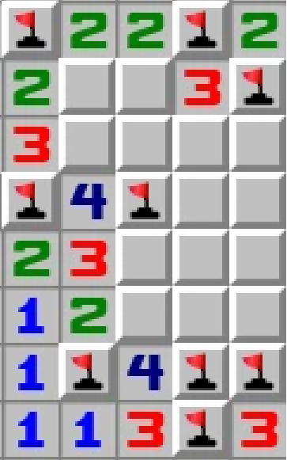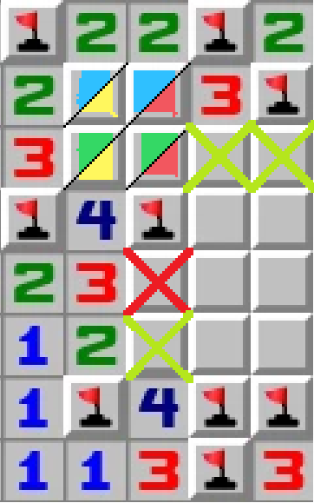
Pattern found by: Not Anon
Depth: 4
Difficulty: D
The blue cells contain one mine
The green cells contain 2 mines
The “box” contains between 3 mines

One of these mines goes into the yellow cells
The red cells contain two mines
The 3 sees some of the red cells, that contain 1-2 mines, so the lime crossed cells are safe.

You can also apply this backwards and prove that the cell bottom-right of the 4 is a mine, which simplifies it to a basic box

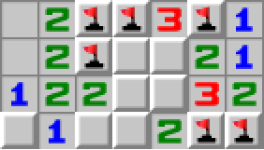
18 Finned Box Pattern
Pattern found by Scar

Depth: 4

Difficulty: C

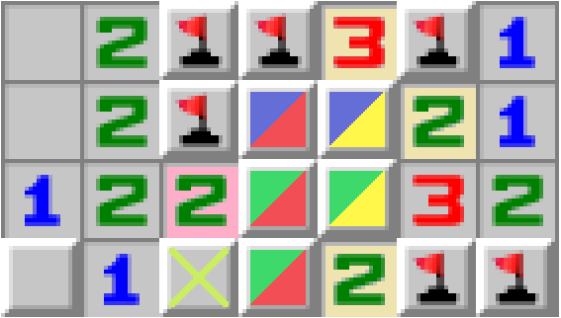

The blue cells contain one mine
The green cells contain one mine

The finned box contains two total mines

One of these is in the yellow cells
The red cells contain one mine
The 2 sees the red cells, therefore the lime crossed cell is safe.

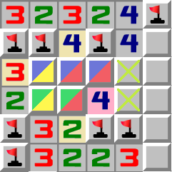
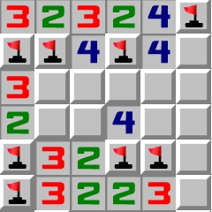
19 Finned Box Pattern II
Pattern found by Scar
Depth: 4
Difficulty: C
The blue cells contain two mines
The green cells contain one mine

The finned box contains a total of three mines

One of these mines is in the yellow cells
The other two mines are in the red cells
The 4 sees the red cells, so the lime crossed cells are safe.

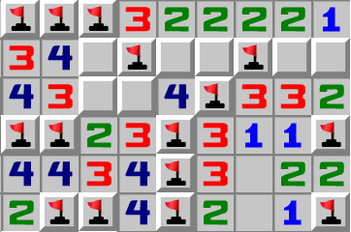

20 Swapped Box Pattern

Depth: 4

Difficulty: C

The blue cells contain one mine
The green cells contain one mine
The box contains 2 total mines
The yellow cells contain one of those mines
So the red cells contain the final mine
The 4 sees the red cells and three mines so the green crossed cell is safe.

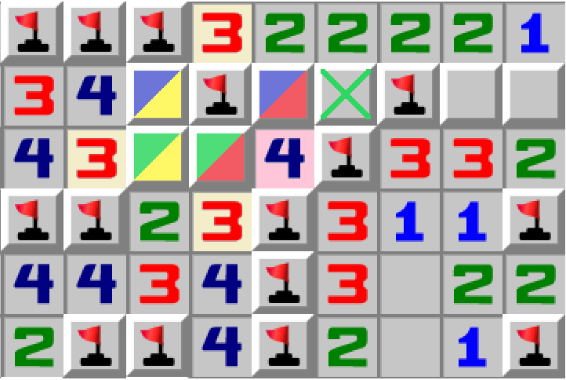

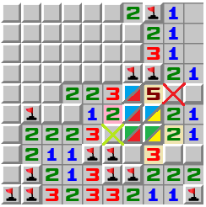
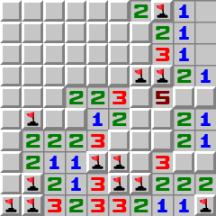
21 Mutated Box Pattern (Finned Bounded Box)
Improved Description by Not Anon
Pattern found by Scar
Depth: 4
Difficulty: E
The blue cells contain 2-3 mines
The green cells contain one mine.

The finned box will therefore contain 3 or 4 mines

One of these mines goes into the yellow cells
The red cells contain two mines, as three mines is not possible.
The 2 sees the red cells, so the lime crossed cell is safe.

Since we have concluded that the red cells contain two mines, and the yellow cells one mine, we know that the blue and green cells collectively contain three mines as well, and we know that one mine goes into the green cells, so there will be two mines in the blue cells. The 5 sees the blue cells, so the fifth mine goes into the red crossed cell

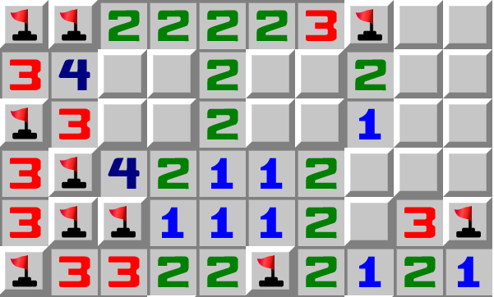
22 Double Box Pattern

Depth: 8
Difficulty: D
The blue cells contain one mine
The green cells contain one mine
The “box” contains a total of two mines
The yellow cells contain one mine
The red cells contain the other mine

The purple cells contain one mine
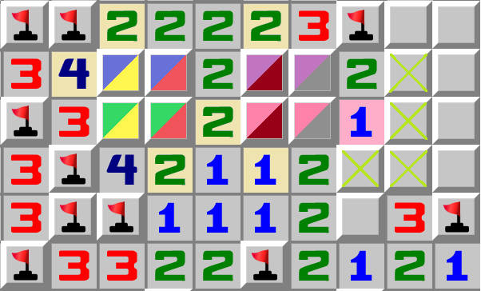
The pink cells contain one mine
The “box” contains a total of two mines
The maroon cells contain one mine
The grey cells contain the other mine

The 1 sees the grey cells, so the lime crossed cells are safe.

23 Finned Double Box Pattern
*reconstruction, was found on a twitch stream which made the quality very low

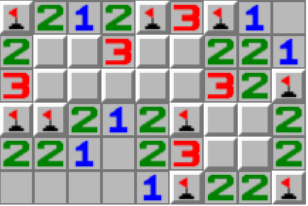
23A Explanation 1

Encountered by: Unknown Twitch Streamer

Difficulty: D

Depth: 8 (See 23B)

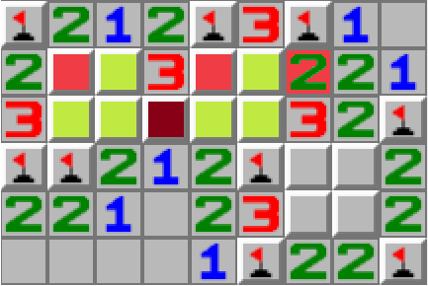

Let’s assume the maroon cell is a mine.
We now know two other mines
The 2 only sees one mine now, which is impossible
The maroon cell is therefore safe.

23B Explanation 2 (WARNING, UNNECESSARILY COMPLICATED)
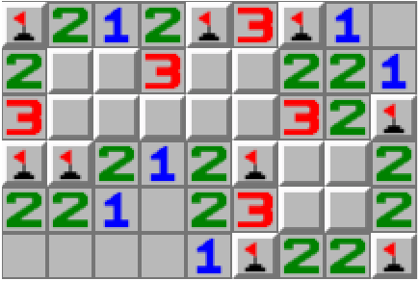
Encountered by: Unknown Twitch Streamer
Difficulty: D
Depth: 8 (See 23B)

The blue cells contain one mine
The green cells contain one mine

The finned box contains two mines

One of these mines is in the yellow cells
The red cells contain one mine
The purple cells contain one mine
The pink cells contain one mine

The box contains two mines

One of these mines is in the gray cells
The brown cells contain one mine
The 2 sees the brown cells, so the lime crossed cell is safe
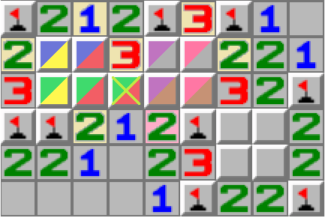

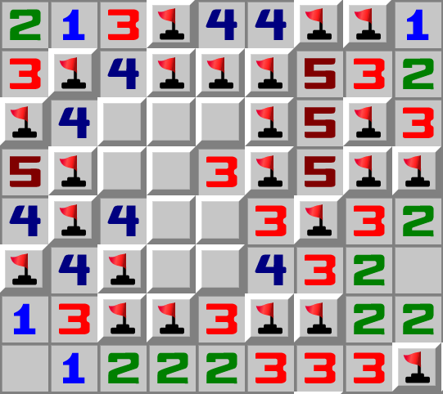
24 Single Joined Box Pattern

Found By: Rory

Difficulty: D
Depth: 8

The blue cells contain one mine
The green cells contain one mine
The box contains 2 mines
The yellow cells contain one mine
So the last mine goes into the red cells.
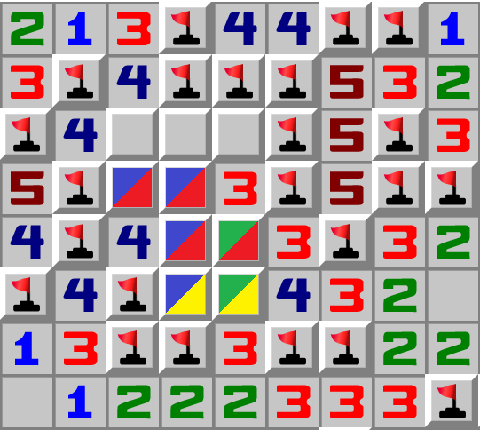

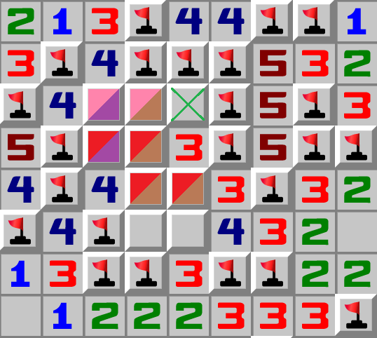
The red cells contain one mine
The pink cells contain one mine
The box contains 2 mines
The purple cells contain one mine,
So the brown cells contain one mine

The 3 sees the brown cells, so the lime crossed cell is safe
^The pattern can be applied both ways

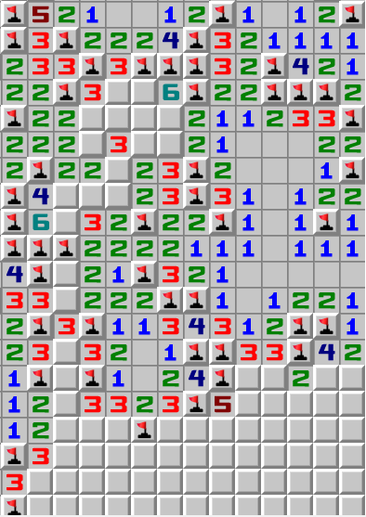
The blue cells contain a mine
The green cells contain two mines
The box contains 3 mines
The yellow cells contain one of the 3 mines
The red cells therefore contain two mines

The pink cells contain one mine
The box contains 3 mines
The purple cells contain one of the 3 mines
The brown cells therefore contain two mines
The lime cells contain one mine
The gray cells contain one mine
The 3 sees the gray cells, so the red crossed cell is a mine, resulting in safe cells.
^The pattern can be applied both ways

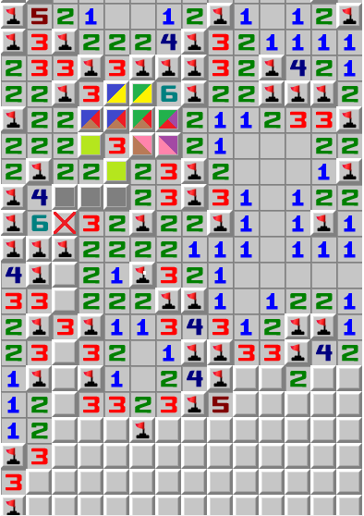

25 Caterpillar

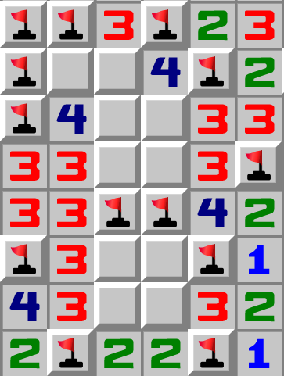
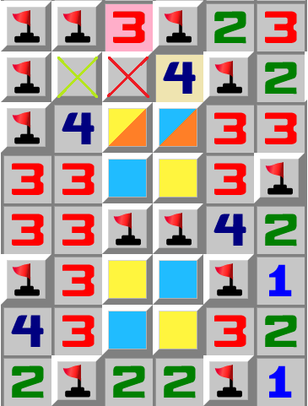
25A Caterpillar Explanation 1
Found by: 84436
Difficulty: D
Depth: 10 (See 25B)
Either the Blue or Yellow cells will contain mines
This means that one of the orange cells contains a mine
Because of this the the red crossed cell contains a mine
The 3 sees the red crossed cell, so the lime crossed cell is safe.

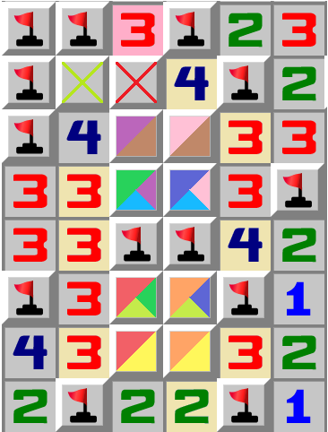
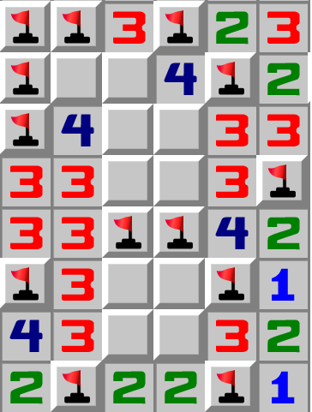
25B Caterpillar Explanation 2 (WARNING, UNNECESSARILY COMPLICATED)

Found by: 84436

Difficulty: D
Depth: 10
* Breathes in*
The red cells contain one mine
The orange cells contain one mine
The black box contains 2 total mines
One of these goes into the yellow cells
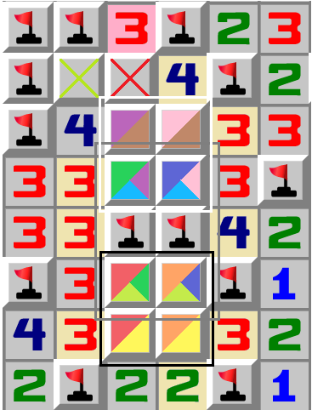
The other goes into the lime cells
-------------------------------------------------------------------------------------------------------------------------------------------------------------------------------
The green cells contain one mine
The blue cells contain one mine
The grey box contains 2 total mines
One of these is in the lime cells
The other goes into the cyan cells.
-------------------------------------------------------------------------------------------------------------------------------------------------------------------------------
The purple cells contain one mine
The pink cells contain one mine
The white box contains 2 total mines
One of these is in the cyan cells
The other goes into the brown cells
The red crossed cell is a mine since the brown cells contain one mine
The 3 sees the red crossed cell, so the lime crossed cell is safe.

26 Butterfly ( Finned Caterpillar )

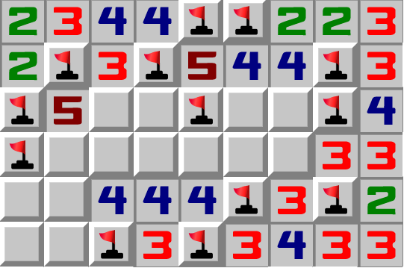
26A Butterfly Explanation 1

Found by: 84436
Difficulty: D
Depth: 10 (See 26B)
Either the Blue or Yellow cells will contain mines
This means that the orange cells contain a mine
Because of this the the red crossed cell contains a mine

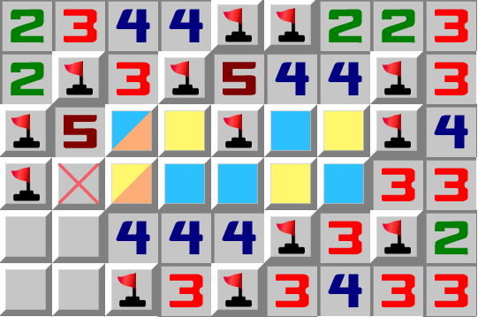


26B Butterfly Explanation 2 (WARNING, UNNECESSARILY COMPLICATED)
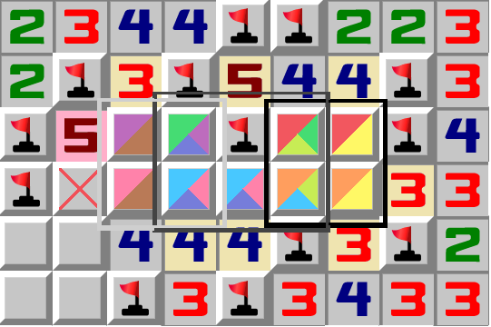
Found by: 84436
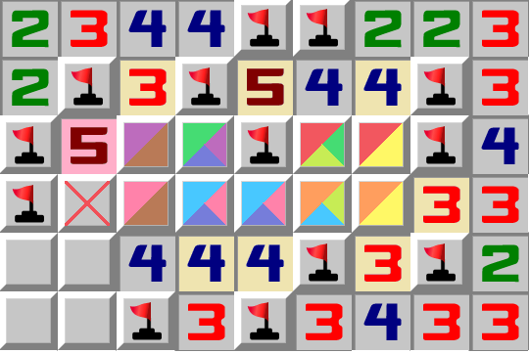
The red cells contain one mine
The orange cells contain one mine
The black box contains 2 total mines
One of these goes into the yellow cells
The other goes into the lime cells
--------------------------------------------------------------------------------------------------------------------
The green cells contain one mine
The cyan cells contain two mines.
The grey box contains 3 total mines
One of these is in the lime cells
The two other mines go into the blue cells.
-------------------------------------------------------------------------------------------------------------------------------------------------------------------------------
The purple cells contain one mine
The pink cells contain one mine
The white box contains 2 total mines
One of these is in the blue cells
The other goes into the brown cells
The 5 sees the brown cells, so the red crossed cell is a mine.

Box Logic Summary

One surprisingly easy way to look for box logic in complicated positions is just by looking for a 2x2, and checking the surrounding cells for a potential finned box. Great examples of these are the 20 Mutated Box and this:
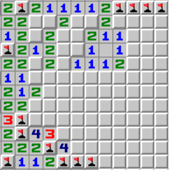

Can you find three safe cells?

Notice the 2x2 in the center? Try to figure out if you can apply box logic to it, also do not forget to look for fins, this 2x2 has two potential fins.

I was gonna turn the “Higher Complexity” section into logic that utilizes special regions or splitting regions. Currently all of them are just special/output regions (aka box logic), some more interesting like the mutated and joined boxes, but still the same thing. You could call this entire section the box logic section, but hopefully this is wrong, and there is other curious logic like it, that is not considered to be a box.

Boxes use 4 regions, 3 known, and 1 “unknown” that can be figured out using the other 3 regions. The unknown region is sometimes referred to as the output region

Joined Box
A joined box is basically a pattern where one box’s output region is used as an input for another box, which gives another output region. Currently only two samples have been listed, and both of them are just two boxes creating this chain. The main type of box I am hunting for is a multi- joined box (three+ boxes), or some wacky single joined box, I think that these are by far the most interesting types of box logic.

Higherer Complexity (Simple Inward Chains)
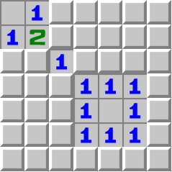

SIC 3x3{1}

Found by: 84436
Difficulty: D
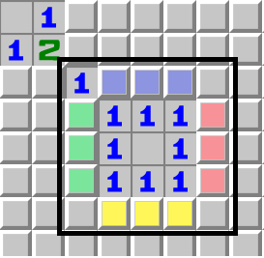
The black box will contain 4-7 mines
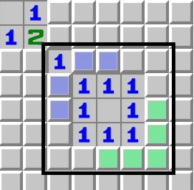

On the image on the left, the black box contains 2-4 mines

4 Mines is the only valid option then.
We can now use a kind of “local minecount” to make eliminations
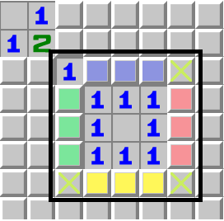
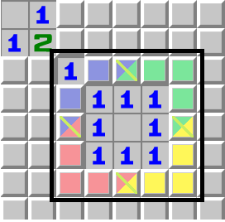
If any of the multicolored cells are mines, they will satisfy 2 colors, although each color will only have one mine, therefore the mulitcolored cells are safe.

Of course, you can also use contradiction by assuming one of the 7 safe cells are mines and seeing that they are invalid.

SIC #2
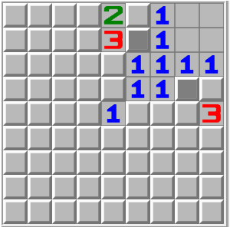Lets assume one of the grey cells is a mine, then we’ll assume the other grey cell is a mine. Then we will look for cells with the same state in both situations.
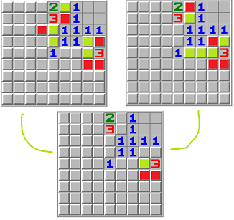
This board situation can be achieved in beginner with decent (but sub-optimal) guessing.

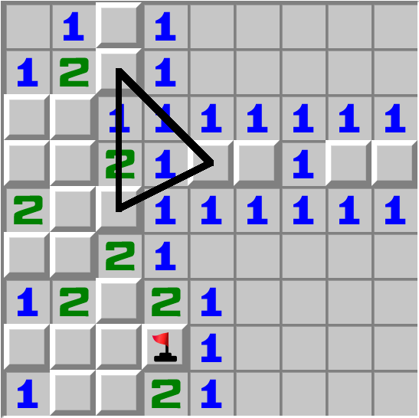
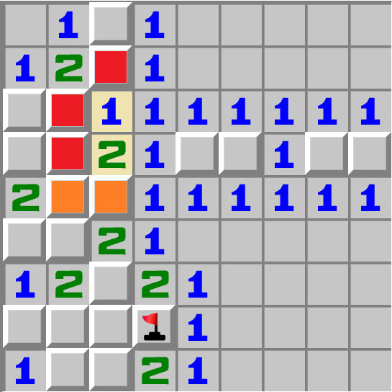
SIC #3
Found By: FracturedAnvil
Difficulty: D
The red cells contain one mine
The orange cells contain at least one mine
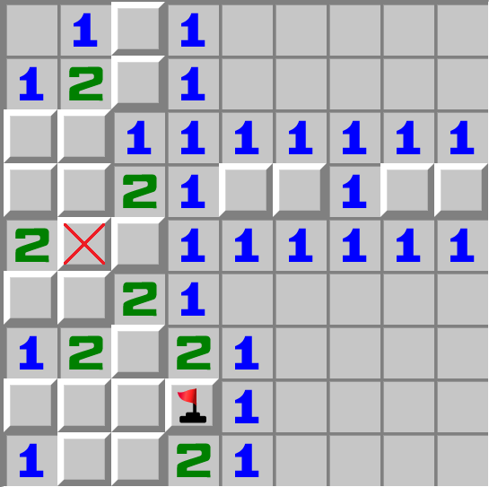
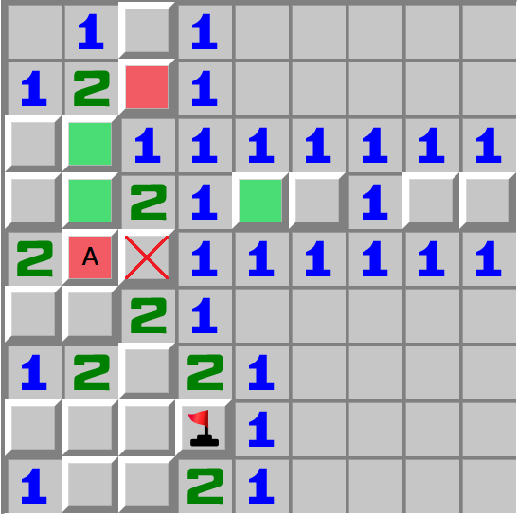
Left: Cell A is a mine.
Right: Cell B is a mine. This results in cell A being a mine.

Cell A is always a mine, as the orange cells need one mine at least.

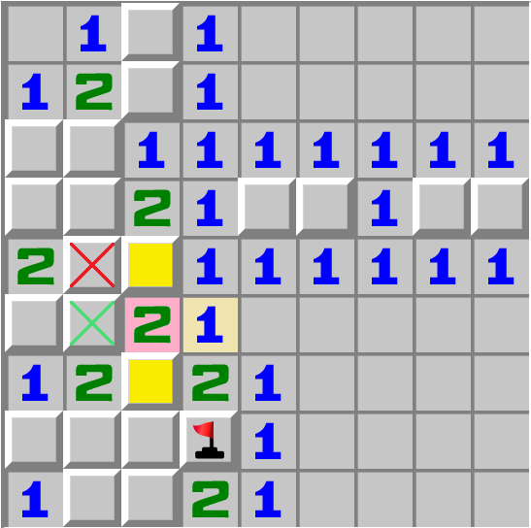

The yellow cells contain one mine
The 2 sees the red crossed cell and the yellow cells, so the green crossed cell is safe.

Chains

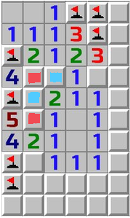
Inward Chain #1
Either the red cells or the blue cells are mines, lets see if there are any cells with the same state in both situations.

As seen, there are a whopping six cells found to be safe.
Pattern found and shared by (1) LooneyMar (u/LooneyMar) - Reddit
Post: (1) Minesweeper GO campaign 950+ level, supposed to not have a single point where u have to guess it, are there any guaranteed safe/unsafe points i'm missing? : Minesweeper (reddit.com)

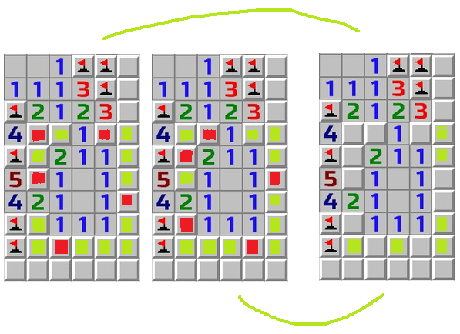

Outward Chain #1
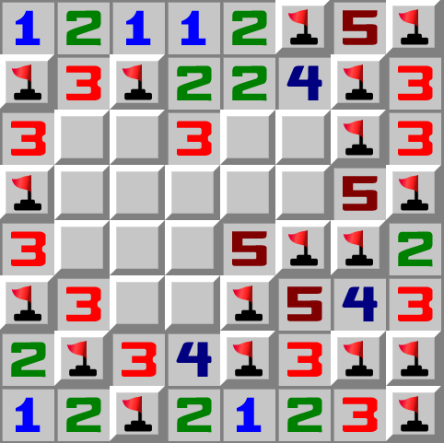

Difficulty: D

This small area might be able to have its amount of mines determined, let’s try it out.
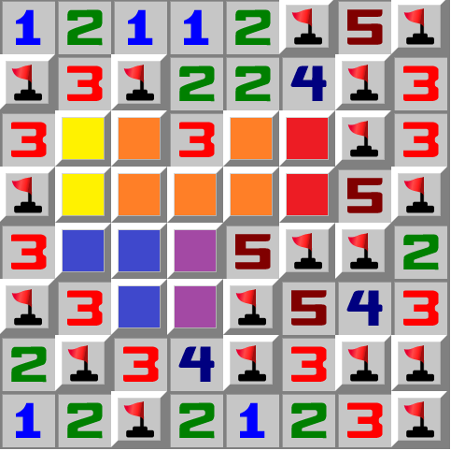

Red cells contain one mine
Orange cells contain two mines
Yellow cells contain one mine
Blue cells contain one mine
The purple cells contain 0,1,2 mines.
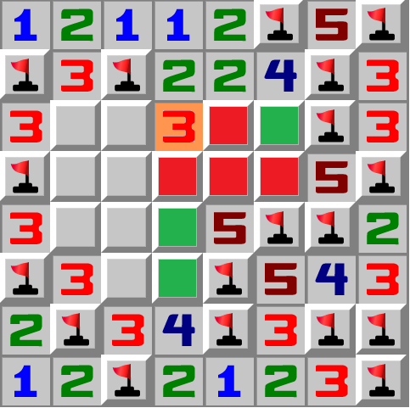

Purple cannot have 0 mines, as that would end up in the 3 having 4 mines.

Thus purple must have 1 or 2 mines, giving the total area 6 or 7 mines, let’s try minecount in both cases.

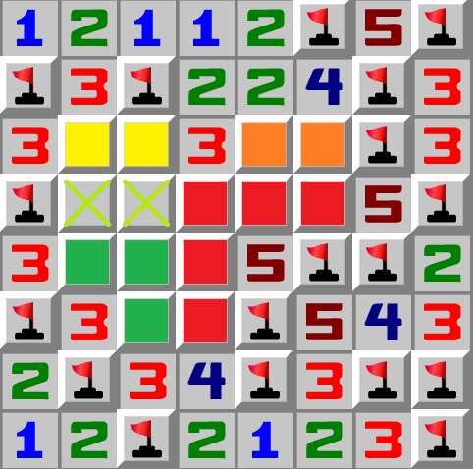
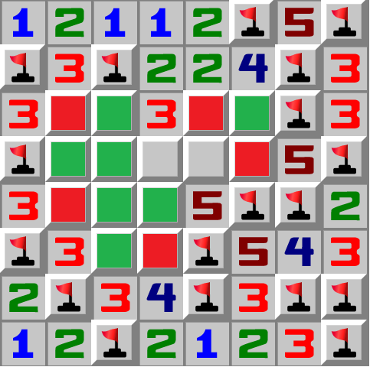

After some logic...

(6), Red cells contain three mines
^V, the bottom two cells of the area are safe and a mine respectively in both outcomes.
Orange cells contain one mine
Yellow cells contain one mine
Green cells contain one mine
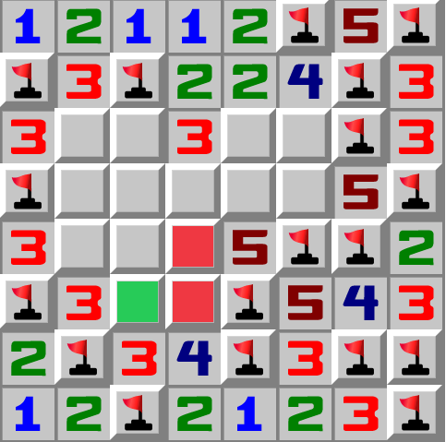
There are 6 mines, so the lime crossed cells are safe
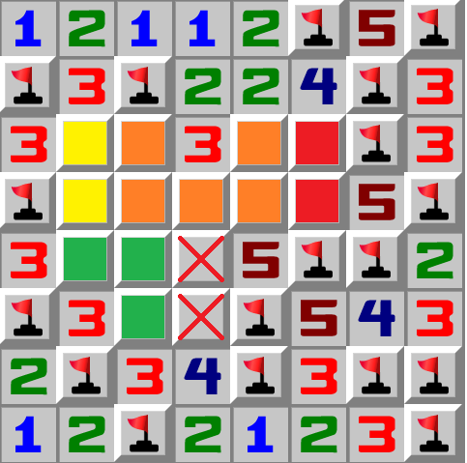

After some logic...

(7), Red cells contain one mine
Orange cells contain two mines
Yellow cells contain one mine
Green cells contain one mine
There are 7 mines, so the red crossed cells are the only place where the last mines go

Seems to be the only outward chain documented, box logic not included

Combinations
! I’ve assigned types to all of “combinations” patterns, examples of the same type will have similar logic, for example #1 and #2 are quite similar.

Combinations #1 >α
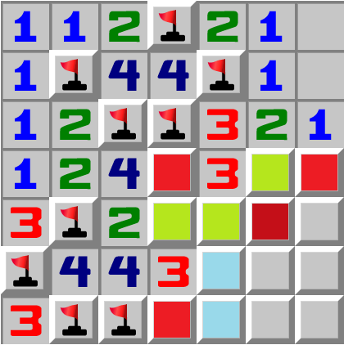
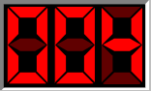
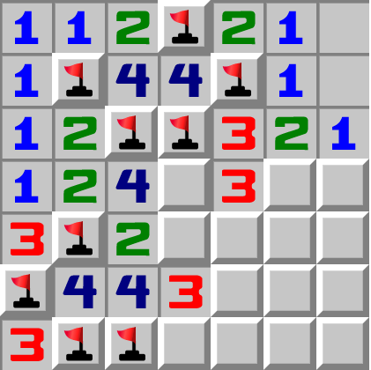
Found / Provided by: Viper17 / Not Anon
Difficulty: D
Let’s assume the maroon cell is a mine.
We now know the positions of 4 out of the 4 mines
This is scenario is impossible, since one of the cyan cells must contain another mine, which would require at least 5 mines
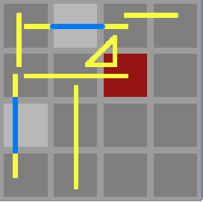
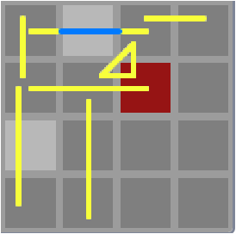
Therefore the maroon cell is safe.

Type: Alpha

Combinations #2 >α
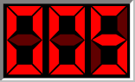
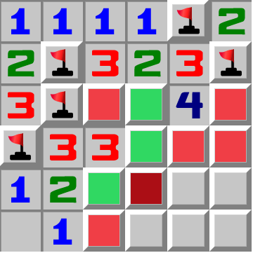

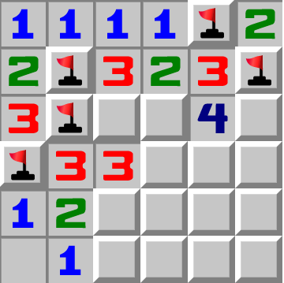
Found by: braintrain
Difficulty: D

Let’s assume the maroon cell is a mine.
We now know the positions of 6 mines
This is scenario is impossible, since there are only 5 mines
Therefore the maroon cell is safe.

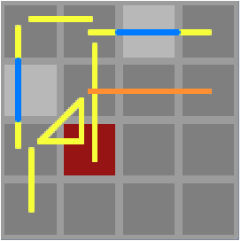

Type: Alpha

Combinations #3 >Γ
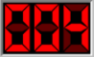
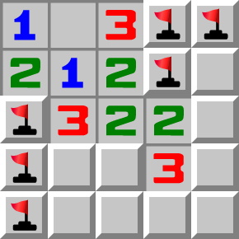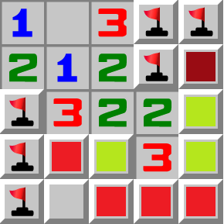
Difficulty: C
Let’s assume the maroon cell is a mine.
We now know the positions of 5 mines, which is impossible since there are only 4 mines in this particular area.
Therefore the maroon cell is safe.

HD Image Reconstruction by Not Anon
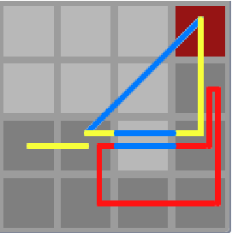

Type: Gamma

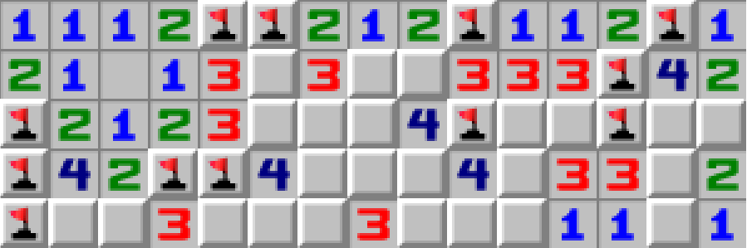
Combinations #4 <α
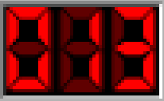

Pattern found by Scar
Difficulty: E
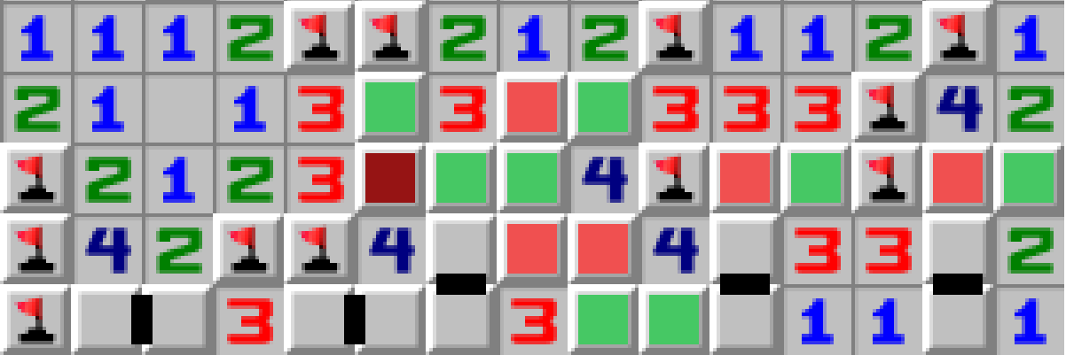
Let’s assume the maroon cell is a mine.
We now know the positions of 6 mines
Each pair contains one mine
We now know about 6 mines and 5 pairs, so the area contains 11 mines
This is impossible, as there need to be 13 mines
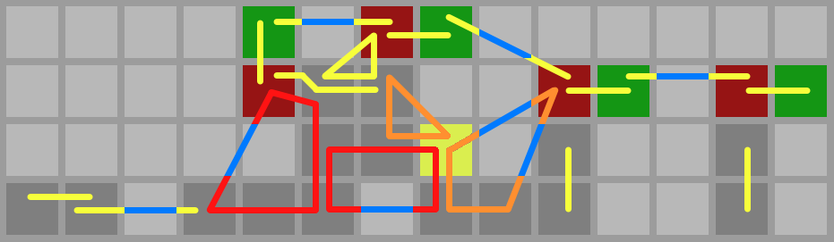
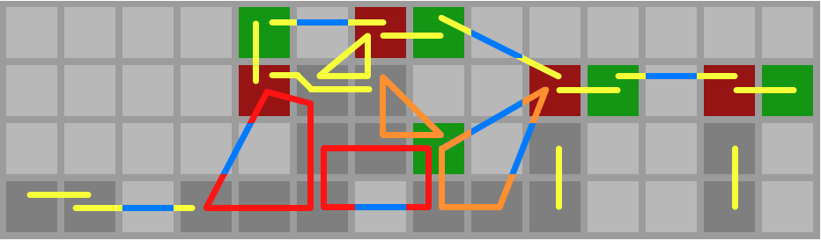
Therefore the maroon cell is safe.

< Reconstruction by Not Anon
Type: Delta

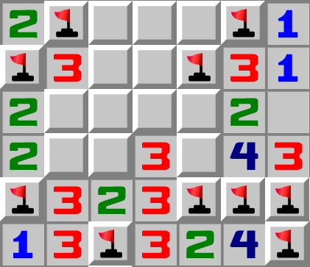
Combinations #5 >α
Difficulty: D
Let’s assume the maroon cell is a mine.
We now know the positions of 4 mines
The teal cells also contain one mine
This is impossible, as we only have 4
mines.
Therefore the maroon cell is safe.

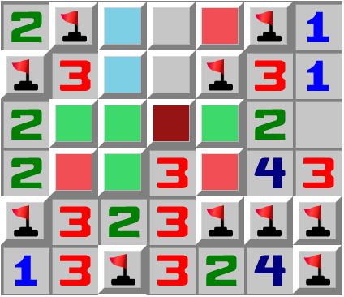
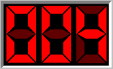

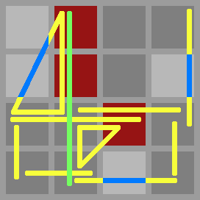
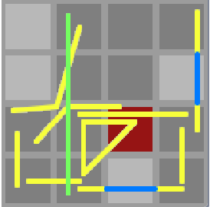
< Reconstruction by Not Anon
Type: Beta
Pretend the green region is a yellow region; there are so many regions that I made it green to avoid confusion.

You can get 2 more safe cells trough box logic now

Combinations #6 >Γ
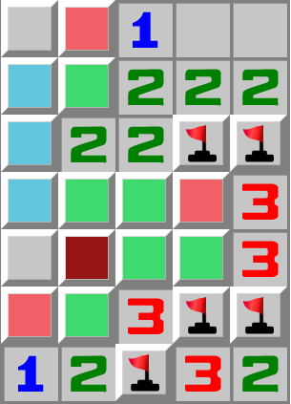
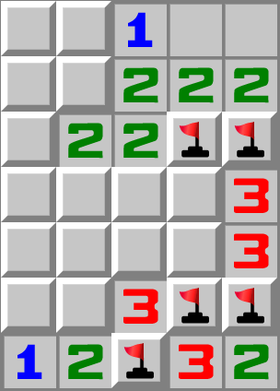
Pattern Found / Provided by: nbsp28 / gramana
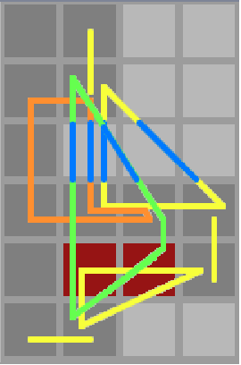
Let’s assume the maroon cell is a mine.
We now know the positions of 4 mines
The teal cells also contain one mine
This is impossible, as we only have 4
mines.
Therefore the maroon cell is safe.
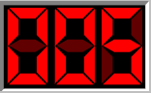

Type: Gamma

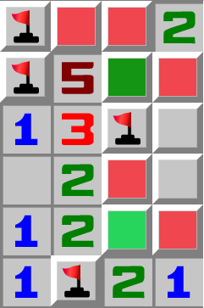
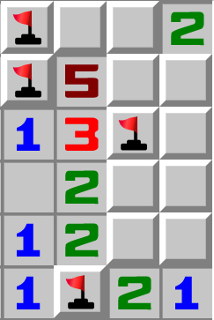
Combinations #7 >φ

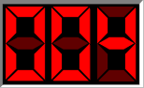
Difficulty: C
Let’s assume the dark green cell is safe.
We now know the positions of 5 mines
This is impossible, as we only have 4
mines.
Therefore the dark green cell is a mine.
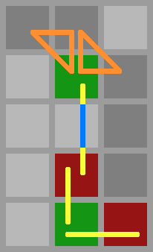

< by Not Anon
Type: Phi

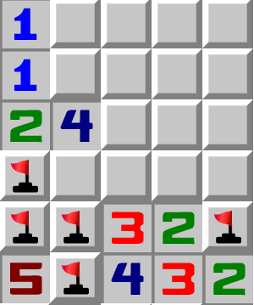
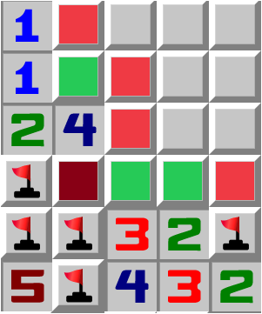
Combinations #8 >β
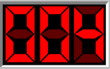
Found By: Rory
Difficulty: C
Let’s assume the dark green cell is safe.
We now know the positions of 5 mines
This is impossible, as we only have 4
mines.
Therefore the dark green cell is a mine.
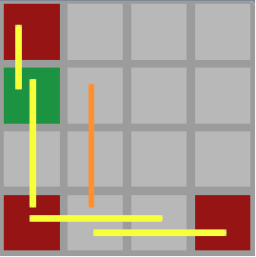

Type: Beta

Combinations Summary
Quick rundown of what the drawings below the explanations mean:
Light gray cells = “air” cells, or mines
Dark gray cells = covered a.k.a unknown cells
Yellow lines = cells connected form a region that contains one mine
Orange lines = cells connected form a region that contains two mines
Red lines = cells connected form a region that contains three mines
Blue lines = air lines. Is used to mark cells that are not part of the region, but where the initial line still goes trough
Maroon cells = Elimination Cell, reaches a contradiction if a mine
Green cells = Reverse Elimination Cell, reaches a contradiction if safe
Orange cells = Inverted Elimination Cell, reaches the opposite contradiction if a mine
Yellow cells = Inverted Reverse Elimination Cell, reaches the opposite contradiction if safe
Black cells = only when there are too many elimination cells, the non-elimination cells are marked instead.

Other terms:
Elimination cell = Cell that is considered a mine that creates a contradiction
Reverse Elimination cell = Cell that is considered safe, which creates a contradiction
Inverted Elimination cell = Cell that unlike the other elimination cells, is the opposite bound, lower bound vs upper bound or upper bound vs lower bound
“>” = Too many mines are needed, creating the contradiction
“<” = Not enough room to put down all of the mines, creating the contradiction, rarer.

Combo Box αβ
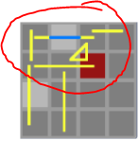
A structure found in a lot of combinations examples:
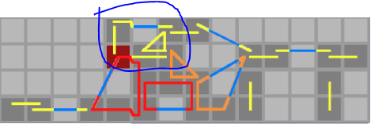
A few observations:
-The elimination cell seems to be in this box when the box is present, as seen in “Combinations #3”, there is no combo box, so the elimination cell is somewhere else
-The elimination cell seems to touch the triangle that is part of the structure, any combinations example that has this will be named “alpha”.
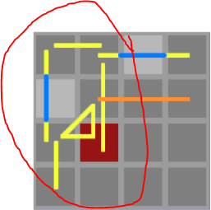
I feel like based on the fact that a good number of combinations patterns have these boxes, looking for these is a good idea. Keep in mind that these are not required for a combinations pattern, as seen in i.e. “Combinations #3”



< Combinations #8, this is somewhat similar to the box, but not completely. I will call this a broken box, type beta.

Factory Shape Γ
A shape found in quite a lot (mostly easier) combinations, examples (Comb. #3, Comb. #6):
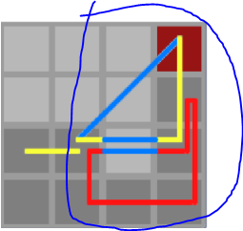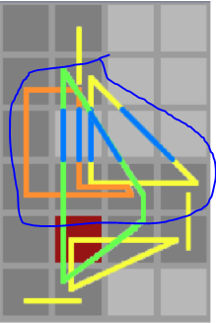
A few observations:
-If there is a factory shape, there is not always a combination cell inside of it, but it still seems relevant.
-The base can vary, 3 mines (ex1) and 2 mines (ex2)
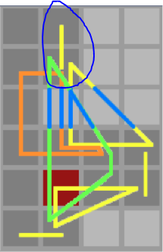
-There seems to be a yellow region next to it. This should be part of the shape.
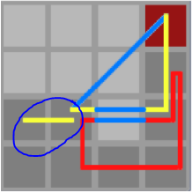
( )

For now, I will name any combinations with the factory shape “gamma”, due to lack of sample

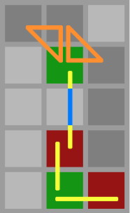
Other Types φ
φ = lacks sample, has some similarity to Γ

Other / Uncategorized

Some of these may be low res / not clear

Pattern #1
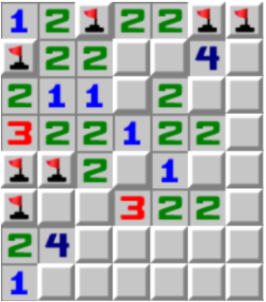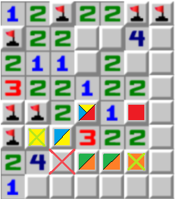
Depth: 5
Difficulty: B
The red cells contain one mine
The orange cells contain one mine
The yellow cells contain one mine

The 3 sees the orange and yellow cells, therefore the red crossed cell contains a mine as the 4 other cells would contain 2 mines at most

The green cells contain one mine due to the 3
The 2 sees the red and green cells, therefore the lime crossed cell is safe
The cyan cells contain one mine due to the 3
The 2 sees the cyan cells, therefore the lime crossed cell is safe

Pattern #2
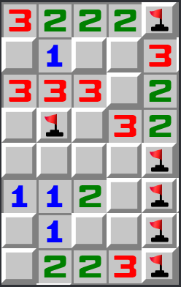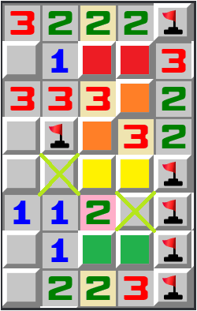
Depth: 4
Difficulty: B
The red cells contain one mine
The orange cells contain one mine
The yellow cells contain one mine
The green cells contain one mine
The 2 sees both the yellow cells and green cells, therefore the lime crossed cells are safe.

HD Image Reconstruction by Not Anon

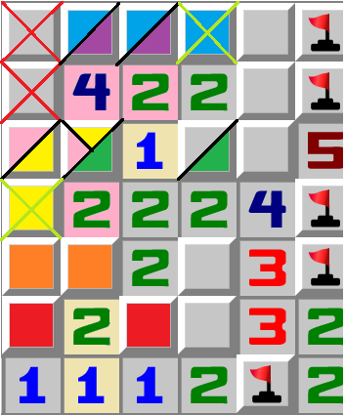
P-Pattern Advanced+
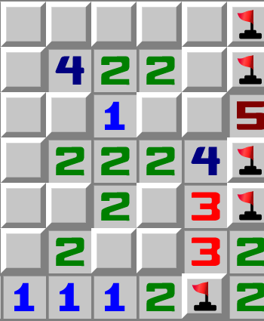
Depth: 7
Difficulty: C
The red cells contain one mine
The orange cells contain one mine
The yellow cells contain one mine
The green cells contain one mine
The cyan cells contain one mine
The 4 sees both the blue and yellow cells, so the third and fourth mine go into the red crossed cells.
The purple cells contain one mine
The 2 sees both the purple and green cells, so the lime crossed cell is safe
The pink cells contain one mine
The 2 sees both the orange and pink cells, so the lime crossed cell is safe.

Imgur: The magic of the Internet

Epilogue/Links
A few notes regarding the current state of the document
-”Holes”,”Holes+”, and “High Complexity” are very unfinished, I have been mostly working on the box logic and “Combinations” sections
-If you have better suggestions for pattern names tell me
-The “Game Records of Rare Patterns” can getsubmissions
-The “Artificially Created” section can get submissions

Chain Library
Terminology Here is a dump of that page->

Minesweeper Terminology

(Blue words are important words)
3bv - Bechtel's Board Benchmark Value, Indicated the required number of left clicks on a specified board, bigger / higher density boards will have a higher 3bv due to having less openings.
3bv limit - Minimum 3bv required for a board to be allowed into rankings. For beginner, intermediate and expert, it is 5/30/100 respectively for WoM, 2/30/100 for Authoritative Minesweeper
3bv/s - 3bv / time in seconds , is a general indicator of speed (higher = better), but high 3bv boards will have a higher 3bv/s if played at the same pace. A pretty mediocre speed indication, the best use for this statistic is using it to compare speeds when playing the same board. ~3 bv/s is very good. There are also other statistics to indicate board length (H.ZiNi, ZiNi, etc), which you can also use similarly. Those will not be listed in here.
50/50 - An instance of a forced guess where you have a 50/50 chance of winning or losing. It is also common to refer to any forced guess, or even any guess, as a “50/50”.
50/50 Breaker - A pattern exclusive to No-Guessing boards. 50/50 Breakers and other No-Guessing logic for a more detailed explanation. As seen in the 50/50 section, a 50/50 breaker could also refer to metalogic surrounding other kinds of forced guesses.
Achievements - Feature on WoM, There are 18 obtainable achievements, not 20 which is what some believe. Achievements | World of Minesweeper For information.
Arena - Feature on WoM, Arena | World of Minesweeper for information.
Arena Tickets - See Arena.
AxB/C - A and B indicate board size, C is the number of mines on the specified board size. A is usually the board width.
Beg - short for Beginner.
Beginner - The commonly used term for 8x8/10, 9x9/10, 10x10/10 (depends on the used program or website, 9x9/10 is used on WoM, but 8x8/10 is the board size used by clones)
Blast - Usually means losing the game, since you hit a mine.
Cell - A square on a board, i.e. a 9x9 board has 81 cells.
Chord(ing) - when left + right clicking (Can also be solely left click) on a number with the correct number of flags around it, it will open the unflagged cells. It is named after a chord (the musical one) because it requires 2 inputs simultaneously, see Clicks for more.
Clicks - There are three types of clicks: Left click (Opens cell), Right click (Flags cell), Chord (Must be used on a number rather than a cell, opens all of the cells around the number as long as enough cells are flagged)
Corr - Correctness, Clicks / ( Clicks + Wasted Clicks ). This statistic will show you how many of your clicks were useful. Any game should have at least 0.9 Corr regardless of objective (efficiency, speed, winrate, arena, etc) because a correctness of 1.0 is always achievable. This statistic has one flaw, which is that wasted clicks are considered to be only the ones that do absolutely nothing (do not affect the board in any way), so placing unnecessary flags will not negatively impact your Correctness (In fact, it will improve it). Corr also punishes prechording.
Density - the percentage of cells that have a mine. There is also an alternative definition being the probability of a floating cell having a mine. These two definitions produce near identical values for all boards excluding extreme cases. Density changes as a board gets solved and generally trends upwards.
Difficulty -
Easy (NG) - Essentially beginner, except it can be solved without guessing (9x9/10)
Eff - Abbreviation for Efficiency.
Efficiency - The same as IOE, but expressed as a percentage rather than decimal. (See IOE for all of the information.)
Endurance - How much time it took to solve 100 games of beginner,
intermediate or expert. Time must be below 24h. Feature on WoM. Boards such as Evil NG also have an endurance feature, but this may be an unintentional addition.
Equipment - Represents parts of a ship. Can be bought. Higher quality equipment’s price increases exponentially, quality caps at 100%. Equipment | World of Minesweeper for more information.
Evil (NG) - 30x20/130, can be solved without guessing, and guarantees a pattern with a depth of 3 or above, that also has “evil” status. (Some depth 3 patterns do not have this.)
Exp - Short for Expert, can also refer to Experience instead of XP
Experience - Used on WoM, approximately indicates how much you have played, the reward is Experience gained = Solved 3bv * ( 1 + Equipment Bonus ) ← this formula is outdated
Expert - The commonly used term for 30x16/99, has a mine density of 20.625%.
Exposed Cell - An unopened cell that is touched by an opened cell(s)
Floating Cell - An unopened cell that is only touched by other unopened cells.
Forced guess - a situation that must be solved with a guess regardless of future information (including minecount)
FPL -
Gems - Valuable item on WoM, can be sold and used to buy equipment. Gems | World of Minesweeper for more details.
GSC - Golden Sheep Cup
Guessing - Opening a cell where you do not know the state of.
Guide(s) - Feature on WoM, where people can browse through guides. Guides | World of Minesweeper for the list and how to submit guides.
Hard (NG) - Essentially expert, except there is a guarantee of no guesses if one uses all patterns designated “Hard” difficulty and lower. (30x16/99)
Heptaveegesimal -
High Difficulty - Feature on WoM, any board with a difficulty of 1000+. Difficulty is calculated based on winrate and misclick factor.
Hopsing - A game which is both a Time PB and a 3bv/s PB, a Time PB usually requires a low 3bv, and a 3bv/s PB usually requires a high 3bv, so games like these are rare. Named after Robert Bendtiz, nicknamed Hopsing who got a 53.06 second time with 3.30 3bv/s, on a 172 3bv board.
HZNE - (Read ZNE, IOE) H.ZiNi / Clicks. Very similar to IOE and ZNE, but in IOE, 3bv is used, and in ZNE, ZiNi is used. This is considered to be the “improved” ZNE, as it’s more useful for comparison. This is a very good statistic, as it compares the efficiency of a game with a very strong human-like algorithm. Beating H.ZiNi is possible, but is negative in a way, this means that you played differently from the algorithm, most definitely in a worse way, but got lucky and ended up being more efficient. ← false

HZNT - HZNE * ( 1 / Corr ) , or H.ZiNi / Non-wasted Clicks. Similar to HZNE, except ThrP is used rather than IOE.
H.ZiNi -(Read ZiNi) Human ZiNi. Relatable to ZiNi with two major exceptions: 1. It opens all openings first. 2. When there are multiple options with the highest premium, it chooses randomly rather than the top-left most, which is what ZiNi does. This also means that H.ZiNi can technically be more efficient than ZiNi, if it ends up being efficient by opening all openings, or less commonly, if the top-left most cell ends up being very inefficient. (Link to examples below) This statistic was made because it’s better to compare to rather than ZiNi, as it simulates a slightly more human behavior at aiming for efficiency. Other specifics regarding H.ZiNi can be found at ZiNi
Link: Minesweeper Board Museum (mzrg.com) by qqwref aka Michael Gottlieb
Int - Abbreviation for Intermediate
Intermediate - The commonly used term for 16x16/40. Has a mine density of 15.625% like beginner.
IOE - (Read 3bv) 3bv / Clicks. Indication of how efficient the game was. This value differs a lot for each game, even if the games were played at an equal skill level. It’s possible to get an IOE above 1.00, this requires efficient chording. (See Efficiency Guide by Danoouch on the bottom page for deeper explanation and help.)
IOE Sum - Similar to Sum, Except the highest IOE for the three standard modes; beginner, intermediate, expert. For example: a 1.70 beginner IOE, a 1.30 intermediate IOE and a 1.15 expert IOE would be a 1.7 + 1.3 + 1.15 = 4.15 IOE Sum.
IOS - Index of speed, log (3BV) / log (Time - 1). An indication of speed, higher is better. Like RQP and 3bv/s values considered "good" differ for each board size or mine density
Islands - See last page
Llamasweeper
Local Minecount -
Mastery - Used on WoM, shows you how many games out of a 100 you have won for each standard board size. It considers your last 100 games, and looks at how many of them are wins.
Medium (NG) - Essentially intermediate, except there are no guesses. (16x16/40)
Metalogic - Information about a board that is not in the board. One subclass of such logic is No-Guessing logic, but there are other cases of metalogic as well.
Minecoins - Primary currency on WoM, reward for game is (Difficulty * ( 1 + Equipment Bonus). Notice that minecoins are only rewarded if the game is won.
Minecount(ing) - Logic that uses the information of knowing how many mines are left.
Mine Density - (Read Local Density, Floating Cells, Exposed Cells) Total Mines / Total Cells, is an indicator of how hard a board is. Useful to know when guessing, as it will give a very good estimate of how safe a floating cell is. (100% - Mine density = Approximate safety)
NF - No Flagging. Using only left clicking to win a game, generally a slightly slower approach.
NG - (Related: NG Logic) No Guessing. Any NG board will be solvable with standard logic and/or minecounting. Note that any board that requires NG-EL to be solved without guessing is not a true NG board, even though guessing was never done.
NG Logic - Any form of logic that is exclusive to NG boards, and uses the concept that any mine combination that involves guessing is invalid.
No-Flagging - Using only left clicking to win a game, generally a slightly slower approach. Is useful when done in conjunction with flagging, as some sections could be faster without flags.
OBV - (Needs data) (3 - 2.5 * Level + 0.5 * Level^2 ) * (.07 * numbers + .43 * 3BV + 2.27 * openings ) + (-3 + 4 * Level - Level^2) * ( .2 * numbers + .32 * 3BV + 1.38 * openings ) + ( 1 - 1.5 * Level + 0.5 * Level^2 ) * ( .38 * numbers + .23 * 3BV + .99 * openings) = OBV, also known as MBV or M3BV,
“OBV is like 3BV except that it should be just as easy for any given OBV value to get a high OBV/s score. Give it a try!” - Andrew McCauley, inventor of the statistic.
Opening - 0 Cells, and the numbers that touch 0 cells are part of an opening.
PB - Personal Best. Your best game on a specified board (“Best game” is usually based on time. Efficiency PBs or 3bv/s PBs are also quite common. In some clones the time might be rounded up, in others they may be more accurate.
Prechord - a speed strategy: chording a tile opened in the previous move before having checked what number it revealed. This is useful on middle density boards where numbers revealed are often lower but not low enough to be an opening.
Premium - (Incomplete) A value given to a cell to tell you how good it is for guessing (a.k.a how likely you are to win if you opened this cell. It’s a combination between how safe the cell is and how useful it is. There is no specific formula for this. Can also refer to WoM Premium
QG - Needs data
Rank - Feature on WoM, player gets a new rank at 1, 100, 200, etc trophies. Ranks | World of Minesweeper For specifics.
RQP - Rapport Qualite Prix, has different formulas, such as: Time / ( 3BV/s ), (Time)^2 / (3BV/s), on World of Minesweeper it's (Time + 1) / (3BV/s). Simple but good way of measuring speed, more useful than 3bv/s . Lower is better, and values considered "good" differ for each board size and mine density. RQP is flawed (Like 3bv/s), and has a preference for mid range 3bv boards.
STNB - Needs data
Sudosweeper -
Sum - The sum of your beginner, intermediate and expert PB, i.e. having a 2 seconds beginner, 28 seconds intermediate and 85 seconds expert game will give you a sum of 2 + 28 + 85 = 115.
Square - Same thing as a Cell, “cell” is considered to be the better name.
ThrP - IOE * (1 / Corr), Troughput. Essentially IOE excluding wasted clicks.
Ticket(s) - Feature on WoM, see Arena
Trophies - Feature on WoM, Trophies | World of Minesweeper For details. Trophy cap as of December 2021 is 1180
UPK - Unfair prior knowledge. Knowing information about a specific board that you do not have access to under a normal playtrough. Common form of cheating. Algorithms like ZiNi and H.ZiNi use this.
Win - Opening all safe cells. Placing flags is not required.
Winrate - The odds of winning a specific board. There is most likely a formula for this, but this has not been found yet. Keep in mind that winrate estimates might not be accurate, as players have different guessing / logic skills.
Winstreak - How many consecutive games in a row have been won. Winstreak records on Beginner, Intermediate and Expert are 135/39/13 (needs confirmation) respectively.
WoM - Abbreviation of World of Minesweeper, aka Minesweeper Online | World of Minesweeper , can also refer to the developer.
World of Minesweeper - Minesweeper Online | World of Minesweeper, can also
refer to the developer.
WS - Abbreviation for winstreak.
XP - Abbreviation for experience.
ZiNi - Algorithm that estimates the minimum number of total clicks required (Right clicks and chords are included unlike 3bv). This algorithm is not perfect but gets close, this is because with the addition of right clicks and chords, the complexity skyrockets. Here are the exacts behind ZiNi: https://minesweepergame.com/forum//viewtopic.php?f=15&t=70
- “ZiNi” is a combination of “Zi” and “Ni”, which are named after the two creators. It’s possible to beat ZiNi, but any number of clicks above one is highly unlikely. Anything above two is exceptional. ZiNi (and H.ZiNi) have been made in such a way that they will always beat or tie 3bv.
ZNE - ZiNi / Clicks. Similiar to IOE, but considered to be more accurate, as ZiNi utilizes right clicks and chords. Although it’s sometimes believed that the human limit of ZNE is 1.00, this is not true, as it’s possible to beat ZiNi.
ZNT - ZNE * ( 1 / Corr ) , or ZiNi / Non-wasted Clicks. Similiar to ZNE, except ThrP is used rather than IOE.

Islands - Example
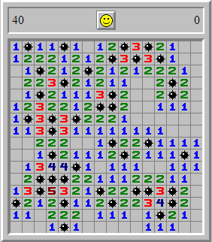Lets calculate the number of islands on this intermediate board. To start, we consider all openings and mines to be “sea”.
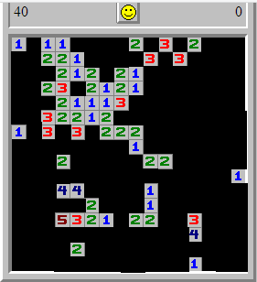Now, let’s count the number of islands.
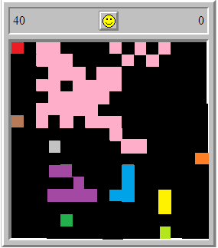There are 10 islands, also note that diagonally adjacent squares are considered to be part of the same island.

