# 📑 Capstone Project Report

## 1. Project Overview

• Project Title: Language Translation with Text to speech  
• Author(s): Ajay Kumar Singaraju/ 9885775827  
• Date:  
• Version:1.0  
• Technology Stack: Streamlit, Google Gemini API, Google Text to Speech, Lang chain.  
• Description:  
The goal is to develop a web application that enables users to either enter text directly or upload files. The user will be able to see the translated text on the UI and also, they can download the translated audio file(s).

Key Features:

* User can either enter text or upload files (Supported file type are pdf, txt, xls, csv)
* User can also download the translated audio

## 2. Functional Screenshots

### 2.1 Normal User Input

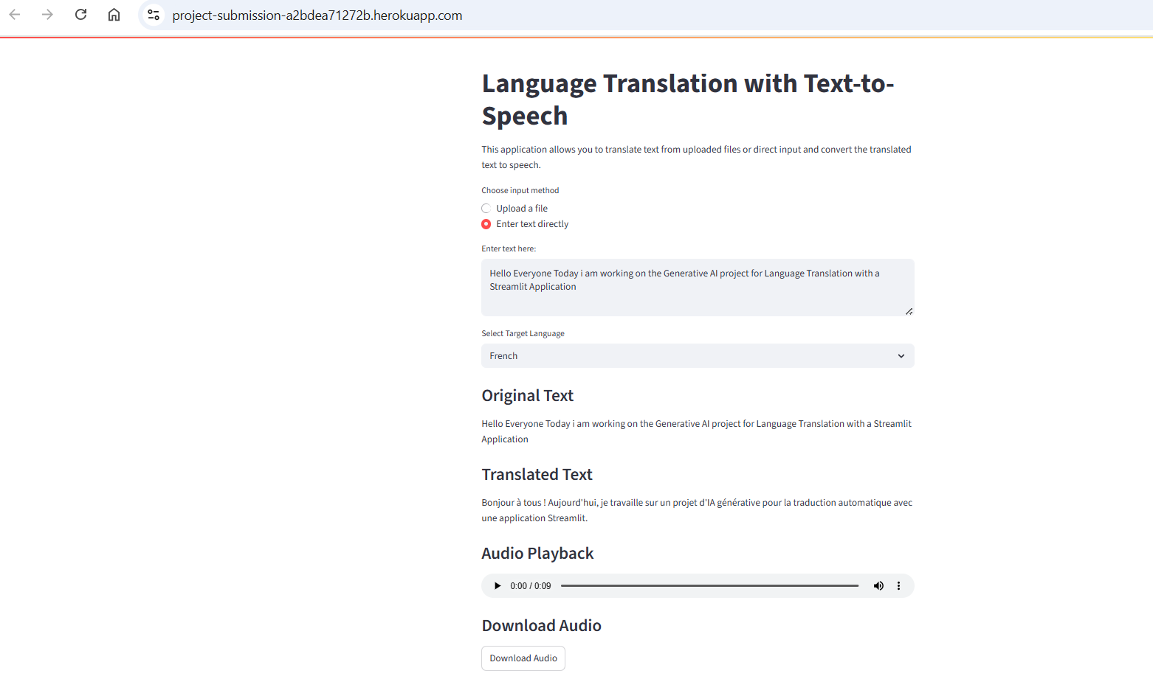

**2.2 Upload PDF file**

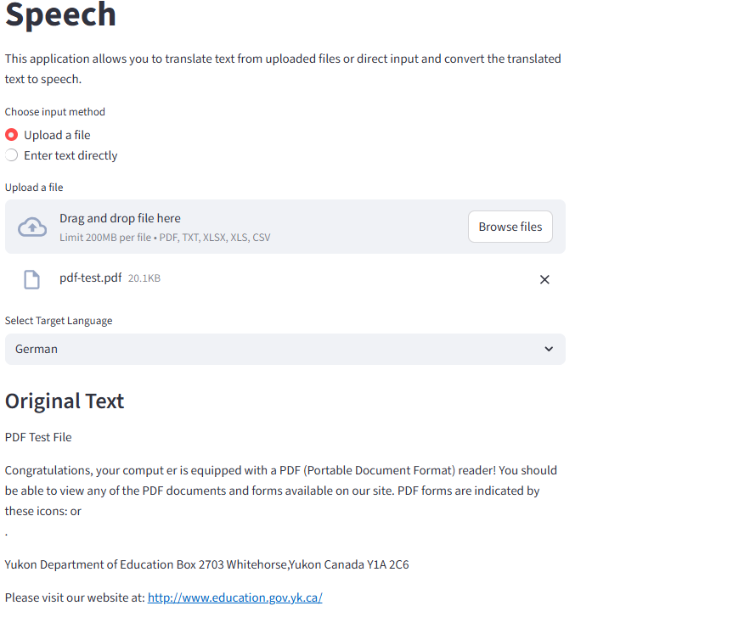

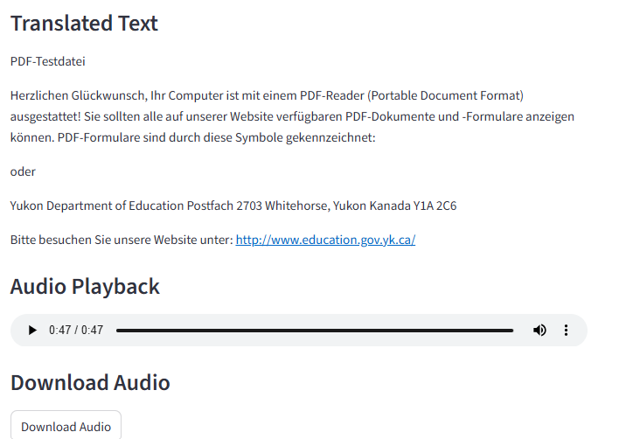

**2.3 Upload XLS File**

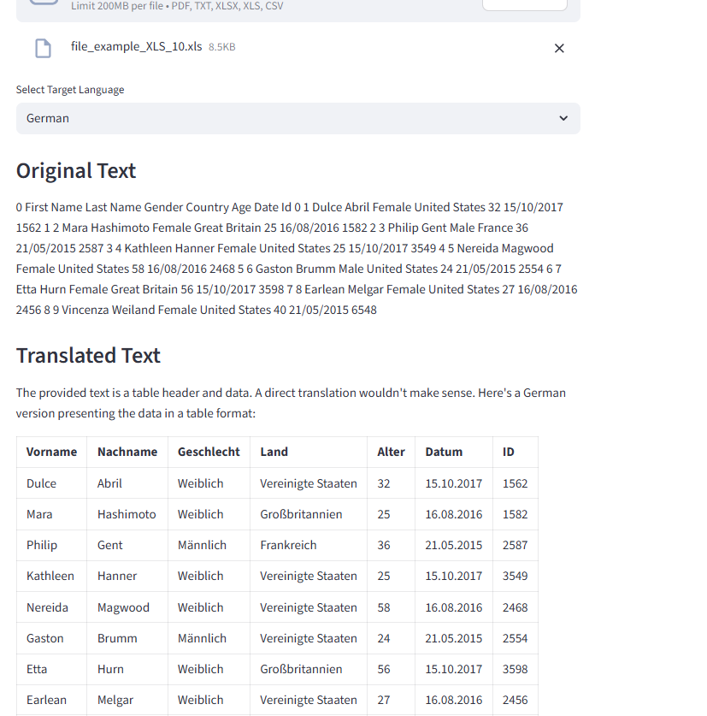

**2.4 Upload CSV File**

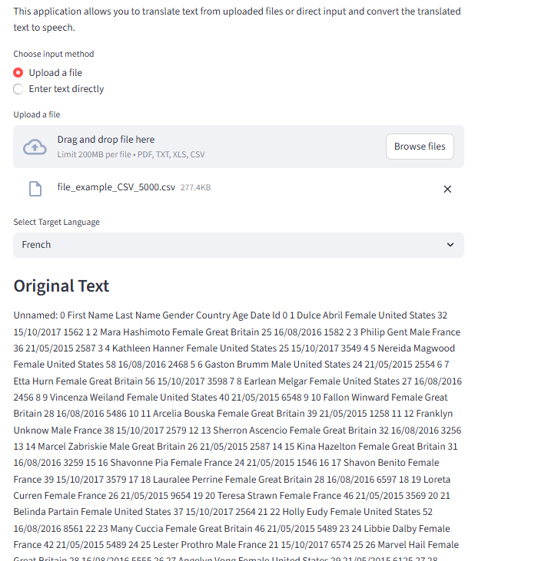

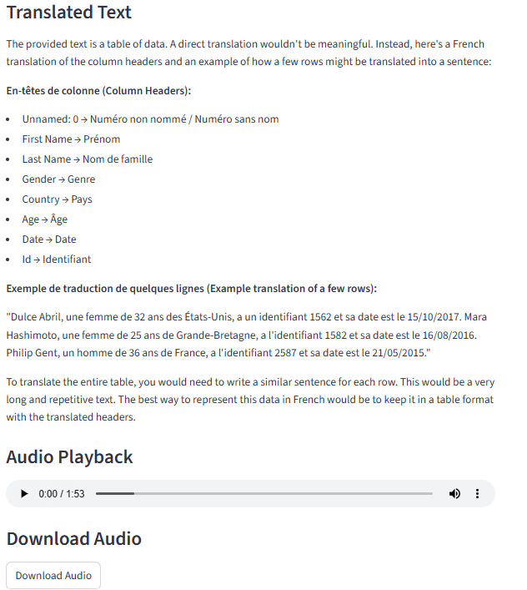

## 3. Deployment Steps

The Streamlit application is deployed to Heroku which is an AI platform as a service (AI PaaS) that enables developers to build, run, and scale applications entirely in the cloud.

### 3.1 Prerequisites

* Heroku login and payment details has to be configured properly to create an application
* Code has to committed to GIT repository with necessary artifacts.

### 3.2 Heroku Deployment

Following files should be present in the Git Repository

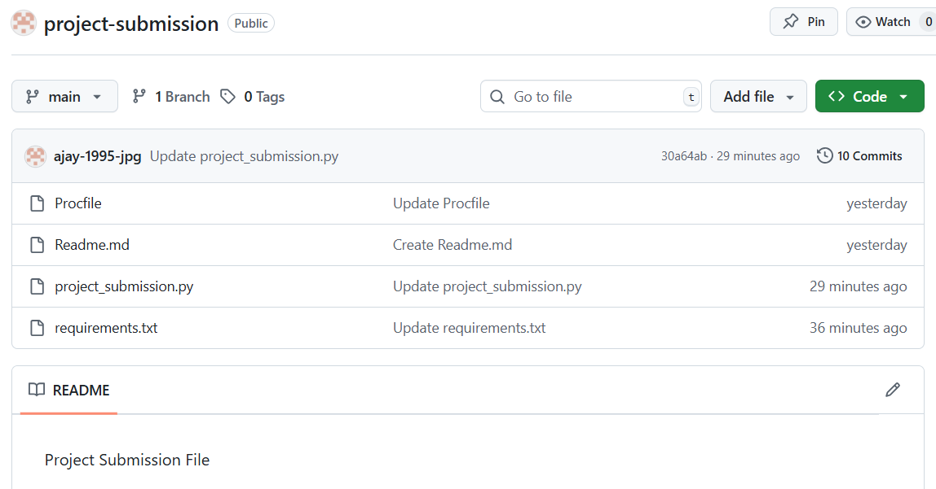

* project_submission.py -> python file for streamlit web application
* Procfile -> A Procfile is a plain text file, without a file extension, placed in the root directory of an application. Its primary purpose is to declare the process types and the commands that should be executed to start them on platforms like Heroku

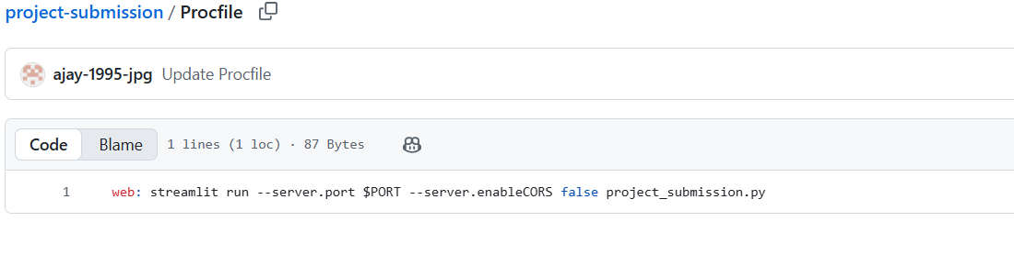

* requirement.txt -> all the modules which are required for the project to run successfully.

### 3.3 Deployment Method

Heroku provides an option for user(s) to directly configure the Git repository so that it can pull the code, build and start the application.

We can enable auto deployment or Manual deployment but for this current project submission Manual deployments are triggered.

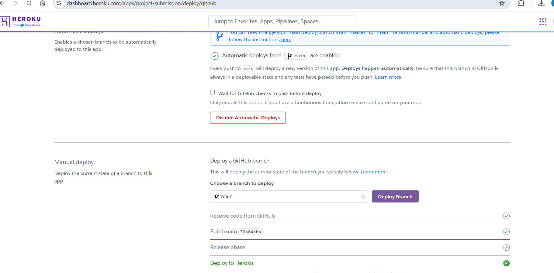

All the environment variables can be configured under the settings/Config Vars. For the current project I have configured the GOOGLE_API_KEY

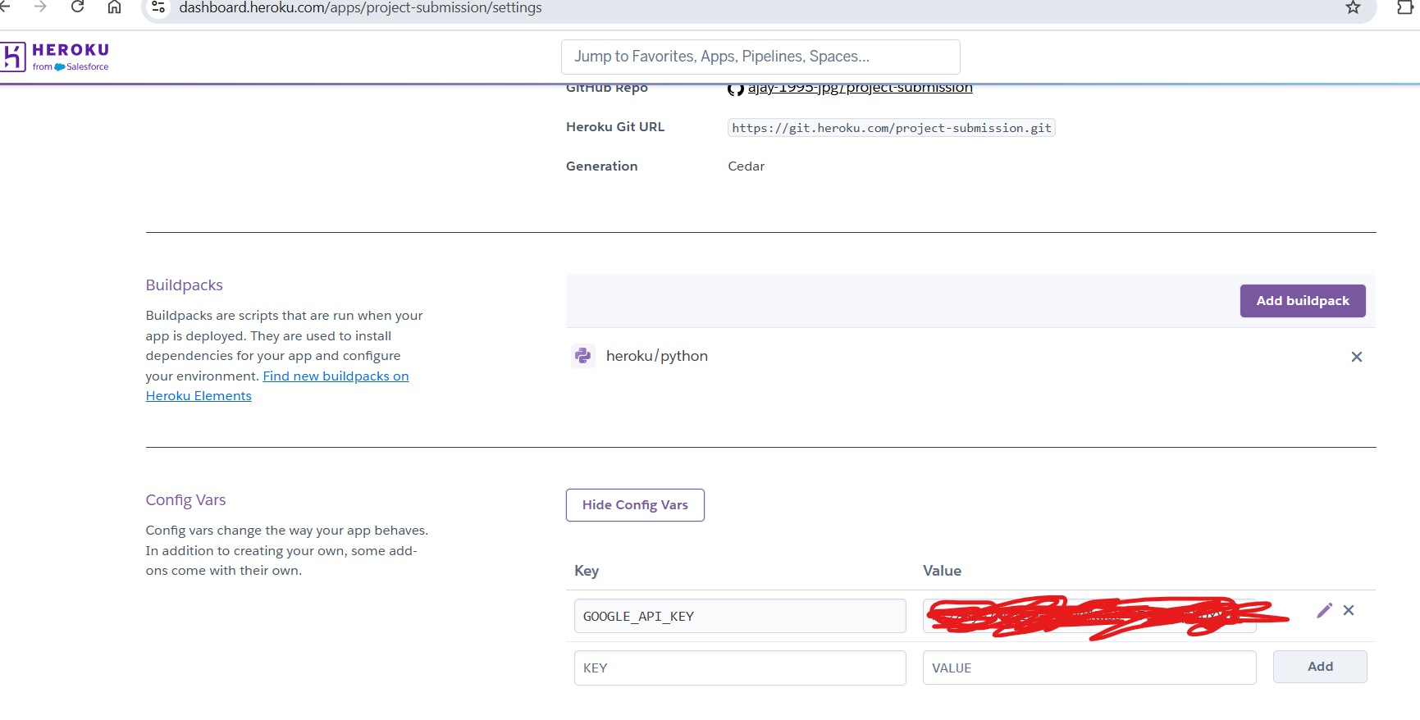

Build logs and Application logs can also be viewed in the project dashboard

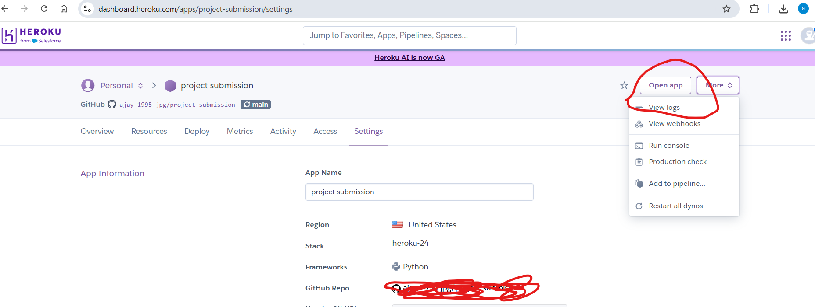

### 3.4 Application URL

<https://project-submission-a2bdea71272b.herokuapp.com/>

## 4. Troubleshooting Steps

Application Logs while build and deployment will be quite helpful to Troubleshoot the issues and resolve them accordingly.