Customer Shopping Behavior Analysis

- Project Overview
This project provides a comprehensive end-to-end analysis of retail transactional data, covering 3,900 purchases across diverse product categories. By integrating Python for data engineering, SQL for deep-dive business logic, and Power BI for visual storytelling, the study uncovers the underlying drivers of customer spending, subscription stickiness, and product performance.

- Dataset Summary
- Rows: 3,900
- Columns: 18
- Key Features: Customer demographics (Age, Gender, Location, Subscription Status)
- Purchase details (Item Purchased, Category, Purchase Amount, Season, Size, Color)
- Shopping behavior (Discount Applied, Promo Code Used, Previous Purchases, Frequency of Purchases, Review Rating, Shipping Type)
- Missing Data: 37 values in Review Rating column

- Exploratory Data Analysis using Python
We began with data preparation and cleaning in Python:

● Data Loading: Imported the dataset using pandas.

● Initial Exploration: Used df.info() to check structure and .describe() for summary statistics.

● Missing Data Handling: Checked for null values and imputed missing values in the Review Rating column using the median rating of each product category.

● Column Standardization: Renamed columns to snake case for better readability and documentation.

● Feature Engineering: Created ‘age_group’ column by binning customer ages.

● Data Consistency Check: Verified if discount_applied and promo_code_used were redundant; dropped promo_code_used.

● Database Integration: Connected Python script to MySQL and loaded the cleaned DataFrame into the database for SQL analysis

- Data Analysis using SQL (Business Transactions)
We performed structured analysis in MySQL to answer key business questions:

  - High-Spending Discount Users – Identified customers who used discounts but still spent above the average purchase amount.

  - Top 5 Products by Rating – Found products with the highest average review ratings.

  - Subscribers vs. Non-Subscribers – Compared average spend and total revenue across subscription status.

  - Discount-Dependent Products – Identified 5 products with the highest percentage discounted purchases.

  - Customer Segmentation – Classified customers into New, Returning, and Loyal segments based on purchase history.

  - Revenue by Age Group – Calculated total revenue contribution of each age group.

- Dashboard in Power BI
Finally, we built an interactive dashboard in Power BI to present insights visually
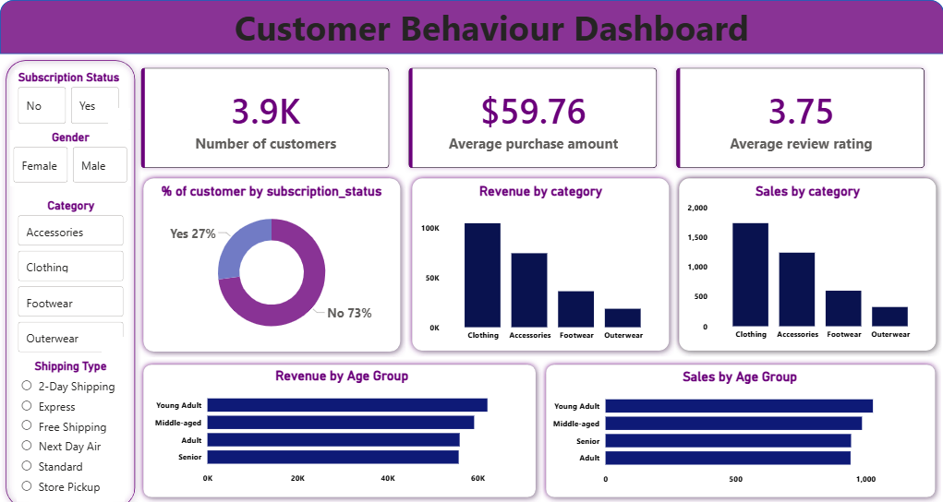

- Business Recommendations
- Boost Subscriptions – Promote exclusive benefits for subscribers.

- Customer Loyalty Programs – Reward repeat buyers to move them into the “Loyal” segment.

- Review Discount Policy – Balance sales boosts with margin control.

- Product Positioning – Highlight top-rated and best-selling products in campaigns.

- Targeted Marketing – Focus efforts on high-revenue age groups and express-shipping users.

