**OPENSTACK DOCUMENTATION**

**CREATING AN INSTANCE**

**Step 1**: Login to your openstack account.

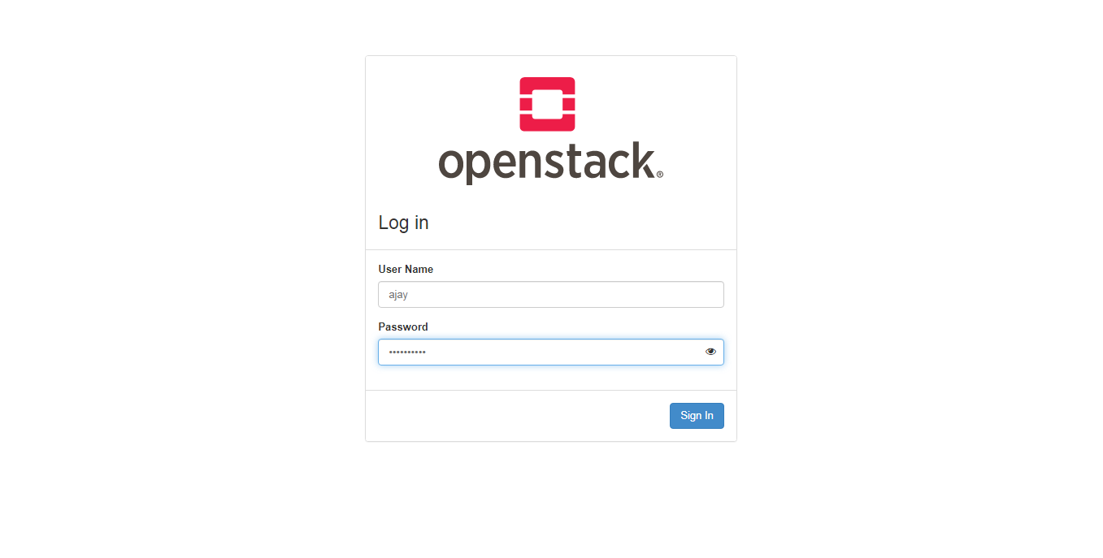

**Step 2**: Click on instances on your left side options list. Now click on “Create Instance”.

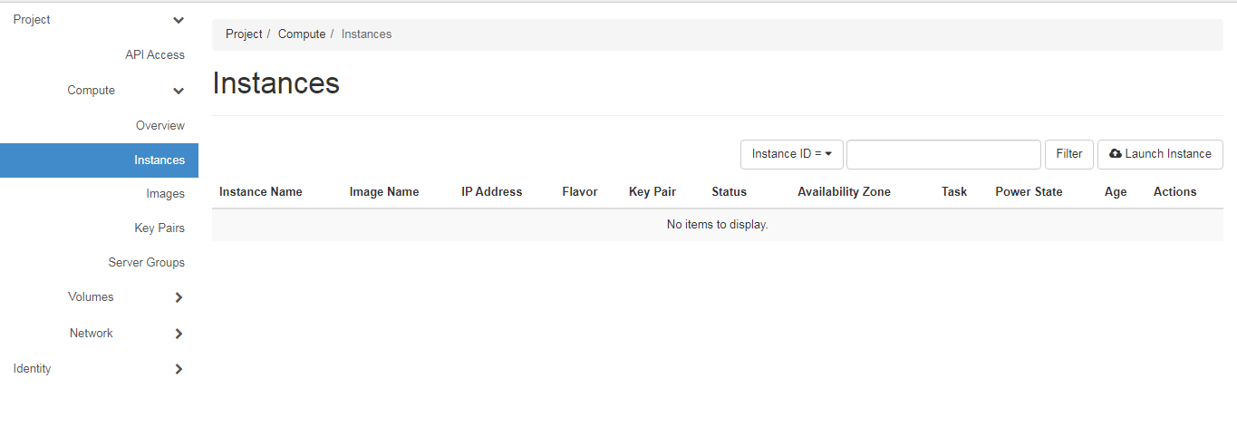

**Step 3**: Now a new dialogue box appears which contains all the necessary options to select the resources for the instance. First, give a name to the instance.

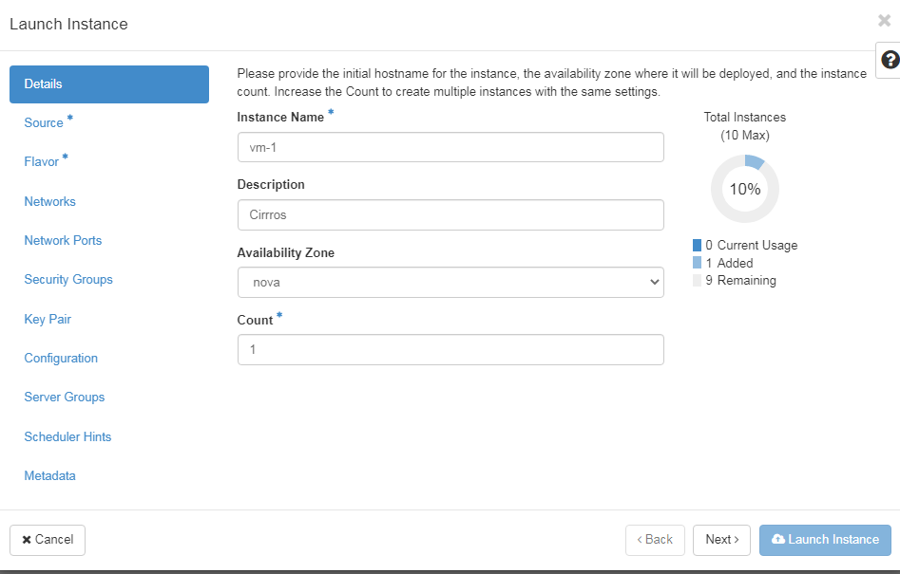

**Step 4**: Now click on source where you will find the source file you want to select. Here you can also select a volume if you need.

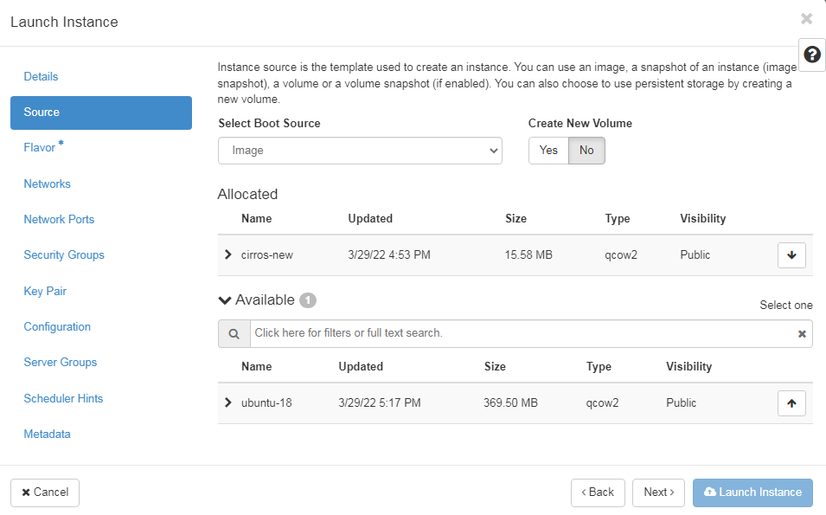

**Step 5**: Now select the desired flavor for the instance. This is to select the required memory and storage for the instance we are creating. Then click on launch instance.

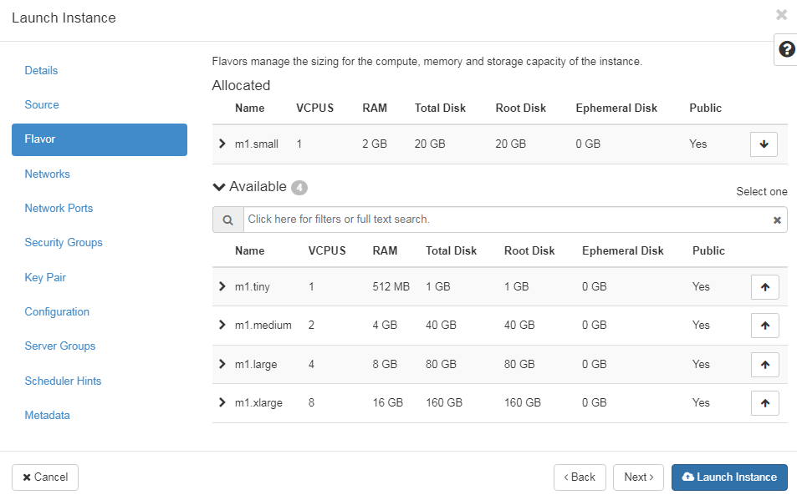

**Step 6**: On the dashboard, the created instance will be displayed. It contains the name, public IP, Image name, status, Age, etc.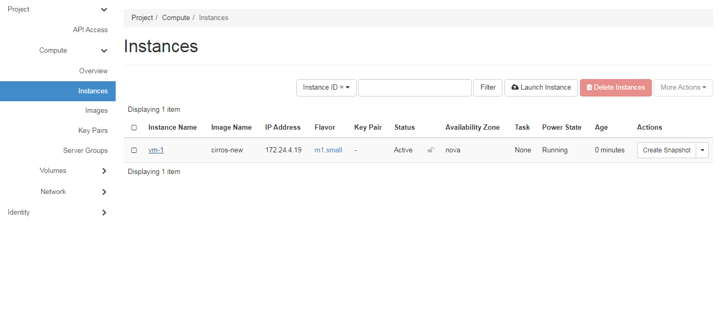

**Step 7**: We can see more details of the instance by clicking the name of the instance. Several other options like “logs” gives the logs of the instance and console provides the terminal access to the instance.

