Store Management System:

1. Admin Panel:

Dashboard:
1.Overview of total products, orders, customers, and sales.

Product Management:
1.Add, update, delete, and view products.
2.Manage product details such as name, price, quantity, and category.
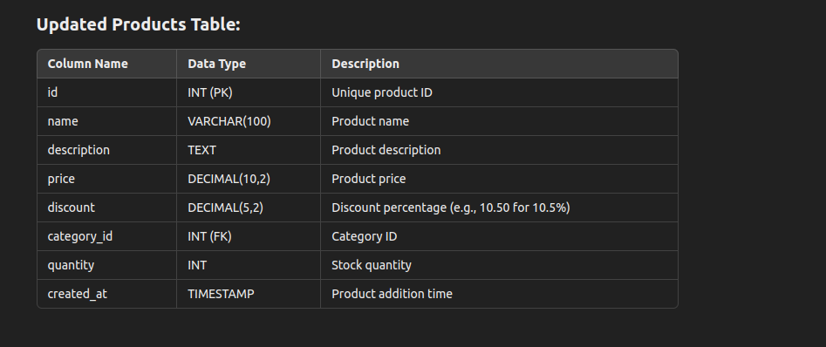
Category Management:
1.Add, update, delete, and view product categories.
2.Organize products into different categories.

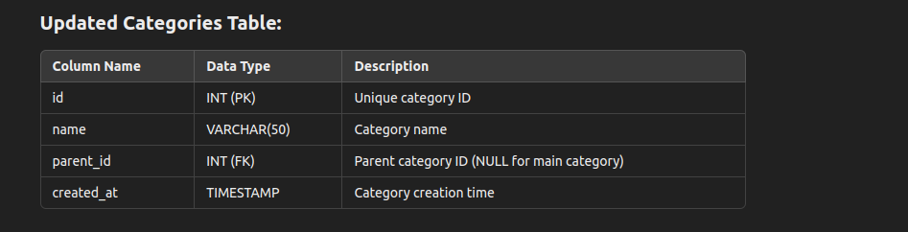

Order Management:
1.View all customer orders.
2.Update order status (e.g., pending, completed).

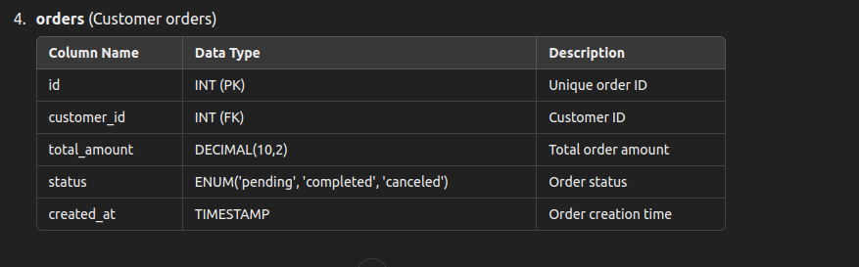
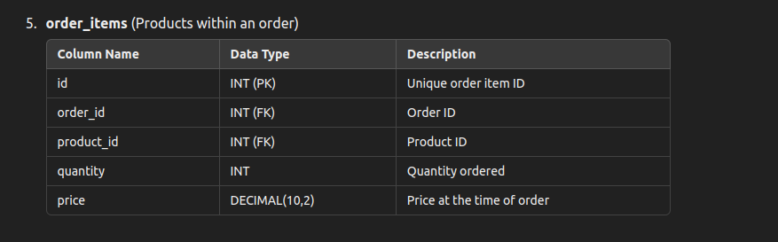

Customer Management:
1.View and manage customer information.
2.Delete or update customer details.

User Management:
1.Admin login and logout.
2.Manage admin users and permissions.

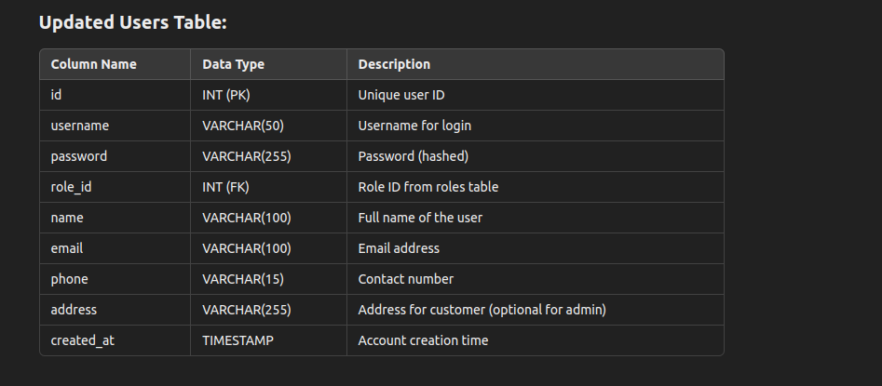

Role Management:
1.Add, update, delete, and view products.

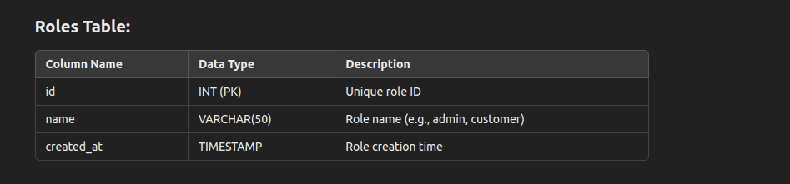

2. Customer Panel:
Product Browsing:
1.View products with details and categories.

Order Placement:
1.Add products to the cart and place orders.

Order History:
1.View past orders and order status.

Profile Management:
1.Update personal information and contact details.

Authentication:
1.Register and log in with secure authentication.

3. Database Connection (PDO):
->Centralized database configuration using PDO for secure and efficient database interactions.q

