* The emphasis will be on methods that are replicable and testable

The predictability of an event or a quantity depends on several factors including:

1. how well we understand the factors that contribute to it;
2. how much data is available;
3. how similar the future is to the past;
4. whether the forecasts can affect the thing we are trying to forecast.

For example, short-term forecasts of residential electricity demand can be highly accurate because all four conditions are usually satisfied.

1. We have a good idea of the contributing factors: electricity demand is driven largely by temperatures, with smaller effects for calendar variation such as holidays, and economic conditions.
2. There is usually several years of data on electricity demand available, and many decades of data on weather conditions.
3. For short-term forecasting (up to a few weeks), it is safe to assume that demand behaviour will be similar to what has been seen in the past.
4. For most residential users, the price of electricity is not dependent on demand, and so the demand forecasts have little or no effect on consumer behaviour.

On the other hand, when forecasting currency exchange rates, only one of the conditions is satisfied: there is plenty of available data. However, we have a limited understanding of the factors that affect exchange rates, the future may well be different to the past if there is a financial or political crisis in one of the countries, and forecasts of the exchange rate have a direct effect on the rates themselves. If there are well-publicised forecasts that the exchange rate will increase, then people will immediately adjust the price they are willing to pay and so the forecasts are self-fulfilling. In a sense, the exchange rates become their own forecasts. This is an example of the “efficient market hypothesis”.

In the early stages of a forecasting project, decisions need to be made about what should be forecast. For example, if forecasts are required for items in a manufacturing environment, it is necessary to ask whether forecasts are needed for:

1. every product line, or for groups of products?
2. every sales outlet, or for outlets grouped by region, or only for total sales?
3. weekly data, monthly data or annual data?

It is also necessary to consider the forecasting horizon. Will forecasts be required for one month in advance, for 6 months, or for ten years?

How frequently are forecasts required? Forecasts that need to be produced frequently are better done using an automated system than with methods that require careful manual work.

The data required for forecasting may already exist. These days, a lot of data are recorded, and the forecaster’s task is often to identify where and how the required data are stored.

If there are no data available, or if the data available are not relevant to the forecasts, then **qualitative forecasting** methods must be used. These methods are not purely guesswork—there are well-developed structured approaches to obtaining good forecasts without using historical data.

**Quantitative forecasting** can be applied when two conditions are satisfied:

1. numerical information about the past is available;
2. it is reasonable to assume that some aspects of the past patterns will continue into the future.

Most quantitative prediction problems use either time series data (collected at regular intervals over time) or cross-sectional data (collected at a single point in time).

When forecasting time series data, the aim is to estimate how the sequence of observations will continue into the future.

The simplest time series forecasting methods use only information on the variable to be forecast, and make no attempt to discover the factors that affect its behaviour. Therefore they will extrapolate trend and seasonal patterns, but they ignore all other information such as marketing initiatives, competitor activity, changes in economic conditions, and so on

An explanatory model is useful because it incorporates information about other variables, rather than only historical values of the variable to be forecast. However, there are several reasons a forecaster might select a time series model rather than an explanatory or mixed model. First, the system may not be understood, and even if it was understood it may be extremely difficult to measure the relationships that are assumed to govern its behaviour. Second, it is necessary to know or forecast the future values of the various predictors in order to be able to forecast the variable of interest, and this may be too difficult. Third, the main concern may be only to predict what will happen, not to know why it happens. Finally, the time series model may give more accurate forecasts than an explanatory or mixed model.

The thing we are trying to forecast is unknown (or we would not be forecasting it), and so we can think of it as a random variable.

s. In other words, the further ahead we forecast, the more uncertain we are.

. Often, a forecast is accompanied by a **prediction interval** giving a range of values the random variable could take with relatively high probability. For example, a 95% prediction interval contains a range of values which should include the actual future value with probability 95%.

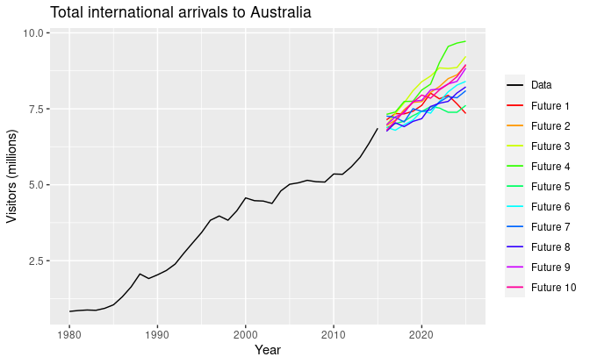

(not preferred)

Rather than plotting individual possible futures as shown in Figure [1.2](https://otexts.com/fpp3/perspective.html#fig:austa1), we usually show these prediction intervals instead. Figure [1.3](https://otexts.com/fpp3/perspective.html#fig:austa2) shows 80% and 95% intervals for the future Australian international visitors. The blue line is the average of the possible future values, which we call the **point forecasts**.

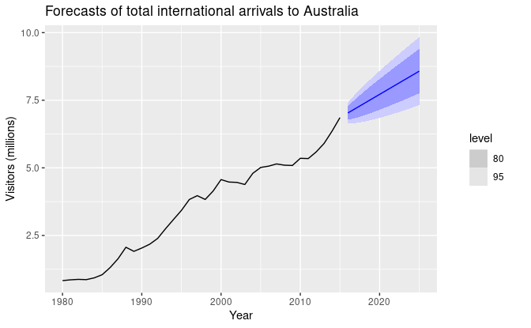

(preferred)

