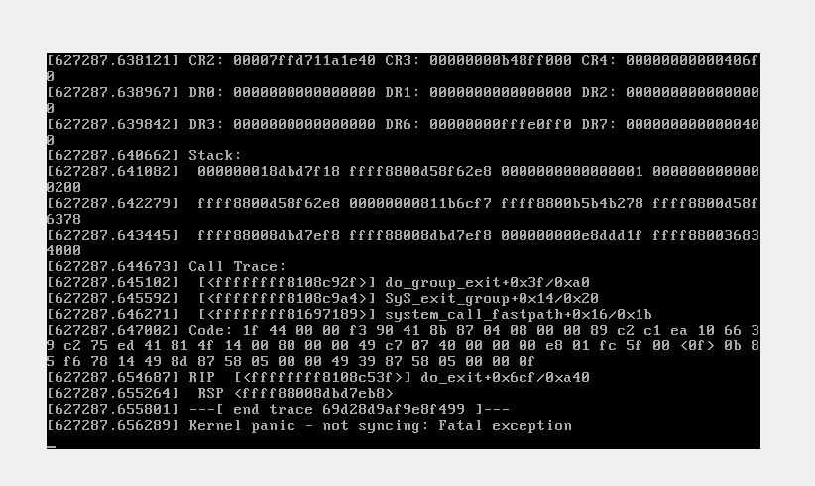

**Resolution**

* Follow the below steps:

  1)  Go to single user mode or Linux rescue mode.

  2)   Remove the installed "smartstart-8.00-0" package and all it is dependencies packages.

  3)  Rebuild the initial ramdisk image. Refer following article : [How do I rebuild the initial ramdisk image in Red Hat Enterprise Linux?](https://access.redhat.com/kb/docs/DOC-1959)

  4)  Edit the "/boot/grub/grub.conf" file and point the new rebuilded initrd image instead of old image.

  5)  Now boot the system with the new initrd image.

