**Set B**

Q: Make a tutorial presentation/documentation on, R control Structure: If else, while, for loops, functions. Write programming example for each of them. (Use Screenshots of full screen for each step, so that it can be differentiated from other person.

**R Control Structure**

There are a few control structures in R that help to control the flow of the program. In R, there are decision-making structures like if-else that control execution of the program conditionally.

1. **If Statement:-**  If statement will be executed if the condition inside the if statement is true. For Example:-

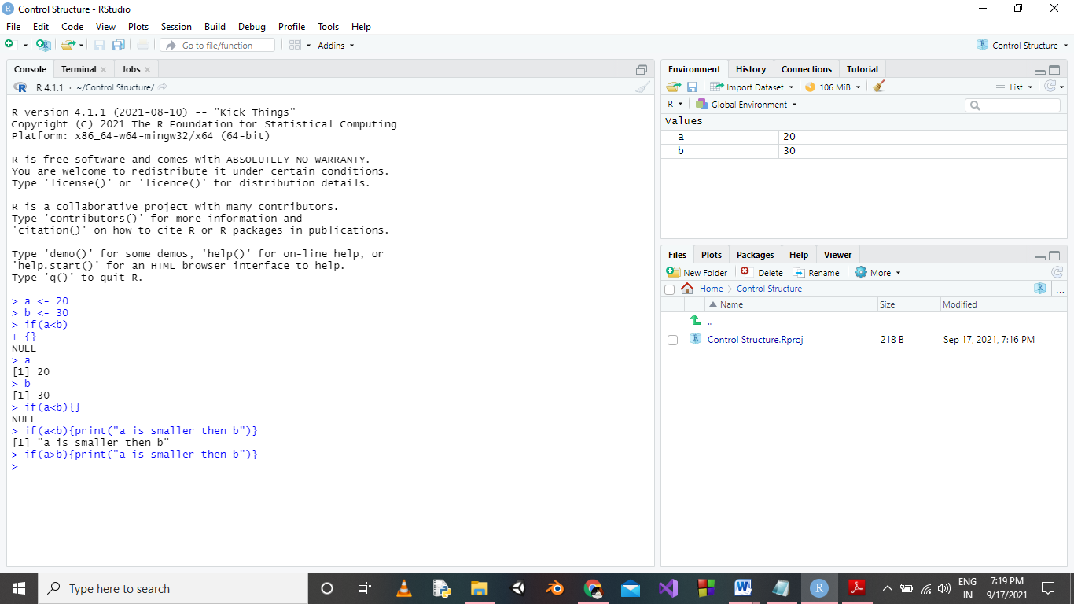

1. If Else Statement:- If the condition given in if statement is true then if statement will be executed else the else part will be executed. For Example:-

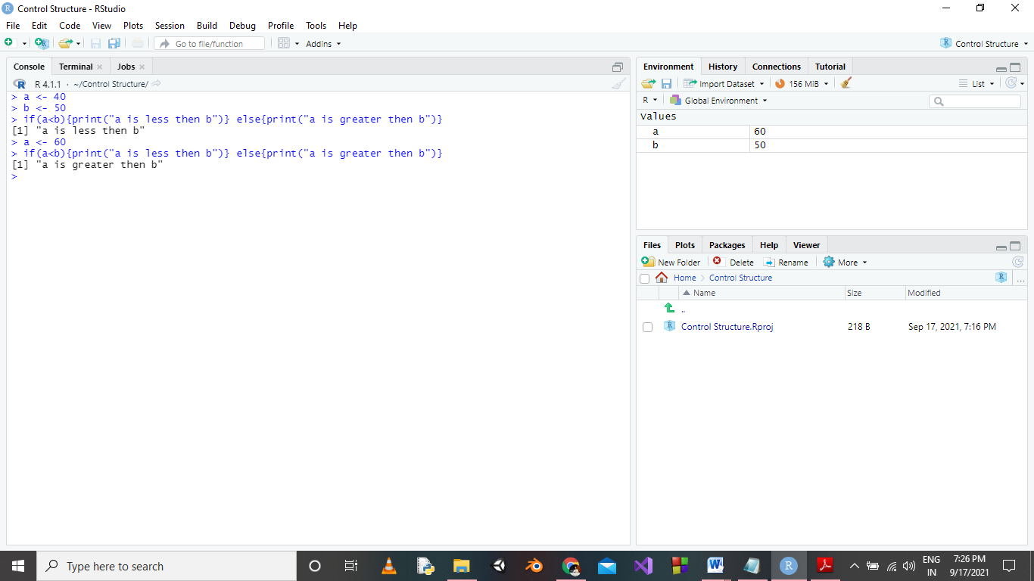

1. If Else Ladder:- If condition is more , then we can use if else ladder as shown in figure.

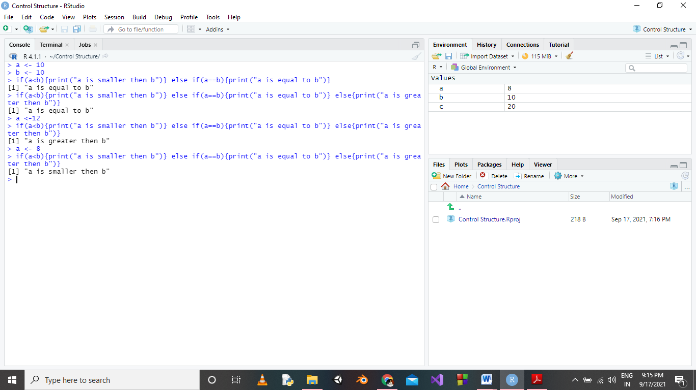

1. Switch Statement:- It is used when we have multiple alternatives. For Example :-

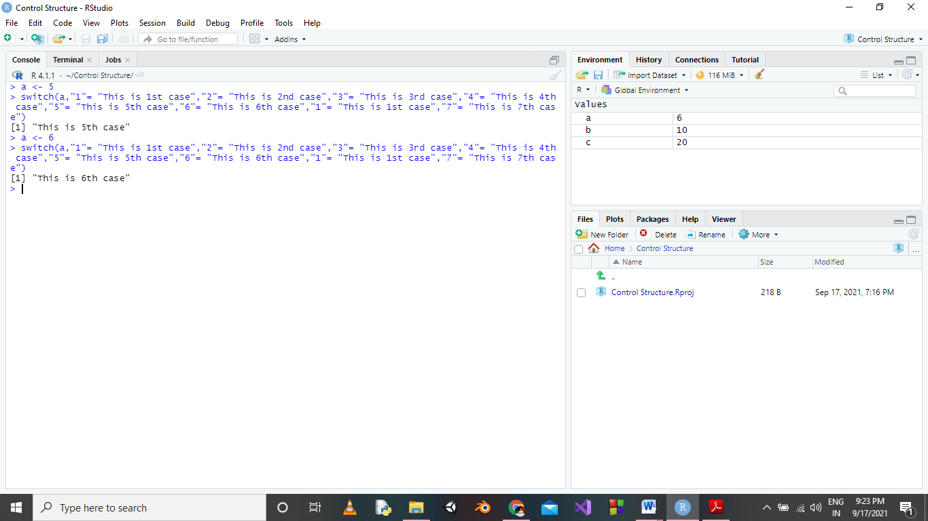

1. For Loop:- The for loop in R, repeats through sequences to perform repeated tasks. They work with an iterable variable to go through a sequence. The following is the syntax of for loops in R: For Example:-

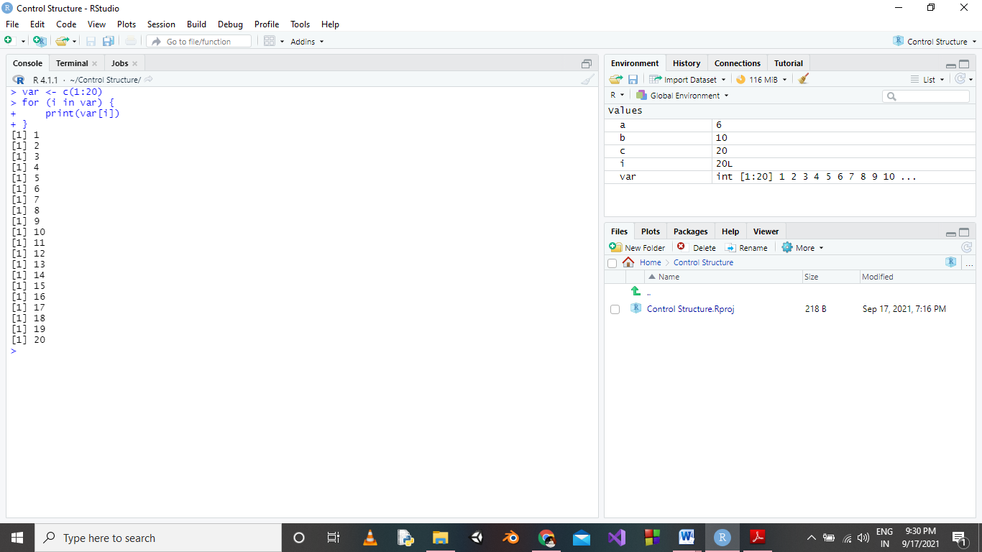

1. While Loop:- The while loop in R evaluates a condition. If the condition evaluates to TRUE it loops through a code block, whereas if the condition evaluates to FALSE it exits the loop. For Example:-

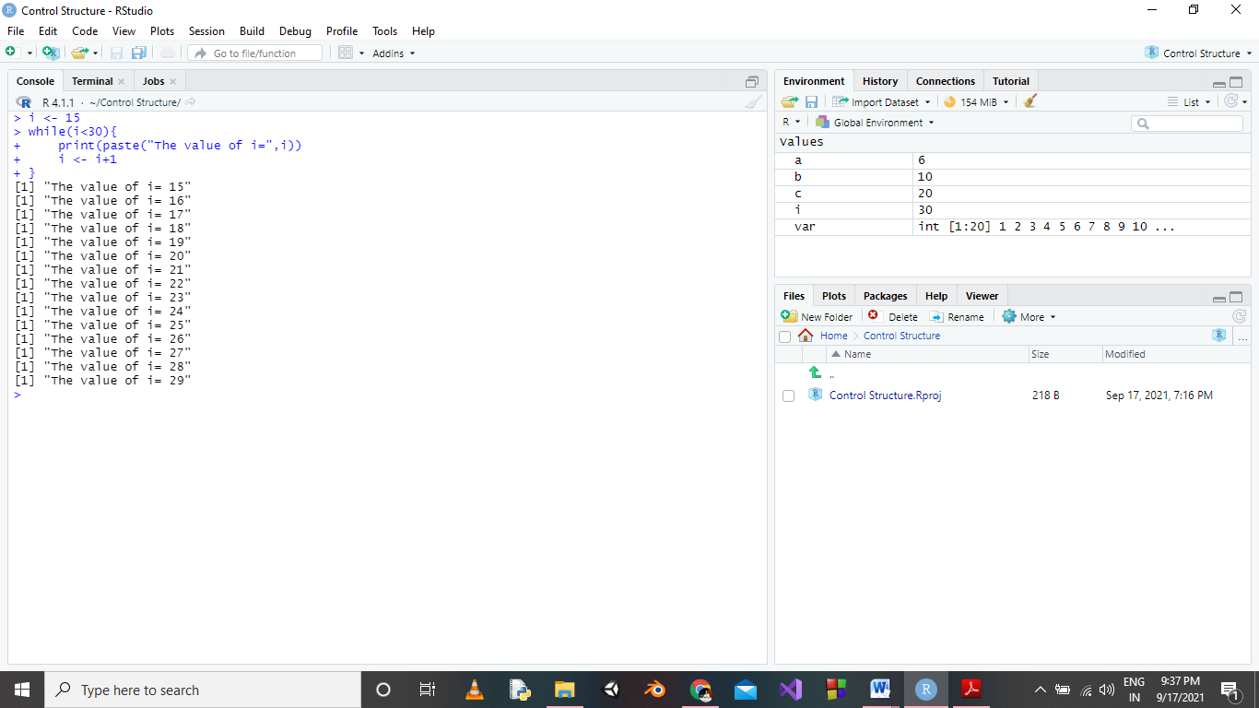

1. Functions :- A function, in a programming environment, is a set of instructions. A programmer builds a function to avoid repeating the same task, or reduce complexity.

Syntax

function_name <- function(arg_1, arg_2, ...) {

Function body

}

Example of Built in Functions:-

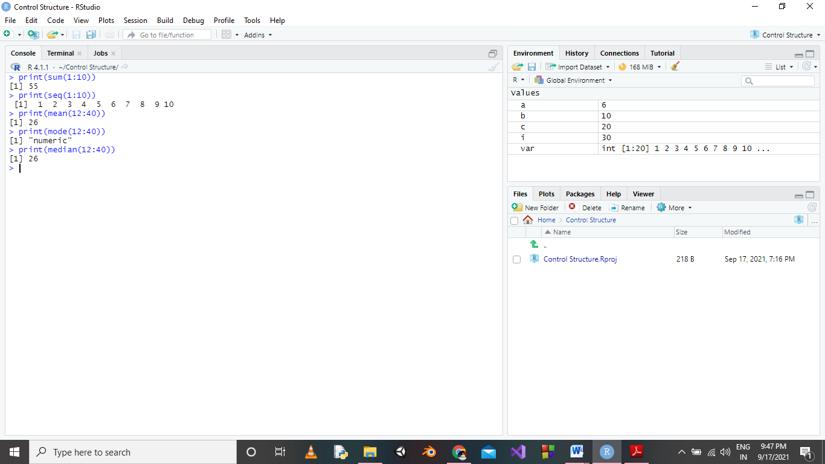

Example of User Defined Function

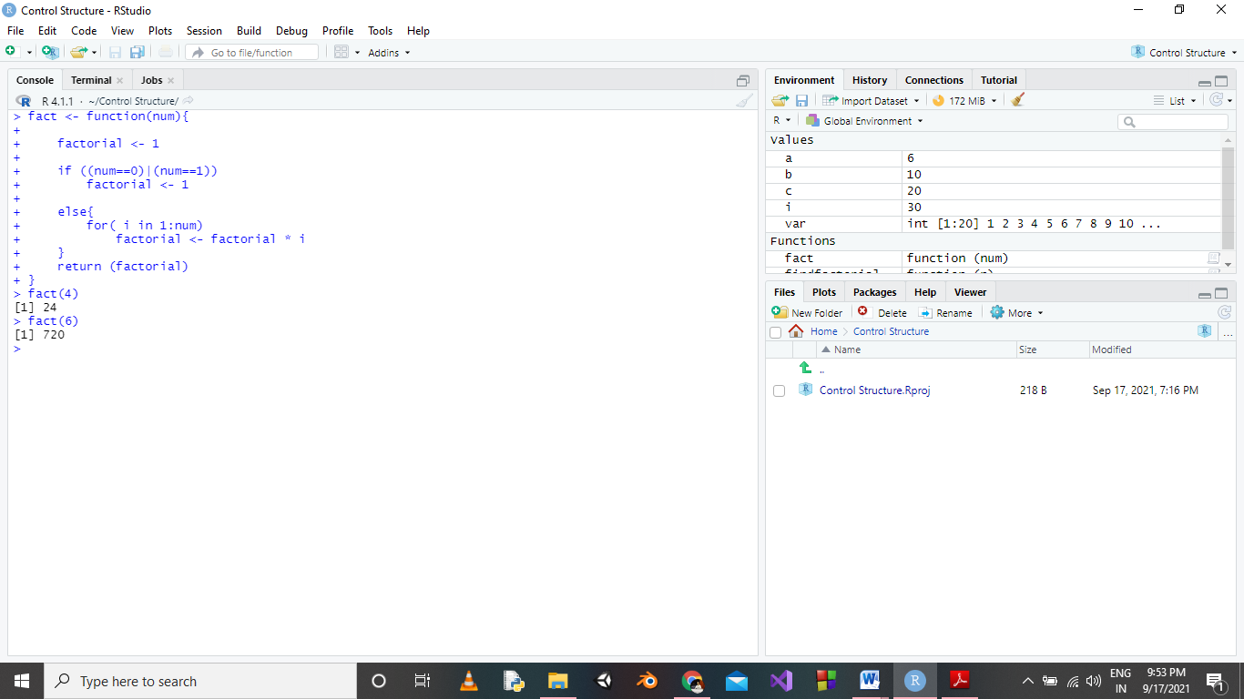

In above figure name of function is fact and we are calling the function by using fact(num).

**Thank You**