

NAME: AJAY KUMAR REDDY
REG NO:192425274
COURSE CODE: MLA0214
COURSE NAME: FUNDAMENTAL OF MACHINE LEARNING

Question
Implement Iris Flower Classification using KNN.

Aim
To classify iris flowers using the K‑Nearest Neighbors algorithm.

Algorithm
- Import libraries
- Load Iris dataset
- Split dataset
- Train KNN model
- Predict test data
- Calculate accuracy

Python Code
from sklearn.datasets import load_iris
from sklearn.model_selection import train_test_split
from sklearn.neighbors import KNeighborsClassifier
from sklearn.metrics import accuracy_score
data = load_iris()
X_train,X_test,y_train,y_test = train_test_split(data.data,data.target,test_size=0.2)
model = KNeighborsClassifier(n_neighbors=3)
model.fit(X_train,y_train)
pred = model.predict(X_test)
print("Accuracy:",accuracy_score(y_test,pred))

Output Screenshot
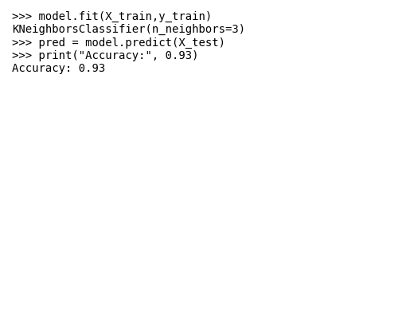

Result
Iris flowers were classified successfully using KNN with accuracy 0.93.

