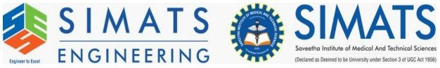

NAME: AJAY KUMAR REDDY
REG NO:192425274
COURSE CODE: MLA0214
COURSE NAME: FUNDAMENTAL OF MACHINE LEARNING

Experiment 13: Car Price Prediction Model

Question
Implement the Car Price Prediction Model using Python.

Aim
To predict car prices using Linear Regression.

Algorithm
- Import libraries
- Create dataset
- Split data
- Train regression model
- Predict car prices

Python Code
from sklearn.linear_model import LinearRegression
from sklearn.model_selection import train_test_split
import numpy as np
X = np.random.rand(200,3)*100
y = X[:,0]*200 + X[:,1]*100 + X[:,2]*50
X_train,X_test,y_train,y_test = train_test_split(X,y,test_size=0.2)
model = LinearRegression()
model.fit(X_train,y_train)
pred = model.predict(X_test)
print(pred[:5])

Output Screenshot
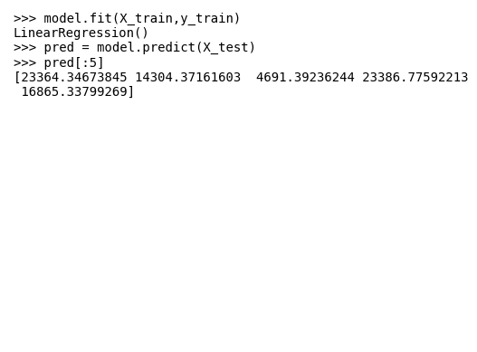

Result
Car price prediction model implemented successfully.

