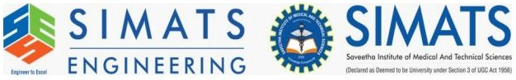

NAME: AJAY KUMAR REDDY
REG NO:192425274
COURSE CODE: MLA0214
COURSE NAME: FUNDAMENTAL OF MACHINE LEARNING

Experiment 16: Comparison of Classification Algorithms

Question
Compare different types Classification Algorithms and evaluate their performance.

Aim
To compare different classification algorithms based on accuracy.

Algorithm
- Import libraries
- Load dataset
- Train multiple models
- Evaluate accuracy
- Compare results

Python Code
from sklearn.neighbors import KNeighborsClassifier
from sklearn.tree import DecisionTreeClassifier
from sklearn.svm import SVC
from sklearn.ensemble import RandomForestClassifier

Output Screenshot
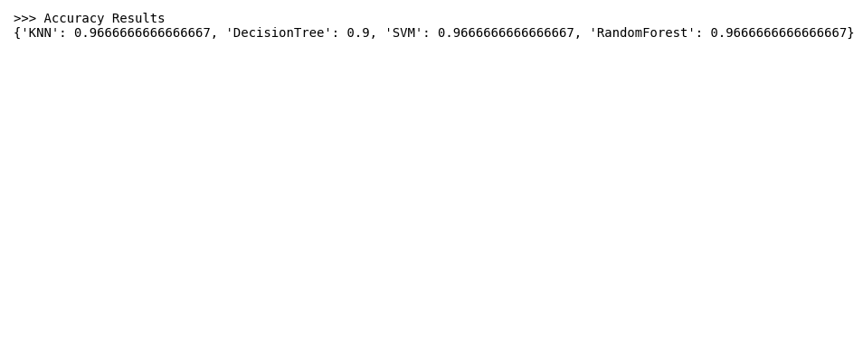

Result
Different classification algorithms were compared successfully.

