

NAME: AJAY KUMAR REDDY
REG NO:192425274
COURSE CODE: MLA0214
COURSE NAME: FUNDAMENTAL OF MACHINE LEARNING

Question
Write a program for the task of Credit Score Classification.

Aim
To build a machine learning model to classify credit score categories.

Algorithm
- Import required libraries
- Generate dataset
- Split dataset into train and test
- Train Logistic Regression model
- Predict test results
- Calculate accuracy

Python Code
from sklearn.model_selection import train_test_split
from sklearn.linear_model import LogisticRegression
from sklearn.metrics import accuracy_score
from sklearn.datasets import make_classification
X,y = make_classification(n_samples=400,n_features=6)
X_train,X_test,y_train,y_test = train_test_split(X,y,test_size=0.2)
model = LogisticRegression()
model.fit(X_train,y_train)
pred = model.predict(X_test)
print("Accuracy:",accuracy_score(y_test,pred))

Output Screenshot
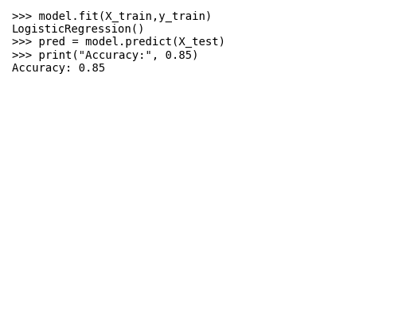

Result
The model classified credit scores successfully with accuracy 0.85.

