Game Design Document
Fill up the Following document

- Write the title of your project.
Snake Gam

- What is the goal of the game?
The snake has to east as many apples as possible and grow big

- Write a brief story of your game?
So the snake will be moving with the help of player and the fruits will be spawning randomly. The snake has to be trying to eat the fruits and grow big. The snake will try to go very big and be the biggest snake in the world
- Which are the playing characters of this game?
- Playing characters are the ones which respond to the user based on the input from the user
- Cars, monkeys, dinos, wizards etc, are the playing characters in the game.
Number | Character Name | What can this character do?
1 | Snake | Moved by player and eat  Fruits and grow big
2
3
4
5
6
7
8

- Which are the Non Playing Characters of this game?
- Non Playing characters are the ones which don't have an action or a behaviour when the user interacts with the game.
- Hurdles, stones, bananas, coins, etc are non playing characters in the game.
Number | Character Name | What can this character do?
1 | Fruit | The fruits will spawn randomly and get eaten by snake
2
3
4
5
6
7
8

Draw your imagination of this game. What does this game look like?
- Draw the game either on your computer or on paper,
- Add images of scenes of the game to show each of the playing and non-playing characters at least once.

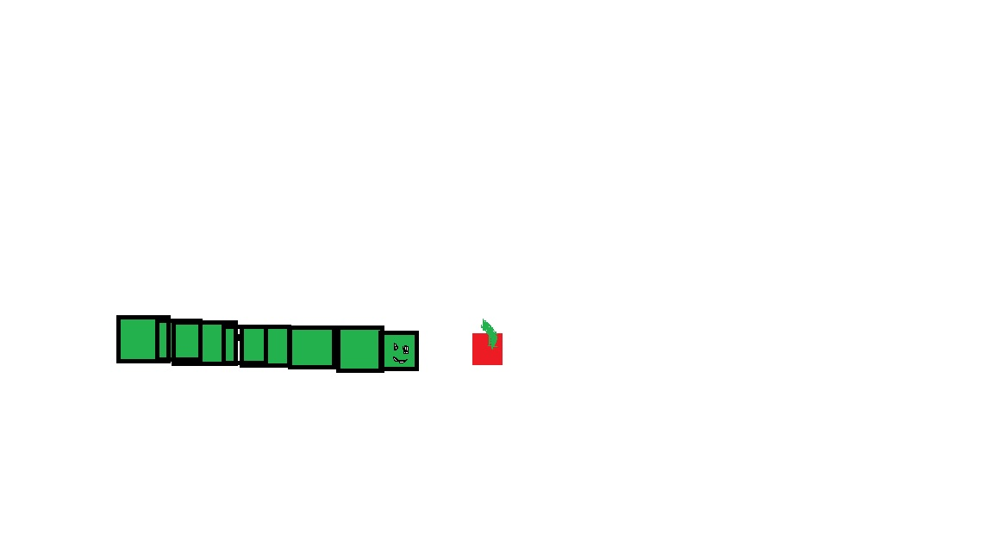

How do you plan to make your game engaging?
BY Making the snake go faster when the snake grows bigger and maybe generate fruits different for snake to have different abilities; Add music and sound effects.

