# CAPSTONE PROJECT REPORT

(Project Term January-May 2023)

***(Music Recommendation System using Facial Emotions)***

Submitted by

(Sanjay Chaudhary) Reg No : 11913399

(Ajay Sehrawat) Reg No : 11906441

(Vinit Kumar) Reg No : 11904669

(Vivek) Reg No : 11910823

(Sahyogvir Singh) Reg No : 11904949

(Aryaman Negi) Reg No : 11901773

**Project Group Number : CSERGC0078**

**Course Code: CSE445**

Under the Guidance of

**Name of faculty/mentor**: Komal Arora (Assistant Professor)

**School of Computer Science and Engineering**



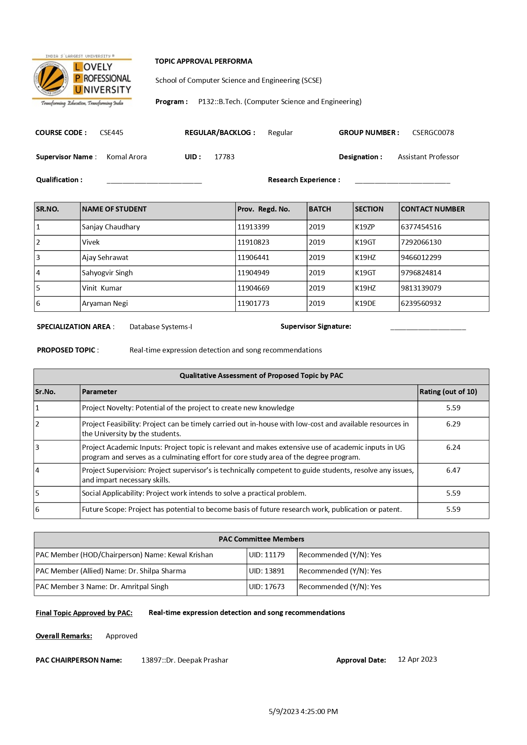

# DECLARATION

We hereby declare that the project work entitled (“***Music Recommendation System using Facial Emotions***”) is an authentic record of our own work carried out as requirements of Capstone Project for the award of B.Tech degree in( Computer Science and Engineering ) from Lovely Professional University, Phagwara, under the guidance of Ms. Komal Arora during January to May 2023. All the information furnished in this capstone project report is based on our own intensive work and is genuine.

Project Group Number: …CSERGC0078…

Name of Student 1: Sanjay Chaudhary Registration Number: 11913399

Name of Student 2: Ajay Sehrawat Registration Number: 11906441

Name of Student 3: Vinit Kumar Registration Number: 11904669

Name of Student 4: Vivek Registration Number: 11910823

Name of Student 5: Sahyogvir Singh Registration Number: 11904949

Name of Student 6: Aryaman Negi Registration Number: 11901773

(Signature of Students) :

# CERTIFICATE

This is to certify that the declaration statement made by this group of students is correct to the best of my knowledge and belief. They have completed this Capstone Project under my guidance and supervision. The present work is the result of their original investigation, effort and study. No part of the work has ever been submitted for any other degree at any University. The Capstone Project is fit for the submission and partial fulfillment of the conditions for the award of B.Tech degree in Computer Science and Engineering from Lovely Professional University, Phagwara.



**Signature and Name of the Mentor**

( Assistant Professor)

**School of Computer Science and Engineering,**

Lovely Professional University, Phagwara, Punjab.

Date : 09 May 2023

# ACKNOWLEDGEMENT

We would like to express our deepest appreciation to all those who provided us the possibility to complete this report. We give special gratitude to our subject mentor, **Komal Arora**, whose contribution in stimulating suggestions and encouragement, helped us to coordinate our project especially in writing this report and enhancing our idea of project and initiating it.

Furthermore, we would also like to acknowledge with much appreciation the crucial role of our parents, who provided all required and necessary materials and support to complete this project of **“Music Recommendation System using Facial Emotions”**. We have to appreciate the guidance given by other supervisor as well as the panels especially in our project presentation that has improved our presentation skills thanks to their comment and advice.

Project Group No : CSERGC0078



Name of Student 1: Sanjay Chaudhary Reg No: 11913399 Sign:



Name of Student 2: Ajay Sehrawat Reg No: 11906441 Sign:

Name of Student 3: Vinit Kumar Reg No: 11904669 Sign:

Name of Student 4: Vivek Reg No: 11910823 Sign:

Name of Student 5: Sahyogvir Singh Reg No: 11904949 Sign:

Name of Student 6: Aryaman Negi Reg No: 11901773 Sign:

Contents

CAPSTONE PROJECT REPORT 1

DECLARATION 3

CERTIFICATE 4

ACKNOWLEDGEMENT 5

Chapter 1: Introduction 8

1.1 Overview 8

1.2 Project Description 8

A.Need for Facial emotion Recognition: 9

Chapter 2: The Problem Statement 11

2.1 Problem Description 11

2.2 Solution OF The Problem 11

Chapter 3: Existing Systems 13

3.1 Introduction 13

3.2 What’s new in the system to be developed? 13

3.3 DFD OF Present Systems 14

Chapter 4: Problem Analysis 16

4.1 Product Definition 16

4.2 Feasibility Analysis 16

4.3 Project Plan 18

Chapter 5: Software Requirement Analysis 19

5.1 Introduction 19

5.2 Specific Requirements 19

Functional Requirements: 19

Non-Functional Requirements 20

Chapter 6: Design 22

6.1 System Design 22

6.2 Design Notations 23

• Use Case Model 23

• Working Of Model 24

6.3 Detailed Design 24

6.4 Flowcharts 25

Chapter 7: Testing 26

7.1 Functional Testing 26

7.2 Structural Testing 26

7.3 Levels of Testing 27

7.4 Testing of Project 28

Chapter 8: Implementation 29

8.1 Implementation of the Project 29

8.2 Post Implementation and Software Maintenance 29

Chapter 9: Project Legacy 30

9.1 Current Status of The Project 30

9.2 Remaining areas of Concern 30

9.3 Technical and Managerial Lessons Learnt 30

Chapter 10: User Manual 31

Chapter 11: System Snapshots 32

11.1 Machine Learning Algorithm Snapshots 32

Chapter 12: References 36

# Chapter 1: Introduction

## 1.1 Overview

The utilization of facial expression analysis in artificial intelligence has broad applications, ranging from facilitating interaction between computers and humans to generating data-driven animations[1]. Given its significance in detecting emotions from facial cues, it has become an essential component of AI and a hot topic of research. Music is an art form that has a profound connection with human emotions and possesses the exceptional ability to elevate one's mood. This research aims to utilize a serial model comprising of Conv2d, Maxpool2d, Dropout, and Dense layers to detect and identify emotion through facial traits and expressions. This model will detect emotions and play music, accordingly, ensuring individuals' positivity at all times. The project has the capability to detect the fundamental seven emotions conveyed through human expression. The central idea behind the model is to efficiently identify facial emotions and suggest suitable songs with accuracy[2].

## 1.2 Project Description

There can be many types of facial expressions ranging from happy to sad, anger, and fear, and are essential for effective human communication. They provide nonverbal cues that reveal emotional states and intentions. Researchers have investigated facial emotions to gain a more comprehensive understanding of the physiological and cognitive processes that underlie the recognition of facial expressions. Technological advancements have facilitated the more accurate and objective measurement and analysis of facial emotions, leading to a deeper comprehension of their neurological and cultural roots. As per the findings**Error! Reference source not found.** of psychologists, 55% of emotional understanding comes from visual factors, while 38% comes from audio cues like rhythm, pitch, and tone. Language plays a relatively smaller role, contributing only 7%, which is influenced by the complexity of language used worldwide[3].

### Need for Facial emotion Recognition:

Facial emotion recognition technology has gained immense attention in last few years for its capacity to allow machines to interpret human emotions based on facial expressions. Its potential applications range across various fields, including psychology, neuroscience, human-computer interaction, and artificial intelligence.

In psychology and neuroscience, facial emotion recognition is used to study emotional processes and their neural mechanisms, which can aid in the identification and cure of psychiatric disorders, for example autism spectrum disorder and depression**Error! Reference source not found.**.

In human-computer interaction, facial emotion recognition can enhance the accuracy and efficiency of emotion-based systems, such as emotion-aware robots and virtual assistants, leading to more natural and responsive interactions in gaming and virtual reality environments[4].

In artificial intelligence, facial emotion recognition can be used in security systems, fraud detection, and market research. It can also help create more personalized and adaptive systems that respond to the user's emotional state**Error! Reference source not found.**, leading to better customer satisfaction and engagement.Facial emotion recognition has tremendous potential to transform the way we interact with machines and each other, making it an important area of research and development in technology and psychology.

So, a music recommendation system that identifies human emotions and suggests songs accordingly can significantly enhance the user's music listening experience. Traditional music recommendation systems rely on user behaviour data, such as previously played songs and playlists, to suggest new songs to users. However, these systems do not take into account the user's current emotional state, which can significantly impact their music preference[5].

By utilizing facial emotion recognition and deep learning techniques, we can develop a music recommendation system that provides more personalized recommendations to users. When a user uploads a picture of their face, the system can analyze their facial expression and determine their emotional state, such as happiness, sadness, or excitement. Based on this information, the system can suggest songs that match the user's mood and preferences.

A music recommendation system that identifies human emotions can help users discover new songs that they might not have found otherwise. It can also create a more immersive music listening experience by playing songs that match the user's current emotional state. Overall, a music recommendation system that identifies human emotions and suggests songs accordingly has the potential to significantly enhance the user's music listening experience and create a deeper connection between music and emotions[6].

# Chapter 2: The Problem Statement

## 2.1 Problem Description

Music has a profound effect on our emotions and moods. It can help us relax, energize, and uplift our spirits. However, finding the right music that matches our current emotional state can be challenging. Music recommendation systems can help solve this problem by suggesting songs that match our mood and preferences. However, traditional music recommendation systems rely solely on user behavior data and do not take into account the user's current emotional state, which is a crucial factor in music preference.

A music recommendation system that identifies human emotions and suggests songs accordingly can significantly enhance the music listening experience. By utilizing facial emotion recognition and deep learning techniques, the system can analyze the user's emotional state and recommend songs that match their mood. This creates a more personalized and immersive experience, making the music listening experience more enjoyable and memorable[7].

Moreover, a music recommendation system that identifies human emotions and suggests songs accordingly can help users discover new songs that they might not have found otherwise. It can also provide a means of exploring different genres and styles of music that match the user's current emotional state, leading to a deeper appreciation of music.

Overall, a music recommendation system that identifies human emotions and suggests songs accordingly has the potential to revolutionize the way we listen to music. It can create a more personalized, immersive, and enjoyable music listening experience, enhancing our emotional connection with music and improving our overall well-being.

## 2.2 Solution OF The Problem

To solve this problem, a music recommendation system can be developed that identifies human emotions and suggests songs that match the user's mood. This system will utilize facial emotion recognition and deep learning techniques to analyze the user's facial expression and determine their emotional state, such as happiness, sadness, excitement, or relaxation. Based on this analysis, the system will suggest songs that match the user's mood and preferences.

The proposed music recommendation system has several advantages over traditional systems. Firstly, it provides a more personalized music listening experience, catering to the user's emotional state at the time. Secondly, it helps users discover new songs that they may not have found otherwise. By playing songs that match the user's current emotional state, the system creates a deeper connection between the user and the music, enhancing their overall listening experience[7].

Furthermore, the system can be integrated with popular music streaming services such as Spotify which we are still working on to establish, enabling seamless access to a vast library of songs. The system can also be integrated with a mobile application or a web interface, making it easily accessible to users on different devices.

In conclusion, the proposed music recommendation system that identifies human emotions and suggests songs accordingly has significant potential to revolutionize the music listening experience. It addresses the problem of finding the right music to match our current emotional state, providing a personalized and immersive experience that enhances our emotional connection with music.

# Chapter 3: Existing Systems

## 3.1 Introduction

Music recommendation systems have become increasingly popular in recent years, with the growth of music streaming services and the vast amount of music available at our fingertips. However, traditional music recommendation systems only consider user behavior data and do not take into account the user's current emotional state, which is a critical factor in music preference. To address this limitation, a music recommendation system has been developed that identifies human emotions and suggests songs accordingly[8]. This system utilizes facial emotion recognition and deep learning techniques to analyze the user's emotional state and recommend songs that match their mood. This paper explores the existing system and its effectiveness in enhancing the music listening experience.

## 3.2 What’s new in the system to be developed?

The objective of this proposed music recommendation system is to revolutionize the way we create and curate music playlists. The system will utilize facial detection technology in conjunction with deep convolutional neural networks (CNN) to accurately recognize and analyze the emotions of the user. By reading and interpreting the user's facial expressions in real-time, the system will determine the user's mood and suggest music tracks that align with their emotional state.[4]

The proposed system will use a pre-existing playlist or a custom one to generate a subset of songs that match the user's emotions. The "one versus all" approach of the CNN will be employed for training and classification, enabling multi-class categorization.

The music recommendation system will prove beneficial in various scenarios, such as during workouts, while traveling, or while studying. It will offer a personalized music experience based on the user's emotions, making it a valuable tool for enhancing mood and productivity. The proposed system will be easy to use and can be implemented on a variety of devices, including smartphones, laptops, and desktops.

The existing music recommendation system that identifies human emotions and suggests songs accordingly has several advantages over traditional systems. Firstly, it provides a more personalized music listening experience by catering to the user's emotional state at the time. Secondly, it helps users discover new songs that they may not have found otherwise[9]. By playing songs that match the user's current emotional state, the system creates a deeper connection between the user and the music, enhancing their overall listening experience.

Moreover, the system in future can be integrated with popular music streaming services, such as Spotify, making it easily accessible to users. It can also be integrated with a mobile application or web interface, allowing users to access the system from different devices.

## 3.3 DFD OF Present Systems

Fig 1: 0 Level DFD for present systems

Fig 2: Level 1 DFD of Our System

# Chapter 4: Problem Analysis

## 4.1 Product Definition

The music recommendation system utilizes advanced technologies such as facial emotion recognition and deep learning algorithms to analyze the user's emotional state and provide song recommendations that align with their mood. Its user-friendly interface and potential integration with popular music streaming services make it easily accessible to users. The system enhances the overall music listening experience by establishing a stronger connection between the user and the music, which improves their mood and promotes a sense of wellbeing. To use the system, users simply need to open the user interface, sit in front of the camera for a few seconds, and let the system capture video using OpenCV[10]. From this, the system creates frames and analyzes human behavior to predict the emotion and provide song suggestions to enhance the user's mood. Overall, this music recommendation system has the potential to transform the way people listen to music and elevate their music listening experience.

**Feature of Product includes:**

* It recognizes 7 basic human emotions.
* It can recommend songs based on those emotions.
* Song recommendation works like this when a user is “Sad” it will play songs to “Happy” the mood of the user, similarly when a user is “Angry” or “Feared” it will play “Calm” and soothing songs that will relax the user.
* The UI is easy to use and understand by a user with very less prior knowledge.

## 4.2 Feasibility Analysis

All aspects of this system, including technical, financial, and organizational feasibility, have been thoroughly considered and deemed feasible. The users have expressed positive feedback regarding the GUI, considering it to be one of the best interfaces available. It is not only cost-effective, but also innovative, precise, visually appealing, and user-friendly. These aspects are crucial during project development, as cost-effectiveness, overall appearance, and feasibility are highly significant factors that must be taken into consideration.

The effectiveness of existing systems and software available in the market heavily relies on the important factors mentioned. Keeping these factors in mind, a website product has been launched to address the issues faced by users when accessing the current software available, which are often paid or difficult to locate. This project offers an easy-to-use interface for users to access the product, providing a solution to the problems faced by them[11].

After completing the project, it is essential to perform regular operations such as updating the dataset to achieve accurate results and allowing the model to learn more. Training the model on additional datasets will help it to learn more and improve its ability to accurately recognize human emotions. These critical factors greatly impact the effectiveness of the product and the services it provides. As a result, taking these factors into account, a website product was launched to address the issues faced by users when accessing the current software available in the market, which are often costly or challenging to locate.

**To determine the technical feasibility of the project, several steps need to be taken:**

1. Firstly, we need to check whether we have the dataset which we have to use to train the algorithm. It is the most important factor in technical feasibility.
2. After obtaining the dataset, we must assess whether we can effectively train the algorithm using the available data.
3. It is important to evaluate whether integrating the graphical user interface (GUI) with the machine learning (ML) model is feasible, as accessing the system without the interface can be difficult to use.
4. When the system is running, we sometimes get errors, so we make sure to provide users assistance with them.
5. The system can also work on low internet connection.

## 4.3 Project Plan

Fig 3: Gantt Chart for Project Plan

# Chapter 5: Software Requirement Analysis

## 5.1 Introduction

To complete our project, we have used various open libraries and frameworks like OpenCV, Kera’s, TensorFlow, Flask etc. Music Recommendation System using facial emotions is easy to use, all you need to run the interface there you just need to show your face to camera, and it will detect your emotion and recommend you the songs to listen to. Once the user runs the application it will access the web cam from where it will capture frames and then run algorithm on those frames and match the algorithm result with dataset to identify the emotion. Now whenever user emotion changes it will identify them and recommend related songs.

## 5.2 Specific Requirements

All the functional and non-functional requirements and listed below

### Functional Requirements:

* **User Interface:** To ensure ease of use and accessibility of the application, it is vital to have a user-friendly interface that is well-designed and contains all relevant information. The music recommendation feature should be appropriately placed and suggest music that is relevant to the user's preferences.
* **Dataset Availability:** The team is responsible for ensuring that the dataset is always available for the proper functioning of the ML model. It is crucial to update the dataset regularly to achieve accurate results as the accuracy of the output is directly proportional to the accuracy of the dataset. Any noisy data should be promptly reported to the administrator for analysis and correction to maintain the dataset's integrity. By regularly updating the dataset, the ML model can efficiently predict the output with high accuracy**.**
* **Administrative Function:** Functions such as adding new information, implementing new modules or functions, uploading new images to the dataset, updating website content, and training the dataset on new data fall under the purview of administration/management or system administration.
* **Reporting Requirements:** If users encounter any issues during the application's development, the admin will address them based on their reports and feedback, thereby enhancing the website's quality which we are still working on to add in the system which will receive feedbacks from the user.
* **Authorization Levels:** The system should be fully authorized so that no third party can manipulate the system. The information should be relevant and in case any unwanted situation happens the admin should be informed.

### Non-Functional Requirements

* **Securit**y: The data which is provided to the user should be secure and it should not tend to look up the user data stored in the system. And it should not cause malware to the user’s system. No third party should access the details provided by the users.
* **Usability:** The system must have an interactive user interface (UI) that makes it user-friendly for all users who meet the minimum system requirements to access the website. Access to the website should be granted to all eligible users without any discrimination.
* **Performance:** Performance is crucial whether the system is used offline or online. If the system is online, it should be able to operate on low internet speed, and a stable connection should be ensured. The system's performance should be evaluated based on its ability to produce the most precise results in all circumstances.
* **Supportability:** To ensure that the services are accessible to all users without any hindrance, the application must be compatible with multiple operating systems and able to run on all systems. It is common to encounter websites that do not function on various systems, and this issue must be avoided to reach a broader audience and increase site traffic.
* **Reliability:** A reliable system is essential for users, and to ensure reliability, applications and websites should refrain from tracking user activity by accessing their personal systems. Such activities can pose a significant threat, and users must be able to access services without fear of compromising their personal information.

# Chapter 6: Design

## 6.1 System Design

The application has been designed to be user-friendly, with a simple and intuitive design. It can be accessed easily through a web browser and requires a camera for scanning purposes. The administrator of the application has the flexibility to modify the code as needed, including adding or removing information modules from the system. This privilege allows for easy customization and maintenance of the application[12].

The team's responsibilities have been divided among six members, each with a specific role. One team member is responsible for ensuring the relevance of website content, while another focuses on developing the feedback system. The remaining team members are assigned tasks by their colleagues, and their work is dedicated to improving the website's usability and accuracy. This involves adding new modules and enhancing the website's user-friendliness to provide the best possible experience for users.

**Customer/Users**

Our application is designed to cater to a diverse range of users, from **students** to **researchers**. It can be easily accessed through mobile phones, allowing users to automatically detect their emotions and receive song recommendations based on their mood.

The music recommendation system that identifies human emotions and suggests songs has great importance in the field of **psychology** and **research**. It can be used to study the effects of music on human emotions, behaviour and cognition. Researchers can use this system to understand the relationship between music and human emotions and to determine the most effective ways to use music in therapy, counselling and other interventions.

Additionally, this system can be useful in the clinical setting to assist psychologists and therapists in treating patients with mental health conditions. For instance, in cases where patients may find it difficult to articulate their emotions, the music recommendation system can help in identifying their emotional state and suggest appropriate songs that can help in improving their mood and promote well-being[13].

Moreover, this system has the potential to improve the overall music listening experience for individuals. By recommending music based on their emotional state, the system can create a more personalized listening experience and enhance the connection between the individual and the music. This can have positive effects on mood, motivation, and productivity, among other factors.

Overall, the music recommendation system that identifies human emotions and suggests songs has great potential in psychology and research, as it can provide valuable insights into the relationship between music and human emotions, as well as improve the therapeutic process for mental health patients.

## 6.2 Design Notations

### Use Case Model

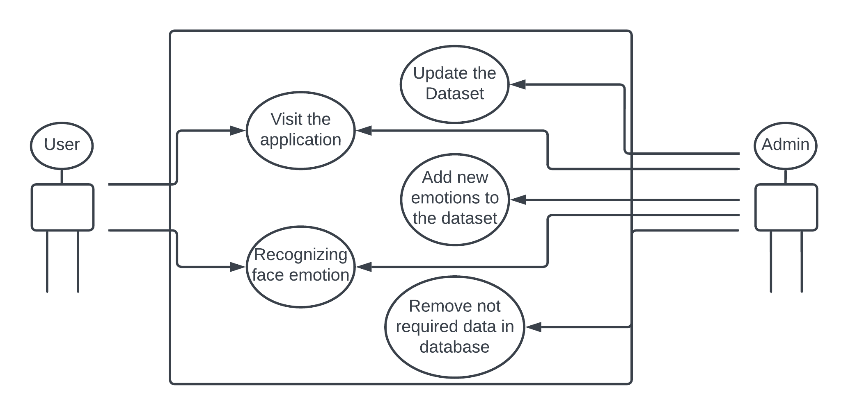

Fig 4: Use Case Model of The Project

### Working Of Model

Fig 5: Working of The Model

## 6.3 Detailed Design

The Project's design and analysis have been divided into two categories: Machine Learning model and GUI. Python serves as the primary language for the development of the Machine Learning model, utilizing a variety of machine learning techniques and algorithms to achieve high accuracy predictions. Various technologies such as Kera's, TensorFlow, OpenCV, and HaarCascade are utilized, with the aid of open source libraries. For the GUI, HTML, CSS, and JS scripting languages are utilized. The Flask library in Python serves as a crucial tool for integrating these two components into a single, cohesive application.

## 6.4 Flowcharts

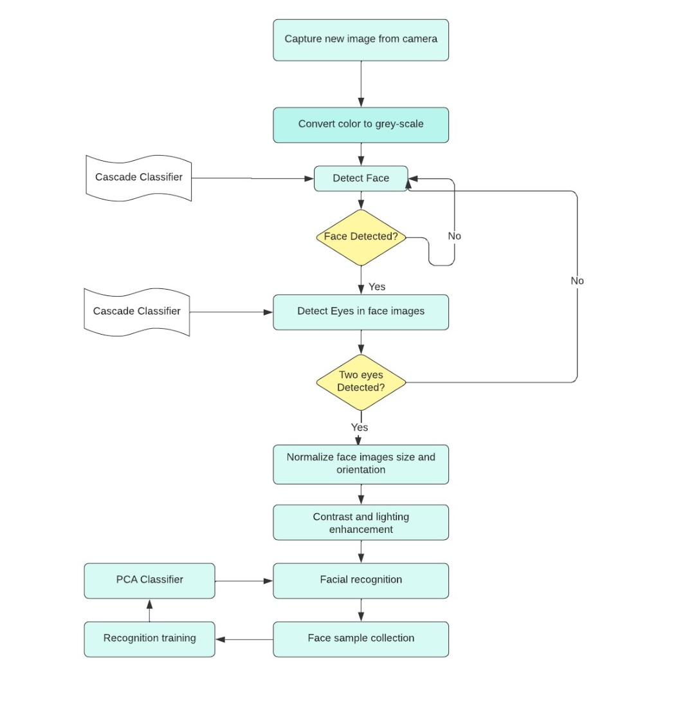

Fig 6: Flow Chart of The Prepared Model

# Chapter 7: Testing

The application has undergone meticulous testing, with a focus on both its functionality and structure. Throughout the development process, all features were regularly checked and tested. After a thorough testing process, the application is now fully prepared for use.

## 7.1 Functional Testing

Functional testing is a kind of black box texting where it does not matter that how you have written the code. The sole of the functional testing is check whether the system is working well or not. To evaluate the system the system is passed through a few designed test cases. If the system passes the test cases and the result conquer the target so system is declared well working.

**Functional Testing involves five steps:**

1. To identify the function of software which it supposed to be.
2. The input is created on the bases of functions specification.
3. To identify the output based on the function’s specification.
4. The execution of the test cases is monitored.
5. A comparison has been made between the output and expected values.

## 7.2 Structural Testing

Structural testing is used to test the structure of the code unlike functional testing where structure does not matter. But in Structural testing everything revolves around the structure of the code. Structural testing is also known as white box testing, clear box testing, glass box testing or transparent testing.

In white-box testing, programming skills and internal structure of the the code are used to design test cases. The tester has to choose inputs to find paths through the code and determine the appropriate outputs.

While White-box testing can be applied at different levels including the unit, integration and system levels of the software testing process but usually done at the unit level. It can test paths within a unit, paths between units during integration, and between subsystems during a system level test. It can help to identify many errors through the code.

Structural testing is used to test the structure of the code unlike functional testing where structure does not matter. But in Structural testing everything revolves around the structure of the code. Structural testing is also known as white box testing, clear box testing, glass box testing or transparent testing. In white-box testing, programming skills and internal structure of the the code are used to design test cases. The tester has to choose inputs to find paths through the code and determine the appropriate outputs.

While White-box testing can be applied at different levels including the unit, integration and system levels of the software testing process but usually done at the unit level. It can test paths within a unit, paths between units during integration, and between subsystems during a system level test. It can help to identify many errors through the code.

## 7.3 Levels of Testing

There are four levels of testing which are unit testing, integration testing, system testing and acceptance testing.

* + - Unit testing verifies weather each component of the software working well as individual or not
    - Integration testing ensures weather all the units after combining working well or not to hit the target.
    - It is the next level of testing where the software is tested as whole whether it works well or not.
    - The final is the acceptance testing where green signal is given to launch the product is it passes all the criteria.

Fig 7: Diagram of Level Testing

## 7.4 Testing of Project

After the project work is completed, we tested it whether it works well it not. The results show the success has been marked across different test cases.

# Chapter 8: Implementation

## 8.1 Implementation of the Project

To implement the project, we used the various open source library in python. This library includes NumPy, TensorFlow, pandas, OpenCV, Kera’s etc. These libraries help to make the project very easily. There is one important library we have used in this project which is Flask. This library helps us to connect the machine learning(ML) model with GUI developed using Scripting Language (HTML, CSS, JS)[14].

## 8.2 Post Implementation and Software Maintenance

The main focus after developing the software the main focus was to improve the quality of the software. We make sure that application can be accessed on low internet connection. Lot of time we have seen people find it difficult to handle the interface. To Conquer the problem, we have made the interface so easy that anyone can handle. We want to extend the functionality of the project with time so we need constant feedback from user that how we can improve the functionality which will be implemented in the future. The next thing we did is to make sure whether our application is easily accessible at all the location and devices[14]. The system can extend the functionality at ant point of time without actually change the other functionality. The system is designed to help anyone from different arrears or fields. The system is easily extendable and easy to deploy.

# Chapter 9: Project Legacy

## 9.1 Current Status of The Project

This project work has been done on small scale and it is running on the local host. But it can be easily extendable for the future use. Once after done with the testing we discovered lots of errors which has been removed and the project is now in most optimization state and working properly.

## 9.2 Remaining areas of Concern

Some remaining areas of concern for the project include some issues which we are currently working on fixing:

* We want to train the model on more types of emotions.
* Currently the model is trained on a few epochs which we increase futher in the future.
* Extend the resources of the system.
* Implement a feedback system on the website.

## 9.3 Technical and Managerial Lessons Learnt

Technically we came to know about so many libraries which we used to make the project including NumPy, pandas, TensorFlow etc. We also came to know about how to connect the Machine Learning model with User interface. In managerial lesson, we learnt about how to manage the large project by dividing them into small modules and about time management, how much time we should assign to the modules according to their priority.

# Chapter 10: User Manual

User manual or the Help Guide for the developed software project provides the key steps and measures as well as some tips to the users of the website project who want to manage and control the web application as administrators and maintain its working.

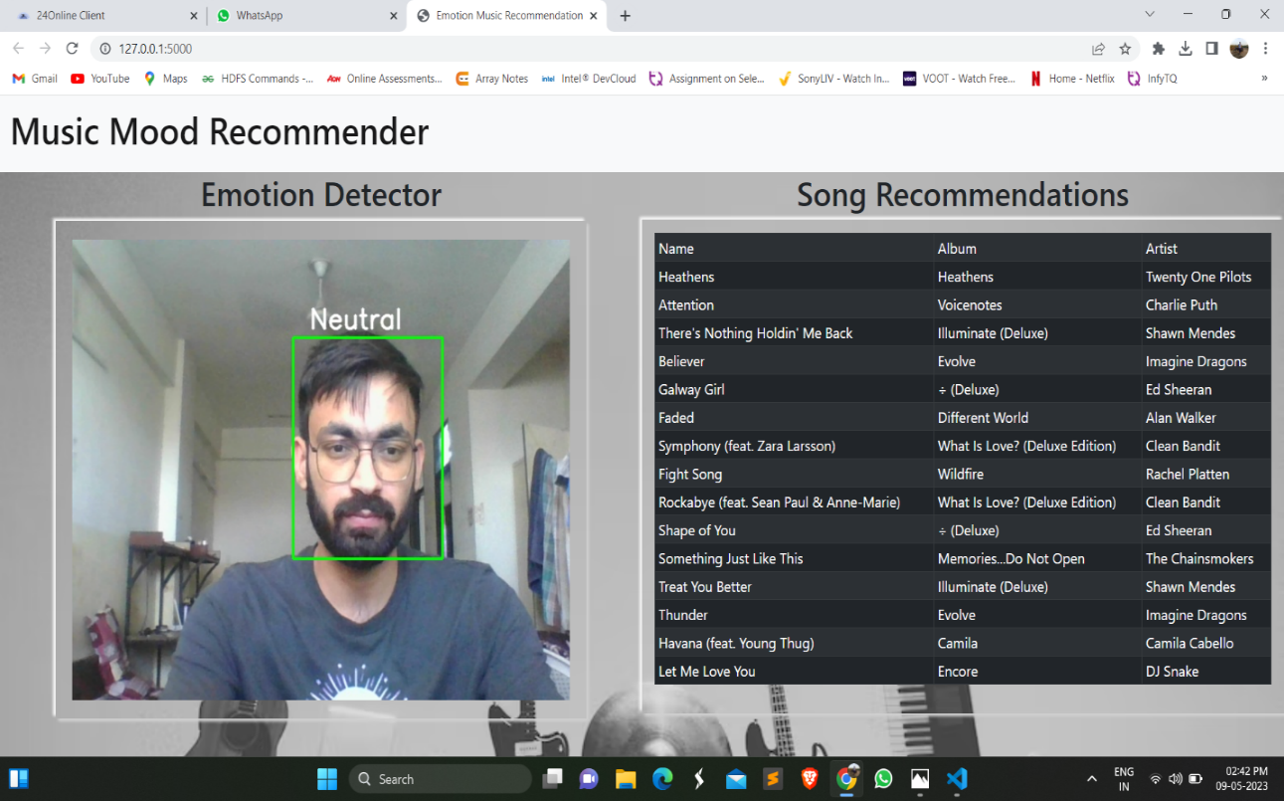

Fig 8: Snapshot of system recognizing human emotion and recommending songs.

Using our application is a very simple task all you need to visit the website and face the camera Once the model decides your facial emotion it shows the songs recommended. You just have to sit in front of the camera and face the camera properly with good lighting. The application will open the camera to scan the emotion, detect it and recommend the song. After processing the results will be displayed to you over the screen as shown above in figure.

# Chapter 11: System Snapshots

## 11.1 Machine Learning Algorithm Snapshots

Fig 9: Source Code Snapshot

Fig 10: Source Code Snapshot

Fig 11: Source Code Snapshot

Fig 12: Source Code Snapshot

Fig 13: Source Code Snapshot

Fig 14: Source Code Snapshot

Fig 15: Source Code Snapshot

Fig 16: Source Code Snapshot

# Chapter 12: References

1. C. Dalvi, M. Rathod, S. Patil, S. Gite and K. Kotecha, "A Survey of AI-Based Facial Emotion Recognition: Features, ML & DL Techniques, Age-Wise Datasets and Future Directions," in IEEE Access, vol. 9, pp. 165806-165840, 2021, doi: 10.1109/ACCESS.2021.3131733.
2. Gao Z, Zhao W, Liu S, Liu Z, Yang C and Xu Y (2021) Facial Emotion Recognition in Schizophrenia. Front. Psychiatry 12:633717. doi: 10.3389/fpsyt.2021.633717
3. Rathod, M.; Dalvi, C.; Kaur, K.; Patil, S.; Gite, S.; Kamat, P.; Kotecha, K.; Abraham, A.; Gabralla, L.A. Kids’ Emotion Recognition Using Various Deep-Learning Models with Explainable AI. Sensors 2022, 22, 8066. https://doi.org/10.3390/s22208066
4. Liang Yu et al 2019 IOP Conf. Ser.: Mater. Sci. Eng. 490 042022DOI 10.1088/1757-899X/490/4/042022
5. Tarun Kumar Arora, Pavan Kumar Chaubey, Manju Shree Raman, Bhupendra Kumar, Yagnam Nagesh, P. K. Anjani, Hamed M. S. Ahmed, Arshad Hashmi, S. Balamuralitharan, Baru Debtera, "Optimal Facial Feature Based Emotional Recognition Using Deep Learning Algorithm", Computational Intelligence and Neuroscience, vol. 2022, Article ID 8379202, 10 pages, 2022. https://doi.org/10.1155/2022/8379202
6. Nitish Srivastava, Geoffrey Hinton, Alex Krizhevsky, Ilya Sutskever, Ruslan Salakhutdinov; 15(56):1929−1958, 2014.
7. Onkar Dhengale , Dhruv Goel , Vrushabh Bhanjewal , Aditya Lokhande, Gopal Upadhye, 2022, A Comparative Study of CNN Techniques and Datasets Regarding Facial Emotion Recognition, INTERNATIONAL JOURNAL OF ENGINEERING RESEARCH & TECHNOLOGY (IJERT) Volume 11, Issue 11 (November 2022),
8. D. Tyas Purwa Hapsari, C. Gusti Berliana, P. Winda and M. Arief Soeleman, "Face Detection Using Haar Cascade in Difference Illumination," 2018 International Seminar on Application for Technology of Information and Communication, Semarang, Indonesia, 2018, pp. 555-559, doi: 10.1109/ISEMANTIC.2018.8549752.
9. R. Yustiawati et al., "Analyzing Of Different Features Using Haar Cascade Classifier," 2018 International Conference on Electrical Engineering and Computer Science (ICECOS), Pangkal, Indonesia, 2018, pp. 129-134, doi: 10.1109/ICECOS.2018.8605266.
10. Wang C, Xu S, Yang J. Adaboost Algorithm in Artificial Intelligence for Optimizing the IRI Prediction Accuracy of Asphalt Concrete Pavement. Sensors (Basel). 2021 Aug 24;21(17):5682. doi: 10.3390/s21175682. PMID: 34502573; PMCID: PMC8434306.
11. Chollet, F. (2018). Deep Learning with Python. Manning Publications.
12. Goodfellow, I., Bengio, Y., & Courville, A. (2016). Deep Learning. MIT Press.
13. Simonyan, K., & Zisserman, A. (2014). Very Deep Convolutional Networks for Large-Scale Image Recognition. arXiv preprint arXiv:1409.1556.
14. Szegedy, C., Ioffe, S., Vanhoucke, V., & Alemi, A. (2017). Inception-v4, Inception-ResNet and the Impact of Residual Connections on Learning. In Thirty-First AAAI Conference on Artificial Intelligence