# CAPSTONE PROJECT REPORT

(Project Term August-November, 2019)

## Fruit Recognition System

Submitted by

|  |  |
| --- | --- |
| **Rishav Agarwal** | **Registration Number:** 11612425 |
| **Rishbh Lath** | **Registration Number:** 11602540 |

**Project Group Number CSERGC0501**

**Course Code** CSE439

Under the Guidance of

**Komal Arora, Assistant Professor**

**School of Computer Science and Engineering**



**TOPIC APPROVAL PERFORMA**

School of Computer Science and Engineering (SCSE)

**Program :** P132::B.Tech. (Computer Science & Engineering)

**COURSE CODE :** CSE439 **REGULAR/BACKLOG :** Regular **GROUP NUMBER :** CSERGC0501

**Supervisor Name** : Komal Arora **UID :** 17783 **Designation :** Assistant Professor

**Qualification : Research Experience :**

|  |  |  |  |  |  |
| --- | --- | --- | --- | --- | --- |
| **SR.NO.** | **NAME OF STUDENT** | **REGISTRATION NO** | **BATCH** | **SECTION** | **CONTACT NUMBER** |
| 1 | Rishav Agarwal | 11612425 | 2016 | K1621 | 9056481138 |
| 2 | Rishbh Lath | 11602540 | 2016 | K1621 | 7018644521 |

**SPECIALIZATION AREA** : Database Systems **Supervisor Signature: PROPOSED TOPIC** : Fruit Recognition System using Colour Analysis

|  |  |  |
| --- | --- | --- |
| **Qualitative Assessment of Proposed Topic by PAC** | | |
| **Sr.No.** | **Parameter** | **Rating (out of 10)** |
| 1 | Project Novelty: Potential of the project to create new knowledge | 7.00 |
| 2 | Project Feasibility: Project can be timely carried out in-house with low-cost and available resources in | 6.11 |
| the University by the students. |
| 3 | Project Academic Inputs: Project topic is relevant and makes extensive use of academic inputs in UG | 7.22 |
| program and serves as a culminating effort for core study area of the degree program. |
| 4 | Project Supervision: Project supervisor’s is technically competent to guide students, resolve any issues, | 6.44 |
| and impart necessary skills. |
| 5 | Social Applicability: Project work intends to solve a practical problem. | 7.22 |
| 6 | Future Scope: Project has potential to become basis of future research work, publication or patent. | 6.11 |

|  |  |  |
| --- | --- | --- |
| **PAC Committee Members** | | |
| PAC Member (HOD/Chairperson) Name: Kewal Krishan | UID: 11179 | Recommended (Y/N): Yes |
| PAC Member (Allied) Name: Gurpreet Singh | UID: 17671 | Recommended (Y/N): Yes |
| PAC Member 3 Name: Savleen Kaur | UID: 18306 | Recommended (Y/N): Yes |

|  |  |  |  |
| --- | --- | --- | --- |
| **Final Topic Approved by PAC:** | | **Fruit Recognition System using Colour Analysis** | |
| **Overall Remarks:** | Approved |  |  |
| **PAC CHAIRPERSON Name:** | | 11024::Amandeep Nagpal | **Approval Date:** 29 Apr 2019 |
| 11/17/2019 10:20:00 AM | |  |  |

## DECLARATION

We hereby declare that the project work entitled “**Fruit Recognition System**” is an authentic record of our own work carried out as requirements of Capstone Project for the award of B.Tech degree in **Computer Science and Engineering** from Lovely Professional University, Phagwara, under the guidance of **Komal Arora**, during July to November 2019. All the information furnished in this capstone project report is based on our own intensive work and is genuine.

Project Group Number: CSERGC0501

Name of Student 1: Rishav Agarwal Registration Number: 11612425 Name of Student 2: Rishbh Lath Registration Number: 11602540

(Signature of Student 1) Date:

(Signature of Student 2) Date:

## CERTIFICATE

This is to certify that the declaration statement made by this group of students is correct to the best of my knowledge and belief. They have completed this Capstone Project under my guidance and supervision. The present work is the result of their original investigation, effort and study. No part of the work has ever been submitted for any other degree at any University. The Capstone Project is fit for the submission and partial fulfilment of the conditions for the award of B.Tech degree in Computer Science and Engineering from Lovely Professional University, Phagwara.

#### Komal Arora Assistant Professor

**School of Computer Science and Engineering,**

Lovely Professional University, Phagwara, Punjab.

Date:

**ACKNOWLEDGEMENT**

We would like to express our deepest appreciation to all those who provided us the possibility to complete this report. A special gratitude we give to our subject mentor, **Komal Arora**, whose contribution in stimulating suggestions and encouragement, helped us to coordinate our project especially in writing this report and enhancing our idea of project and initiating it.

Furthermore, we would also like to acknowledge with much appreciation the crucial role of our parents, who provided all required and necessary materials and support to complete this project of **“Fruit Recognition System”**. We have to appreciate the guidance given by other supervisor as well as the panels especially in our project presentation that has improved our presentation skills thanks to their comment and advices.

Project Group Number: Name of Student 1: Rishav Agarwal

Registration Number: 11612425 Name of Student 2: Rishbh Lath Registration Number: 11602540

(Signature of Student 1)

Date:

(Signature of Student 2) Date:

## TABLE OF CONTENTS

Inner first page (i)

Declaration… (ii)

Certificate… (iii)

Acknowledgement… (iv)

Table of Contents… (v)

|  |  |  |  |
| --- | --- | --- | --- |
| 1. | Introduction | | 1-3 |
|  | 1.1 Overview | | 1 |
|  | 1.2 | Project Description | 1 |
| 2. | The Problem Statement | | 4-5 |
| 3. | Existing System | | 6-7 |
|  | 3.1. | Introduction | 6 |
|  | 3.2. | Existing Software | 6 |
|  | 3.3. | DFD For Present System | 7 |
| 4. | Problem Analysis | | 8-10 |
|  | 4.1. | Product Definition | 8 |
|  | 4.2. | Feasibility Analysis | 8 |
|  | 4.3. | Project Plan | 10 |
| 5. | Software Requirement Analysis | | 11-13 |
|  | 5.1. | General Description | 11 |
|  | 5.2. | Specific Requirements | 11 |
| 6. | Design | | 14-17 |
|  | 6.1. | System Design | 14 |
|  | 6.2. | Design Notations | 15 |
|  | 6.3. | Detailed Design | 16 |
|  | 6.4. | Flowcharts | 17 |

|  |  |  |  |
| --- | --- | --- | --- |
| 7. | Testing | | 18-20 |
|  | 7.1. | Functional Testing | 18 |
|  | 7.2. | Structural Testing | 18 |
| 8. | Implementation | | 21 |
|  | 8.1. | Implementation Of The Project | 21 |
|  | 8.2. | Post-Implementation And Software Maintenance | 21 |
| 9. | Project Legacy | | 22 |
|  | 9.1. | Current Status Of The Project | 22 |
|  | 9.2. | Remaining Areas Of Concern | 22 |
|  | 9.3. | Technical And Managerial Lessons Learnt | 22 |
| 10. | User Manual: A Complete Document of the Software Developed | | 23 |
| 11. | Source Code and System Snapshots | | 24-32 |
| 12. | Bibliography | | 33 |

# CHAPTER 1 INTRODUCTION

## Overview

A Several fruit recognition techniques has been developed based upon the colour and shape attributes. However, when there are different fruit images, they may have similar or identical colour and shape values. Therefore, the traditional colour features and shape features analysis methods used by Ml model are still not powerful and effective enough to identify and distinguish fruits images. The proposed new Fruit recognition system has been introduced, which combines three features analysis methods: colour, shape

and sized in order to increase accuracy of recognition system. This method can classifies and recognizes the fruit images based on obtained features values by using nearest neighbours classification. In result, system shows the fruit name to the user. The designed fruit recognition system classifies and identifies fruits successfully up to 96% accuracy. This system can also be very useful tool or software in a variety fields such as educational, image retrieval, malls, agriculture and plantation science.

## Project Description

The Fruit Recognition system is an useful and important field of computer science concerned with recognizing patterns and shapes particularly visual and sound patterns. It is a central skill to the optical character recognition, voice recognition, Face recognition and handwriting recognition. It uses methods from statistics, machine learning and other areas of the Deep Learning. The comonly used applications are text classification to categorize the different type of texts for example spam and non- spam E-mails, speech recantation for specified purposes such as translating different languages to English (Hindi to English, Spanish to English), text recognition for postal codes, or the automatic face recognition which deals with digital images as input to the pattern recognition systems in smart devices. In few last years, several types of image

analysis techniques are applied to analyse the agricultural images such as fruits and vegetables, for classification and recognize purposes. The fruits recognition system can be used as image content descriptor which can be able to describe the low level visual features of images or contents of the fruit images for the CBIR system.

The very popular techniques of analyses that have been used for both classifications and recognition of three dimensional fruit images are on the bases of colour and shape analysis methods. However, different fruit images can have the same or identical colour and shape. Thus using colour or shape features analysis methods is not consider robust and effective enough to identify and classify fruits images. Therefore, a recognition approach for three dimensional fruit images is proposed, which combines colour-based, shape- based, and size-based methods to enhance the accuracy of the recognition result. The System recognizes provided the real query of fruit image by extracting features values, colour, shape, size and computing extracted features parameter in order to measure the distance between the computed features values of t image with the stored features parameters of every fruit.

Fruit Recognition System is useful and effective system that has been developed based on various motivations from the real world. Hence, this project can add assistance to research on pattern recognition system, especially on fruits spherical pattern recognition and classification system dealing with various other objects. The designed system of three different features including colour, shape, and size to perform sequential pattern classification. We can easily extend the features of useful tool for other object classification and recognition problems. The software solution can be used in various fields including education, image retrieval, and plant science research. This can be used for educational purpose to enhanced learning for small kids and Down syndrome patients, of fruits pattern recognition and fruits features classification based on the fruit recognition result. This fruit recognition system can be used in grocery store to automate labelling of the price. It can further help the plant scientist to do further analysis on variation in morphology of fruit shape in order to help them understand the genetic or to track

morphology of fruit shape in order to help them understand the genetic or to track the changes occur in fruit over the time.

There are many web applications and personal software are used by the companies which are chargeable. Even many of them are not accurate enough to classify and analyse the images. Our system is easy to access able and extendable for the described usage.

3

# CHAPTER 2 THE PROBLEM STATEMENT

## Problem Description

The main scope of project is to provide the assistance in big firms, malls and store houses where the fruits are stored in a large or small quantity. The system has capability to recognize the fruit image as soon as you place the object. It can be helpful in big firms where the fruits have to be extracted from the variety of fruits in that case it can easily identify the fruit in few fractions of seconds. In malls where the fruits are kept in fridge, this project can help to track the position of the object and inform to the system. Again, this can be the submodule of the application where it can be deployed in mobile application and enable the people to recognize the image using the camera for example it can be used inn kid learning application where children can easily identify the kind of fruit with the assistance of the application. Many times, there are people who visit to non- native places where they don’t know about various fruits in the market only because of not having the correct and precise information. This project is going to help all the aspirants and visitors’ users who want help. The project website will be available with the direct link.

## Solution of The Problem

The project has main objective to recognise and the classify the fruit category with highest accuracy. We have designed the Machine Learning model. The model has been trained with the dataset containing different fruits of various variety, shape and colour. We are trying to predict the fruit with the highest accuracy. To serve the purpose we have designed web application which is very easy to handle. The user can visit the application. There is full description given about the work carried out in this project. The application required access to the web cam so it can capture the images of query fruit. Once the system captures the image. It can easily predict the fruit name. In case the user has any

4

kind of query or feedback he can suggest us through our web application only.

The system can be easily extendable as per the requirement. We can easily extend the features of useful tool for other object classification and recognition problems. The software solution can be used in various fields including education, image retrieval, and plant science research. This can be used for educational purpose to enhanced learning for small kids and Down syndrome patients, of fruits pattern recognition and fruits features classification.

5

# CHAPTER 3 EXISTING SYSTEMS

## Introduction

The concept of Fruit recognition system has taken to provide the assistance where the work is carried out by large work force of human, Now using this system one can easily identify the fruit in few fractions of second. There are many web applications and personal software are used by the companies which are chargeable. Even many of them are not accurate enough to classify and analyse the images. Our system is easy to access able and extendable for the described usage.

.

## What’s the new in the system to be developed?

The previous system had approximately less accuracy as compared to our system where we have tried to boost the accuracy score by combining different features including parameters such as size, colour and shape. This approach has enhanced the accuracy to another extent. The system can be easily extendable as per the requirement. We can easily extend the features of useful tool for other object classification and recognition problems. The software solution can be used in various fields including education, image retrieval, and plant science research.

This can be used for educational purpose to enhanced learning for small kids and Down syndrome patients, of fruits pattern recognition and fruits features classification. Once user click on the camera button the application will access the web cam. Now user can show any kind of fruit in front of camera which will be further processed by the machine learning model. Once the process is completing you can see the result displayed with accuracy on the screen. The user can exit at any time from the application.

6

## DFD for Present System

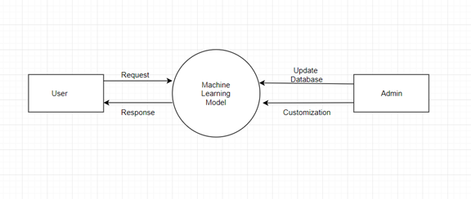

**Figure 1: 0 Level DFD for present system**

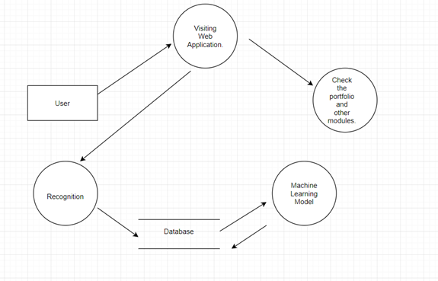

**Figure 2: Level 1 DFD**

7

# CHAPTER 4 PROBLEM ANALYSIS

## Product Definition

Our Product Fruit Recognition System is easy to use, all you need to visit the interface there you need to select the option named as open camera. Once user click on the camera button the application will access the web cam. Now user can show any kind of fruit in front of camera which will be further processed by the machine learning model. Once the process is completing you can see the result displayed with accuracy on the screen. The user can exit at any time from the application.

Features of product includes:

* + - It can recognize the fruit.
    - The interface is user friendly which makes it easy to handle.

## Feasibility Analysis

This system is feasible through all the aspects including technical feasibility, financial feasibility, organizational feasibility etc. This GUI is one of the best interfaces according to user views and expectations. It is cost effective, innovative, accurate, attractive and easy to use as the most challenging factors during the development of a project is its cost effectiveness, look or we can call an overview of the project and very significant is feasibility.

If existing systems and software available in the market, these important factors play a major role in the effectiveness of their products and services provide by the product, so considering all these factors the website product has been launched as solution for the problems being that are faced by the users while accessing the services currently offered by the software present in the market which are mostly paid or difficult to find. This project provides the

8

users with an easy interface to contact us, also having the feature of current my work on the platform, users can easily get to know ours vision.

Once the project is completed, we need to do some operations that need to be done in time to time such as updating our dataset to give accurate results and our model can learn more and more. Train our model on more dataset that will further help our model learn more as a result it will improve the accuracy to recognize the fruit image. These important factors play a major role in the effectiveness of their products and services provide by the product, so considering all these factors the website product has been launched as solution for the problems being that are faced by the users while accessing the services currently offered by the software present in the market which are mostly paid or difficult to find.

*To detect the technical feasibility few steps to be carried out:*

1. Firstly, we need to check weather we have the dataset which we have to use to train the algorithm. It is the most important factor in technical feasibility
2. Once having the dataset, we need to see weather we can trained the algorithm using the available dataset or not.
3. To access the system without the interface is hard to use, so wee need to see weather is it consistent to attached the GUI with the ML model.
4. Wen thee system is running we get so many errors so we make sure to provide them assistance the users into that.
5. We are enabling the system to work on low internet connection as well

## Project Plan

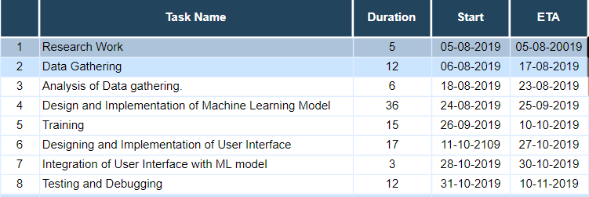

**Figure 3: Gantt chart of Project Plan.**

# CHAPTER 5 SOFTWARE REQUIREMENT ANALYSIS

## Introduction

To complete our project, we have used various open libraries and frameworks. Fruit Recognition System is easy to use, all you need to visit the interface there you need to select the option named as open camera. Once user click on the camera button the application will access the web cam. Now user can show any kind of fruit in front of camera which will be further processed by the machine learning model.

## Specific Requirements

All the Functional and Non-Functional requirements are listed below.

### Functional Requirements

* + - **User Interface:** *A user friendly interface is required so that user can easily handle it and access the application.* The interface should be well designed and contained all the information. The buttons should be at appropriate place. No module should misbehave in terms of technical glitch
    - **Dataset Availability:** The dataset should be available at all the time so that ML model can function properly. This is handled by the team itself. The work of updating should be carried in time by the team. Since we know that more accurate that dataset the more satisfied will be the results, therefore the work should be done extensively. The data should be updated regularly so that ML model can become more and more efficient to predict the effective output with high accuracy. In case if we found any noisy data it should be immediately report to the administrator so the data sat can be analysed and get corrected.
    - **Administrative functions:** The function come under the control of administration/management or the system admin comes under this such as adding of new information, implementing new modules or functions, uploading of new documents, updating the content of website.
    - **Reporting Requirements:** This is the case when use found any inconvenience during the development of the application. On the basis of these reports and feedback, the admin will correct the issue which will add the improved quality of website.
    - **Authorization Levels:** The system should be fully authorized so that no third party can manipulate the system. The information should be relevant and in case of any unwanted situation happened the admin should

### Non-Functional Requirements

* + - **Security:** The data which is provided to user should be secure and it should not tend to look up the user data stored in the system. And it should not cause malwares to the users system. No third party should access the details provided by the users.
    - **Usability:** This system should be interactive and must have interactive user interface (UI) which make it very convenient to use. Every user who have the basic system meets the criteria to access the website should be given privilege to access it.
    - **Performance:** The performance matters a lot weather its offline or online. If your system is running online then make sure the system can be operated on low internet speed. The performance can be accounted in terms of result. The system should tend to show the most accurate result in all the cases.
    - **Supportability:** The websites should be run able through all the systems and multi operating system. Many times, we have seen websites not working across many systems. So, this should be avoiding so that all the users can access the services without any problem. It can help to visit through large and large audience.
    - **Reliability:** System should be reliable to the user. Then it comes to the reliability lots of websites tries to track the activity of user by diving into their personal systems such activities should be denied so that user can access the services without any threat.

# CHAPTER 6

**DESIGN**

## System Design

We have tried to keep the design of the application very simple and easy to understand. The application can be easily run on the Browser. The camera is the main resource require by the web application for the scanning purpose. The adminstartor of the application can easily change the code as per the requirement. He has the privilege to add the new information and to remove the any module or to add new module to the system.

The responsibility of the team has been divided into two members of the team. One makes sure that content displayed on the website is relevant or not while the other works on the feedback received by the other member. More or less the work for the both the members are the same. Both works to develop and enhance the usability of website by adding new modules to the website.

### Customer/User Profiles

The user of our application can be anyone from student to the researcher in the field. The application can be used in the malls where fruits are kept so that it can automatically label the fruit and easily found out the quantity available and inform the administration.

The researchers can use it to find the changes in pattern or shape over the time. This algorithm is even helpful to the student in learning apps where they can easily find out the fruit type using the help of application. It can be fun learning to the students who looks for the digital learning. Digital Learning is the way that another generation will learn. Schools or colleges are using smart devices to teach the students. So, it can be helpful for them.

Again, this can be the submodule of the application where it can be deployed in mobile application and enable the people to recognize the image using the camera for example it can be used inn kid learning application where children can easily identify the kind of fruit with the assistance of the application. Many times, there are people who visit to non- native places where they don’t know about various fruits in the market only because of not having the correct and precise information. This project is going to help all the aspirants and visitors’ users who want help. The project website will be available with the direct link.

## Design Notations

#### Use Case Model

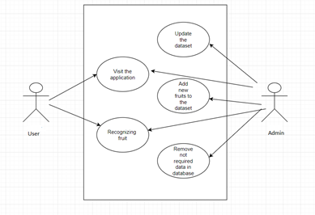

**Figure 4: Use Case Model of the project.**

#### E-R Diagram

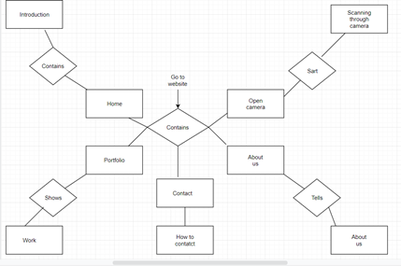

**Figure 5: ER Diagram**

## Detailed Design

Design and analysis of the Project has been designed into two categories. The first part is Machine Learning model and the other is GUI. For the development of Machine Learning model, we have use Python as a primary language. To develop the model, we have use various open source library which help the development to be possible. Another part is GUI to establish that we have use scripting language like HTML, CSS, JS. Apart from that to integrate these two works together we have used EEL library in python which was the most important to integrate the entire application as single unit.

16

## Flowcharts

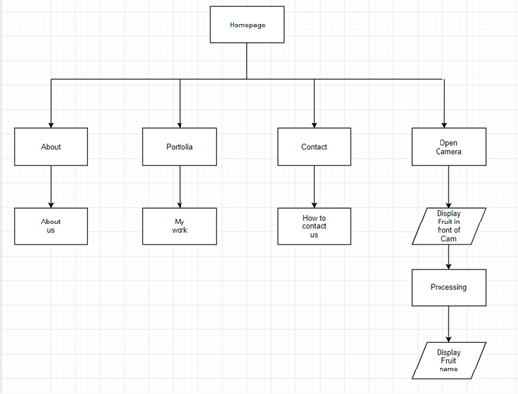

**Figure 6: Flowchart of the System.**

17

# CHAPTER 7 TESTING

We have precisely tested the application by taking the functionality and the application structure in mind. All the features were regularly checked during the development and after the development was over. The application has been tested thoroughly and now ready to use.

## Functional Testing

Functional testing is the kind of black box texting where it does not matter that how you have written the code. The sole of the functional testing is check whether the system is working well or not. To evaluate the system the system is passed through few designed test cases. If the system passes the test cases and the result conquer the target so system is declared well working.

Functional testing involved five steps:

1. To identify the function of software which it supposed to be.
2. The input is created on the bases of functions specification.
3. To identify the output based on the function’s specification.
4. The execution of the test cases is monitored.
5. The comparison is been the output and expected values.

## Structural Testing

Structural testing is used to test the structure of the code unlike functional testing where structure does not matter. But in Structural testing everything revolves around the structure of the code. Structural testing is also known as white box testing, clear box testing, glass box testing or transparent testing.

In white-box testing, programming skills and internal structure of the the code are used to design test cases. The tester has to choose inputs to find paths through the code and determine the appropriate outputs.

While White-box testing can be applied at different levels including the unit, integration and system levels of the software testing process but usually done at the unit level. It can test paths within a unit, paths between units during integration, and between subsystems during a system level test. It can help to identify many errors through the code.

Structural testing is used to test the structure of the code unlike functional testing where structure does not matter. But in Structural testing everything revolves around the structure of the code. Structural testing is also known as white box testing, clear box testing, glass box testing or transparent testing. In white-box testing, programming skills and internal structure of the the code are used to design test cases. The tester has to choose inputs to find paths through the code and determine the appropriate outputs.

While White-box testing can be applied at different levels including the unit, integration and system levels of the software testing process but usually done at the unit level. It can test paths within a unit, paths between units during integration, and between subsystems during a system level test. It can help to identify many errors through the code.

## Levels of Testing

There are four levels of testing which are unit testing, integration testing, system testing and acceptance testing.

* + - Unit testing verifies weather each component of the software working well as individual or not
    - Integration testing ensures weather all the units after combining working well or not to hit the target.
    - It is the next level of testing where the software is tested as whole whether it works well or not.
    - The final is the acceptance testing where green signal is given to launch the product is it passes all the criteria.

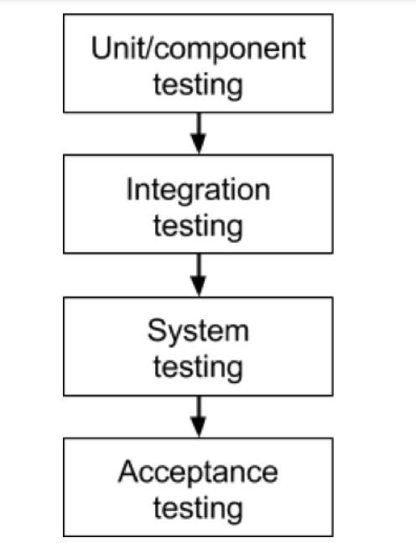

**Figure 7: Diagram of Level of testing**

## Testing of Project

After the project work is completed, we tested it weather it works well it not. The results show the success has been marked across different test cases.

20

# CHAPTER 8 IMPLEMENTATION

## Implementation of the Project

To implement the project, we used the various open source library in python. This library includes NumPy, TensorFlow, padas etc. These libraries help to make the project very easily. There is one important library we have used in this project which is EEL. This library helps us to connect the Ml model with GUI developed using Scripting Language (HTML, CSS, JS).

## Post-Implementation and Software Maintenance

The main focus after developing the software the main focus was to improve the quality of the software. We make sure that application can be accessed on low internet connection. Lots of time we have seen people find it difficulty to handle the interface. To Conquer the problem, we have made the interface so easy that anyone can handle. We want to extend the functionality of the project with time so we need constant feedback from user that how we can improve the functionality. The next thing we did is to make sure weather our application is easily accessible at all the location and devices. The system can extend the functionality at ant point of time without actually change the other functionality. The system is designed to help anyone from different arrears or fields. The system is easily extendable and easy to deployed.

21

# CHAPTER 9 PROJECT LEGACY

## Current Status of the Project

This project work has been done on small scale and it is running on the local host. But it can be easily extendable for the future use. Once after done with the testing we discovered lots of errors which has been removed and the project is now in most optimization state and working properly.

## Remaining Areas of Concern

Some Remaining areas of concerns about the project include issues:

* + - We want to train the model for other objects.
    - Currently our model is trained over few epochs which we can increases further.
    - Extend the resource of the system.

## Technical and Managerial Lessons Learnt

Technically we came to know about so many libraries which we used to make the project including NumPy, pandas, TensorFlow etc. We also come to know about how to connect the Machine Learning model with User interface. In managerial lesson, we learnt about how to manage the large project by dividing them into small modules and about time management, how much time we should assign to the modules according to their priority.

# CHAPTER 10 USER MANUAL

User manual or the Help Guide for the developed software project provides the key steps and measures as well as some tips to the users of the website project who want to manage and control the web application as administrators and maintain its working.

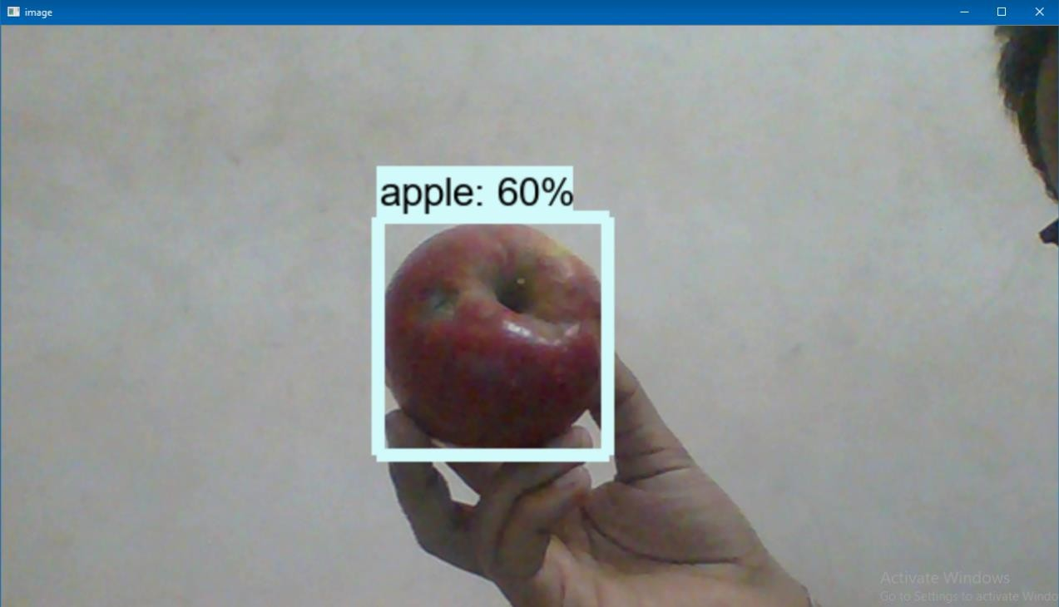

**Figure 7: Snapshot of system recognized fruit as apple.**

Using out application is very simple task all you need to visit the website. Ton the Homepage you can checkout the various modules portfolio, My work etc. Once you decide that you want to recognize the fruit. You just have to click on the open camera button over the screen. The application will open the camera to scan the fruit. After processing the results will be displayed to you over the screen

# CHAPTER 11 SYSTEM SNAPSHOTS

### Machine Learning Algorithm Source Code

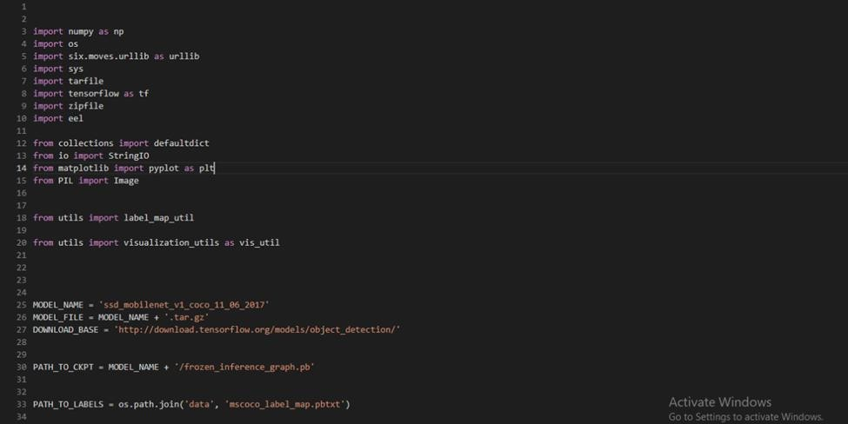

**Figure 8: Source code snapshot**

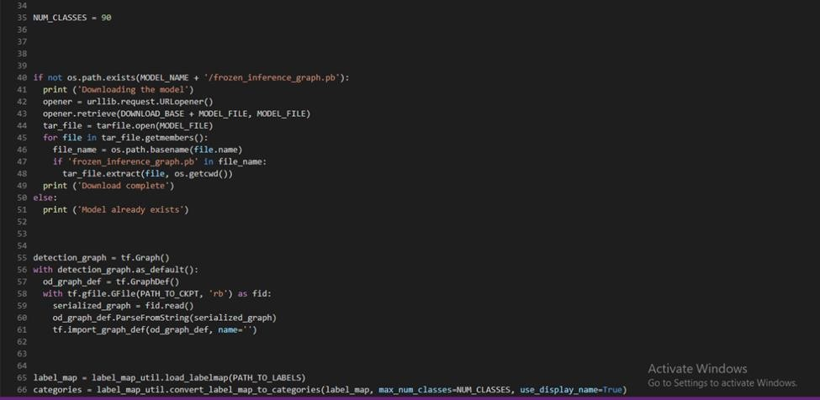

**Figure 9: Source code snapshot**

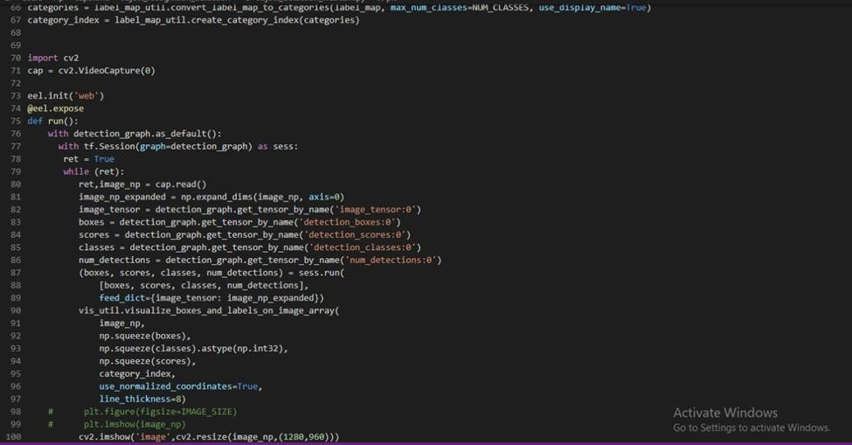

**Figure 10: Source code snapshot**

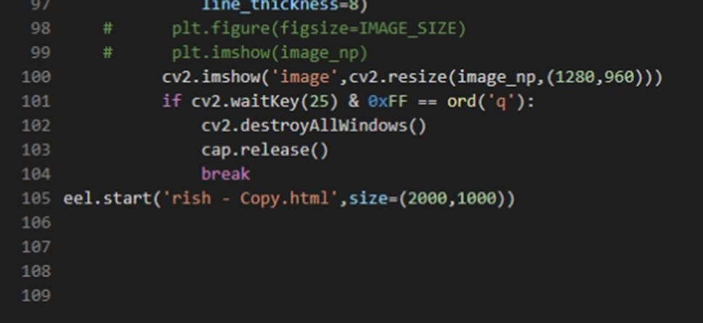

**Figure 11: Source code snapshot**

**25**

### GUI Source Code

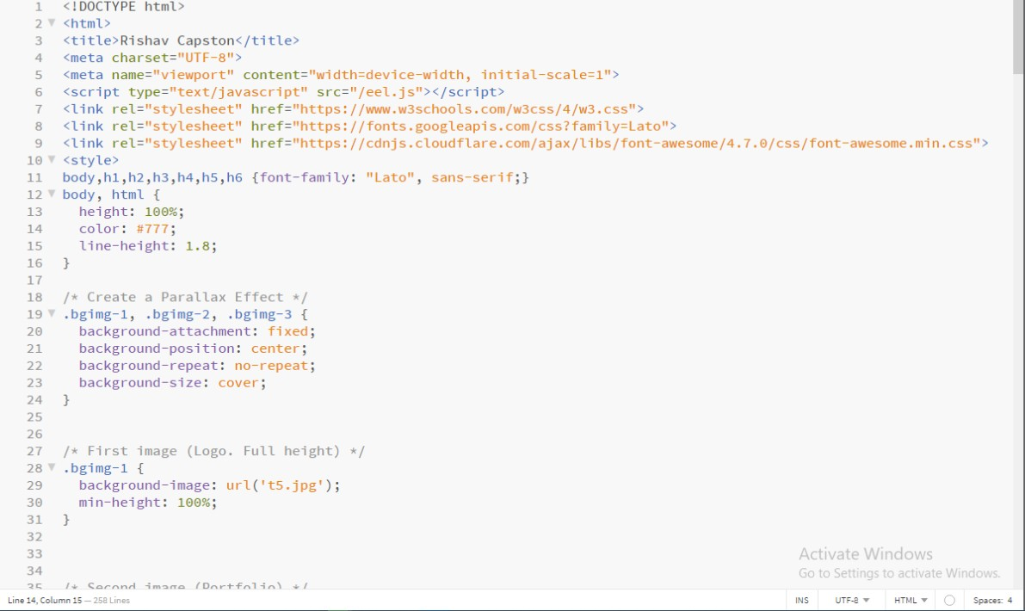

**Figure 12: Source code snapshot**

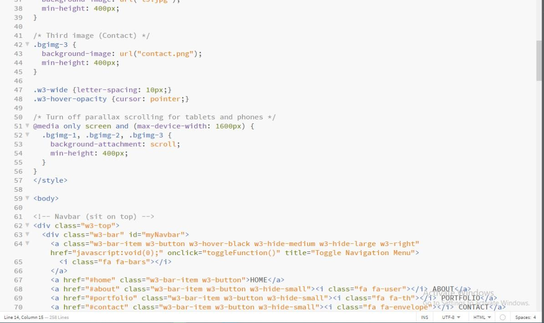

**Figure 13: Source code snapshot**

26

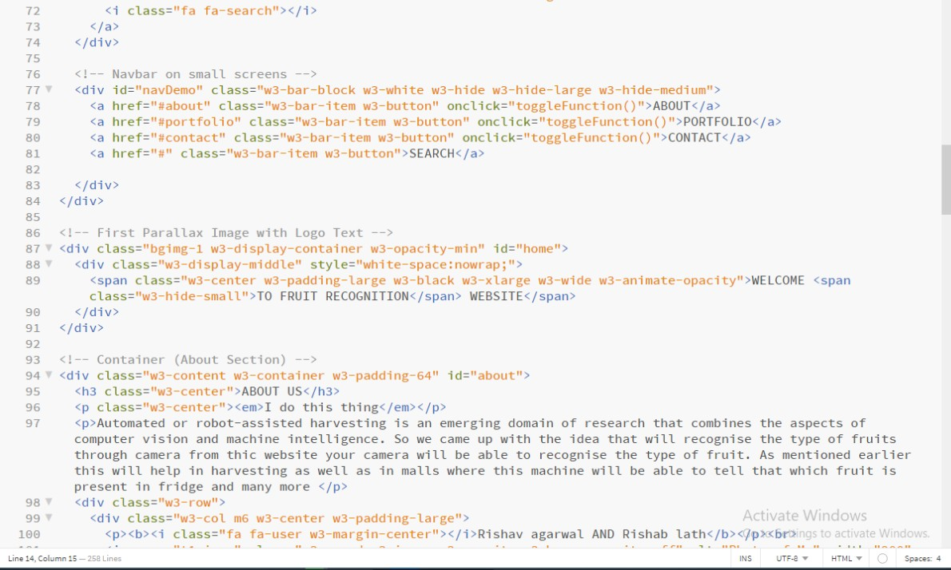

**Figure 14: Source code snapshot**

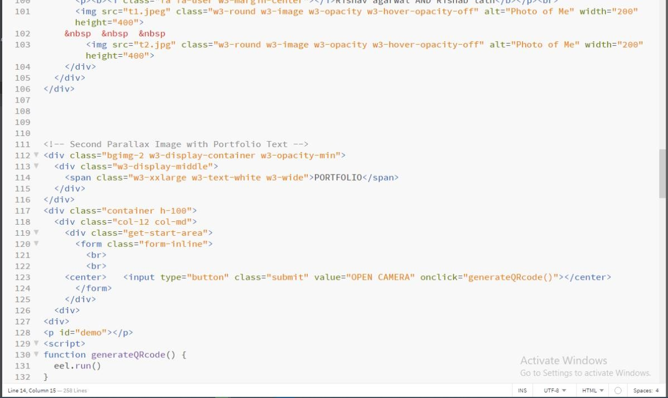

**Figure 15: Source code snapshot**

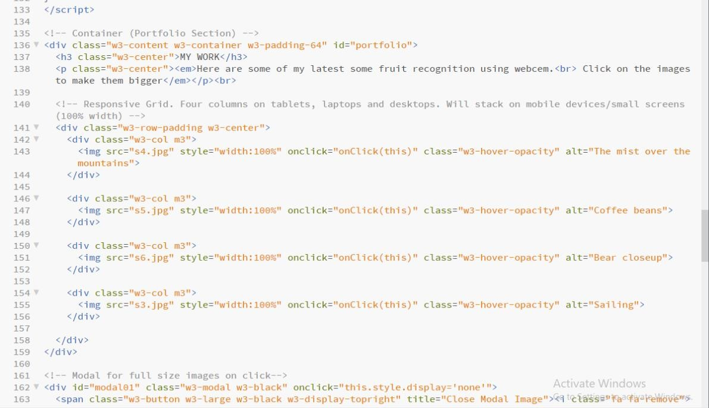

**Figure 16: Source code snapshot**

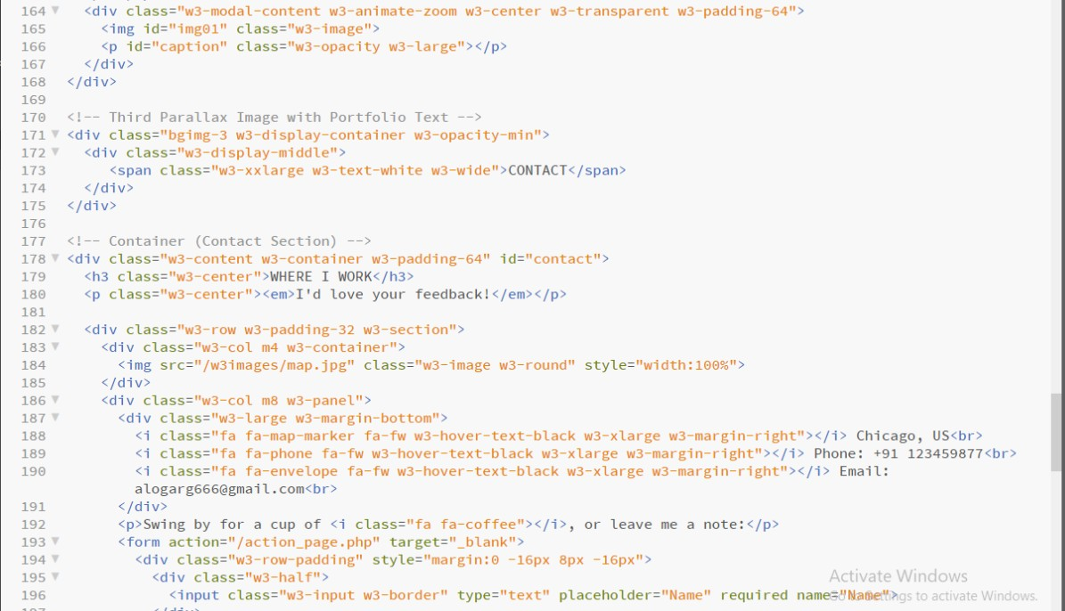

**Figure 17: Source code snapshot**

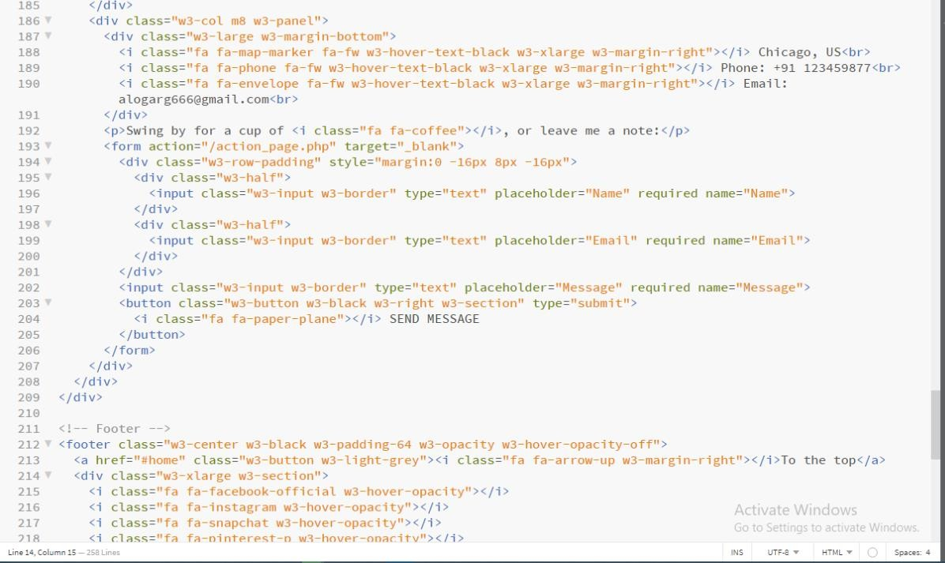

**Figure 18: Source code snapshot**

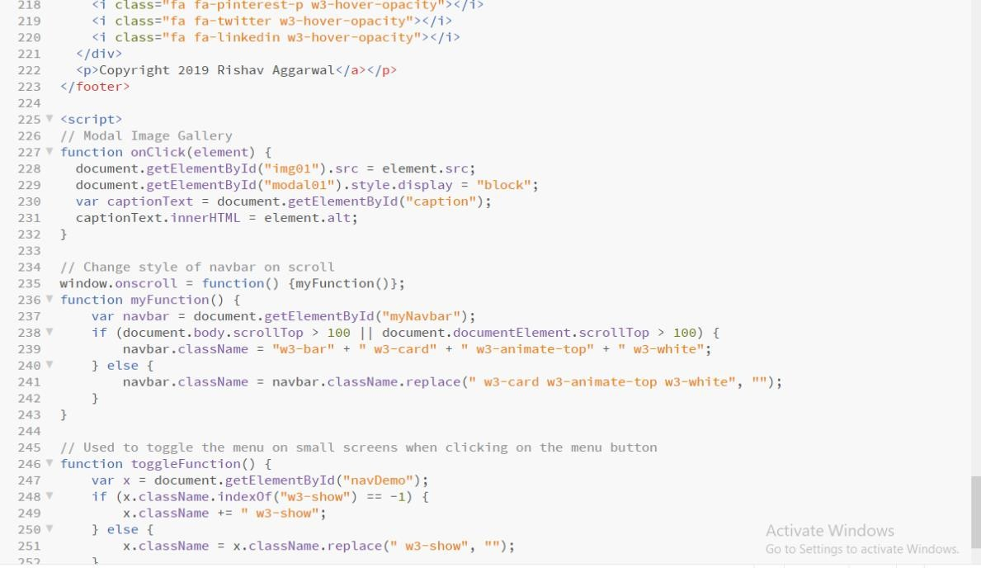

**Figure 19: Source code snapshot**

### GUI Snapshots

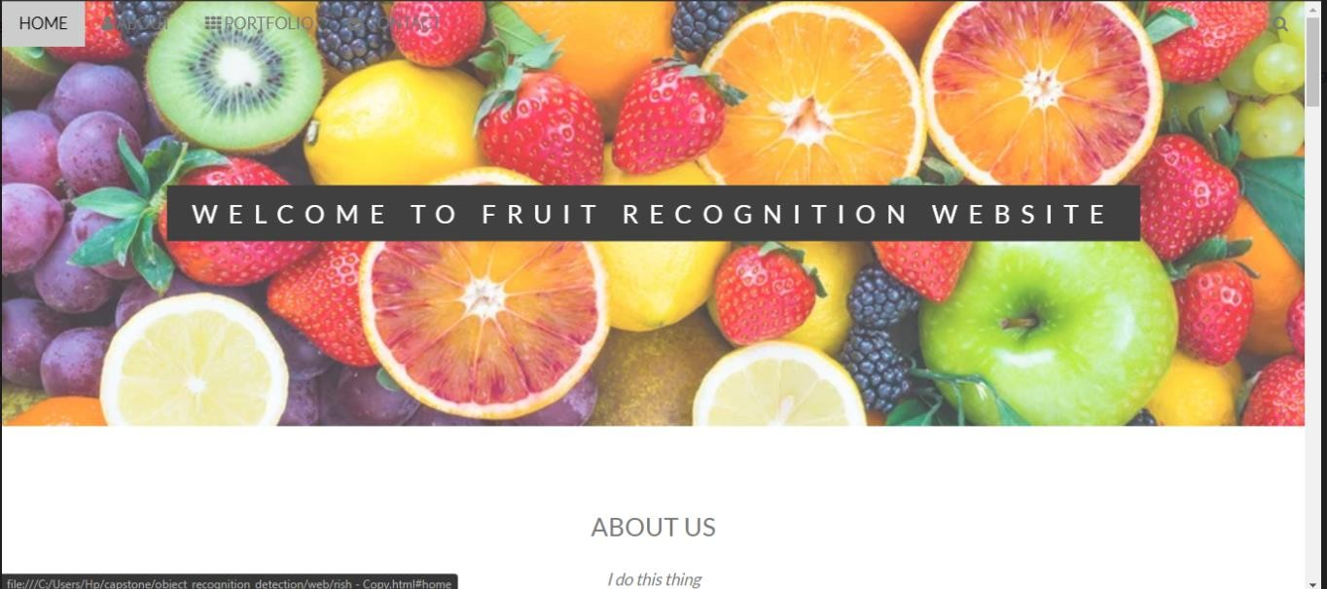

**Figure 20: GUI snapshot**

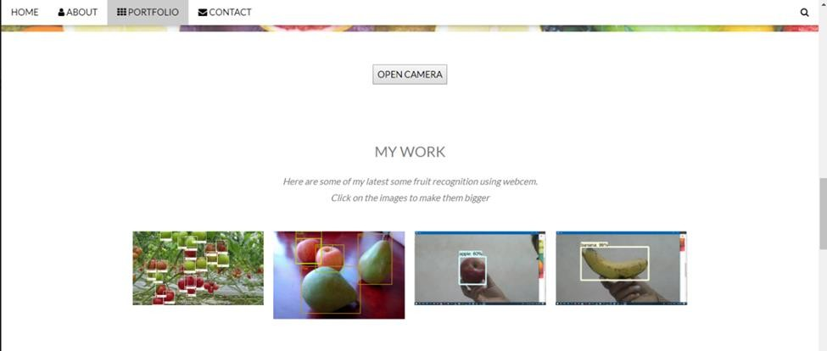

**Figure 21: GUI snapshot**

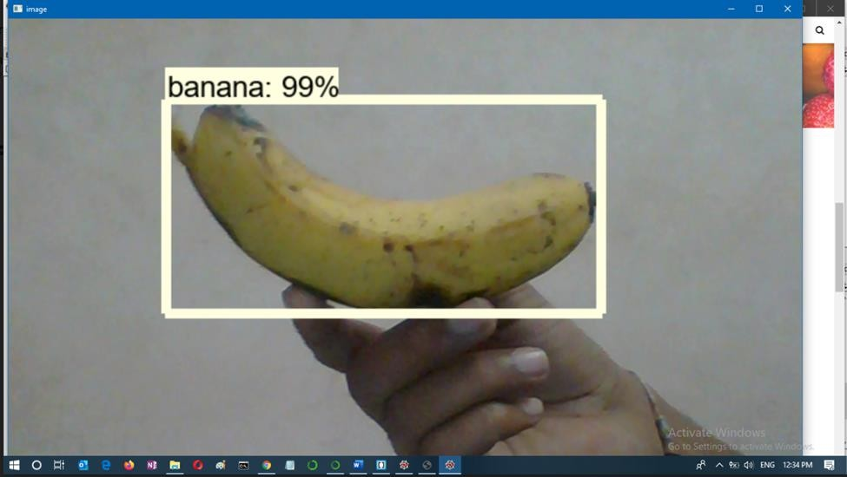

**Figure 22: GUI snapshot**

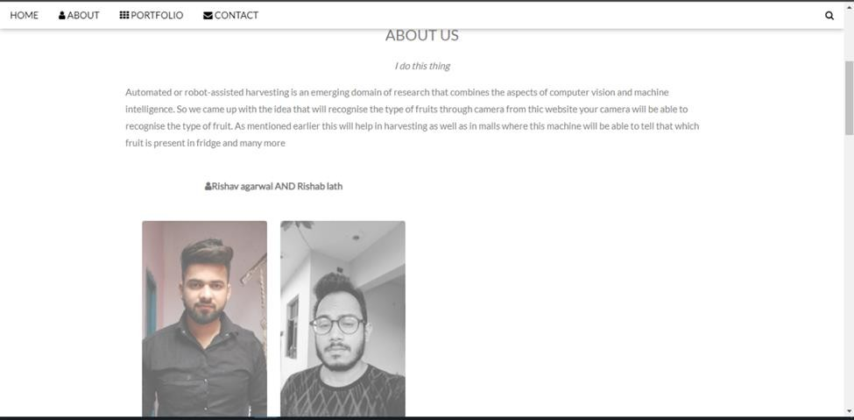

**Figure 23: GUI snapshot**

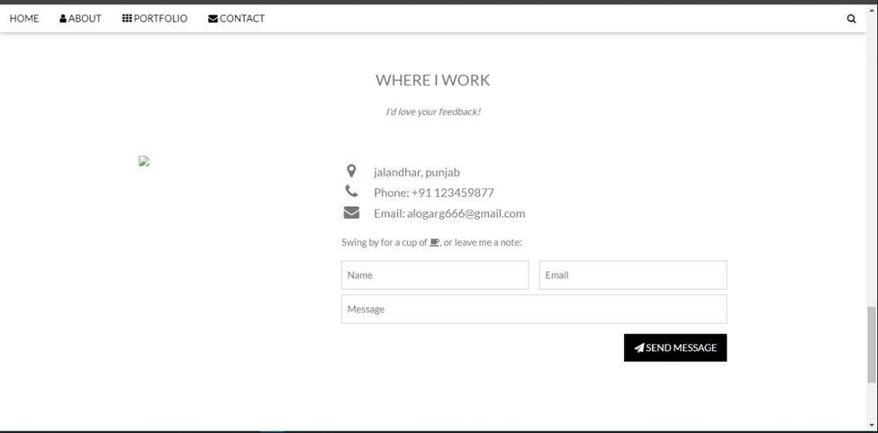

**Figure 24: GUI snapshot**

# CHAPTER 12 BIBLIOGRAPHY

1. <https://www.draw.io/>
2. <https://www.tensorflow.org/api_docs/python/tf>
3. <https://pandas.pydata.org/>
4. <https://www.geeksforgeeks.org/numpy-in-python-set-1-introduction/>
5. <https://pythonprogramming.net/image-recognition-python/>
6. [https://www.visual-paradigm.com/guide/data-flow-diagram/what-is-data-flow-](https://www.visual-paradigm.com/guide/data-flow-diagram/what-is-data-flow-diagram/) [diagram/](https://www.visual-paradigm.com/guide/data-flow-diagram/what-is-data-flow-diagram/)
7. <https://nitratine.net/blog/post/python-gui-using-chrome/>
8. <https://www.w3schools.com/html/>
9. <https://arxiv.org/abs/1712.00580>

33