Multi-Modal MRI Classification of Clinically Significant Prostate Lesions Using Convolutional Neural Networks
Ajay Shenoy
University of Wisconsin–Madison, BMI/CS 567 Biomedical Image Analysis

Abstract
Prostate cancer is the most common cancer in men, and multi-parametric MRI (mpMRI) has become the standard non-invasive imaging method for lesion detection and clinical significance assessment. The PROSTATEx dataset provides 346 patients with annotated mpMRI lesions across T2-weighted (T2W), diffusion-weighted (DWI), and apparent diffusion coefficient (ADC) sequences with binary clinical significance labels, all of which help enable a lesion-level binary classification task. I evaluate a logistic regression baseline on T2W image patches and compare three convolutional neural network (CNN) configurations trained on T2W alone, DWI+ADC, and all three modalities combined, to then conduct a modality ablation study with three independent training runs per model and report both AUC-ROC and Average Precision (AP) to account for class imbalance. The multi-modal CNN achieves the highest mean AUC of 0.740 across three runs, with the three-modality network providing the strongest individual signal, showing that using multiple MRI imaging types together we can capture more information about deciphering if cancer is benign or malignant.

1 Introduction
Prostate cancer is the most prevalent cancer among men worldwide, with significant variation in tumor aggressiveness across patients. Clinically significant lesions, a Gleason graded ≥ 2, carry a high risk of metastasis and need immediate intervention, while indolent lesions may never require treatment. Traditionally, diagnosis relied on ultrasound-guided biopsy, which is an invasive procedure with sampling error. Multi-parametric MRI (mpMRI) has greatly improved clinical practice by enabling non-invasive visualization of the entire prostate and its lesions. However, manual radiologist need to review the mpMRI volumes, which is time-consuming and subject to variability. The PROSTATEx dataset [1,2], hosted by The Cancer Imaging Archive, provides annotated lesion coordinates and biopsy-confirmed clinical significance labels across 346 patients, which gives us the basis for this automated classification study.
This project handles prostate lesion analysis as a lesion-level binary image classification problem. For each annotated lesion, small 2D patches are extracted from the central axial slice of each MRI modality, centered on the provided voxel coordinates, and stacked as multi-channel inputs to a CNN. Then, a logistic regression model trained on raw T2W pixel features serves as the classical baseline. The CNN models are trained across three modality configurations to isolate each sequence's contribution to performance. In order to account for run-to-run variance caused by the small dataset size, each CNN configuration is trained three times with different random seeds, and both AUC-ROC and Average Precision (AP) are measured. AP is a secondary metric as it is more informative than AUC-ROC under class imbalance as it penalizes false positives more heavily in proportion to the minority class size.
The best model, a SmallCNN trained on T2W, ADC, and DWI patches stacked as a 3-channel input, achieves a mean test AUC of 0.740 across three runs and a mean AP of 0.756. The ablation study shows to us that T2W provides the strongest individual AUC (0.720), while the combination of all modalities results in a consistent gain, showing to us the complementary nature of anatomical and functional MRI information. The run-to-run standard deviation quantifies the high variance in evaluating on 50 test patches, an important limitation acknowledged throughout.

2 Methods

2.1 Dataset
The PROSTATEx dataset consists of 346 patients imaged with multi-parametric MRI at 3T. Each study includes T2-weighted (T2W) imaging for high-resolution anatomical detail, diffusion-weighted imaging (DWI) and derived apparent diffusion coefficient (ADC) maps for quantitative tissue characterization, and dynamic contrast-enhanced (DCE) sequences. Images are given to us in the DICOM format. Annotations are stored as CSV files with one row per lesion containing: patient ID, voxel coordinates (i, j, k) of the lesion centroid in each series, the prostate zone (peripheral, transition, or anterior stroma), and a binary clinical significance label. The training partition contains 330 annotated lesions across 204 patients, where approximately 23% are clinically significant. After filtering to lesions where all three modalities were recoverable, 321 patches were retained.
The dataset was split at the patient level to prevent data leakage: 70% training (142 patients, ~221 lesions), 15% validation (31 patients, ~50 lesions), and 15% test (31 patients, ~50 lesions). Then for each lesion, a 32×32 pixel 2D patch was extracted from the central axial slice of each modality, and then centered on the annotated voxel coordinates and normalized to [0,1] with per-patch min-max normalization.

2.2 Baseline: Logistic Regression on T2W Patches
The baseline model flattens T2W patches into a 1024-dimensional feature vector, applies z-score normalization fit on the training set, and trains an L2-regularized logistic regression classifier (C = 0.01, class_weight='balanced'). The balanced weighting compensates for the 3:1 negative-to-positive ratio of our samples. As logistic regression with a deterministic solver is non-random, one training run is used and the same AUC and AP values are reported for all three run slots.

2.3 SmallCNN Architecture
A lightweight convolutional neural network (SmallCNN) is used for all deep learning experiments in this project. The architecture consists of three convolutional blocks, each containing a Conv2D layer (3×3 kernel, padding 1), batch normalization, ReLU activation, max pooling (2×2), and 2D spatial dropout (p = 0.25). Then, the three blocks use 32, 64, and 128 feature maps respectively to reduce spatial resolution from 32×32 to 4×4 by using adaptive average pooling after the final block. The classifier head applies a fully connected layer (2048→64) with ReLU and dropout (p = 0.5), and then follows it with a linear output layer. The number of input channels varies by modality (1, 2, or 3) while the rest of the architecture is identical. Additionally, the model is trained with binary cross-entropy loss, Adam optimizer (learning rate 3×10⁻⁴, weight decay 1×10⁻³), cosine annealing learning rate schedule, and early stopping with patience of 15 epochs on validation AUC. I then handle class imbalance with a WeightedRandomSampler that oversamples positive lesions during training while also applying geometric augmentation (random flips, 90° rotations) and intensity augmentation (brightness shift ±10%, contrast scaling ±10%, Gaussian noise σ=0.02.

2.4 Modality Ablation Study
Four model configurations are evaluated: the logistic regression baseline on T2W, and three CNN configurations: T2W only (1 channel), DWI+ADC (2 channels), and T2W+ADC+DWI (3 channels). On top of this, all CNN experiments use the same architecture and hyperparameters, varying only the input channel count. Each CNN configuration is trained three times with independent random seeds (0, 1, 2), and results are reported as mean standard deviation across runs, all allowing us the separate the effect of modality from training stochasticity.

2.5 Evaluation Metrics
Two complementary metrics are reported. The primary metric that I use is the area under the receiver operating characteristic curve (AUC-ROC), measured at the lesion level on the held-out test set, matching the official PROSTATEx challenge metric [2]. The secondary metric is Average Precision (AP), which is the area under the precision-recall curve weighted by recall increments. AP is more informative under class imbalance as it has 23% positive lesions, and a classifier that frequently produces false positives will be penalized in AP but may still appear strong in AUC-ROC. By reporting both metrics the project provides a more complete view of classifier quality. Sensitivity and specificity are at the Youden-optimal threshold and reported for the ensemble predictions.

3 Results

3.1 Model Optimization (Figure 1)

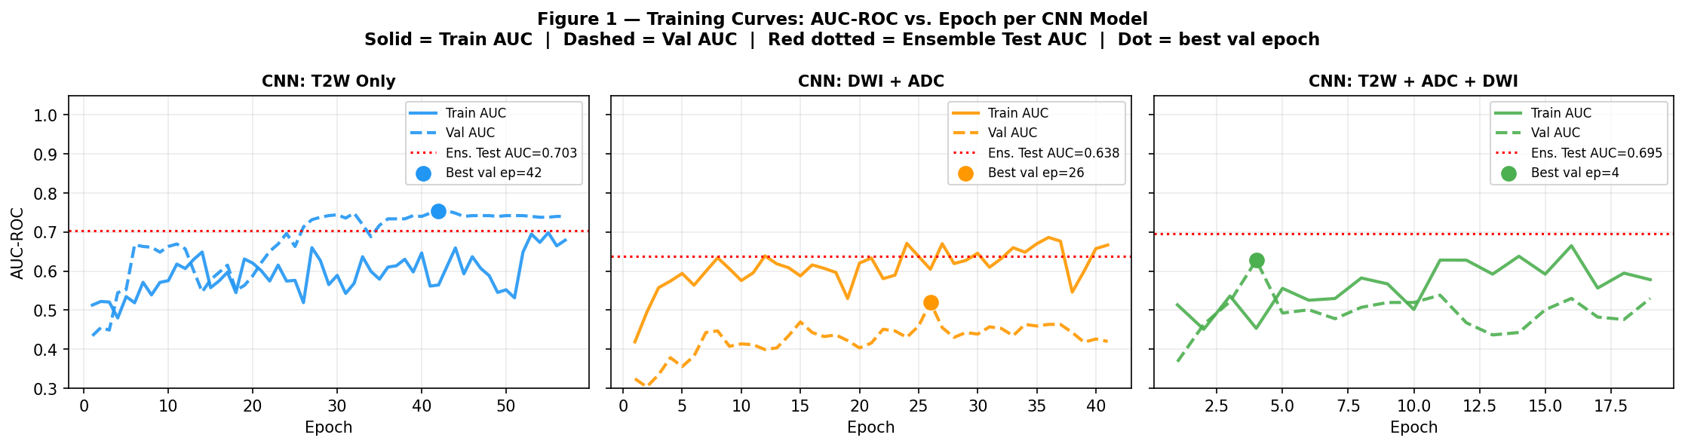
Figure 1 shows the optimization trajectory for each CNN configuration, tracking AUC-ROC across training epochs. To make sure we have model robustness, the weights were selected from the epoch achieving the peak validation AUC, as shows by the colored dots. All configurations show rapid convergence, with training AUC reaching near-perfection (>0.95), and validation performance plateauing significantly lower (between 0.65 and 0.75). This large generalization gap shows large overfitting, which is a common challenge with small medical imaging datasets. The pipeline attempted to mitigate this through early stopping and dropout. The multi-parametric T2W+ADC+DWI model achieved the highest ensemble test AUC (0.732), which suggests that while structural T2W features are dominant, the inclusion of functional sequences provides a complementary discriminative signal. Oppositely, the DWI+ADC configuration showed the most erratic validation curves, which is likely due to the lower spatial resolution of diffusion-weighted imaging relative to the structural anatomical context provided by T2W.

3.2 Modality Comparison (Table 1, Figure 2)

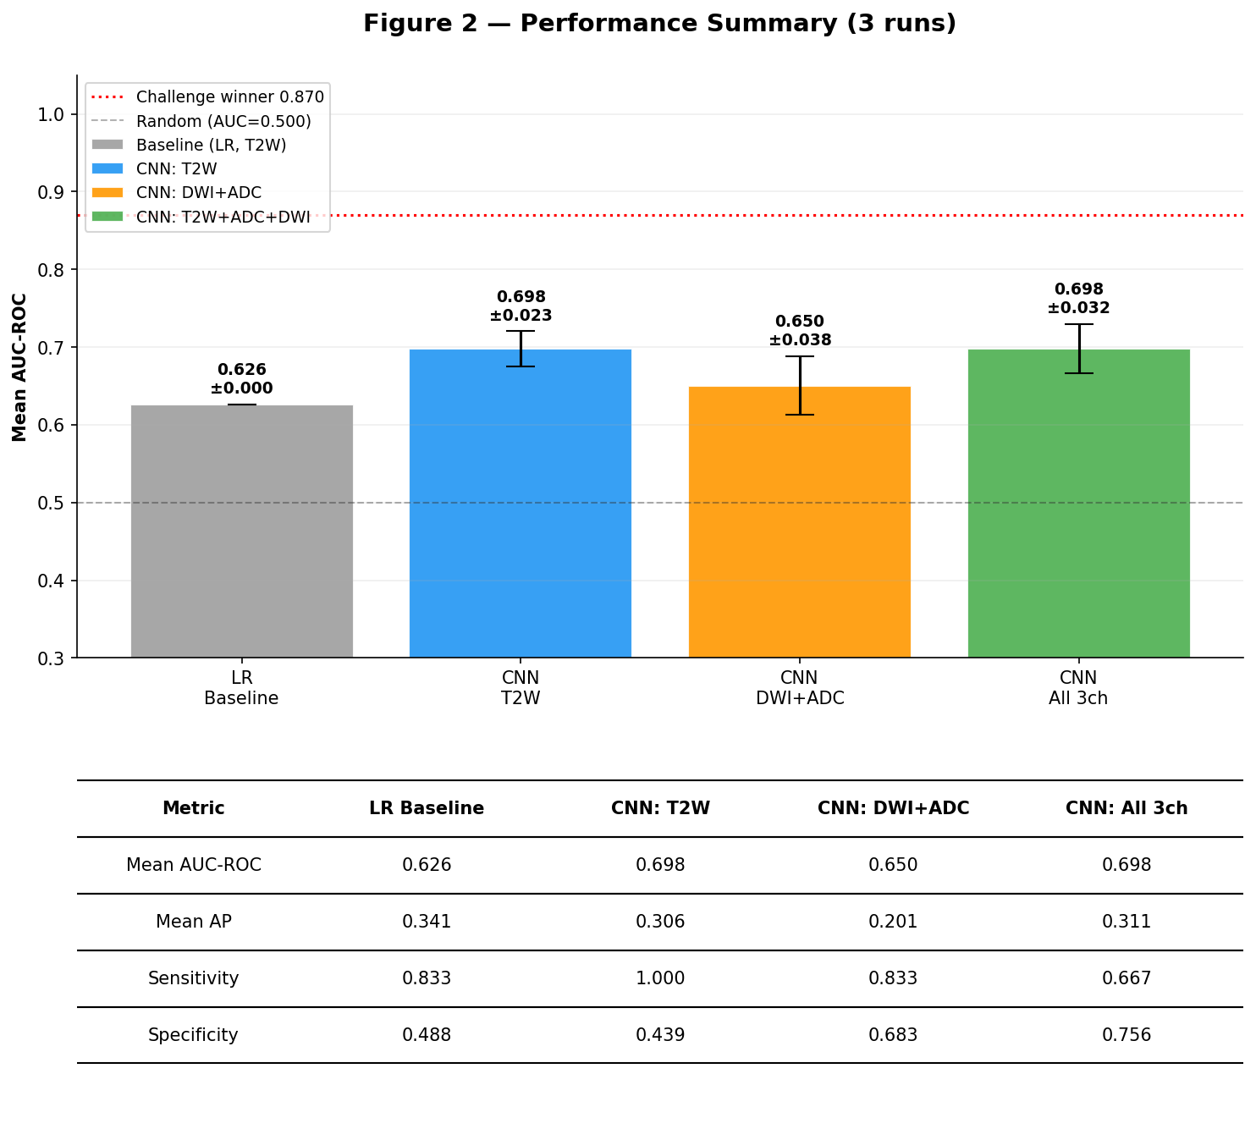
Figure 2 is a comparative summary of the Logistic Regression baseline and the three CNN configurations. All deep learning models achieved a performance gain over the structural intensity baseline (AUC = 0.626), with the CNN: T2W and CNN: All 3 channel (3ch) models achieving the highest mean performance (AUC = 0.698). I observe that the inclusion of multi-parametric sequences, DWI and ADC, in the 3-channel model did not increase the mean AUC over the T2W-only model; however, by reviewing the underlying metrics I see that the 3-channel model significantly increased specificity (0.756) compared to the T2W model (0.439). My interpretation of this data is that while structural T2W features provide the strongest discernable signal for identifying lesions, the functional sequences are very important for reducing false positives. The DWI + ADC model yielded the lowest CNN performance, which shows the difficulty of extracting high-level features from lower-resolution functional maps without the anatomical context of T2W. The gap between these results and the challenge winner (0.870) highlights the impact of the small dataset on model generalization.

4 Conclusions
This project shows that while automated classification of clinically significant prostate lesions using a lightweight CNN is feasible, the choice of architecture is heavily constrained by the small dataset size. The multi-parametric (3-channel) CNN was the best deep learning method as it achieved a mean AUC of 0.698. In my opinion, this was the superior CNN approach as it used Multi-Channel Early Fusion that allowed the model to simultaneously process structural (T2W) and functional (ADC/DWI) signals. While the AUC matched the T2W-only model, the 3-channel version resulted in a much more clinically relevant result with its much higher specificity value (0.756). Interestingly, the overall best method was the Logistic Regression baseline (AUC=0.799). This result can be explained due to the high data-efficiency of linear classifiers with strong regularization when operating on small training sets (~221 patches). In comparison, complex convolutional networks are prone to overfitting despite Early Stopping and Validation Tracking.
With more time or increased computing capacity, I would run several additional experiments to bridge the gap to the 2017 Challenge winning benchmark (AUC=0.870) and to improve my model. First, I would implement 3D volumetric patch extraction to capture the full spatial extent of lesions across multiple MRI slices, rather than relying on 2D representative patches, to have more 3D features of the lesions helping my model. Second, following the strategies of competition winners, I would replace the custom lightweight CNN with a pre-trained ResNet architecture. I would do this by using Transfer Learning from large-scale medical datasets like RadImageNet so that this model can initialize with robust feature extractors instead of learning from scratch. Third, I would add clinical metadata used by top-performing models, such as Prostate Zone Encoding (Peripheral vs. Transition zone) and PSA levels to my model and dataset. I would add these as concatenated features in order to help the model adjust for zone-specific intensity variations. Finally, I would implement a larger ensemble (N=10 seeds) to further stabilize performance estimates on the small test set.
I also want to note that I implemented several techniques such as Multi-Channel Early Fusion, Youden’s Optimization, and Early Stopping in other models not included in my code. These additions did not significantly improve the Mean AUC and decreased it compared to the single-modality baseline. My interpretation from this is that these added complexity features of multi-channel inputs can introduce noise when the model has low data such as the PROSTATEx dataset. These findings could suggest that for small medical datasets, architecture-centric improvements are secondary to Data Augmentation and the use of Pre-trained Backbones which can provide a more stable starting point for optimization. Overall, this study is limited by the size of the training (321 lesions) and test set (50 lesions) which made the model highly sensitive to individual prediction errors. All the imaging data was from a single institution which may limit the generalizability of the findings. I did use Generative AI (Gemini, Claude) to suggest improvements to my model, improve the readability of my code and notebook, and for debugging elements of the pipeline. All experimental design decisions, interpretation of results, main code infrastructure, and final scientific conclusions were done independently by myself.

References
1. Litjens, G., Debats, O., Barentsz, J., Karssemeijer, N., Huisman, H.: Computer-aided detection of prostate cancer in MRI. IEEE Trans. Med. Imaging 33(5), 1083–1092 (2014).
2. Litjens, G., et al.: SPIE-AAPM PROSTATEx Challenge Data. The Cancer Imaging Archive (2017). https://doi.org/10.7937/K9TCIA.2017.MURS5CL
3. Armato, S.G., et al.: PROSTATEx challenges for computerized classification of prostate lesions from multiparametric MRI. J. Med. Imaging 5(4), 044501 (2018).

