1. CREATE DATABASE STUDENT

2.

1. CREATE TABLE StudentBasicInformation (StudentName VARCHAR(50) NOT NULL, StudentSurname VARCHAR(50) NOT NULL, StudentRollNo INT(12) PRIMARY KEY NOT NULL, StudentAddress VARCHAR(255) NOT NULL, StudentPhoneNumber INT(12) NOT NULL, StudentFatherName VARCHAR(50) NOT NULL, StudentMotherName VARCHAR(50) NOT NULL);
2. CREATE TABLE StudentAdmissionPaymentDetails(StudentRollNo INT PRIMARY KEY, AmountPaid INT NOT NULL, AmountBalance INT, FinesINT, MethodOfPayment varchar(100) NOT NULL, Hosteller varchar(3) NOT NULL, LateAdmission varchar(3) NOT NULL);
3. CREATE TABLE StudentSubjectInformation(SubjectOpted varchar(255) NOT NULL, StudentRollNo INT PRIMARY KEY, SubjectTotalMarks INT NOT NULL, SubjectObtainedMarks INT NOT NULL, StudentMarksPercentage FLOAT(5,2) NOT NULL, IsPassed varchar(7) NOT NULL);
4. create table SubjectScholarshipInformation(StudentRollNo INT PRIMARY KEY, ScholarshipName MEDIUMTEXT, ScholarshipDescription Varchar(20), ScholarshipAmount INT, ScholarshipCategory varchar(30), ScholarshipTenure INT, ScholarshipCurrency varchar(15));

3. & 4.

Described the above tables below and assignment part 3 and 4 respectively

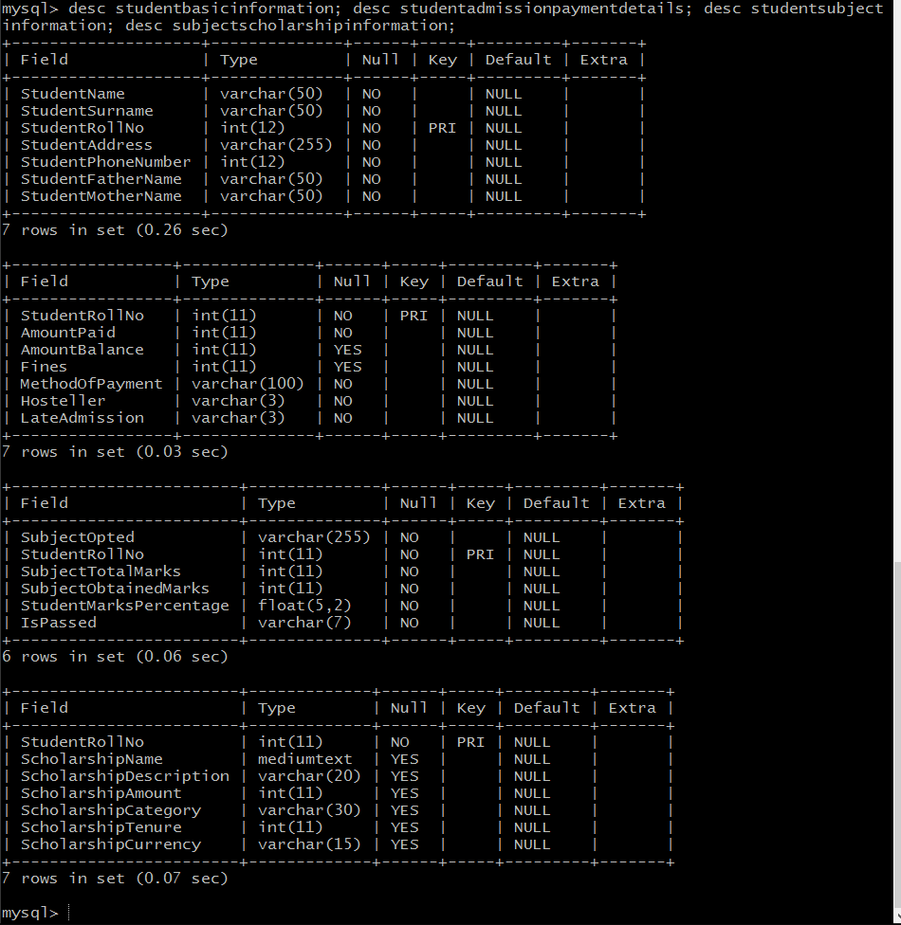

Insert into StudentBasicInformation values ("Ashit","Mundra",2,"11 i-g near pipani Rajasthan", 8005518456,"peter", "Merry"), ("Axar","Patel",3,"1 i-g near test Rajasthan", 80546,"parker", "skarlet"), ("Bhavya","Agrawal",4,"51 g near taka Gujrat", 8054611,"ps", "luci"), ("Bob","Sharma",5,"16 hig near naka Karnataka", 8011546,"depak", "Marry"), ("Carry","Minati",6,"18 lig near toli Maharashtra", 80541096,"dinesh", "Merry"), ("Chaya","Sharma",7,"21 i-g near sonagiti Maharashtra", 86660546,"peter", "mickey"), ("Daisy","Shah",8,"15 migg near pipani UP", 80500046,"deep", "pluto"), ("Dhairya","Verma",9,"91 cig pipani Rajasthan", 81110546,"peter", "Merry");

Insert into studentadmissionpaymentdetails values (1, 15000, 2000, 3, "UPI","Yes","Yes"), (2, 15000, 2000, 3, "UPI","Yes","No"), (3, 18000, 7000, 6, "Draft","Yes","Yes"), (4, 25000, 5000,5, "UPI","No","No"), (5, 17000, 0, 3, "Cheque","Yes","Yes"), (6, 15000, 2000, 3, "Draft","Yes","No"), (7, 35000, 2000, 5, "UPI","No","Yes"), (8, 25000, 3000, 6, "Net","Yes","No"), (9, 15000, 2000, 3, "UPI","No","Yes"), (10, 15000, 2000, 3, "UPI","No","Yes")

Insert into studentsubjectinformation values ("Physics",1, 100, 64, 72, "yes"), ("Maths",2, 100, 78, 72, "yes"), ("Physics",3, 100, 84, 88, "yes"), ("Physics",4, 100, 94, 96, "yes"), ("Maths",5, 100, 64, 72, "yes"), ("Chemistry",6, 100, 94, 91, "yes"), ("Maths",7, 100, 90, 91, "yes"), ("Physics",8, 100, 64, 72, "yes"), ("Physics",9, 100, 64, 72, "yes"), ("Physics",10, 100, 64, 72, "yes");

Insert into SubjectScholarshipInformation values (1, "Merit", NULL, 1000, "Marks", 15000,"Rupee"), (2, "Merit", NULL, 1000, "Marks", 15000,"Rupee"), (3, "Merit", NULL, 2000, "Marks", 15000,"Rupee"), (4, "Football", NULL, 1000, "Sports", 15000,"Rupee"), (5, "Merit", NULL, 1000, "Marks", 15000,"Rupee"), (6, "Merit", NULL, 1000, "Marks", 15000,"Rupee"), (7, "Volleyball", NULL, 1000, "Sports", 15000,"Rupee"), (8, "Volleyball", NULL, 1000, "Sports", 15000,"Rupee"), (9, "Merit", NULL, 1000, "Marks", 15000,"Rupee"), (10, "Cricket", NULL, 1000, "Sports",15000,"Rupee");

select \* from studentbasicinformation;

select \* from studentsubjectinformation;

select \* from subjectscholarshipinformation;

select \* from studentadmissionpaymentdetails;

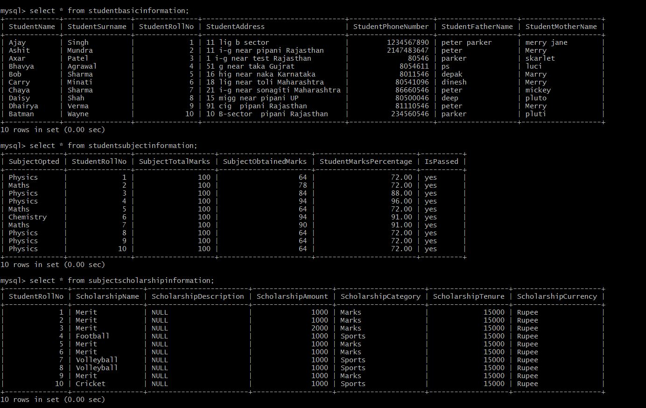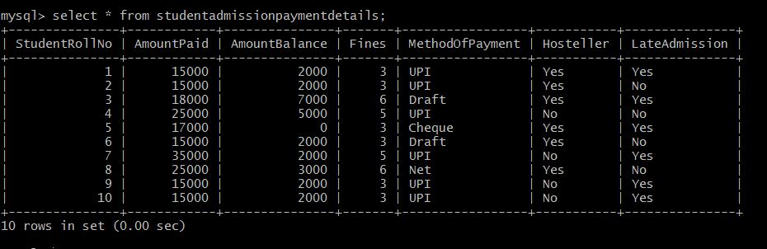

5)

a) update StudentBasicInformation set City="Bombay" where City="Mumbai"; # 2 updations update StudentBasicInformation set StudentName="Kishan" where StudentSurname="Sharma"; # 2 updations update StudentBasicInformation set StudentAddress="Uttar Pradesh" where StudentAddress="UP"; # 2 updations

b) update StudentAdmissionPaymentDetails set AmountBalance=0 where StudentRollNo="1001"; # 2 updations update StudentAdmissionPaymentDetails set Semester=7 where StudentRollNo="1010"; # 1 updations update StudentAdmissionPaymentDetails set AmountBalance=5000 where StudentBank="ICICI"; # 2 updations

c) update StudentSubjectInformation set StudentMarksPercentage=NULL where Division="B-"; # 7 updations

d) update SubjectScholarshipInformation set ScholarshipAmount=0 where ScholarshipName="Volleyball"; # 2 updations

6 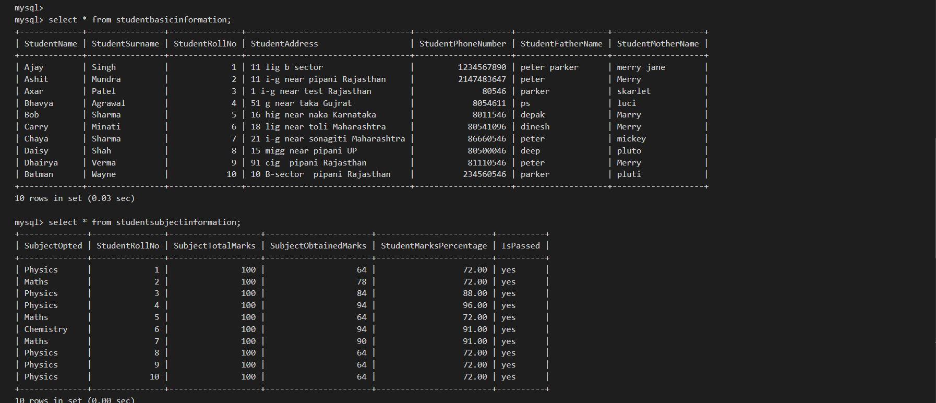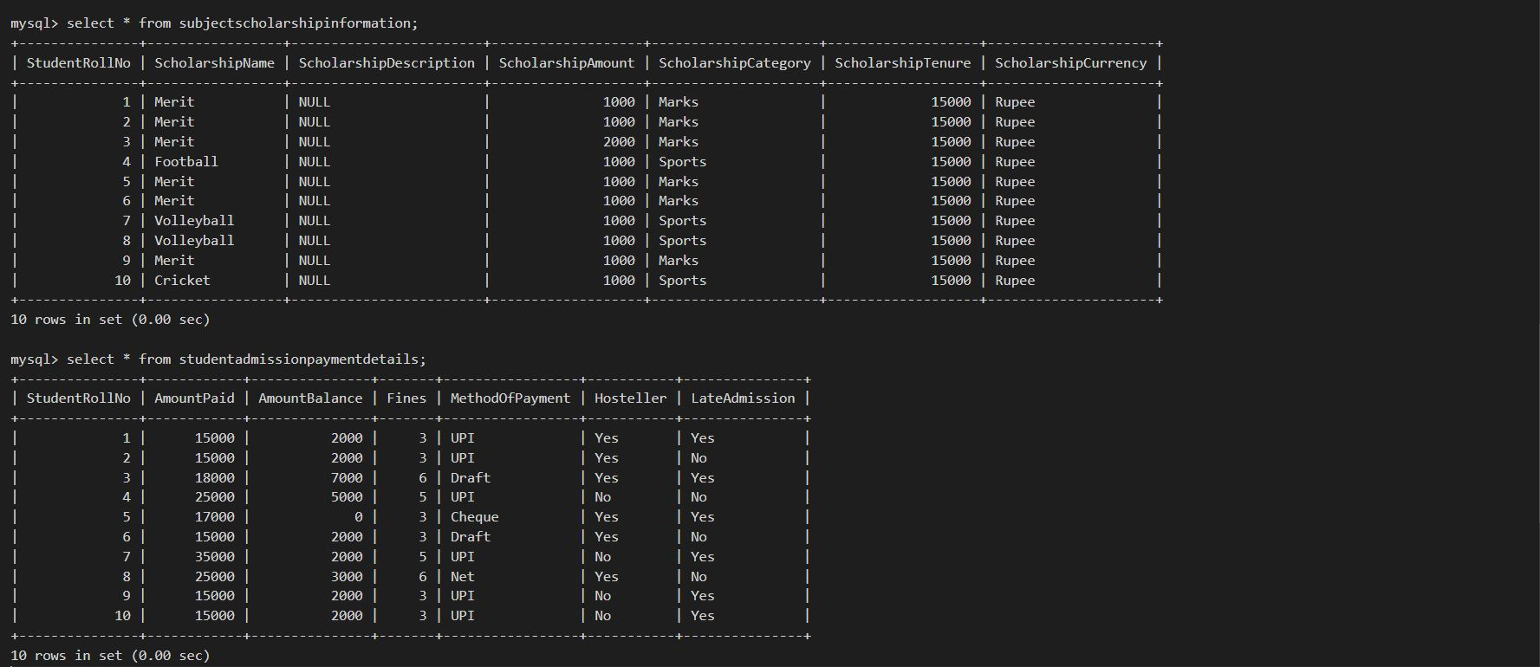

7

select \* from subjectscholarshipinformation where scholarshipamount > 5000;

8

