**PROJECT – DIARY**

**Academic Year 2020-21**





(UNIVERSITY OF MUMBAI)

#### 2020-21

**GROUP DETAILS**

Group No:- 12

Group Members:

1. Abhishek Girkar

2. Mohit Khambayat

3. Ajay Waghmare

#### Project Title: **Subjective Answer Checking System**

Project Type: Inhouse/~~Outhouse~~ Company Name(if outhouse):

Internal Guide Name: Prof. Supriya Choudhary / Co Guide :Ashwini Phalke

External Guide Name(if outhouse):

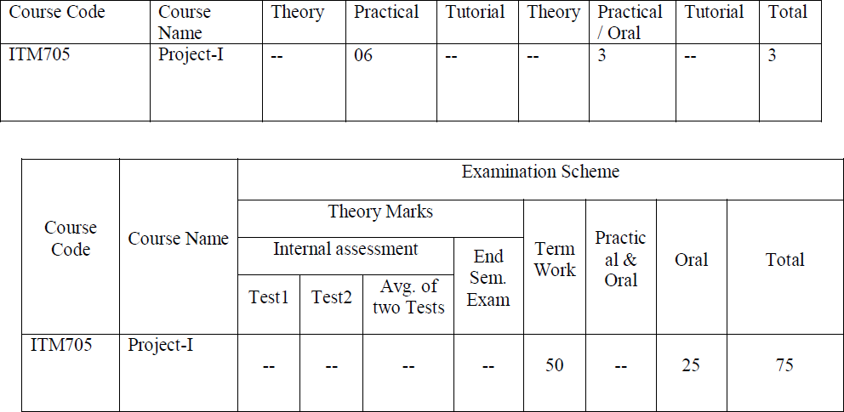

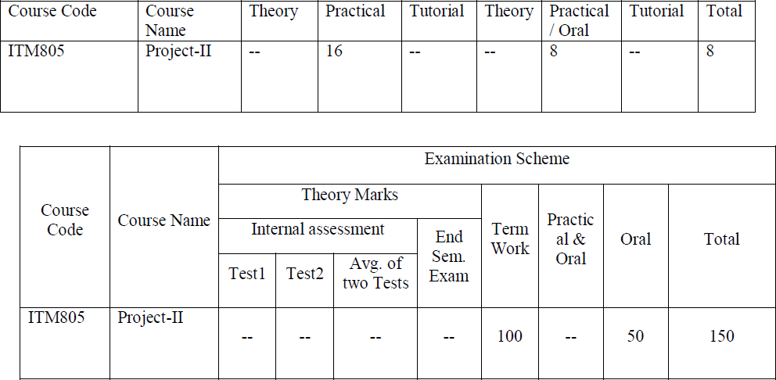

**Lab Objectives:** Students will try:

1. To offer students a glimpse into real world problems and challenges that need IT based solutions
2. To enable students to create very precise specifications of the IT solution to be designed.
3. To introduce students to the vast array of literature available of the various research challenges in the field of IT
4. To create awareness among the students of the characteristics of several domain areas where IT can be effectively used.
5. To enable students to use all concepts of IT in creating a solution for a problem
6. To improve the team building, communication and management skills of the students.

**Lab Outcomes:** Student will be able to:

1. Discover potential research areas in the field of IT
2. Conduct a survey of several available literature in the preferred field of study
3. Compare and contrast the several existing solutions for research challenge
4. Demonstrate an ability to work in teams and manage the conduct of the research study.
5. Formulate and propose a plan for creating a solution for the research plan identified
6. To report and present the findings of the study conducted in the preferred domain

**Guidelines:**

1. The project work is to be conducted by a group of three students
2. Each group will be associated with a project mentor/guide. The group should meet with the project mentor/guide periodically and record of the meetings and work discussed must be documented.
3. Department has to allocate 1 day in VII semester and 2 day in VIII semester every week.
4. Students will do literature survey in Sem VI or Sem VII.
5. Students will do design, implementation and coding in Sem VII.
6. Each group along with its guide/mentor shall identify a potential research area/problem domain, on which the study is to be conducted.
7. Each team will do a rigorous literature survey of the problem domain by reading and understanding at least 3-5 research papers from current good quality national/international journals/conferences. (Papers selected must be indexed by Scopus/IEEE/Springer/ACM etc.). The list of papers surveyed must be clearly documented.
8. The project assessment for term work will be done at least two times at department level by giving presentation to panel members which consist of at least three (3) members as Internal examiners (including the project guide/mentor) appointed by the Head of the department of respective Programme.
9. A report is to be prepared summarizing the findings of the literature survey. A comparative evaluation of the different techniques surveyed is also to be done.
10. Students will do testing and analyze in Sem VIII
11. Teams must analyze all the results obtained by comparing with other standard techniques.
12. Every team must publish their work in national / international conference/journals (if possible publish in Scopus indexed journals).

**Project Work**

**Progress Report**

#### **Meeting Details:**

In the first week of project Academic calendar the project topic selection was done. In this meeting how to select topic as per area of interest was told. So for that importance Of IEEE papers and other research paper, during topic selection was told. Research papers of previous 5 years to find topic. Research papers related to our topic to be search. Referring to literature survey of selected Papers was done.

**Suggestions/changes:-**

**No suggestion**

Project Guide

(Internal)

#### **Meeting Details:**

#### In this meeting presentation was taken on google meet application. Some suggestion after Selection of topic, Topic was selected, as per interest in area like machine learning and Natural Language Processing. We decided to find out the drawback of existing system, studied various Algorithms for the selected topic and build a whole architecture on rough pages then we had given presentation on our topic to college panel for final approval.

**Suggestions/changes:-**

**Finalization of Topic.**

Project Guide

(Internal)

#### **Meeting Details:**

#### In week 7, we prepared an abstract of our chosen topic wherein we have discussed

#### about the project details, requirements, it’s application in future, etc. We gave valid

#### references of the studied IEEE papers. In the meeting, we presented the literature

#### survey, discussed about the hardware and software requirements, put forth the pros and

#### cons of the existing system and demonstrated the features of our proposed system.

#### **Suggestion/Changes:**

#### **Study valid dataset and Algorithms for your project**

#### 

Project Guide

(Internal)

#### **Meeting Details:**

In this week, we designed a UML diagrams like Use case diagram, Sequence Diagram. Use case diagram described how the actors can interact with the system. Data flow diagram gave a brief overview of how the data will flow in the system and what processes it with go through. We explained these diagrams in the meeting conducted by the guide.

**Suggestions/changes:-**

**No suggestion**

Project Guide

(Internal)

#### **Meeting Details:**

#### In 9th week , we studied the xlrd module which can retrieve information from a

#### spreadsheet.There are many methods of comparing string in python like regex,

#### Simple compare. One of method like fuzzywuzzy library where we can have a score

#### out of 100, that denotes two string are equal by giving similarity index.

Suggestions/changes:-

**Start with the implementation**.

Project Guide

(Internal)

#### Meeting Details:

#### In week 11-12, we designed Tkinter application for comparing the input answer with given answer. We provided a text area for the user to provide the original text for which comparison is needed. The user can then provide an input for the number of lines he/she wants.

Suggestions/changes:-

**No suggestion**

Project Guide

(Internal)

#### Meeting Details:

Suggestions was given by external in last semester.

1.work on synonym

2. make your system more presentable

Suggestions/changes:-

Project Guide

(Internal)

#### Meeting Details:

We studied more NLP concepts and create structure of website

started learning django. intially started to make

login module for student where student can register as well as can login

into the system

Suggestions/changes:-

Project Guide

(Internal)

#### Meeting Details:

Review taken by guide where we shown our changes in topic

And started further work on project, after completing login module we

started implement teacher module in our System.

Suggestions/changes:-

Learn form element of Django.

Project Guide

(Internal)

#### Meeting Details:

Continue working on website to make website more attractive and responsive

and also removes some bugs in website.

Suggestions/changes:-

Project Guide

(Internal)

#### Meeting Details:

Discussion of paper publication format and content creation of separate modules

as per requirement.

Suggestions/changes:-

Project Guide

(Internal)

#### Meeting Details:

Front end shown to guide and made changes according to guide suggestion

Draft of technical paper was shown to guide and approval was given for

Our paper to be publish in IRJET conference.

Suggestions/changes:-

Project Guide

(Internal)

#### Meeting Details:

1.Published paper and certificates shown to guide

2. Worked on back end structure

Suggestions/changes:-

Project Guide

(Internal)

#### Meeting Details:

1.Started integrating NLP module with Django website

2.Started to make final report.

Suggestions/changes:-

Project Guide

(Internal)

#### Meeting Details:

Suggestions/changes:-

Project Guide

(Internal)

#### Meeting Details:

Suggestions/changes:-

Project Guide

(Internal)

#### Meeting Details:

Suggestions/changes:-

Project Guide

(Internal)

#### Meeting Details:

Suggestions/changes:-

Project Guide

(Internal)

#### Meeting Details:

Suggestions/changes:-

Project Guide

(Internal)

#### Meeting Details:

Suggestions/changes:-

Project Guide

(Internal)

#### Meeting Details:

Suggestions/changes:-

Project Guide

(Internal)

#### Meeting Details:

Suggestions/changes:-

Project Guide

(Internal)

#### Meeting Details:

Suggestions/changes:-

Project Guide

(Internal)

#### Meeting Details:

Suggestions/changes:-

Project Guide

(Internal)

#### Meeting Details:

Suggestions/changes:-

Project Guide

(Internal)

#### Meeting Details:

Suggestions/changes:-

Project Guide

(Internal)

#### Meeting Details:

Suggestions/changes:-

Project Guide

(Internal)

**Project Evaluation**

Group No:_____ Topic Name:____________________________________________

|  |  |  |  |  |
| --- | --- | --- | --- | --- |
| **Sr No** | **SEM** | **REVIEW NO** | **DATE** | **COMMITTEE MEMBERS** |
| 1 | VII | 1 |  | Guide name:  Internal examiner 1:  Internal examiner 2: |
| 2 | VII | 2 |  | Guide name:  Internal examiner 1:  Internal examiner 2: |
| 3 | VIII | 3 |  | Guide name:  Internal examiner 1:  Internal examiner 2: |
| 4 | VIII | 4 |  | Guide name:  Internal examiner 1:  Internal examiner 2: |

Name of Guide: ___________________________________

Name of Project Coordinator: ________________________

Name of HOD IT: _________________________________