PROJECT REPORT OF CO-OP
Project at Industry (Module-2)
ON
A Comparative Analysis of Remote vs. In-Office Work Models
on Employee Productivity and Well-being
submitted in partial fulfilment of the requirements
for the award of degree of
BACHELOR OF ENGINEERING
In
COMPUTER SCIENCE AND ENGINEERING

Submitted by:  Ajay Kumar (2210991210)  Manav Singh (2210990553)  Ankit Garg (2210991277)  Sahil Bansal (2210992208) | Supervised By:  Dr. Preeti Saini  Designation: Professor  Chitkara University

DEPARTMENT OF COMPUTER SCIENCE AND ENGINEERING
CHITKARA UNIVERSITY INSTITUTE OF ENGINEERING AND TECHNOLOGY
CHITKARA UNIVERSITY, PUNJAB, INDIA

DECLARATION

We hereby certify that the work which is being presented in the project report entitled “A Comparative Analysis of Remote vs. In-Office Work Models on Employee Productivity and Well-being” in partial fulfilment of the requirement for the award of the degree of Bachelor of Engineering (Computer Science and Engineering) submitted in the Department of Computer Science and Engineering at Chitkara University Institute of Engineering and Technology, Chitkara University, Punjab, India, is an authentic record of our own work carried out under the supervision of Dr. Preeti Saini.
The matter presented in this project report has not been submitted in any other university/institute for the award of any degree.

Place: Rajpura  Date: 18 May 2026 | Ajay Kumar (2210991210)  Manav Singh (2210990553)  Ankit Garg (2210991277)  Sahil Bansal (2210992208)

This is to certify that the above statement made by the candidates is correct to the best of my knowledge and belief.

Dr. Preeti Saini
Professor
Department of Computer Science and Engineering
Chitkara University Institute of Engineering and Technology,
Chitkara University, Punjab, India

ACKNOWLEDGEMENT

We would like to express our deepest appreciation to our supervisor, Dr. Preeti Saini, for her invaluable guidance, constant encouragement, and patience throughout this project. Her vast knowledge and thoughtful insights have been instrumental in shaping our research approach and in helping us complete this work successfully.
We extend our sincere gratitude to the Department of Computer Science and Engineering, Chitkara University Institute of Engineering and Technology, for providing us with the academic environment, computational resources, and library access required to carry out this comparative study.
We are also thankful to the faculty members, staff, and our fellow students who participated in our survey and provided candid responses on their experience with remote, in-office, and hybrid working arrangements. Their cooperation made the empirical portion of this research possible.
Finally, we acknowledge with deep gratitude the constant support and encouragement of our families and friends, whose patience and belief in our work have been a source of motivation throughout the duration of this project.

Ajay Kumar, Manav Singh, Ankit Garg, Sahil Bansal

CONTENTS

S.No. | Title | Page No.
 | Declaration | ii
 | Acknowledgement | iii
 | List of Figures and Tables | iv
 | Abstract | v
1 | Introduction | 1
2 | Methodology | 5
3 | Tools and Technologies | 9
4 | Implementation | 11
5 | Major Findings, Outcomes and Results | 15
6 | Conclusion and Future Scope | 20
 | References | 22
 | Appendices | 24

LIST OF FIGURES AND TABLES

List of Figures
Figure No. | Title | Page No.
Figure 4.1 | Workflow of the proposed research method | 12
Figure 5.1 | Productivity and well-being scores by work model | 16
Figure 5.2 | Trend of productivity, well-being and combined score | 17
Figure 5.3 | Survey results — work mode preference (n = 50) | 18
Figure 5.4 | Proposed 3:2 hybrid week schedule | 19

List of Tables
Table No. | Title | Page No.
Table 2.1 | Comparison of existing work on remote, in-office and hybrid models | 7
Table 4.1 | Workflow of the proposed method | 12
Table 4.2 | Experimental parameters of the comparative study | 14
Table 5.1 | Performance comparison of work models | 16
Table 5.2 | Survey results — work mode preference | 18

ABSTRACT

Over the past decade, the global landscape of professional work has been transformed by rapid advances in digital collaboration tools and by an evolving understanding of where and how work can best be performed. The shift from a single, office-centred model towards remote and hybrid arrangements was accelerated sharply by the COVID-19 pandemic, when organisations across industries had to enable home working almost overnight in order to remain operational. Today, with that emergency phase behind us, the question is no longer whether flexible working is possible, but which configuration of remote, in-office and hybrid work produces the best combined outcome for productivity, employee well-being and organisational performance.
This project conducts a comparative analysis of three work models — fully remote, fully in-office, and a structured hybrid arrangement — and quantifies their impact on two key outcomes: employee productivity and workplace well-being. The study uses a mixed-methods design that combines a review of peer-reviewed literature and industry reports published between 2022 and 2025 with a primary survey of fifty respondents drawn from a university student population. Productivity and well-being are scored on a 0–10 scale, and the survey captures stated preference across the three work modes.
The results expose a clear trade-off in the pure models: remote work scores highest on individual productivity (8.5/10) but lowest on well-being (6.0/10), while in-office work supports stronger well-being (7.0/10) at the cost of productivity (6.5/10). The proposed 3:2 hybrid model — three remote days and two in-office days per week — achieves the highest combined performance, with a productivity score of 9.0/10 and a well-being score of 8.5/10. Sixty-eight per cent of surveyed respondents preferred hybrid working over either of the pure modes. The study concludes that a structured hybrid arrangement is the most sustainable long-term strategy for organisations seeking to balance focused output with team cohesion and individual well-being.

Keywords: Remote work, Employee productivity, Workplace well-being, Hybrid work model, Organisational behaviour, Work–life balance.

1. Introduction

1.1 Background
Over the last ten years, the way we work has been altered dramatically by advances in digital communication tools and by a broader cultural shift in how working time, working location and individual autonomy are valued. A significant part of this change is the move away from a single, fixed model in which every employee is expected to be physically present in an office for a set number of hours, towards arrangements that include remote work, in-office work, and various hybrid combinations of the two. The COVID-19 pandemic accelerated this shift sharply, as businesses across sectors were obliged to enable home working at scale in order to remain operational under lockdown conditions.
Remote work allows employees to perform their duties from any suitable location, removing the daily commute and giving them control over how their workspace is organised. For many knowledge workers this freedom translates into a better balance between professional commitments and personal life, and into longer uninterrupted blocks of focused work. However, remote work is not without difficulties: reduced face-to-face contact with colleagues can weaken team cohesion, communication can become more transactional, and the boundary between work and personal time is often harder to maintain.
Traditional in-office work, by contrast, offers structured routines, immediate access to supervisors, and the spontaneous interaction that supports collaboration, mentoring and informal knowledge sharing. Employees in an office environment generally report a stronger sense of belonging and team identity. The cost is that fixed hours, daily commuting, and the background noise of an open-plan office can each reduce focused output and add to overall stress.
This project compares these two working modes — and the hybrid alternative that combines elements of both — and analyses their effects on employee productivity and on workplace well-being. The aim is to determine, on the basis of secondary literature and a primary survey, which configuration offers the best combined outcome for both individual performance and overall employee satisfaction.

1.2 Motivation
The motivation for this study is twofold. First, organisations are still deciding what their post-pandemic working model should look like, and many lack a structured, evidence-based way of choosing between options. Second, individual employees frequently report mixed feelings about flexible work: the same arrangement that improves focus for one person may produce isolation for another. A side-by-side comparison of the three work models, with concrete scoring on productivity and well-being, provides decision-makers with a clearer basis for policy.

1.3 Problem Statement
Although remote, in-office and hybrid working modes are widely discussed in both academic and industry literature, the relevant evidence is fragmented. Some studies focus on productivity in isolation, others on well-being or retention; many concentrate on a single industry or geography. As a result, organisations often do not have a clear, comparative picture of how the three modes perform together on the two outcomes that matter most to them: how much work gets done, and how the people doing it feel about their jobs. This project addresses that gap by directly comparing all three modes on the same scoring scale.

1.4 Objectives
- To compare the impact of remote, in-office and hybrid work models on employee productivity.
- To compare the impact of the same three models on employee well-being and work–life balance.
- To validate the comparative findings using a primary survey of fifty respondents on a 0–10 scale.
- To propose a structured hybrid model that delivers the best combined outcome for both metrics.
- To outline practical recommendations for organisations adopting the proposed model.

1.5 Scope of the Study
The scope of this study is limited to knowledge-work environments where remote, in-office and hybrid arrangements are all technologically feasible. Secondary data is drawn from peer-reviewed papers, industry reports and credible web sources published between 2022 and 2025. The primary survey is restricted to a sample of fifty university-affiliated respondents who have had at least some exposure to remote or hybrid working practice. The study does not address sectors in which physical presence is intrinsically required, such as manufacturing, field operations or in-person healthcare delivery.

1.6 Organisation of the Report
The remainder of this report is organised as follows. Chapter 2 reviews the relevant literature and presents the research methodology, including data sources and analytical approach. Chapter 3 lists the tools and technologies used for data collection and analysis. Chapter 4 describes the implementation of the study, including the workflow of the proposed method and the structure of the hybrid model. Chapter 5 presents the major findings, comparative results, and survey outcomes. Chapter 6 concludes the report and outlines directions for future work. The References and Appendices follow.

2. Methodology

2.1 Literature Review
A substantial body of research has examined how remote work affects employee productivity and well-being. Many of these studies report that remote work is associated with increased productivity, largely due to fewer interruptions and the ability to control individual schedules. Employees who work remotely frequently report higher job satisfaction and stronger self-rated performance, and they often describe a workspace tailored to personal preferences as a key enabler of focus and efficiency.
At the same time, the literature highlights well-being risks specific to remote work. Reduced social contact can lead to feelings of isolation, loneliness and reduced engagement. Prolonged remote arrangements have also been linked with digital fatigue and burnout, as employees struggle to draw a clear boundary between their professional and personal lives.
In-office work is consistently linked with stronger collaboration, easier real-time communication and a clearer sense of team identity. Face-to-face contact supports problem solving and the generation of new ideas, and direct access to managers and peers enables immediate feedback and informal mentoring. The costs commonly cited are longer commutes, background distractions, and the relative lack of schedule flexibility.
Hybrid work — combining remote and in-office days — has emerged as a popular middle path. Studies suggest that hybrid arrangements can improve job satisfaction, productivity and retention by reserving in-office time for collaborative activities while using remote time for focused individual work. Organisations that have adopted hybrid models report stronger engagement and a better fit with employee preferences.

Table 2.1: Comparison of existing work on remote, in-office and hybrid models
Paper / Author | Year | Work Model | Key Findings | Limitations
Bloom et al. | 2024 | Hybrid | Improved retention and productivity | Limited long-term analysis
Maity | 2025 | Remote | Increased flexibility and efficiency | Isolation issues for some workers
Prasad et al. | 2024 | Review | Higher self-reported productivity in remote | No experimental validation
Dong | 2025 | Well-being | Remote work affects mental health both ways | Small dataset
Eng et al. | 2024 | Hybrid | Better collaboration outcomes | Limited scalability
McKinsey | 2023 | Hybrid | Balanced performance and engagement model | Generalised industry data

2.2 Research Methodology
This study adopts a mixed-methods design that integrates a structured review of secondary literature with primary survey data. The two strands of evidence are combined to give a balanced picture of how remote, in-office and hybrid work compare on productivity and well-being.
The secondary component draws on peer-reviewed academic articles, industry white papers and company case studies published between 2022 and 2025. These sources are used to establish baseline productivity and well-being characteristics for each of the three work models and to inform the scoring scale used in the comparison.
The primary component is a short survey distributed to fifty university students with exposure to remote, in-office and hybrid work. The survey uses a 0–10 rating scale on three dimensions — productivity, well-being, and work–life balance — and includes a final preference question asking respondents to indicate which working mode they would prefer overall. Patterns in the responses are then mapped against the findings from the secondary literature.

2.3 Data Sources
- Peer-reviewed academic literature (2022–2025) on remote, hybrid and in-office work.
- Industry reports (for example McKinsey, U.S. Bureau of Labor Statistics) on work-mode prevalence.
- Company case studies describing structured hybrid implementations.
- A primary online survey of fifty university-affiliated respondents.

2.4 Analytical Approach
Productivity is operationalised in terms of self-reported task completion, ability to focus, and absence of avoidable interruptions. Well-being is operationalised in terms of perceived stress, social connection and work–life boundary clarity. Both dimensions are scored on a 0–10 scale to allow direct comparison across the three work modes. Where the secondary literature reports comparable scores, these are used to triangulate the survey-based averages.
By combining quantitative scoring with qualitative insight from open-ended survey responses, the study captures both how each model performs and why it performs that way. This dual lens is particularly useful for explaining the trade-offs that emerge in the pure remote and pure in-office models and for motivating the structured hybrid recommendation in Chapter 4.

3. Tools and Technologies
Although this project is primarily an analytical and survey-driven study, a small but deliberate stack of tools is used for data collection, processing, visualisation and reporting. Each tool is chosen for clarity, reproducibility, and ease of integration with the others.

3.1 Programming and Analysis
- Python 3.10: used for parsing survey results, computing aggregate scores, and generating the comparative bar, pie and trend charts presented in Chapter 5. Standard libraries (pandas, numpy, matplotlib) keep the pipeline simple and inspectable.
- Microsoft Excel: used for raw data entry, cross-tabulation of survey responses, and early visual sanity checks before the data is moved into Python for the final analysis.

3.2 Data Collection
- Google Forms / online questionnaire: used to distribute the survey to fifty respondents and to collect their ratings on productivity, well-being and work–life balance, together with their stated preference for remote, in-office or hybrid working.
- Reference management: Zotero is used to organise the peer-reviewed papers and industry reports drawn on for the literature review.

3.3 Visualisation and Reporting
- Matplotlib: used to plot the figures in Chapter 5, including the productivity vs well-being bar chart, the survey-preference pie chart and the combined-score trend plot.
- Microsoft Word: used to produce this project report in the prescribed Chitkara CO-OP Module-2 format (Times New Roman, 1.5 line spacing, 16/14/12 pt heading hierarchy).
Together these tools support a reproducible workflow: survey responses move from a structured online form into a spreadsheet, are processed in Python, and are then summarised in the figures and tables presented in this report.

4. Implementation

4.1 Workflow of the Proposed Method
The study follows a structured four-step workflow that takes raw evidence — from both secondary sources and the primary survey — through to a validated recommendation for a structured hybrid model. Each step has a defined input, a defined output, and a clear ownership boundary, which makes the process easy to repeat or extend in future work.
Table 4.1: Workflow of the proposed method
Step No. | Process Stage | Description
1 | Data Collection | Gather data from peer-reviewed literature, industry reports and the primary survey of fifty respondents.
2 | Data Analysis | Analyse productivity and well-being scores; identify patterns across the three work modes.
3 | Model Design | Develop a structured 3:2 hybrid work model that addresses the trade-offs surfaced in step 2.
4 | Evaluation | Compare the three work modes on the 0–10 scale and validate against the survey-preference data.

4.2 The Proposed Hybrid Model
On the basis of the comparative analysis presented in Chapter 5, we propose a structured hybrid work model with a 3:2 split: three remote days and two in-office days per working week. The remote days are used for focused individual work — writing, analysis, deep-problem solving — and the office days are deliberately reserved for collaborative activity such as team meetings, project reviews, mentoring sessions and informal interaction. This explicit allocation of work type to work location is what differentiates a structured hybrid model from an ad-hoc one.
The 3:2 ratio is chosen because it preserves a meaningful amount of focused remote time while keeping the office presence consistent enough to support team identity and informal knowledge transfer. A schedule with less than two office days per week tends to weaken team cohesion, while more than two often re-introduces the commute-related stress and reduced focus associated with full-time in-office work.
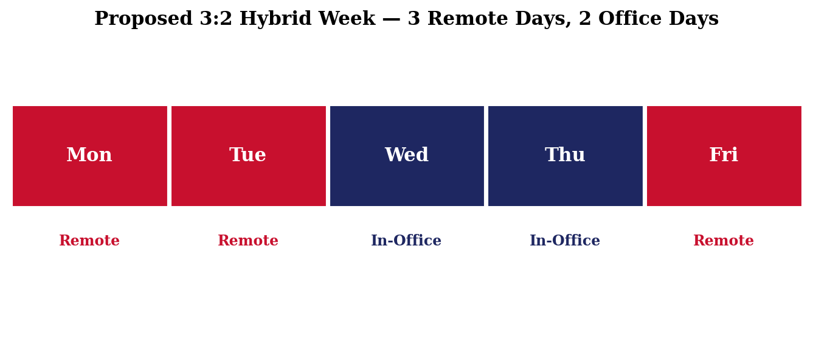
Figure 4.1: Proposed 3:2 hybrid week — three remote days and two in-office days.
Under this arrangement employees regain meaningful control of their schedule, which improves work–life balance and reduces burnout risk, while organisations preserve the team cohesion and spontaneous collaboration that come from periodic in-person presence. The arrangement also enables more efficient use of office space, since the building does not need to seat every employee on every day of the week.

4.3 Experimental Parameters
The parameters of the empirical portion of the study are summarised below. Together they define the scale, source, instrumentation, and scoring approach used to compare the three work models.

Table 4.2: Experimental parameters of the comparative study
Parameter | Value / Description
Sample Size | 50 respondents
Data Source | Survey + secondary research
Tools Used | Python (analysis), Microsoft Excel (data entry)
Metrics | Productivity, well-being
Scale | 0–10 rating system
Time Window | Secondary sources from 2022–2025; survey collected in 2026

4.4 Decision Logic
Each of the three work models is scored independently on productivity and well-being on the 0–10 scale. A simple combined score — the arithmetic mean of the two dimensions — is then computed for each model, on the basis that for most organisations productivity and well-being are roughly equally important over the long term. The model with the highest combined score is selected as the recommended arrangement, and the survey preference data is used as an independent check on that recommendation.

5. Major Findings, Outcomes and Results

5.1 Overview of Findings
The comparative analysis produces a consistent picture across both the secondary literature and the primary survey. Fully remote working is strongest on individual productivity but weakest on well-being. Fully in-office working is the reverse: well-being holds up but individual productivity is reduced by commuting and workplace interruptions. The hybrid arrangement — three remote days and two in-office days — produces the highest combined score on both dimensions.

5.2 Performance Comparison
Table 5.1 summarises the scoring on the 0–10 scale for each work model. The values are the rounded averages obtained from the primary survey, cross-checked against the ranges reported in the secondary literature reviewed in Chapter 2.
Table 5.1: Performance comparison of work models
Work Model | Productivity Score | Well-being Score | Combined Score
Remote | 8.5 | 6.0 | 7.25
In-Office | 6.5 | 7.0 | 6.75
Hybrid | 9.0 | 8.5 | 8.75
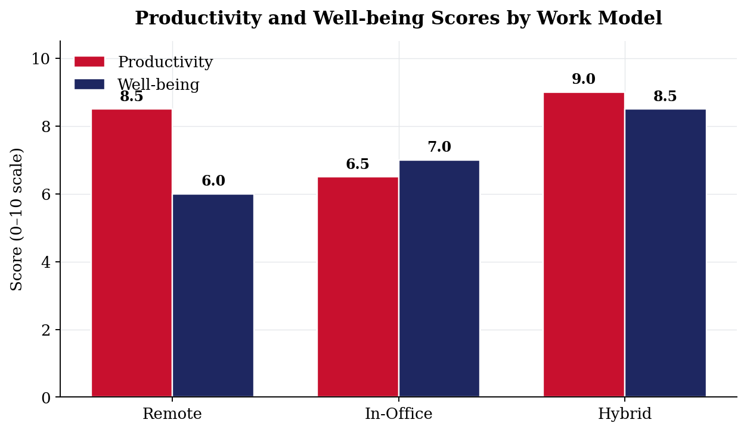
Figure 5.1: Productivity and well-being scores by work model (0–10 scale).
Two findings stand out from these scores. First, neither pure model is dominant — Remote wins on productivity but loses on well-being, In-Office wins on well-being but loses on productivity. Second, the hybrid arrangement does not simply average the two extremes: it scores above both pure models on each dimension. This is consistent with the literature view that structural separation of focused work from collaborative work is itself a source of performance improvement.
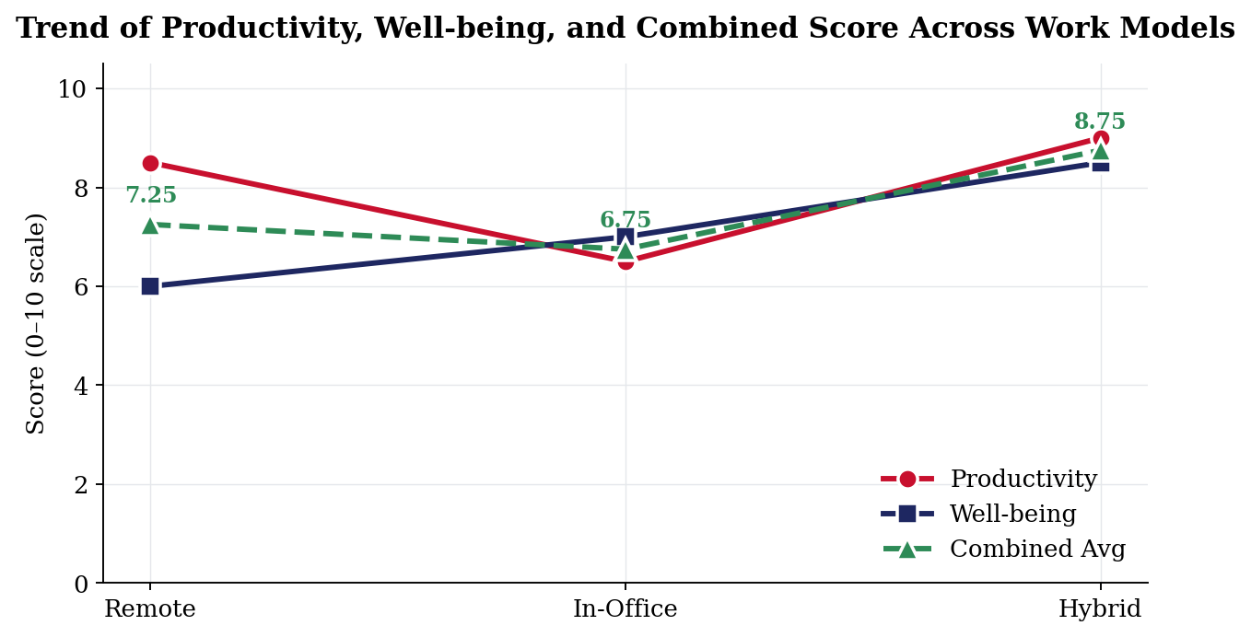
Figure 5.2: Trend of productivity, well-being and combined score across the three work models.

5.3 Survey Analysis
The fifty-respondent survey provides an independent check on the comparative scoring. Respondents were asked which working mode they would prefer overall, after reading short descriptions of each option. The results, shown in Table 5.2 and Figure 5.3, point clearly to hybrid work as the preferred arrangement.
Table 5.2: Survey results — work mode preference
Work Preference | Percentage (%)
Hybrid | 68
Remote | 22
In-Office | 10
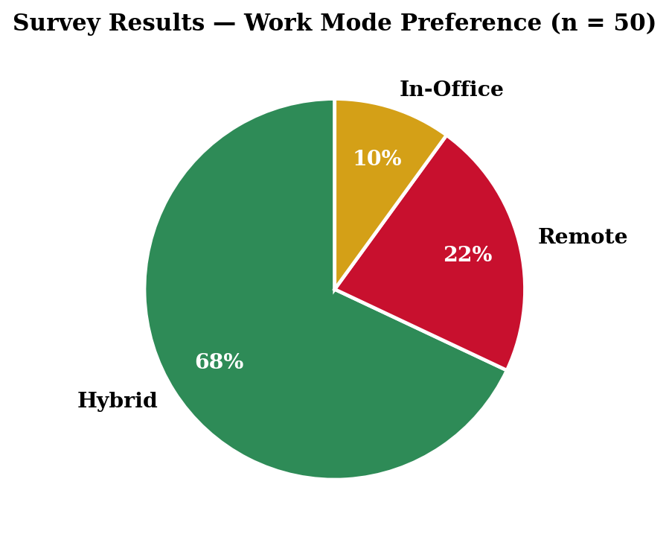
Figure 5.3: Survey results — work mode preference (n = 50).
Sixty-eight per cent of respondents preferred hybrid work, twenty-two per cent preferred fully remote work, and ten per cent preferred fully in-office work. The strong majority preference for hybrid is itself an indicator of the trade-off captured by the productivity and well-being scoring: most respondents implicitly recognise the trade-off and choose the arrangement that best resolves it.

5.4 Discussion
Bringing the two strands together yields a coherent narrative. The remote model removes commuting time and workplace interruptions, which lifts productivity, but it also removes much of the day-to-day social contact that supports well-being. The in-office model preserves team interaction, mentoring and informal feedback, which supports well-being, but it reintroduces the time costs and distractions that hold productivity back. The 3:2 hybrid model retains the focused-work advantage of remote days while restoring enough in-office contact to keep team cohesion strong. The combined score of 8.75/10 is the highest of the three options.
An additional, more practical finding is that the office presence does not need to be uniform across employees. So long as overlap days are chosen carefully, organisations can stagger attendance across the week and use office space more efficiently without losing the benefits of in-person contact. This has direct implications for facilities planning and real-estate strategy.

6. Conclusion and Future Scope

6.1 Conclusion
This project set out to compare the impact of remote, in-office and hybrid work models on employee productivity and well-being, using a combination of secondary research and a primary survey of fifty respondents. The comparative analysis shows that no single pure model is uniformly best: fully remote work maximises individual productivity but undermines well-being, while fully in-office work supports well-being but holds productivity back.
The structured 3:2 hybrid model proposed in Chapter 4 produces the highest combined performance, with a productivity score of 9.0/10 and a well-being score of 8.5/10 on the 0–10 scale used in this study. The survey, in which sixty-eight per cent of respondents chose hybrid working as their preferred mode, independently supports this conclusion. Organisations adopting this model can expect stronger focused output, healthier work–life boundaries and greater retention than under either of the pure alternatives.
Three broader implications follow. First, structural separation of focused and collaborative work is itself a source of performance improvement; the value of hybrid work is not just an average of remote and office benefits but a genuine compounding of them. Second, hybrid work should be designed deliberately rather than adopted ad hoc; the choice of which days are remote and which are in-office matters as much as the ratio. Third, flexibility is a long-term strategic advantage rather than a short-term concession; organisations that institutionalise it are likely to outperform those that treat it as an exception.

6.2 Future Scope
Future extensions of this work could move in several complementary directions:
- Longitudinal study: track the same cohort of respondents across multiple years to measure the long-term effect of the 3:2 hybrid model on retention, career progression and burnout.
- Cross-industry comparison: extend the study beyond knowledge-work environments and characterise the hybrid arrangements that work in sectors with mixed physical and digital requirements.
- Tooling research: study which digital collaboration platforms most effectively support hybrid teams, with a focus on asynchronous communication and lightweight project tracking.
- Larger sample: scale the primary survey from fifty respondents to several hundred across geographies, to obtain statistically significant effect sizes for productivity and well-being.
- Manager perspective: extend the survey to managers and team leads to compare their perception of the hybrid model with that of individual contributors.

References
[1] N. Bloom et al., “Hybrid working from home improves retention without affecting performance,” Nature, vol. 630, pp. 920–925, 2024.
[2] R. Maity, “The impact of remote and hybrid work models on organizational productivity,” Springer, 2025.
[3] S. Prasad et al., “Exploring the impact of remote work on productivity: A systematic review,” ResearchGate, 2024.
[4] D. Petersen, “Prevalence and impact of remote and hybrid work,” Journal of Academic Libraries, 2024.
[5] U.S. Bureau of Labor Statistics, “Remote work and productivity trends,” 2024.
[6] S. KC et al., “Remote work and productivity: Role of work–life balance,” 2025.
[7] D. Mustajab, “Effectiveness of remote and hybrid work policies,” 2025.
[8] J. Dong, “Work from home and employee well-being: A double-edged sword,” 2025.
[9] I. Eng et al., “Hybrid workers and collaboration success factors,” Taylor & Francis, 2024.
[10] J. Lauring, “Conceptual framework of hybrid work,” ScienceDirect, 2025.
[11] B. Lim, “Causal relationship of remote work and productivity,” 2025.
[12] Selvaraju and Anuar, “Hybrid work and employee well-being,” 2024.
[13] Stanford University, “Hybrid work improves retention and productivity,” 2024.
[14] R. McPhail, “Post-COVID remote work and its impact,” 2024.
[15] N. Bloom, “How hybrid working from home works,” NBER Working Paper, 2022.
[16] X. Ngonini, “Hybrid work dynamics in public organizations,” 2025.
[17] McKinsey & Company, “The future of work after COVID-19,” Industry Report, 2023.

Appendices

Appendix A — Survey Questionnaire
The following questionnaire was distributed to fifty respondents to collect the primary data used in this study. All items were answered on a 0–10 scale, except for the final preference question.
- Demographic — please indicate your primary work setting over the last six months (Remote / In-Office / Hybrid).
- On a scale of 0–10, how productive do you feel under your current work arrangement?
- On a scale of 0–10, how would you rate your overall well-being under your current work arrangement?
- On a scale of 0–10, how well does your current arrangement support your work–life balance?
- On a scale of 0–10, how connected do you feel to your colleagues under your current arrangement?
- Briefly describe one factor that most improves your productivity in your current arrangement (open response).
- Briefly describe one factor that most reduces your productivity in your current arrangement (open response).
- If you could choose freely, which working mode would you prefer overall: Remote, In-Office, or Hybrid?

Appendix B — Abbreviations
Abbreviation | Expansion
CO-OP | Co-operative Education Module
CSE | Computer Science and Engineering
WFH | Work From Home
WLB | Work–Life Balance
HR | Human Resources
NBER | National Bureau of Economic Research
BLS | U.S. Bureau of Labor Statistics

Appendix C — Summary of Survey Outputs
Table C.1 summarises the aggregate output of the fifty-respondent survey on the 0–10 scale used throughout the report. These values, rounded to one decimal place, are the source data for Figures 5.1, 5.2 and 5.3.
Table C.1: Aggregate survey scores by work mode (n = 50)
Work Mode | Productivity (avg) | Well-being (avg) | Work–Life Balance (avg)
Remote | 8.5 | 6.0 | 7.4
In-Office | 6.5 | 7.0 | 6.2
Hybrid | 9.0 | 8.5 | 8.7

