Ex No: | THE SNAKE VERSUS THE WIND
Date: | THE SNAKE VERSUS THE WIND

AIM:
To find the movement of the snake for the every second of the journey.

PSEUDOCODE:
void sna(char ch[],int x,int y)
{
arr[x][y]=count;
count++;
if(ch[0]=='n')
{
if(x-1>=0 && arr[x-1][y]==0)
sna(ch,x-1,y);
else if(y-1>=0 && arr[x][y-1]==0)
sna(ch,x,y-1);
else if(y+1<n && arr[x][y+1]==0)
sna(ch,x,y+1);
else if(x+1<n && arr[x+1][y]==0)
sna(ch,x+1,y);
}
else if(ch[0]=='s')
{
if(x+1<n && arr[x+1][y]==0)
sna(ch,x+1,y);
else if(y-1>=0 && arr[x][y-1]==0)
sna(ch,x,y-1);
else if(y+1<n && arr[x][y+1]==0)
sna(ch,x,y+1);
else if(x-1>=0 && arr[x-1][y]==0)
sna(ch,x-1,y);

}
else if(ch[0]=='e')
{

if(y+1<n && arr[x][y+1]==0)
sna(ch,x,y+1);
else if(x-1>=0 && arr[x-1][y]==0)
sna(ch,x-1,y);
else if(x+1<n && arr[x+1][y]==0)
sna(ch,x+1,y);
else if(y-1>=0 && arr[x][y-1]==0)
sna(ch,x,y-1);

}
else if(ch[0]=='w')
{

if(y-1>=0 && arr[x][y-1]==0)
sna(ch,x,y-1);
else if(x-1>=0 && arr[x-1][y]==0)
sna(ch,x-1,y);
else if(x+1<n && arr[x+1][y]==0)
sna(ch,x+1,y);
else if(y+1<n && arr[x][y+1]==0)
sna(ch,x,y+1);

}
}

ALGORITHM:

#include<stdio.h>
#include<string.h>
#include<stdlib.h>
int arr[60][60];
int count=1;
int n;

void sna(char ch[],int x,int y);

int main()
{
printf("enter the array size");
scanf("%d",&n);
int i,j;
for(i=0;i<n;i++)
{
for(j=0;j<n;j++)
{
printf("%d ",arr[i][j]);
}

printf("\n");
}
int x,y;
printf("\nenter the starting point");
scanf("%d",&x);
scanf("%d",&y);

char ch[0];
printf("enter the direction");
scanf("%s",ch);

sna(ch,x,y);

for(i=0;i<n;i++)
{
for(j=0;j<n;j++)
{
printf("%d ",arr[i][j]);
}
printf("\n");
}

return 0;
}

void sna(char ch[],int x,int y)
{
arr[x][y]=count;
count++;
if(ch[0]=='n')
{
if(x-1>=0 && arr[x-1][y]==0)
sna(ch,x-1,y);
else if(y-1>=0 && arr[x][y-1]==0)
sna(ch,x,y-1);
else if(y+1<n && arr[x][y+1]==0)
sna(ch,x,y+1);
else if(x+1<n && arr[x+1][y]==0)
sna(ch,x+1,y);
}
else if(ch[0]=='s')
{
if(x+1<n && arr[x+1][y]==0)
sna(ch,x+1,y);
else if(y-1>=0 && arr[x][y-1]==0)
sna(ch,x,y-1);
else if(y+1<n && arr[x][y+1]==0)
sna(ch,x,y+1);
else if(x-1>=0 && arr[x-1][y]==0)
sna(ch,x-1,y);

}
else if(ch[0]=='e')
{

if(y+1<n && arr[x][y+1]==0)
sna(ch,x,y+1);
else if(x-1>=0 && arr[x-1][y]==0)
sna(ch,x-1,y);
else if(x+1<n && arr[x+1][y]==0)
sna(ch,x+1,y);
else if(y-1>=0 && arr[x][y-1]==0)
sna(ch,x,y-1);

}
else if(ch[0]=='w')
{

if(y-1>=0 && arr[x][y-1]==0)
sna(ch,x,y-1);
else if(x-1>=0 && arr[x-1][y]==0)
sna(ch,x-1,y);
else if(x+1<n && arr[x+1][y]==0)
sna(ch,x+1,y);
else if(y+1<n && arr[x][y+1]==0)
sna(ch,x,y+1);

}
}

OUTPUT:
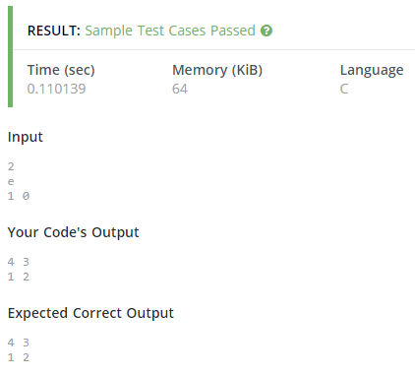

RESULT:
Thus the program to find the movement of the snake is successfully executed and output was verified.

Ex No: | DUPLICATION OF NUMBER
Date: | DUPLICATION OF NUMBER

AIM:
To find the duplication of the number.

PSEUDOCODE:-
void duplication(int n){
while(n--){
scanf("%d",&num);
int temp,count=0,rem,base=1;
int sum=0;
temp=num ;
while(temp>0){
rem=temp%2;
sum+=rem*base;
temp/=2;
base*=10;}
while(sum>0){
rem=sum%10;
if(rem==1)
count++;
sum=sum/10;
}
printf("\n value of the position%d",count%2);
}

}

ALGORITHM:
#include <stdio.h>
int n;
int num;
void duplication(int n){
while(n--){
scanf("%d",&num);
int temp,count=0,rem,base=1;
int sum=0;
temp=num ;
while(temp>0){
rem=temp%2;
sum+=rem*base;
temp/=2;
base*=10;}
while(sum>0){
rem=sum%10;
if(rem==1)
count++;
sum=sum/10;
}
printf("\n value of the position%d",count%2);
}

}
int main(void) {
int n;
scanf("%d",&n);
duplication(n);
return 0;}

OUTPUT:
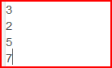

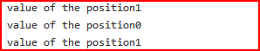

RESULT:
Thus the program to find duplication of number is successfully executed and output was verified.

Ex No: | PRICE OF THE TOY
Date: | PRICE OF THE TOY

AIM:
To f ind the price of the 3d toy..

PSEUDOCODE
void price(int h,int w,int arr[h][w]){
for(int i=0;i<h;i++){
for(int j=0;j<w;j++){
if(j==0)
sum+=arr[i][j];
if(i==h-1)
sum+=arr[i][j];
if(i<h-1){
if(arr[i][j]-arr[i+1][j]>0){
sum=sum+(arr[i][j]-arr[i+1][j]);
}
if(j<w-1){
if(arr[i][j+1]-arr[i][j]>0){
sum+=(arr[i][j+1]-arr[i][j]);
}
}
sum+=1;
}
}
}
printf("price %d",2*sum);
}

ALGORITHM:
#include <stdio.h>
int arr[10][10],h,w,sum=0;
void price(int h,int w,int arr[h][w]){
for(int i=0;i<h;i++){
for(int j=0;j<w;j++){
if(j==0)
sum+=arr[i][j];
if(i==h-1)
sum+=arr[i][j];
if(i<h-1){
if(arr[i][j]-arr[i+1][j]>0){
sum=sum+(arr[i][j]-arr[i+1][j]);
}
if(j<w-1){
if(arr[i][j+1]-arr[i][j]>0){
sum+=(arr[i][j+1]-arr[i][j]);
}
}
sum+=1;
} }
} printf("price %d",2*sum);
}
main(){
int h,w;
scanf("%d",&h);
scanf("%d",&w);
int arr[h][w];
for(int i=0;i<h;i++)
{
for(int j=0;j<w;j++){
scanf("%d",&arr[i][j]);
}
}
price(h,w,arr);
}

OUTPUT:
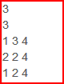

RESULT:
Thus the program to find the 3D toy is successfully executed and output was verified.

Ex No: | POWER OF 2
Date: | POWER OF 2

AIM:
To find the given number is check 2^n or not.

PSEUDOCODE:
Void power(int a)
{
if(num&(num-1))
printf("IT'S NOT A POWER OF 2");
else
printf("IT'S A POWER OF 2");
}

ALGORITHM:
#include<stdio.h>
#include<string.h>
int main()
{
int num;
printf("enter the number");
scanf("%d",&num);
if(num&(num-1))
printf("IT'S NOT A POWER OF 2");
else
printf("IT'S A POWER OF 2");
}

OUTPUT:
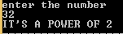

RESULT:
Thus the program to check power of 2 number is successfully executed and output was verified.

Ex No: | PYTHOGORAS TRIPLETS
Date: | PYTHOGORAS TRIPLETS

AIM:
To find the pythogoras triplets numbers.

PSEUDOCODE:
Void trib(int num)
{
int n,m;
m=2;
int a,b,c=0,i;
while((num/2)+1>c)
{
for(i=1;i<m;i++)
{
a=m*m-i*i;
b=2*m*i;
c=m*m+i*i;

if(a+b+c==num)
printf("%d%d%d",a,b,c);
}
m++;
}
}
ALGORITHM:
#include<stdio.h>
#include<string.h>
int main()
{
int num;
scanf("%d",&num);
int n,m;
m=2;
int a,b,c=0,i;
while((num/2)+1>c)
{
for(i=1;i<m;i++)
{
a=m*m-i*i;
b=2*m*i;
c=m*m+i*i;

if(a+b+c==num)
printf("%d%d%d",a,b,c);
}
m++;
} return 0; }

OUTPUT:
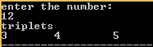

RESULT:
Thus the program to find pythogoras triplets number is successfully executed and output was verified.

Ex No: | MULTIPLICATION OF LARGE NUMBERS
Date: | MULTIPLICATION OF LARGE NUMBERS
AIM:
To find the multiplication of largest two number.

PSEUDOCODE:
Void mul(char str1[],char str2[]){
length1=strlen(str1);
length2=strlen(str2);
if((str1[0]==0)||(str2[0]==0))
{
printf("0");
}
else
{
for(i=0;i<length1;i++)
{
str1[i]=str1[i]-48;
}
for(i=0;i<length2;i++)
{
str2[i]=str2[i]-48;
}
for(i=length2;i>=0;i--)
{
r=0;
for(j=length1;j>=0;j--)
{
temp[k++]=((str2[i]*str1[j])+r)%10;
r=((str2[i]*str1[j])+r)/10;
}
temp[k++]=r;
x++;
for(y=0;y<x;y++)
temp[k++]=0;
}
k=0,r=0;
for(i=0;i<(length1+length2+2);i++)
{
sum=0;
y=0;
for(j=1;j<=length2+1;j++)
{
if(i<=length1+j)
{
sum=sum+temp[y+i];
}
y+=j+length1+1;
}
f[k++]=(sum+r)%10;
r=(sum+r)/10;
}
f[k]=r;
j=0;
for(i=k-1;i>=0;i--)
{
result[j++]=f[i]+48;
}
result[j++]='\0';
if((str1!="0")&&(str2!="0"))
{
if(result[0]!='0')
{
for(i=0;result[i]!='\0';i++)
{
final[g++]=result[i];
}
}
else
{
for(i=1;result[i]!='\0';i++)
{
final[g++]=result[i];
}
}
}
ALGORITHM:
#include<stdio.h>
#include<stdlib.h>
#include<string.h>
#include<math.h>
int main()
{
char str1[100000],str2[10000],result[10000],final[100000];
int temp[10000];
int i,j,test,r,k=0,x=0,y,sum,g=0,t;
int length1,length2;
int f[10000];
printf("enter the testcases");
scanf("%d",&test);
for(t=0;t<test;t++)
{
printf("enter the string");
scanf("%s%s",str1,str2);
length1=strlen(str1);
length2=strlen(str2);
if((str1[0]==0)||(str2[0]==0))
{
printf("0");
}
else
{
for(i=0;i<length1;i++)
{
str1[i]=str1[i]-48;
}
for(i=0;i<length2;i++)
{
str2[i]=str2[i]-48;
}
for(i=length2;i>=0;i--)
{
r=0;
for(j=length1;j>=0;j--)
{
temp[k++]=((str2[i]*str1[j])+r)%10;
r=((str2[i]*str1[j])+r)/10;
}
temp[k++]=r;
x++;
for(y=0;y<x;y++)
temp[k++]=0;
}
k=0,r=0;
for(i=0;i<(length1+length2+2);i++)
{
sum=0;
y=0;
for(j=1;j<=length2+1;j++)
{
if(i<=length1+j)
{
sum=sum+temp[y+i];
}
y+=j+length1+1;
}
f[k++]=(sum+r)%10;
r=(sum+r)/10;
}
f[k]=r;
j=0;
for(i=k-1;i>=0;i--)
{
result[j++]=f[i]+48;
}
result[j++]='\0';
if((str1!="0")&&(str2!="0"))
{
if(result[0]!='0')
{
for(i=0;result[i]!='\0';i++)
{
final[g++]=result[i];
}
}
else
{
for(i=1;result[i]!='\0';i++)
{
final[g++]=result[i];
}
}
for(i=0;i<g-2;i++)
{
printf("%c",final[i]);
}
}
}
}
}
OUTPUT:
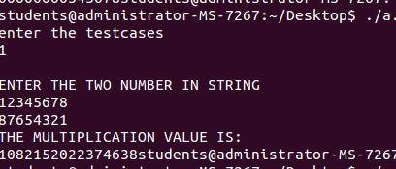

RESULT:
Thus the program to find multiplication of two largest number is successfully executed and output was verified.

QUESTION:
Find the frequency of particular number in a array.Running time will be o(log n)
INPUT:
4
1,1,2,3
1
OUTPUT:
2

Ex No: | FREQUENCY OF NUMBER
Date: | FREQUENCY OF NUMBER

AIM:
To find the frequency of number using binary search tree.

PSEUDOCODE:
struct node *inorder(struct node *root,int ele)
{ struct node *temp=root;

if(temp!=NULL)
{
inorder(temp->left,ele);
if(ele==temp->data){
printf("The number%d\tFrequency is %d\n",ele,temp->count);}
inorder(temp->right,ele);
}
}

ALGORITHM:
#include<stdio.h>
#include<stdlib.h>

struct node
{
int data;
int count;
struct node *left,*right;
};
struct node *create(int ele);
struct node *inorder(struct node *root,int ele);
struct node *root=NULL;
int main()
{
int ele,i;
int n;
printf("enter the number of element for inserting");
scanf("%d",&n);
for(i=0;i<n;i++)
{
scanf("%d",&ele);
create(ele);
}
printf("enter the element for find frequency ");
scanf("%d",&ele);
inorder(root,ele);
return 0;
}

struct node *create(int ele)
{
struct node *newnode=(struct node *)malloc(sizeof(struct node));
struct node *temp;
newnode->data=ele;
newnode->left=NULL;
newnode->right=NULL;
newnode->count=1;
temp=root;

if(temp==NULL)
{
root=newnode;
}
else
{
while(1)
{

if(ele==temp->data)
{
temp->count+=1;
return 0;
}
else if(ele<temp->data)
{
if(temp->left==NULL)
{
temp->left=newnode;
return 0;
}
temp=temp->left;
}
else
{
if(temp->right==NULL)
{
temp->right=newnode;
return 0;
}
temp=temp->right;
}
}
}

}

struct node *inorder(struct node *root,int ele)
{
struct node *temp=root;

if(temp!=NULL)
{
inorder(temp->left,ele);
if(ele==temp->data){
printf("The number%d\tFrequency is %d\n",ele,temp->count);}
inorder(temp->right,ele);
}
}

OUTPUT:
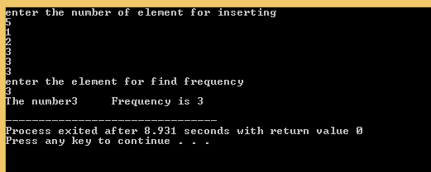

RESULT:
Thus the program to find frequency of number is successfully executed and output was verified.

QUESTION:
Print left most ,right most,internal and external node in BST.

INPUT:
5
7 3 2 9 10
OUTPUT:
Left most: 2 3 7
Right most:10 9
External node:2 10
Internal node: 7 3 9

Ex No: | LEFT , RIGHT ,EXTERNAL AND INTERNAL NODE  ELEMENTS OF BST
Date: | LEFT , RIGHT ,EXTERNAL AND INTERNAL NODE  ELEMENTS OF BST
AIM:
To find the left most,right most,internal and externals element in binary search tree.
PSEUDOCODE:
struct node *inorder(struct node *root)
{ struct node *temp=root;

if(temp!=NULL)
{
inorder(temp->left);
printf(" %d\t",temp->data);
inorder(temp->right);
}
return 0;
}

struct node *leftmost(struct node *root)
{
struct node *temp=root;
if(temp!=NULL)
{
leftmost(temp->left);
printf("%d\t",temp->data);
}
return 0;
}

struct node *rightmost(struct node *root)
{
struct node *temp=root;
if(temp!=NULL)
{
rightmost(temp->right);
printf("%d\t",temp->data);
}
return 0;
}

struct node *internal(struct node *root)
{
if(root==NULL)
return 0;

if((root->left!=NULL)||(root->right!=NULL)||(root->left!=NULL && root->right!=NULL))
{
printf("%d\t",root->data);
internal(root->left);
internal(root->right);
}
}

struct node *external(struct node *root)
{
if(root==NULL)
return 0;

if((root->left==NULL)&&(root->right==NULL))
{
printf("%d\t",root->data);
}

ALGORITHM:
#include<stdio.h>
#include<stdlib.h>

struct node
{
int data;
struct node *left,*right;
};
struct node *create(int ele);
struct node *inorder(struct node *root);
struct node *leftmost(struct node *root);
struct node *rightmost(struct node *root);
struct node *internal(struct node *root);
struct node *external(struct node *root);
struct node *root=NULL;
int main()
{
int ele,i;
int n;
printf("enter the number of element for inserting");
scanf("%d",&n);
for(i=0;i<n;i++)
{
scanf("%d",&ele);
create(ele);
}
printf("\n");
printf("inorder traversels of tree\n");
inorder(root);
printf("\n");
printf("\n left side element of tree\n");
leftmost(root);
printf("\n");
printf("\n right side element of tree \n");
rightmost(root->right);
printf("\n");
printf("\n The internal node of tree\n");
internal(root);
printf("\n");
printf("\n The external node of tree\n");
external(root);
return 0;
}

struct node *create(int ele)
{
struct node *newnode=(struct node *)malloc(sizeof(struct node));
struct node *temp;
newnode->data=ele;
newnode->left=NULL;
newnode->right=NULL;
temp=root;

if(temp==NULL)
{
root=newnode;
}
else
{
while(1)
{

if(ele<temp->data)
{
if(temp->left==NULL)
{
temp->left=newnode;
return 0;
}
temp=temp->left;
}
else
{
if(temp->right==NULL)
{
temp->right=newnode;
return 0;
}
temp=temp->right;
}
}
}

}

struct node *inorder(struct node *root)
{
struct node *temp=root;

if(temp!=NULL)
{
inorder(temp->left);
printf(" %d\t",temp->data);
inorder(temp->right);
}
return 0;
}

struct node *leftmost(struct node *root)
{
struct node *temp=root;
if(temp!=NULL)
{
leftmost(temp->left);
printf("%d\t",temp->data);
}
return 0;
}

struct node *rightmost(struct node *root)
{
struct node *temp=root;
if(temp!=NULL)
{
rightmost(temp->right);
printf("%d\t",temp->data);
}
return 0;
}

struct node *internal(struct node *root)
{
if(root==NULL)
return 0;

if((root->left!=NULL)||(root->right!=NULL)||(root->left!=NULL && root->right!=NULL))
{
printf("%d\t",root->data);
internal(root->left);
internal(root->right);
}
}

struct node *external(struct node *root)
{
if(root==NULL)
return 0;

if((root->left==NULL)&&(root->right==NULL))
{
printf("%d\t",root->data);
}
else
p {
external(root->left);
external(root->right);
}
}

OUTPUT:
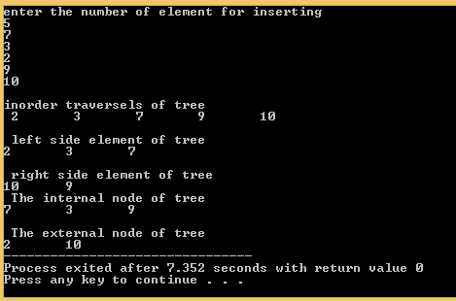

RESULT:
Thus the program to find left most,right most,external and internal element is successfully executed and output was verified.

QUESTION:
Find the height and level order of BST.
INPUT:
5
7 4 3 9 10
OUTPUT:
Height:3
Level order:7 3 9 2 10

Ex No: | HEIGHT,LEVEL ORDER OF BST
Date: | HEIGHT,LEVEL ORDER OF BST

AIM:
To find the height and level order of the binary search tree.

PSEUDOCODE:
int height(struct node *root)
{
int l,r;
if(root==NULL)
{
return 0;
}
l=height(root->left);
r=height(root->right);

if(l>r)
return l+1;
else
return r+1;
}

void level(struct node *root)
{
int h,i;
h=height(root);

for(i=1;i<=h;i++)
{
order(root,i);
}
}

struct node *order(struct node *root,int i)
{
if(root==NULL)
{
return 0;

}

if(i==1)
{
printf("%d\t",root->data);
return 0;
}
else
{
order(root->left,i-1);
order(root->right,i-1);
}
}

ALGORITHM:
#include<stdio.h>
#include<stdlib.h>

struct node
{
int data;
struct node *left,*right;
};
struct node *create(int ele);
struct node *inorder(struct node *root);
int height(struct node *root);
void level(struct node *root);
struct node *order(struct node *root,int i);
struct node *root=NULL;
int main()
{
int ele,i;
int n;
printf("enter the number of element for inserting");
scanf("%d",&n);
for(i=0;i<n;i++)
{
scanf("%d",&ele);
create(ele);
}
printf("\n");
printf("inorder traversels of tree\n");
inorder(root);
printf("\n");
printf("\n Height of tree is");
ele=height(root);
printf("%d",ele);
printf("\n");
printf("\n The level order of tree\n");
level(root);
printf("\n");
return 0;
}

struct node *create(int ele)
{
struct node *newnode=(struct node *)malloc(sizeof(struct node));
struct node *temp;
newnode->data=ele;
newnode->left=NULL;
newnode->right=NULL;
temp=root;

if(temp==NULL)
{
root=newnode;
}
else
{
while(1)
{

if(ele<temp->data)
{
if(temp->left==NULL)
{
temp->left=newnode;
return 0;
}
temp=temp->left;
}
else
{
if(temp->right==NULL)
{
temp->right=newnode;
return 0;
}
temp=temp->right;
}
}
}

}

struct node *inorder(struct node *root)
{
struct node *temp=root;

if(temp!=NULL)
{
inorder(temp->left);
printf(" %d\t",temp->data);
inorder(temp->right);
}
return 0;
}

int height(struct node *root)
{
int l,r;
if(root==NULL)
{
return 0;
}
l=height(root->left);
r=height(root->right);

if(l>r)
return l+1;
else
return r+1;
}

void level(struct node *root)
{
int h,i;
h=height(root);

for(i=1;i<=h;i++)
{
order(root,i);
}
}

struct node *order(struct node *root,int i)
{
if(root==NULL)
{
return 0;

}

if(i==1)
{
printf("%d\t",root->data);
return 0;
}
else
{
order(root->left,i-1);
order(root->right,i-1);
}
}

OUTPUT:
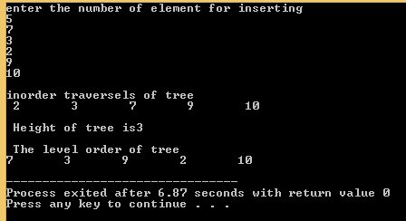

RESULT:
Thus the program to find height and level order is successfully executed and output was verified

QUESTION:
To find the minimum cost of the flower.

INPUT:
n=3
k=3
flower value=2 5 6

OUTPUT :
13

Ex No: | MIN COST OF FLOWER
Date: | MIN COST OF FLOWER

AIM:
To find the minimum amount of flower cost.
PSEUDOCODE:
Void cost(int arr[],int n)
for(i=0;i<n;i++)
{sum+=arr[i];
}
if(n==f)
{
printf("enter the min cost%d\n",sum);
}
else if(n>f)
{
val=n-f;
while(val--)
{
sum+=(val+1)*arr[0];
}
printf("min cost of flowers %d\n",sum);
}
else if(n>f)
{
printf("min cost of flowers%d\n",sum);
}

}

ALGORITHM:
#include<stdio.h>
#include<stdlib.h>
int main()
{
int n,f,i;
printf("enter the no.of.flowers");
scanf("%d",&n);
printf("enter the no.of.friends");
scanf("%d",&f);
int arr[n];
printf("enter the cost of flowers");
for(i=0;i<n;i++)
{
scanf("%d",&arr[i]);
}

int sum=0,val=0;
for(i=0;i<n;i++)
{
sum+=arr[i];
}
if(n==f)
{
printf("enter the min cost%d\n",sum);
}
else if(n>f)
{
val=n-f;
while(val--)
{
sum+=(val+1)*arr[0];
}
printf("min cost of flowers %d\n",sum);
}
else if(n>f)
{
printf("min cost of flowers%d\n",sum);
}

return 0;
}

OUTPUT:
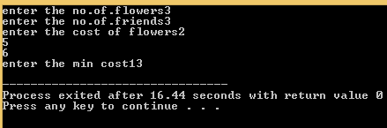

RESULT:
Thus the program of find the minimum cost of the flower was successfully displayed and output was verified.

QUESTION:
To find that given graph contain cycle or not.

INPUT:
0
Source:0
Destination:1
1
Source:1
Destination:2

2
Source:2
Destination:0

OUTPUT:
Graph contain a cycle.

Ex No: | GRAPH CONTAIN CYCLE OR NOT
Date: | GRAPH CONTAIN CYCLE OR NOT
AIM:
To find the given graph contain cycle or not.
PESUDOCODE:
int cycle(struct Graph *graph)
{
inti,x,y;
int *par=(int*)malloc(graph->v*sizeof(int));
memset(par,-1,graph->v*sizeof(int));
for(i=0;i<graph->e;i++)
{
x=find(par,graph->edge[i].s);
y=find(par,graph->edge[i].d);

if(x==y)
return 1;
uni(par,x,y);
}
return 0;
}

int find(int par[],int i)
{
if(par[i]==-1)
return i;

return find(par,par[i]);
}

voiduni(int par[],intx,int y)
{
intxset,yset;
xset=find(par,x);
yset=find(par,y);
par[xset]=yset;
}

ALGORITHM:
#include<stdio.h>
#include<stdlib.h>
struct Edge
{
ints,d;
};
struct Graph
{
intv,e;
struct Edge*edge;
};
struct Graph *newgraph(intv,int e);
int find(int par[],int i);
voiduni(int par[],intx,int y);
int cycle(struct Graph *graph);
int main()
{
int v=3,e=3;
struct Graph*graph=(struct Graph*)malloc(sizeof(struct Graph));
graph=newgraph(v,e);
graph->edge[0].s=0;
graph->edge[0].d=1;
graph->edge[1].s=1;
graph->edge[1].d=2;
graph->edge[2].s=2;
graph->edge[2].d=0;
clrscr();
if(cycle(graph))
printf("graph contain cycle");
else
printf("graph don't have cycle");
getch();
return 0;
}

struct Graph *newgraph(intv,int e)
{
struct Graph *graph=(struct Graph*)malloc(sizeof(struct Graph));
graph->v=v;
graph->e=e;
graph->edge=(struct Edge*)malloc(graph->e * (sizeof(struct Edge)));
return graph;
}

int cycle(struct Graph *graph)
{
inti,x,y;
int *par=(int*)malloc(graph->v*sizeof(int));
memset(par,-1,graph->v*sizeof(int));
for(i=0;i<graph->e;i++)
{
x=find(par,graph->edge[i].s);
y=find(par,graph->edge[i].d);

if(x==y)
return 1;
uni(par,x,y);
}
return 0;
}

int find(int par[],int i)
{
if(par[i]==-1)
return i;

return find(par,par[i]);
}

voiduni(int par[],intx,int y)
{
intxset,yset;
xset=find(par,x);
yset=find(par,y);
par[xset]=yset;
}
OUTPUT:
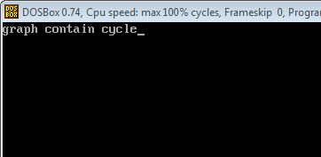

RESULT:
Thus the program to find given graph contain or not was successfully displayed and output was verified.

QUESTION:
Find the meadian between two sorted element.Running time will be on o(log n).

INPUT:
5
1 12 15 26 38
5
2 13 17 30 45

OUTPUT:
16

Ex No: | MEDIAN FINDING ALGORITHM
Date: | MEDIAN FINDING ALGORITHM
AIM:
To find the meadian element between two sorted array.
PSEUDOCODE:
int med(int arr[],int l,int h,int arr1[],int l1,int h1)
{

int mid=(l+(h+1))/2;
int mid1=(l1+(h1+1))/2;
if((h-l<0)&&(h1-l1<0))
{
return -1;
}
else if((h-l==0)&&(h1-l1==0))
{
return (arr[0]+arr1[0])/2;
}
else if((h-l==1)&&(h1-l1==1))
{
return (max(arr[l],arr1[l1])+min(arr[h],arr1[h1]))/2;

}

else if(arr[mid]<arr1[mid1])
{
med(arr,mid,h,arr1,l1,mid1);
}
else if(arr[mid]>arr1[mid1])
{
med(arr,l,mid,arr1,mid1,h1);
}
}
ALGORITHM:
#include<stdio.h>
#include<stdlib.h>
#include<string.h>
int max(int a,int b)
{
if(a>b)
return a;

return b;
}

int min(int a,int b)
{
if(a<b)
return a;

return b;
}

int med(int arr[],int l,int h,int arr1[],int l1,int h1);

int main()
{
int n;
printf("enter the size of an array");
scanf("%d",&n);
int arr[n];
int i;
printf("enter the array values");
for(i=0;i<n;i++)
{
scanf("%d",&arr[i]);
}
int arr1[n];
printf("enter the array2 values");
for(i=0;i<n;i++)
{
scanf("%d",&arr1[i]);
}

int val;
val=med(arr,0,n-1,arr1,0,n-1);
printf("%d",val);
return 0;
}

int med(int arr[],int l,int h,int arr1[],int l1,int h1)
{

int mid=(l+(h+1))/2;
int mid1=(l1+(h1+1))/2;
if((h-l<0)&&(h1-l1<0))
{
return -1;
}
else if((h-l==0)&&(h1-l1==0))
{
return (arr[0]+arr1[0])/2;
}
else if((h-l==1)&&(h1-l1==1))
{
return (max(arr[l],arr1[l1])+min(arr[h],arr1[h1]))/2;

}

else if(arr[mid]<arr1[mid1])
{
med(arr,mid,h,arr1,l1,mid1);
}
else if(arr[mid]>arr1[mid1])
{
med(arr,l,mid,arr1,mid1,h1);
}
}

OUTPUT:
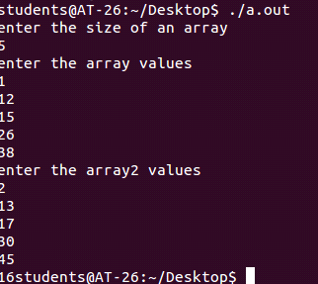

RESULT:
Thus the program to find the meadian element was successfully displayed and output was verified.

QUESTION:
Find the maximum sum of array using the kadane’s algorithm.
INPUT:
8
-2 -5 6 -2 -3 1 5 -6
OUTPUT:
7

Ex No: | KADANE’S ALGORITHM
Date: | KADANE’S ALGORITHM

AIM:
To find the maximum sum use of kadane’s algorithm.

PSEUDOCODE:
int fun(int arr[],int size)
{ int end=0,begin=arr[0];
int i;
for(i=0;i<size;i++)
{
end+=arr[i];
if(end>begin)
begin=end;
if(end<0)
end=0;
}
return begin;
}

ALGORITHM:
#include<stdio.h>
#include<string.h>
#include<stdlib.h>
int fun(int arr[],int size);
int main()
{ int size,arr[50];
int i,ans=0;
printf("enter the size of array\n");
scanf("%d",&size);
for(i=0;i<size;i++)
{
scanf("%d",&arr[i]);
}
ans=fun(arr,size);
printf("%d",ans);
return 0;
}

int fun(int arr[],int size)
{
int end=0,begin=arr[0];
int i;
for(i=0;i<size;i++)
{
end+=arr[i];
if(end>begin)
begin=end;
if(end<0)
end=0;
}
return begin;
}
OUTPUT:
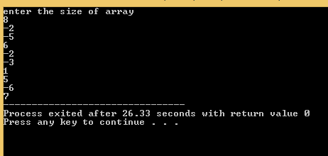

RESULT:
Thus the program of find mamimum sum of array was successfully displayed and the output was verified.

QUESTION:
Implement the fractional knapsack algorithm.
INPUT:
3
10 60
20 100
30 120

50

OUTPUT:
160

Ex No: | FRACTIONAL KNAPSACK ALGORITHM
Date: | FRACTIONAL KNAPSACK ALGORITHM
AIM:
To find the fractional knapsack algorithm.
PSEUDOCODE:
void knapsack(int n, float weight[], float profit[], float capacity)
{
float x[20], tp = 0;
int i, j, u;
u = capacity;
for (i = 0; i < n; i++)
x[i] = 0.0;
for (i = 0; i < n; i++)
{
if (weight[i] > u)
break;
else
{
x[i] = 1.0;
tp = tp + profit[i];
u = u - weight[i];
}

}

if (i < n)
x[i] = u / weight[i];
tp = tp + (x[i] * profit[i]);
printf("\nThe result vector is:- ");
for (i = 0; i < n; i++)
printf("%f\t", x[i]);
printf("\nMaximum profit is:- %f", tp);
}
ALGORITHM:
#include<stdio.h>
#include<string.h>
void knapsack(int n, float weight[], float profit[], float capacity)
{
float x[20], tp = 0;
int i, j, u;
u = capacity;
for (i = 0; i < n; i++)
x[i] = 0.0;
for (i = 0; i < n; i++)
{
if (weight[i] > u)
break;
else
{
x[i] = 1.0;
tp = tp + profit[i];
u = u - weight[i];
}

}

if (i < n)
x[i] = u / weight[i];
tp = tp + (x[i] * profit[i]);
printf("\nThe result vector is:- ");
for (i = 0; i < n; i++)
printf("%f\t", x[i]);
printf("\nMaximum profit is:- %f", tp);
}

void swap(float *a,float *b)
{
float tmp;
tmp=*a;
*a=*b;
*b=tmp;
}
int part(float radio[],float weight[],int low,int high)
{
int piv,i,j;

piv=radio[high];
i=(low-1);
for(j=low;j<high;j++)
{
if(radio[j]<=piv)
{
i++;
swap(&radio[i],&radio[j]);
swap(&weight[i],&weight[j]);
}
}
swap(&radio[i+1],&radio[high]);
swap(&weight[i+1],&weight[high]);
return i+1;
}

void q(float radio[],float weight[],int low,int high)
{
int pi;
if(low<high)
{
pi=part(radio,weight,low,high);
q(radio,weight,low,pi-1);
q(radio,weight,pi+1,high);
}

}
int main()
{
float weight[20], profit[20], capacity;
int num, i, j;
float ratio[20], temp;
printf("\nEnter the no. of objects:- ");
scanf("%d", &num);
printf("\nEnter the wts and profits of each object:- ");
for (i = 0; i <num; i++)
{
scanf("%f %f", &weight[i], &profit[i]);
}

printf("\nEnter the capacityacity of knapsack:- ");
scanf("%f", &capacity);
for (i = 0; i <num; i++)
{
ratio[i] = profit[i] / weight[i];
}

q(ratio,weight,0,num-1);
knapsack(num, weight, profit, capacity);
return 0;
}
OUTPUT:
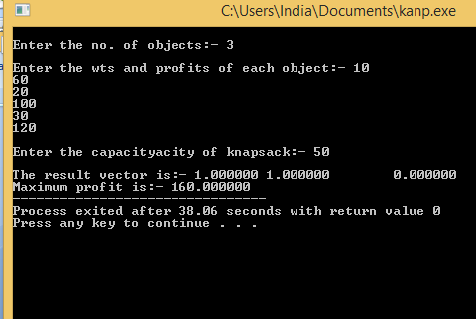

RESULT:
Thus the program of find the fractional knapsack algorithm was successfully executed and output was verified.

QUESTION:
Find the minimum maximum element in array using divide and conquer.

INPUT:
5
1 2 3 4 5

OUTPUT:
- 5

Ex No: | MIN AND MAX
Date: | MIN AND MAX

AIM:
Find the minimum and maximum element using divide and conquer.
PSEUDOCODE:
void find(int arr[],int l,int h)
{
int m;
if(l==h)

{
if(min>arr[l])
{
min=arr[l];
}

if(max<arr[l])
{
max=arr[l];
}
}

else
{
m=(l+h)/2;

find(arr,l,m);
find(arr,m+1,h);

}
}
ALGORITHM:
#include<stdio.h>
int min=999,max=0;
void find(int arr[],int l,int h)
{
int m;
if(l==h)

{
if(min>arr[l])
{
min=arr[l];
}

if(max<arr[l])
{
max=arr[l];
}
}

else
{
m=(l+h)/2;

find(arr,l,m);
find(arr,m+1,h);

}
}
int main()
{
int n;
printf("enter the n");
scanf("%d",&n);
int arr[n];
int i;
printf("enter the array values");
for(i=0;i<n;i++)
{
scanf("%d",&arr[i]);
}
find(arr,0,n-1);
printf("min value%d\tmax value%d",min,max);
return 0;
}

OUTPUT:
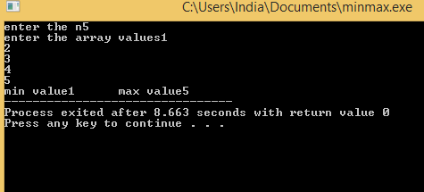

RESULT:
Thus the program of find min and max element was successfully executed and the output was verified.

QUESTION:
Find the longest common subsequences in the two string.

INPUT:
ABCDGH
AEDFHR

OUTPUT:
3

Ex No: | LONGEST COMMON SUBSEQUENCE
Date: | LONGEST COMMON SUBSEQUENCE
AIM:
Find the longest common substring length use the dynamic programming.
PSEUDOCODE:
int LCS(char *x,char *y,int m, int n)
{
if(m==0||n==0)
return 0;
if(x[m-1]==y[n-1])
return 1+LCS(x,y,m-1,n-1);
else
return max(LCS(x,y,m-1,n),LCS(x,y,m,n-1));
}
ALGORITHM:
#include<stdio.h>
int max(int a, int b);

int lcs( char *X, char *Y, int m, int n )
{
int L[m+1][n+1];
int i, j;
for (i=0; i<=m; i++)
{
for (j=0; j<=n; j++)
{
if (i == 0 || j == 0)
L[i][j] = 0;

else if (X[i-1] == Y[j-1])
L[i][j] = L[i-1][j-1] + 1;

else
L[i][j] = max(L[i-1][j], L[i][j-1]);
}
}
return L[m][n];
}

int max(int a, int b)
{
return (a > b)? a : b;
}

int main()
{
char X[100];
char Y[100];
printf("enter first string : ");
scanf("%s",X);
printf("enter second string : ");
scanf("%s",Y);
int m = strlen(X);
int n = strlen(Y);

printf("Length of LCS is %d \n", lcs( X, Y, m, n ) );

return 0;
}

OUTPUT:
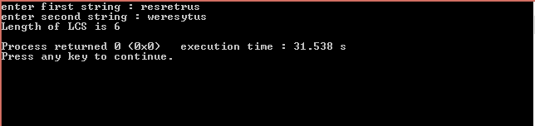

RESULT:
Thus the program of find the longest common substring between the two string was successfully executed and the output was verified.

QUESTION:-

Minimum number of edits to change a normal string to palindromic string

INPUT : -

Peeks

OUTPUT : -

2

Ex No: | CHANGING PALINDROMIC
Date: | CHANGING PALINDROMIC

AIM : -

To find the minimum number of edit to change normal string to palindromic string

PSEUDOCODE :-

int LCS(char *x,char *y,int m, int n)
{
if(m==0||n==0)
return 0;
if(x[m-1]==y[n-1])
return 1+LCS(x,y,m-1,n-1);
else
return max(LCS(x,y,m-1,n),LCS(x,y,m,n-1));
}

Main(){

Read X
Y=Rev(x)
Print((strlen(X)-1)-LCS(X,Y,strlen(X),strlen(Y))

}

ALGORITHM:-

#include<stdio.h>
int max(int a, int b);

int lcs( char *X, char *Y, int m, int n )
{
int L[m+1][n+1];
int i, j;
for (i=0; i<=m; i++)
{
for (j=0; j<=n; j++)
{
if (i == 0 || j == 0)
L[i][j] = 0;

else if (X[i-1] == Y[j-1])
L[i][j] = L[i-1][j-1] + 1;

else
L[i][j] = max(L[i-1][j], L[i][j-1]);
}
}
return L[m][n];
}

int max(int a, int b)
{
return (a > b)? a : b;
}

int main()
{
char X[100],X1[100];
char Y[100];
printf("enter string : ");
scanf("%s",X);
strcpy(X1,X);
strcpy(Y,strrev(X));
int m = strlen(X1);
int n = strlen(Y);

printf("Min edit to change palindromic is %d \n",(m-1)-lcs( X1,Y, m, n ) );

return 0;
}

OUTPUT :-
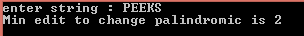

RESULT:-
Thus the minimum edit to change normal string to palindromic string is executed and the output is verified

QUESTION:-

Given a value N, if we want to make change for N cents, and we have infinite supply of each of S = { S1, S2, .. , Sm} valued coins, how many ways can we make the change? The order of coins doesn’t matter.

INPUT:-

No of coins : - 3
Coin variant : - 1 , 2 , 3
Sum = 4

OUTPUT:-

4

Ex No: | COIN EXCHANGE PROBLEM
Date: | COIN EXCHANGE PROBLEM

AIM:-
To find the number of ways to form the given sum using the given coin

PSEUDOCODE: -

int find( int S[], int m, int n )
{
if (n == 0)
return 1;
if (n < 0)
return 0;

if (m <=0 && n >= 1)
return 0;
return count( S, m - 1, n ) + count( S, m, n-S[m-1] );
}

ALGORITHM : -

#include<stdio.h>
int find( int arr[], int m, int n )
{
int i, j, x, y;
int dp[n+1][m];
for (i=0; i<m; i++)
dp[0][i] = 1;
for (i = 1; i < n+1; i++)
{
for (j = 0; j < m; j++)
{
if(i-arr[j] >= 0)
{x=dp[i - arr[j]][j];}
else
x=0;
if(j >= 1)
{y=dp[i][j-1];}
else
y=0;
dp[i][j] = x + y;
}
}
return dp[n][m-1];
}

int main()
{ int n;
printf("Enter no of coins :")
scanf("%d",&n);
int arr[n];
int i;
printf("enter the coin varient \n")
for(i=0;i<n;i++)
scanf("%d",&arr[i]);
int m = sizeof(arr)/sizeof(arr[0]);
int amount;
printf("enter Sum : ");
scanf("%d",&amount);
printf("Number of ways:%d ", find(arr, m, amount));
return 0;
}

OUTPUT:-
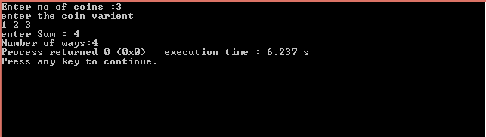

RESULT:-
Thus the number of ways to form the given sum using the given coins is executed and the output is verified

QUESTION : -
Given weights and values of n items, put these items in a knapsack of capacity W to get the maximum total value in the knapsack. In other words, given two integer arrays val[0..n-1] and wt[0..n-1] which represent values and weights associated with n items respectively. Also given an integer W which represents knapsack capacity, find out the maximum value subset of val[] such that sum of the weights of this subset is smaller than or equal to W. You cannot break an item, either pick the complete item, or don’t pick it (0-1 property).

INPUT : -

5
1 4 5 7 4
1 3 4 5 2
9

OUTPUT :-

13

Ex No: | 0-1 KNAPSACK
Date: | 0-1 KNAPSACK

AIM : -

To attain the maximum profit for the given weight

PSEUDOCODE:-
int find(int val[],int wei[],int w, int n)
{

if (n == 0 || w == 0)
return 0;

if (wei[n-1] > w)
return find(val,wei,w,n-1);

else return max(val,wei,val[n-1] + find(w-wei[n-1], n-1),
find(val,wei,w,n-1)
);
}
ALGORITHM:-
#include<stdio.h>

int max(int a, int b) {
if(a>b)
return a;
else
return b;
}

int find(int val[], int wei[], int w, int n)
{
int i, j;
int K[n+1][w+1];

for (i = 0; i <= n; i++)
{
for (j = 0; j <= w; j++)
{
if (i==0 || j==0)
K[i][j] = 0;
else if (wei[i-1] <= j)
K[i][j] = max(val[i-1] + K[i-1][j-wei[i-1]], K[i-1][j]);
else
K[i][j] = K[i-1][j];
}
}

return K[n][w];
}

int main()
{int n;
printf("ENTER THE NUMBER OF WEIGHT AVAILABLE : ");
scanf("%d",&n);
int val[n],wei[n],w,i;
printf("ENTER THE VALUES : \n");
for(i=0;i<n;i++)
scanf("%d",&val[i]);
printf("ENTER THE WEIGHTS :\n");
for(i=0;i<n;i++)
scanf("%d",&wei[i]);
printf("ENTER THE SUM : ");
scanf("%d",&w);

printf("MAXIMUM PROFIT : %d",find(val,wei,w,n));
return 0;
}

OUTPUT:-
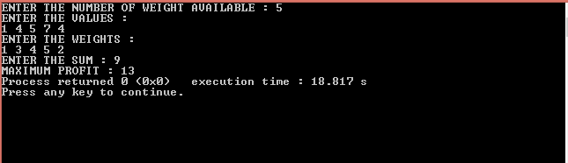

RESULT:-
Thus the maximum profit for a given sum is executed and the output is verified

QUESTION:
Find the optimum Binary Search(minimum cost) Tree for a given vertices

INPUT : -

4
12 15 20 25
4 3 6 2

OUTPUT : -

27

Ex No: | OPTIMAL BINARY SEARCH TREE
Date: | OPTIMAL BINARY SEARCH TREE

AIM:-
To find the optimal binary Search Tree (Minimum cost tree)

PSEUDOCODE :-
int optCost(int freq[], int i, int j)
{
if (j < i)
return 0;
if (j == i)
return freq[i];

int fsum = sum(freq, i, j);
int min = INT_MAX;
for (int r = i; r <= j; ++r)
{
int cost = optCost(freq, i, r-1) +
optCost(freq, r+1, j);
if (cost < min)
min = cost;
}
return min + fsum;
}

int optimalSearchTree(int vertex[], int freq[], int n)
{
return optCost(freq, 0, n-1);
}

ALGORITHM : -

#include <stdio.h>
#include <limits.h>
int sum(int freq[], int i, int j);
int optimalBinarySearchTree(int keys[], int freq[], int n)
{
int cost[n][n],i,L;
for (i = 0; i < n; i++)
cost[i][i] = freq[i];
for (L=2; L<=n; L++)
{
for (i=0; i<=n-L+1; i++)
{
int j = i+L-1,r;
cost[i][j] = INT_MAX;
for (r=i; r<=j; r++)
{
int c =0;
if(r > i)
{
c=c+cost[i][r-1];
}
else
{
c=c+0;
}
if(r < j)
{
c=c+cost[r+1][j];
}
else{
c=c+0;
}
c=c+sum(freq, i, j);
if (c < cost[i][j])
cost[i][j] = c;
}
}
}
return cost[0][n-1];
}

int sum(int freq[], int i, int j)
{
int s = 0,k;
for (k = i; k <=j; k++)
s += freq[k];
return s;
}

int main()
{
int n,i ;
printf("enter number of nodes \n");
scanf("%d",&n);
int vertex[n];
int freq[n];
printf("Enter the vertices : \n");
for(i=0;i<n;i++)
{
scanf("%d",&vertex[i]);
}
printf("Enter the Respective frequencies \n");
for(i=0;i<n;i++)
{
scanf("%d",&freq[i]);
}
printf("Cost of Optimal BST is %d ",optimalBinarySearchTree(vertex, freq, n));
return 0;
}

OUTPUT:-
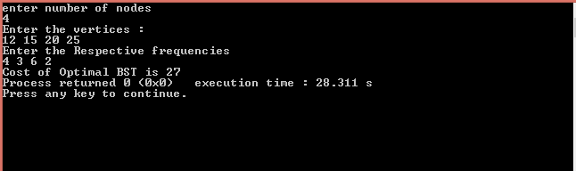

RESULT: -
Thus the program to find optimal binary search tree is executed and the output is verified

QUESTION:-

Given a sequence of matrices, find the most efficient way to multiply these matrices together. The problem is not actually to perform the multiplications, but merely to decide in which order to perform the multiplications.

Input :-

3 4 5 6 2 5

Output :-

154

Ex No: | MATRIX CHAIN MULTIPLICATION
Date: | MATRIX CHAIN MULTIPLICATION

AIM:-

To find the minimum number of multiplication of the multi matrix

PSEUDOCODE : -

int MatrixChain(int p[], int i, int j)
{
if(i == j)
return 0;
int k;
int min = INT_MAX;
int count;
for (k = i; k <j; k++)
{
count = MatrixChainOrder(p, i, k) +
MatrixChainOrder(p, k+1, j) +
p[i-1]*p[k]*p[j];

if (count < min)
min = count;
}
return min;
}

ALGORITHM :-

#include<stdio.h>
#include<limits.h>
int MatrixChain(int p[], int n)
{
int m[n][n];
int i, j, k, L, min;
for (i=1; i<n; i++)
m[i][i] = 0;
for (L=2; L<n; L++)
{
for (i=1; i<n-L+1; i++)
{
j = i+L-1;
m[i][j] = INT_MAX;
for (k=i; k<=j-1; k++)
{
min = m[i][k] + m[k+1][j] + p[i-1]*p[k]*p[j];
if (min < m[i][j])
m[i][j] = min;
}
}
}

return m[1][n-1];
}

int main()
{
int arr[100],n,i;
printf("enter the number of matrix :");
scanf("%d",&n);
printf("Enter the sequence of Matrix \n");
for(i=0;i<=n;i++){
scanf("%d",&arr[i]);
}

printf("Minimum number of multiplications is %d ",MatrixChain(arr, n+1));
return 0;
}

OUTPUT :-

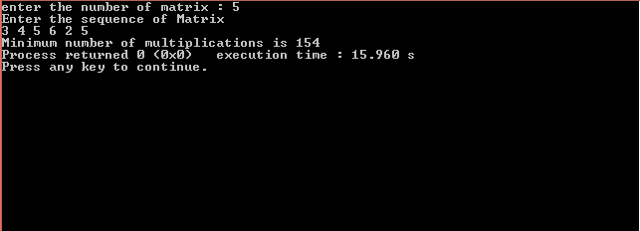

RESULT :-
Thus the minimum multiplication cost of the given set of matrix is compiled and the output is verified

QUESTION:
Given a set of non-negative integers, and a value sum, determine if there is a subset of the given set with sum equal to given sum.

INPUT:
Array size:3
Array value:1 , 2 , 3
Expected sum:6

OUTPUT:
Subset found

Ex No: | SUBSET SUM
Date: | SUBSET SUM

AIM:
To find if there is any sum of subset for a given sum

PSEUDOCODE:

bool isSubsetSum(int set[], int n, int sum)
{
if (sum == 0)
return true;
if (n == 0 && sum != 0)
return false;
if (set[n-1] > sum)
return isSubsetSum(set, n-1, sum);

return isSubsetSum(set, n-1, sum) || isSubsetSum(set, n-1, sum-set[n-1]);
}

ALGORITHM:
#include <stdio.h>
int isSum(int set[], int n, int sum)
{
int subset[n+1][sum+1],i,j;

for (i = 0; i <= n; i++)
subset[i][0] = 1;

for (i = 1; i <= sum; i++)
subset[0][i] = 0;
for (i = 1; i <= n; i++)
{
for (j = 1; j <= sum; j++)
{
if(j<set[i-1])
subset[i][j] = subset[i-1][j];
if (j >= set[i-1])
subset[i][j] = subset[i-1][j] ||
subset[i - 1][j-set[i-1]];
}
}

return subset[n][sum];
}

int main()
{
int n,i,sum;
printf("enter the size of array :");
scanf("%d",&n);
int arr[n];
printf("Enter the elements in array : ");
for(i=0;i<n;i++){
scanf("%d",&arr[i]);
}
printf("Enter the expected sum : ");
scanf("%d",&sum);
if (isSum(arr, n, sum) == 1)
printf("Found");
else
printf("Not Found");
return 0;
}

OUTPUT:-
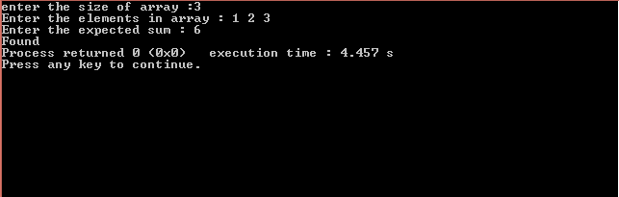

Result:
Thus the program to print found ,Is the sum available in subset or not is compiled and the output is verified

N-QUEEN:
The N Queen is the problem of placing N chess queens on an N×N chessboard so that no two queens attack each other.

Input:
16

Output:

1 0 0 0 0 0 0 0 0 0 0 0 0 0 0 0
0 0 0 1 0 0 0 0 0 0 0 0 0 0 0 0
0 1 0 0 0 0 0 0 0 0 0 0 0 0 0 0
0 0 0 0 0 0 0 0 0 0 0 0 1 0 0 0
0 0 1 0 0 0 0 0 0 0 0 0 0 0 0 0
0 0 0 0 0 0 0 0 0 1 0 0 0 0 0 0
0 0 0 0 0 0 0 0 0 0 0 1 0 0 0 0
0 0 0 0 0 0 0 0 0 0 0 0 0 0 1 0
0 0 0 0 0 1 0 0 0 0 0 0 0 0 0 0
0 0 0 0 0 0 0 0 0 0 0 0 0 0 0 1
0 0 0 0 0 0 0 0 0 0 0 0 0 1 0 0
0 0 0 0 0 0 0 1 0 0 0 0 0 0 0 0
0 0 0 0 1 0 0 0 0 0 0 0 0 0 0 0
0 0 0 0 0 0 1 0 0 0 0 0 0 0 0 0
0 0 0 0 0 0 0 0 1 0 0 0 0 0 0 0
0 0 0 0 0 0 0 0 0 0 1 0 0 0 0 0

Ex No: | N-queen problem
Date: | N-queen problem

AIM:
Implement the N-queen problem using Backtracking.

PSEUDOCODE:
int isSafe(int board[N][N], int row, int col)
{
int i, j;
for (i = 0; i < col; i++)
if (board[row][i])
return 0;
for (i=row, j=col; i>=0 && j>=0; i--, j--)
if (board[i][j])
return 0;
for (i=row, j=col; j>=0 && i<N; i++, j--)
if (board[i][j])
return 0;
return 1;
}

int solveNQUtil(int board[N][N], int col)
{
if (col >= N)
return 1;
int i;
for ( i = 0; i < N; i++)
{
if ( isSafe(board, i, col) )
{
board[i][col] = 1;

if ( solveNQUtil(board, col + 1) )
return 1;

board[i][col] = 0;
}
}

return 0;
}

ALGORITHM:

#include<stdio.h>
int N;
void printSolution(int board[N][N])
{
int i,j;
for ( i = 0; i < N; i++)
{
for ( j = 0; j < N; j++)
printf(" %d ", board[i][j]);
printf("\n");
}
}

int isSafe(int board[N][N], int row, int col)
{
int i, j;

for (i = 0; i < col; i++)
if (board[row][i])
return 0;

for (i=row, j=col; i>=0 && j>=0; i--, j--)
if (board[i][j])
return 0;

for (i=row, j=col; j>=0 && i<N; i++, j--)
if (board[i][j])
return 0;

return 1;
}

int solveNQUtil(int board[N][N], int col)
{

if (col >= N)
return 1;
int i;
for ( i = 0; i < N; i++)
{

if ( isSafe(board, i, col) )
{
board[i][col] = 1;

if ( solveNQUtil(board, col + 1) )
return 1;

board[i][col] = 0;
}
}

return 0;
}

int solveNQ()
{
int i,j;
int board[N][N];
for(i=0;i<N;i++)
{
for(j=0;j<N;j++)
{
board[i][j]=0;
}
}

if ( solveNQUtil(board, 0) == 0 )
{
printf("Solution does not exist");
return 0;
}

printSolution(board);
return 1;
}

int main()
{
printf("enter the number of queens");
scanf("%d",&N);
solveNQ();
return 0;
}

OUTPUT:
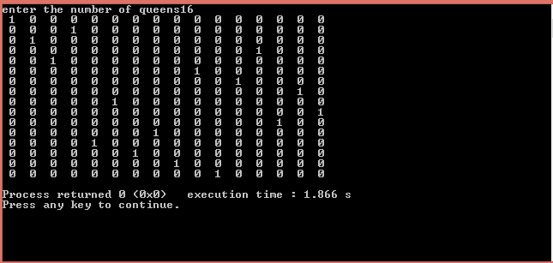

RESULT:
Thus the program to implement the N-queen problem was implemented and the output was verified.

QUESTION : -
Given n rectangular buildings in a 2-dimensional city, computes the skyline of these buildings, eliminating hidden lines. The main task is to view buildings from a side and remove all sections that are not visible.
All buildings share common bottom and every building is represented by triplet
(left, right,height)
INPUT : -

[[1, 5, 11], [2, 7, 6], [3, 9, 13], [12, 16, 7], [14, 25, 3],
[19, 22, 18], [23, 29, 13], [24, 28, 4]]

---.
18 . +-----+
. | |
. | |
15 . | |
. | |
. +-----------+ | | +-----------+
. | | | | | |
. +---|----+ | | | | |
10 . | | | | | | | |
. | | | | | | | |
. | | | | | | | |
. | | | | +-------+ | | | |
. | +-|-------+ | | | | | | |
5 . | | | | | | | | | | | |
. | | | | | | | | | | | +-------+ |
. | | | | | | | +---------|-----|-|-|-+ | |
. | | | | | | | | | | | | | | | |
. | | | | | | | | | | | | | | | |
0 . . . . . . . . . . . . . . . . . . . . . . . . . . . . . . . . . . . . . .

OUTPUT:-

[[1, 11], [3, 13], [9, 0], [12, 7], [16, 3], [19, 18], [22, 3], [23, 13], [29, 0]]

18 . @-----+
. | |
. | |
15 . | |
. | |
. @-----------+ | | @-----------+
. | | | | | |
. @---| | | | | |
10 . | | | | | |
. | | | | | |
. | | | | | |
. | | @-------+ | | | |
. | | | | | | | |
5 . | | | | | | | |
. | | | | | | | |
. | | | @-----| @-| |
. | | | | | | | |
. | | | | | | | |
0 . . . . . . . . . @ . . . . . . . . . . . . . . . . . . . @ . .. . . ………….
0 5 10 15 20 25 30 .

Ex No: | SKYLINE-PROBLEM
Date: | SKYLINE-PROBLEM

AIM :-
To find the outer view co-ordinates of the building

PSEUDOCODE:-

for(i=0;i<n*n;i++)
{
if(arr[i].start==1){
insert(arr[i].height);
max=pri_que[front];
if(tempmax!=max){
printf("[%d , %d]\n",arr[i].x,max);
tempmax=max;
}
}
if(arr[i].start==0){
delete(arr[i].height);
max=pri_que[front];
if(tempmax!=max){
printf("[%d , %d]\n",arr[i].x,max);
tempmax=max;
}
}

ALGORITHM:-

#include<stdio.h>

void insert(int);
void delete(int);
void create();
void check(int);
void display_pqueue();

int pri_que[100];
int front=-1, rear=-1;

struct build{
int x;
int height;
int start;
}arr[100];

void create()
{
front = rear = -1;
}

void insert(int data)
{
if ((front == -1) && (rear == -1))
{
front++;
rear++;
pri_que[rear] = data;
return;
}
else
check(data);
rear++;
}

void check(int data)
{
int i,j;

for (i = 0; i <= rear; i++)
{
if (data >= pri_que[i])
{
for (j = rear + 1; j > i; j--)
{
pri_que[j] = pri_que[j - 1];
}
pri_que[i] = data;
return;
}
}
pri_que[i] = data;
}
void delete(int data)
{
int i;
for (i = 0; i <= rear; i++)
{
if (data == pri_que[i])
{
for (; i < rear; i++)
{
pri_que[i] = pri_que[i + 1];
}

pri_que[i] = -99;
rear--;

if (rear == -1)
front = -1;
return;
}
}
}

main(){
int i,n,left,right,height,j;
printf("enter no of building : ");
scanf("%d",&n);

int k=0;
for(i=0;i<n;i++){
scanf("%d %d %d",&left,&right,&height);
arr[k].x=left;
arr[k].height=height;
arr[k].start=1;

k++;

arr[k].x=right;
arr[k].height=height;
arr[k].start=0;

k++;
}

int temp;

for(i=0;i<k;i++)
{
for(j=i+1;j<k;j++){
//sort based on x
//dissimilar x
if(arr[i].x!=arr[j].x){
if(arr[i].x>arr[j].x){

temp=arr[i].x;
arr[i].x=arr[j].x;
arr[j].x=temp;

temp=arr[i].height;
arr[i].height=arr[j].height;
arr[j].height=temp;

temp=arr[i].start;
arr[i].start=arr[j].start;
arr[j].start=temp;

}
}
else if(arr[i].x!=arr[j].x){
if(arr[i].start==1&&arr[j].start==1){
if(arr[i].height<arr[j].height)
{
temp=arr[i].x;
arr[i].x=arr[j].x;
arr[j].x=temp;

temp=arr[i].height;
arr[i].height=arr[j].height;
arr[j].height=temp;

temp=arr[i].start;
arr[i].start=arr[j].start;
arr[j].start=temp;
}
}
if(arr[i].start==0&&arr[j].start==0){
if(arr[i].height>arr[j].height)
{
temp=arr[i].x;
arr[i].x=arr[j].x;
arr[j].x=temp;

temp=arr[i].height;
arr[i].height=arr[j].height;
arr[j].height=temp;

temp=arr[i].start;
arr[i].start=arr[j].start;
arr[j].start=temp;
}

}
if(arr[i].start==0&&arr[j].start==0){
if(arr[i].height<arr[j].height)
{
temp=arr[i].x;
arr[i].x=arr[j].x;
arr[j].x=temp;

temp=arr[i].height;
arr[i].height=arr[j].height;
arr[j].height=temp;

temp=arr[i].start;
arr[i].start=arr[j].start;
arr[j].start=temp;
}

}
}
}
}

int tempmax=0,max=0;

printf("\nThe co-ordinates of skyline are : \n");
for(i=0;i<k;i++)
{
if(arr[i].start==1){
insert(arr[i].height);
max=pri_que[front];
if(tempmax!=max){
printf("[%d , %d]\n",arr[i].x,max);
tempmax=max;
}
}
if(arr[i].start==0){
delete(arr[i].height);
max=pri_que[front];
if(tempmax!=max){
printf("[%d , %d]\n",arr[i].x,max);
tempmax=max;
}
}

}

}

OUTPUT : -
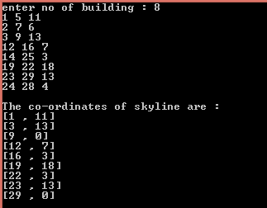

RESULT : -
Thus the skyline program is executed and the output is verified

QUESTION: -

Given a set of cities and distance between every pair of cities, the problem is to find the minimum cost of route that visits every city exactly once and returns to the starting point.

INPUT:-

Enter the Adjacency Matrix

0 10 15 20
5 0 9 10
6 13 0 12
8 8 9 0

OUTPUT : -

The Travelling sales man distance is : 35

Ex No: | TRAVELLING SALESMAN PROBLEM
Date: | TRAVELLING SALESMAN PROBLEM

AIM : -

To find the minimum cost of travelling from the starting vertex and return back to the same vertex by visiting all other vertex exactly ones

PSEUDOCODE :-

int tsp(int mask,int pos){

if(mask==VISITED_ALL){
return dist[pos][0];
}

int ans = INT_MAX , city;
for(city=0;city<n;city++){

if((mask&(1<<city))==0){

int newAns = dist[pos][city] + tsp( mask|(1<<city), city);
ans = min(ans, newAns);
}

}

return ans;
}

ALGORITHM : -

#include<stdio.h>
#define INT_MAX 999999

int n=4,i,j;
int dist[10][10];
int VISITED_ALL;
int dp[16][4];

int min(int x,int y){
if(x<y){
return x;
}
else if (x>y){
return y;
}
else{
return x;
}
}

int tsp(int mask,int pos){

if(mask==VISITED_ALL){
return dist[pos][0];
}
if(dp[mask][pos]!=-1){
return dp[mask][pos];
}
int ans = INT_MAX,city;
for(city=0;city<n;city++){

if((mask&(1<<city))==0){

int newAns = dist[pos][city] + tsp( mask|(1<<city), city);
ans = min(ans, newAns);
}

}

return dp[mask][pos] = ans;
}

int main(){

VISITED_ALL = (1<<n) -1;
for(i=0;i<n;i++){
for(j=0;j<n;j++)
scanf("%d",&dist[i][j]);
}
for(i=0;i<(1<<n);i++){
for(j=0;j<n;j++){
dp[i][j] = -1;
}
}
printf("Travelling Saleman Distance is %d",tsp(1,0));

return 0;
}

OUTPUT :-

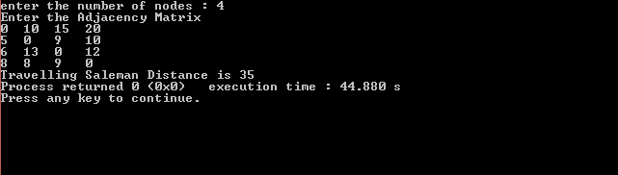

RESULT : -
Thus the minimum cost of traveling from the starting vertex and comes back to the same vertex with visiting all nodes exactly ones is executed and the output is verified

QUESTION:

Hamiltonian Path in an undirected graph is a path that visits each vertex exactly once. A Hamiltonian cycle (or Hamiltonian circuit) is a Hamiltonian Path such that there is an edge (in graph) from the last vertex to the first vertex of the Hamiltonian Path.

INPUT

0 1 0 1 0
1 0 1 1 1
0 1 0 0 1
1 1 0 0 1
0 1 1 1 0

OUTPUT

0->1->2->4->3->0

Ex No: | HAMILTONIAN PATH PROBLEM
Date: | HAMILTONIAN PATH PROBLEM

AIM
To implement algorithm for Hamiltonian Cycle

PSEUDOCODE

function check_all_permutations(adj[][], n)
for i = 0 to n
p[i]=i
while next permutation is possible
valid = true
for i = 0 to n-1
if adj[p[i]][p[i+1]] == false
valid = false
break
if valid == true
return true
p = get_next_permutation(p)
return false

ALGORITHM:

#include<stdio.h>
int V;

void printSolution(int path[]);
int isSafe(int v, int graph[V][V], int path[], int pos)
{
int i;
if (graph [ path[pos-1] ][ v ] == 0)
return 0;
for (i = 0; i < pos; i++)
if (path[i] == v)
return 0;
return 1;
}
int hamCycleUtil(int graph[V][V], int path[], int pos)
{
int v;
if (pos == V)
{
if ( graph[ path[pos-1] ][ path[0] ] == 1 )
return 1;
else
return 0;
}
for (v = 1; v < V; v++)
{
if (isSafe(v, graph, path, pos))
{
path[pos] = v;
if (hamCycleUtil (graph, path, pos+1) == 1)
return 1;
path[pos] = -1;
}
}
return 0;
}
int hamCycle(int graph[V][V])
{
int i;
int path[5];
for (i = 0; i < V; i++)
path[i] = -1;
path[0] = 0;
if ( hamCycleUtil(graph, path, 1) == 0 )
{
printf("\nSolution does not exist");
return 0;
}

print(path);
return 1;
}

void print(int path[])
{
int i;
printf ("Hamiltonian Cycle is\n");
for (i = 0; i < V; i++)
printf("%d->", path[i]);
printf(" %d ", path[0]);
printf("\n");
}

int main()
{
int i,j;
printf("Enter the number of vertex : ");
scanf("%d",&V);
int graph[V][V];
printf("Enter the adjacency matrix for hamiltonian cycle\n");
for(i=0;i<V;i++){
for(j=0;j<V;j++){
scanf("%d",&graph[i][j]);
}
}
hamCycle(graph);
return 0;
}

OUTPUT :

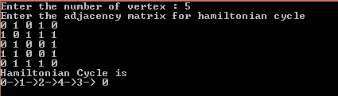

RESULT:
Thus the hamiltonian path is implimented and the output is verified

QUESTION :
To find the minimum spanning tree (minimum cost) using Prim’s Algorithm

INPUT :
0 2 0 6 0
2 0 3 8 5
0 3 0 0 7
6 8 0 0 9
0 5 7 9 0

OUTPUT :

1 -> 1 : cost=2
2 -> 2 : cost=3
3 -> 2 : cost=5
4 -> 1 : cost=4

Total cost of spanning tree=16

Ex No: | MST USING PRIM’S ALGORITHM
Date: | MST USING PRIM’S ALGORITHM

AIM :
To find the minimum spanning tree using prim’s algorithm
PSEUDOCODE :
ne=1
while(ne < n)
{
for(i=1,min=999;i<=n;i++)
for(j=1;j<=n;j++)
if(cost[i][j]< min)
if(visited[i]!=0)
{
min=cost[i][j];
a=u=i;
b=v=j;
}
if(visited[u]==0 || visited[v]==0)
{
printf("\n Edge %d:(%d %d) cost:%d",ne++,a,b,min);
mincost+=min;
visited[b]=1;
}
cost[a][b]=cost[b][a]=999;
}
return mincost

ALGORITHM:

#include<stdio.h>

int a,b,u,v,n,i,j,ne=1;
int visited[10]={0},min,mincost=0,cost[10][10];
void main()
{
printf("\nEnter the number of nodes:");
scanf("%d",&n);
printf("\nEnter the adjacency matrix:\n");
for(i=1;i<=n;i++)
for(j=1;j<=n;j++)
{
scanf("%d",&cost[i][j]);
if(cost[i][j]==0)
cost[i][j]=999;
}
visited[1]=1;
printf("\n");
while(ne < n)
{
for(i=1,min=999;i<=n;i++)
for(j=1;j<=n;j++)
if(cost[i][j]< min)
if(visited[i]!=0)
{
min=cost[i][j];
a=u=i;
b=v=j;
}
if(visited[u]==0 || visited[v]==0)
{
printf("\n %d -> %d : cost:%d",ne++,a,b,min);
mincost+=min;
visited[b]=1;
}
cost[a][b]=cost[b][a]=999;
}

printf("\n Minimun cost=%d",mincost);
}

OUTPUT :

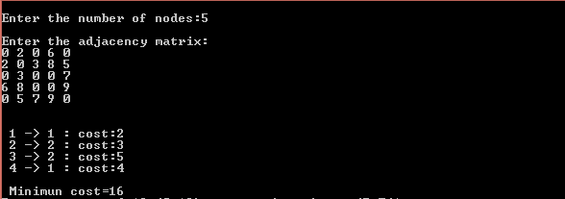

RESULT:
Thus the MST using prim’s algorithm is implemented and the output is verified

QUESTION :
To find the minimum spanning tree using Kruskal’s Algorithm

INPUT :

0 3 1 6 0 0
3 0 5 0 3 0
1 5 0 5 6 4
6 0 5 0 0 2
0 3 6 0 0 6
0 0 4 2 6 0

OUTPUT:

1 -> 1 : cost=3
2 -> 4 : cost=6
3 -> 1 : cost=2
4 -> 2 : cost=5
5 -> 3 : cost=6
Minimum cost = 13

Ex No: | KRUSKAL’S ALGORITHM
Date: | KRUSKAL’S ALGORITHM

AIM :
To find the minimum spanning tree using Kruskal’s Algorithm

PSEUDOCODE

MST-KRUSKAL(G, w)
A ← Ø
for each vertex v V[G]
do MAKE-SET(v)
sort the edges of E into non-decreasing order by weight w
for each edge (u, v) E, taken in non-decreasing order by weight
do if FIND-SET(u) ≠ FIND-SET(v)
then A ← A {(u, v)}
UNION(u, v)
return A

ALGORITHM:
#include<stdio.h>
int i,j,k,a,b,u,v,n,ne=1;
int min,mincost=0,cost[9][9],parent[9];
int find(int);
int uni(int,int);
void main()
{
printf("\nEnter the no. of vertices:");
scanf("%d",&n);
printf("\nEnter the cost adjacency matrix:\n");
for(i=1;i<=n;i++)
{
for(j=1;j<=n;j++)
{
scanf("%d",&cost[i][j]);
if(cost[i][j]==0)
cost[i][j]=999;
}
}
printf("The edges of Minimum Cost Spanning Tree are\n");
while(ne < n)
{
for(i=1,min=999;i<=n;i++)
{
for(j=1;j <= n;j++)
{
if(cost[i][j] < min)
{
min=cost[i][j];
a=u=i;
b=v=j;
}
}
}
u=find(u);
v=find(v);
if(uni(u,v))
{
printf("\n %d -> %d : cost=%d",ne++,a,b,min);
mincost +=min;
}
cost[a][b]=cost[b][a]=999;
}
printf("\n\tMinimum cost = %d\n",mincost);
}
int find(int i)
{
while(parent[i])
i=parent[i];
return i;
}
int uni(int i,int j)
{
if(i!=j)
{
parent[j]=i;
return 1;
}
return 0;
}

OUTPUT :

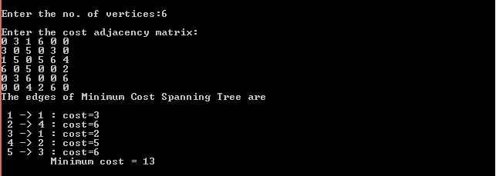

RESULT:
Thus the MST using Kruskal’s Algorithm is implemented and the output is verified

QUESTION :
Finding the shortest path using Dijkstra’s Algorithm

INPUT :

0 10 0 30 100
10 0 50 0 0
0 50 0 20 10
30 0 20 0 60
100 0 10 60 0

OUTPUT:

Enter the starting node:: 1

Distance of 0 = 10
Path = 0 <=1
Distance of 2 = 50
Path = 2 <=1
Distance of 3 = 40
Path = 3 <= 0 <=1
Distance of 4 = 60
Path = 4 <= 2 <=1

Ex No: | DIJKSTRA’S ALGORITHM
Date: | DIJKSTRA’S ALGORITHM

AIM :
To find single source shortest path using Dijkstra’s Algorithm

PSEUDOCODE :

DIJKSTRA(G,s)
INITIALIZE-SINGLE-SOURCE(G, S)
S ← Ø
Q ← V[G]
while Q ≠ Ø
do u ← EXTRACT-MIN(Q)
S ← S U {u}
for each vertex v ∈ Adj[u]
do if dist[v] > dist[u] + w(u,v)
then d[v] ←d[u] + w(u,v)

ALGORITHM:

#include<stdio.h>
#define MAX 10

void dijikstra(int G[MAX][MAX], int n, int startnode);

void main(){
int G[MAX][MAX], i, j, n, u;
printf("\nEnter the no. of vertices:: ");
scanf("%d", &n);
printf("\nEnter the adjacency matrix::\n");
for(i=0;i < n;i++)
for(j=0;j < n;j++)
scanf("%d", &G[i][j]);
printf("\nEnter the starting node:: ");
scanf("%d", &u);
dijikstra(G,n,u);
getch();
}

void dijikstra(int G[MAX][MAX], int n, int startnode)
{
int cost[MAX][MAX], distance[MAX], pred[MAX];
int visited[MAX], count, mindistance, nextnode, i,j;
for(i=0;i < n;i++)
for(j=0;j < n;j++)
if(G[i][j]==0)
cost[i][j]=9999;
else
cost[i][j]=G[i][j];

for(i=0;i< n;i++)
{
distance[i]=cost[startnode][i];
pred[i]=startnode;
visited[i]=0;
}
distance[startnode]=0;
visited[startnode]=1;
count=1;
while(count < n-1){
mindistance=9999;
for(i=0;i < n;i++)
if(distance[i] < mindistance&&!visited[i])
{
mindistance=distance[i];
nextnode=i;
}
visited[nextnode]=1;
for(i=0;i < n;i++)
if(!visited[i])
if(mindistance+cost[nextnode][i] < distance[i])
{
distance[i]=mindistance+cost[nextnode][i];
pred[i]=nextnode;
}
count++;
}
for(i=0;i < n;i++)
if(i!=startnode)
{
printf("\nDistance of %d = %d", i, distance[i]);
printf("\nPath = %d", i);
j=i;
do
{
j=pred[j];
printf(" <-%d", j);
}
while(j!=startnode);
}
}
OUTPUT :

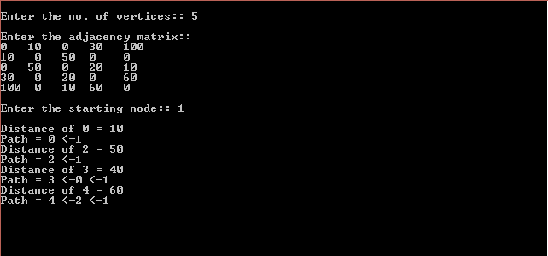

RESULT:
Thus the single source shortest path is implemented using Dijkstra’s Algorithm and the output is verified

QUESTION :
To find the closest pair of points using closest pair algorithm

INPUT :

(1, 1) , (2, 8) , (5, 2) , (2, 9) , (8, 9)

OUTPUT:

The closest two points are (2,8) and (2,9)

Ex No: | CLOSEST PAIR ALGORITHM
Date: | CLOSEST PAIR ALGORITHM

AIM :
To find the closest points using closest pair algorithm

PSEUDOCODE :

double shortestDistance = getDistance( points[p1][0], points[p1][1], points[p2][0], points[p2][1]);
for ( i=0;i<NUMBER_OF_POINTS;i++){
for ( j=i+1;j<NUMBER_OF_POINTS;j++){
double distance=getDistance(points[i][0],points[i][1],points[j][0],points[j][1]);

if(shortestDistance > distance){
p1=i;
p2=j;
shortestDistance = distance;
}
}
}

ALGORITHM:

#include <stdio.h>
#include <math.h>

double getDistance (double x1,double y1, double x2, double y2)
{
return (sqrt((x2-x1)*(x2-x1) + (y2-y1)*(y2-y1)));
}

int main(){
int i,j=0;
int NUMBER_OF_POINTS;
printf("enter number of points :");
scanf("%d",&NUMBER_OF_POINTS);
double points[NUMBER_OF_POINTS][2];
printf ("Enter %d points: \n" , NUMBER_OF_POINTS );
for(i=0; i< NUMBER_OF_POINTS;i++)
{
scanf ("%lf", &points[i][0]);
scanf ("%lf", &points[i][1]);
}

int p1=0,p2=1;
double shortestDistance = getDistance( points[p1][0], points[p1][1], points[p2][0], points[p2][1]);
for ( i=0;i<NUMBER_OF_POINTS;i++){
for ( j=i+1;j<NUMBER_OF_POINTS;j++){
double distance=getDistance(points[i][0],points[i][1],points[j][0],points[j][1]);

if(shortestDistance > distance){
p1=i;
p2=j;
shortestDistance = distance;
}
}
}

printf ("The closest two points are (%.0lf,%.0lf) and (%.0lf,%.0lf) \n", points[p1][0],points[p1][1],points[p2][0],points[p2][1]);
return 0;
}

OUTPUT :

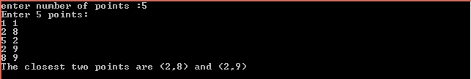

RESULT:
Thus the closest pair Algorithm is implemented and the output is verified

QUESTION :
Given a set of points .Your task is to find the set of points which includes all the other points inside i.e should compute the boundary in which all other points lies inside the boundary

INPUT :

{0, 3}, {2, 2}, {1, 1}, {2, 1}, {3, 0}, {0, 0}, {3, 3}

OUTPUT :

(0,3) , (0,0) , (3,0) , (3,3)

Ex No: | CONVEX HULL ALGORITHM
Date: | CONVEX HULL ALGORITHM

AIM :
To construct convex hull points using Convex Hull Algorithm

PSEUDOCODE :

void convexHull(struct Point points[], int n)
{
if (n < 3) return;
struct Point hull[100];
int k=0;
int l = 0,i;
for (i = 1; i < n; i++)
if (points[i].x < points[l].x)
l = i;
int p = l, q;
do
{
hull[k]=points[p];
k++;
q = (p+1)%n;
for ( i = 0; i < n; i++)
{
if (orientation(points[p], points[i], points[q]) == 2)
q = i;
}
p = q;
} while (p != l);
for (i = 0; i <k; i++)
printf("(%d,%d)\n",hull[i].x ,hull[i].y );
}

ALGORITHM:

#include<stdio.h>

struct Point
{
int x, y;
};

int orientation(struct Point p, struct Point q, struct Point r)
{
int val = (q.y - p.y) * (r.x - q.x) -
(q.x - p.x) * (r.y - q.y);

if (val == 0) return 0;
return (val > 0)? 1: 2;
}

void convexHull(struct Point points[], int n)
{
if (n < 3) return;
struct Point hull[100];
int k=0;
int l = 0,i;
for (i = 1; i < n; i++)
if (points[i].x < points[l].x)
l = i;

int p = l, q;
do
{
hull[k]=points[p];
k++;
q = (p+1)%n;
for ( i = 0; i < n; i++)
{
if (orientation(points[p], points[i], points[q]) == 2)
q = i;
}
p = q;

} while (p != l);
for (i = 0; i <k; i++)
printf("(%d,%d)\n",hull[i].x ,hull[i].y );
}

int main()
{
struct Point points[100];
int n,i;
printf("Enter number of points :");
scanf("%d",&n);
printf("Enter the points : \n");
for(i=0;i<n;i++)
{
scanf("%d %d",&points[i].x,&points[i].y);
}
convexHull(points, n);
return 0;
}

OUTPUT :

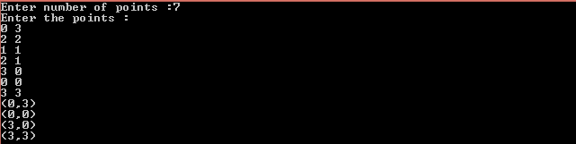

RESULT:
Thus the Convex Hull Algorithm is implemented and the output is verified

QUESTION :

Given a problem consists of n jobs each associated with a deadline and profit and our objective is to earn maximum profit. We will earn profit only when job is completed on or before deadline. We assume that each job will take unit time to complete.

INPUT:

Consider the following 5 jobs and their associated deadline and profit.
index | 1 | 2 | 3 | 4 | 5
JOB | j1 | j2 | j3 | j4 | j5
DEADLINE | 2 | 1 | 3 | 2 | 1
PROFIT | 60 | 100 | 20 | 40 | 20

OUTPUT :

Required Jobs : j2 => j1 => j3
Max Profit : 180

Ex No: | JOB SEQUENCING ALGORITHM
Date: | JOB SEQUENCING ALGORITHM

AIM :
To find the maximum profit of the scheduled jobs within the deadlines

PSEUDOCODE:

for i = 1 to n do
Set k = min(dmax, DEADLINE(i))
while k >= 1 do
if timeslot[k] is EMPTY then
timeslot[k] = job(i)
break
endif
Set k = k - 1
endwhile
endfor

ALGORITHM:

#include <stdio.h>
#define MAX 100
int dmax = 0;

typedef struct Job {
char id[10];
int deadline;
int profit;
} Job;

void jobSequencingWithDeadline(Job jobs[], int n);

int minValue(int x, int y) {
if(x < y) return x;
return y;
}

int main(void) {
int i, j;
Job jobs[100];
int n;
printf("Enter Number of Jobs :");
scanf("%d",&n);
printf("Enter the Job name with deadline and profit : \n");
for(i=0;i<n;i++)
{
scanf("%s %d %d",jobs[i].id,&jobs[i].deadline,&jobs[i].profit);
if(jobs[i].deadline > dmax) {
dmax = jobs[i].deadline;
}
}
Job temp;
for(i = 1; i < n; i++) {
for(j = 0; j < n - i; j++) {
if(jobs[j+1].profit > jobs[j].profit) {
temp = jobs[j+1];
jobs[j+1] = jobs[j];
jobs[j] = temp;
}
}
}
jobSequencingWithDeadline(jobs, n);
return 0;
}

void jobSequencingWithDeadline(Job jobs[], int n) {
int i, j, k, maxprofit;
int timeslot[MAX];
int filledTimeSlot = 0;

printf("\ndeadline: %d\n", dmax);

for(i = 1; i <= dmax; i++) {
timeslot[i] = -1;
}

for(i = 1; i <= n; i++) {
k = minValue(dmax, jobs[i - 1].deadline);
while(k >= 1) {
if(timeslot[k] == -1) {
timeslot[k] = i-1;
filledTimeSlot++;
break;
}
k--;
}

if(filledTimeSlot == dmax) {
break;
}
}

printf("\nRequired Jobs: ");
for(i = 1; i <= dmax; i++) {
printf("%s", jobs[timeslot[i]].id);

if(i < dmax) {
printf(" --> ");
}
}

maxprofit = 0;
for(i = 1; i <= dmax; i++) {
maxprofit += jobs[timeslot[i]].profit;
}
printf("\nMax Profit: %d\n", maxprofit);
}

OUTPUT :

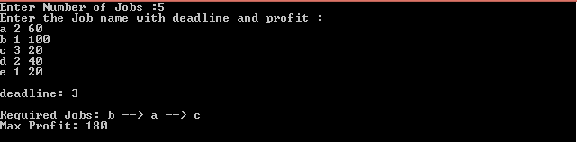

RESULT:
Thus the maximum profit for a given deadline is implemented and the output is verified

QUESTION :
Given a 2x2 matrix . Ordinary matrix multiplication computes eight steps to get the result .Your task is to multiply the given matrix in seven steps

INPUT :

| 1 2 | X | 5 6 |
| 3 4 | | 7 8 |

OUTPUT:

| 19 22 |
| 43 50 |

Ex No: | STRASSEN’S MATRIX MULTIPLICATION
Date: | STRASSEN’S MATRIX MULTIPLICATION

AIM:
To implement matrix multiplication using strassen’s algorithm
PSEUDOCODE :

m1= (a[0][0] + a[1][1]) * (b[0][0] + b[1][1]);
m2= (a[1][0] + a[1][1]) * b[0][0];
m3= a[0][0] * (b[0][1] - b[1][1]);
m4= a[1][1] * (b[1][0] - b[0][0]);
m5= (a[0][0] + a[0][1]) * b[1][1];
m6= (a[1][0] - a[0][0]) * (b[0][0]+b[0][1]);
m7= (a[0][1] - a[1][1]) * (b[1][0]+b[1][1]);

c[0][0] = m1 + m4- m5 + m7;
c[0][1] = m3 + m5;
c[1][0] = m2 + m4;
c[1][1] = m1 - m2 + m3 + m6;

ALGORITHM:
#include<stdio.h>
int main(){
int a[2][2], b[2][2], c[2][2], i, j;
int m1, m2, m3, m4 , m5, m6, m7;

printf("Enter the 4 elements of first matrix: \n");
for(i = 0;i < 2; i++)
for(j = 0;j < 2; j++)
scanf("%d", &a[i][j]);

printf("Enter the 4 elements of second matrix: \n");
for(i = 0; i < 2; i++)
for(j = 0;j < 2; j++)
scanf("%d", &b[i][j]);

m1= (a[0][0] + a[1][1]) * (b[0][0] + b[1][1]);
m2= (a[1][0] + a[1][1]) * b[0][0];
m3= a[0][0] * (b[0][1] - b[1][1]);
m4= a[1][1] * (b[1][0] - b[0][0]);
m5= (a[0][0] + a[0][1]) * b[1][1];
m6= (a[1][0] - a[0][0]) * (b[0][0]+b[0][1]);
m7= (a[0][1] - a[1][1]) * (b[1][0]+b[1][1]);

c[0][0] = m1 + m4- m5 + m7;
c[0][1] = m3 + m5;
c[1][0] = m2 + m4;
c[1][1] = m1 - m2 + m3 + m6;

printf("\nAfter multiplication using Strassen's algorithm \n");
for(i = 0; i < 2 ; i++){
printf("\n");
for(j = 0;j < 2; j++)
printf("%d\t", c[i][j]);
}
printf("\n");

return 0;
}

OUTPUT :

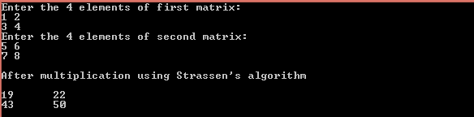

RESULT:
Thus 2x2 matrix multiplication is performed using strassen’s algorithm and the output is verified

QUESTION :

You are Given a graph G . Your task is to find the minimum number of colors used to color the vertices so that no two colors are adjacent to each others

INPUT :

Enter the number of nodes & edges
4 5
edge : 1
(0 1)
edge : 2
(1 3)
edge : 3
(3 2)
edge : 4
(2 1)
edge : 5
(1 0)

OUTPUT :

The Vertices To be Coloured As...
V1:=1
V2:=2
V3:=3
V4:=1
The Chromatic Number is 3

Ex No: | GRAPH COLORING PROBLEM
Date: | GRAPH COLORING PROBLEM

AIM :
To find the chromatic number of the given graph

PSEUDOCODE:

void Gen_Col_Value(int k,int n)
{
while(1)
{
a=color_tab[k]+1;
b=m+1;
color_tab[k] = a%b;
if(color_tab[k]==0) return;
for(j=1;j<=n;j++)
{
if(G[k][j] && color_tab[k]==color_tab[j])
break;
}
if(j==n+1) return;
}
}
void Gr_coloring(int k,int n)
{
Gen_Col_Value(k,n);
if(color_tab[k]==0) return;
if(k==n) return;
else Gr_coloring(k+1,n);
}

ALGORITHM:

#include<stdio.h>
int G[10][10],m,edges,color_tab[10],v1,v2,i,j,n,a,b;
void Gen_Col_Value(int,int);
void Gr_coloring(int,int);
int main()
{
printf("\nEnter the number of nodes & edges\n");
scanf("%d%d",&n,&edges);
m=n-1;
printf("\nEnter the edges of the graph\n\n");
for (i=1;i<=edges; i++)
{
printf("Enter starting and ending of edge : %d\n",i);
scanf("%d%d",&v1,&v2);
G[v1][v2] = G[v2][v1] = 1;
printf("\n");
}
Gr_coloring(1,n);
printf("\n The Vertices To be Coloured As...\n");
int max=0;
for(i=1;i<=n;i++){
printf("\n V%d:=%d",i,color_tab[i]);
if(color_tab[i]>max)
max=color_tab[i];
}
printf("\nThe chromatic color is %d",max);
return 0;
}
void Gen_Col_Value(int k,int n)
{
while(1)
{
a=color_tab[k]+1;
b=m+1;
color_tab[k] = a%b;
if(color_tab[k]==0) return;
for(j=1;j<=n;j++)
{
if(G[k][j] && color_tab[k]==color_tab[j])
break;
}
if(j==n+1) return;
}
}
void Gr_coloring(int k,int n)
{
Gen_Col_Value(k,n);
if(color_tab[k]==0) return;
if(k==n) return;
else Gr_coloring(k+1,n);
}

OUTPUT :

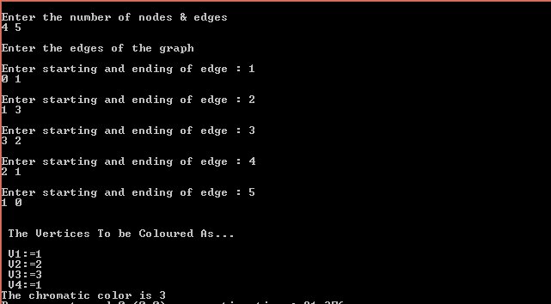

RESULT:
Thus the Chromatic number of the graph is found using graph coloring algorithm

QUESTION:
Given an array of unsorted elements . your task is to sort the array using randomised quick sort

INPUT :

3 4 5 78 62 1 9 6 8 3

OUTPUT :

1 3 3 4 5 6 8 9 62 78

Ex No: | RANDOMISED QUICK SORT
Date: | RANDOMISED QUICK SORT

AIM :
To sort the given array using randomised quick sort

PSEUDOCODE :

int partition_r(int arr[], int low, int high)
{
int temp;
srand(time(NULL));
int random = low + rand() % (high - low);

temp=arr[random];
arr[random]=arr[high];
arr[high]=temp;

return partition(arr, low, high);
}

int partition(int arr[], int low, int high)
{
int pivot = arr[high];
int i = (low - 1);

for (int j = low; j <= high - 1; j++) {
if (arr[j] <= pivot) {
i++;
swap(arr[i], arr[j]);
}
}
swap(arr[i + 1], arr[high]);
return (i + 1);
}

ALGORITHM:

#include<stdio.h>
int partition(int arr[], int low, int high)
{
int i,j,temp;
int pivot = arr[high];
i = (low - 1);

for (j = low; j <= high - 1; j++) {
if (arr[j] <= pivot) {

i++;
temp=arr[i];
arr[i]=arr[j];
arr[j]=temp;
}
}
temp=arr[i + 1];
arr[i + 1]=arr[high];
arr[high]=temp;
return (i + 1);
}

int partition_r(int arr[], int low, int high)
{
int temp;
srand(time(NULL));
int random = low + rand() % (high - low);

temp=arr[random];
arr[random]=arr[high];
arr[high]=temp;

return partition(arr, low, high);
}

void quickSort(int arr[], int low, int high)
{
if (low < high) {
int pivot = partition_r(arr, low, high);
quickSort(arr, low, pivot - 1);
quickSort(arr, pivot + 1, high);
}
}

void printArray(int arr[], int size)
{
int i;
for (i = 0; i < size; i++)
printf("%d ", arr[i]);
printf("\n");
}

int main()
{
int arr[100],n,i;
printf("Enter Number of elements to be sorted : ");
scanf("%d",&n);
printf("Enter the elements : \n");
for(i=0;i<n;i++){
scanf("%d",&arr[i]);
}
quickSort(arr, 0, n - 1);
printf("Sorted array after random quick sort: \n");
printArray(arr, n);
return 0;
}

OUTPUT :

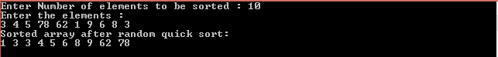

RESULT:
Thus the array is sorted and the output is verified using randomised quick sort

QUESTION :
The problem consist of a sorted array with positive numbers and a key X .your task is to find whether the element is present in the array using randomised search. If found return the index of the element present

INPUT :
ARR[ ]={25 , 30 , 33 , 87 , 121}
K=87

OUTPUT :
Element is present at index 3

Ex No: | RANDOMISED SEARCH
Date: | RANDOMISED SEARCH

AIM :
To search the element in the sorted array using randomised search algorithm
PSEUDOCODE :

int getRandom(int x, int y)
{
srand(time(NULL));
return (x + rand() % (y-x+1));
}
int randomizedBinarySearch(int arr[], int l,
int r, int x)
{
if (r >= l)
{
int mid = getRandom(l, r);
if (arr[mid] == x)
return mid;
if (arr[mid] > x)
return randomizedBinarySearch(arr, l,
mid-1, x);
return randomizedBinarySearch(arr, mid+1,
r, x);
}
return -1;
}

ALGORITHM:

#include<stdio.h>
int getRandom(int x, int y)
{
srand(time(NULL));
return (x + rand() % (y-x+1));
}
int randomizedBinarySearch(int arr[], int l,int r, int x)
{
if (r >= l)
{
int mid = getRandom(l, r);
if (arr[mid] == x)
return mid;
if (arr[mid] > x)
return randomizedBinarySearch(arr, l, mid-1, x);
return randomizedBinarySearch(arr, mid+1, r, x);
}
return -1;
}
int main(void)
{
int arr[100],n,i,x;
printf("Enter Number of elements : ");
scanf("%d",&n);
printf("Enter the elements : \n");
for(i=0;i<n;i++){
scanf("%d",&arr[i]);
}
printf("Enter the key to be searched : ");
scanf("%d",&x);
int result = randomizedBinarySearch(arr, 0, n-1, x);
(result == -1)? printf("Element is not present in array")
: printf("Element is present at index %d", result);
return 0;
}

OUTPUT :

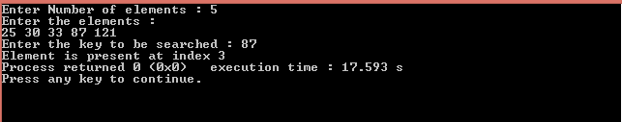

RESULT:
Thus the element searching is performed using randomised search algorithm

