Team Members

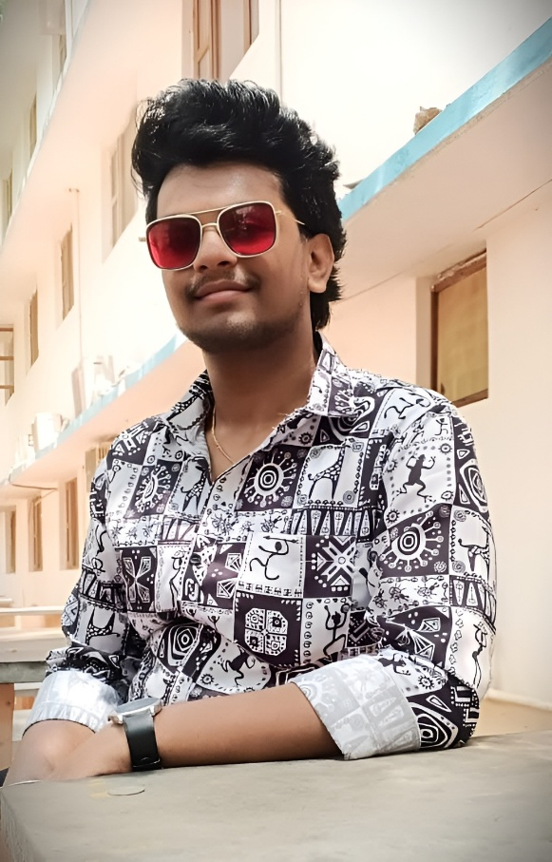

NAME: Ajay Subramoni. A
EDUCATION: B.Tech Artificial Intelligence and Data Science
ROLE: Founder
SKILLS: Full Stack Developer , UI &UX Designer.


NAME: Aravind . P
EDUCATION: BTech Artificial Intelligence and Data Science
ROLE: Business Manager.
SKILLS: UI &UX Designer , Full Stack Developer , Video Editor

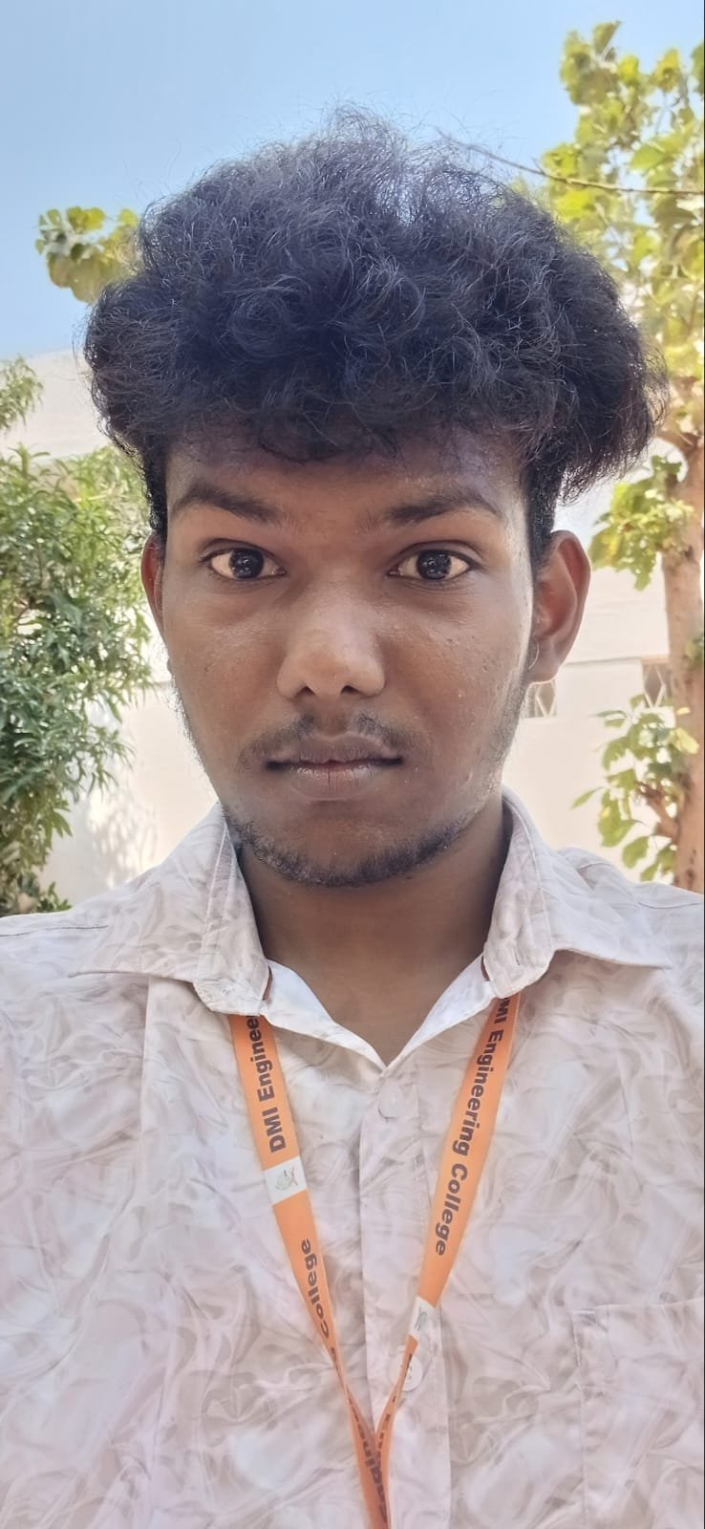

NAME : Sahaya Revin . P
ROLE: Co-Founder
SKILLS: AI/ML Developer , Data Scientist.

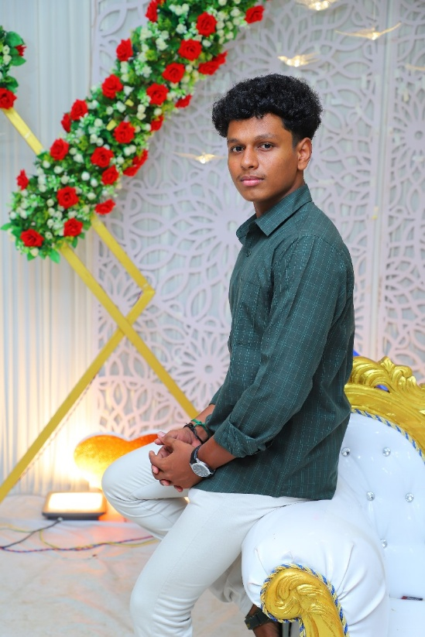
NAME: Manekandan . M
ROLE: Assistant Manager
SKILLS: Full Stack Developer , AI/ML Developer.

