**Dmitry – Passive Information Gathering Tool**

**Dmitry Overview:**

Dmitry, which stands for DeepMagic Information Gathering Tool, is a free and open-source utility available on GitHub. Designed for information gathering, Dmitry can be downloaded and installed on Kali Linux. This command-line tool helps collect valuable information about a target, which can be used for various purposes, including social engineering attacks. Dmitry is capable of gathering a wide range of important data.

**Uses of Dmitry Tool:**

* **Subdomain Search:** Dmitry can be utilized to find subdomains of a target.
* **Port Scanning:** It helps in identifying open ports on the target system.
* **TCP Scanning:** The tool is capable of performing TCP scans.
* **Netcraft Integration:** Dmitry can retrieve information such as operating system, web server details, web host details, and hosting service details using the Netcraft service.
* **WHOIS Lookup:** It can gather data about registered domains, including the registrant's name, address, and contact information.
* **Email Discovery:** The tool can find email addresses associated with the target's domain.

**Switches of Dmitry Tool :**

Dmitry Tool is a command-line tool. There are various commands of the Dmitry tool that can be used with different commands. Different switches used with commands.

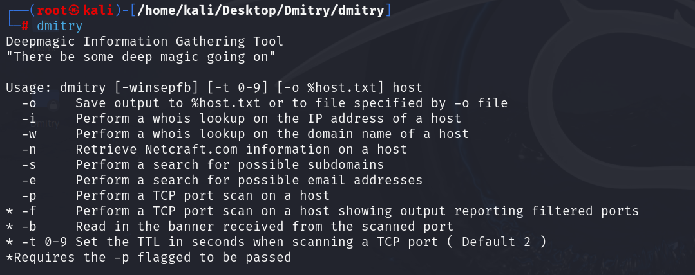

**Installation of Dmitry Tool:**

**Step 1:** First, we have to open our Kali Linux terminal and then Move to the **Desktop** Directory.

**Step 2:** Now, we have to create a new directory named **Dmitry.**

**Step 3:** We have already made the **Dmitry** Directory. Now move into this directory, where we will find the **dmitry** tool to be installed.

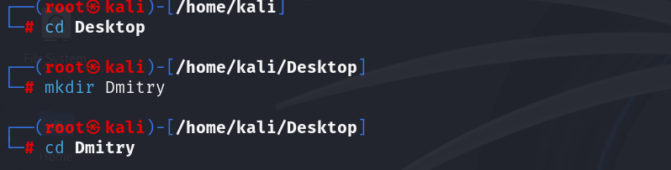

**Step 4:** Now, we can see that we are in a **dmitry** directory. The Dmitry tool must now be cloned and downloaded from **GitHub**. Use the following command to clone the tool.

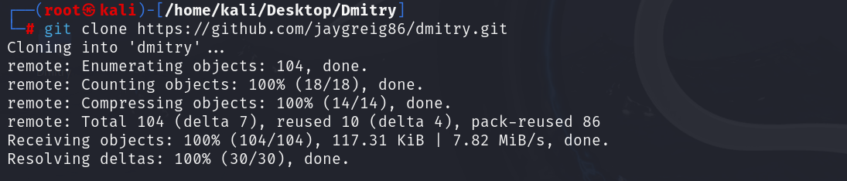

**Step 5:** The Dmitry tool has been successfully downloaded into our Kali Linux. We can now use the tool. Now run the following command to check the listing of the directory.

**Step 6:** Dmitry is a new directory that we can find here. Use the following command to move to this directory, and then use the following commands to list the contents.

Command: ls , cd dmitry , ls

**Step 7:** The file has been downloaded into the directory; use the following command to install the directory; all of the dependencies will be downloaded as a result of this.

Command: Sudo apt-get install automake autoconf

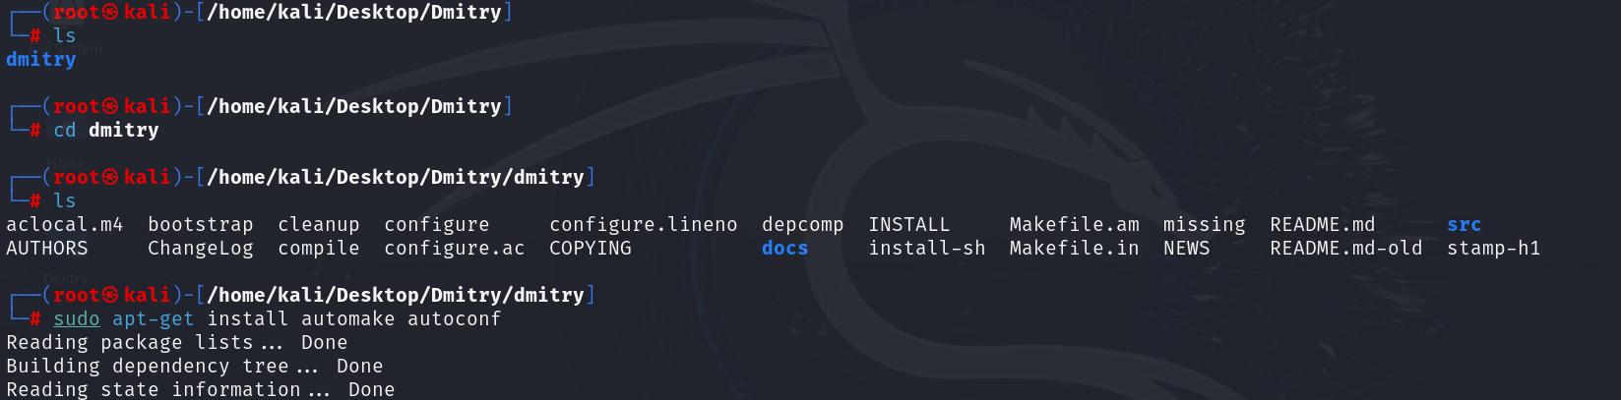

**Step 8:** After we have downloaded all of the dependencies, we need to give the permissions with the command below.

Command: Chmod +x configure

**Step 9:** The tool has been permitted for execution. It's time to initialize the **configuration file** using the following command.

Command: ./configure

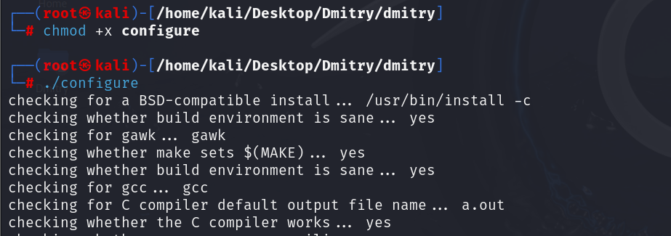

**Step 10:** Now, this is the time to make a configuration available for the tool so that we can run the command that follows.

Command: make

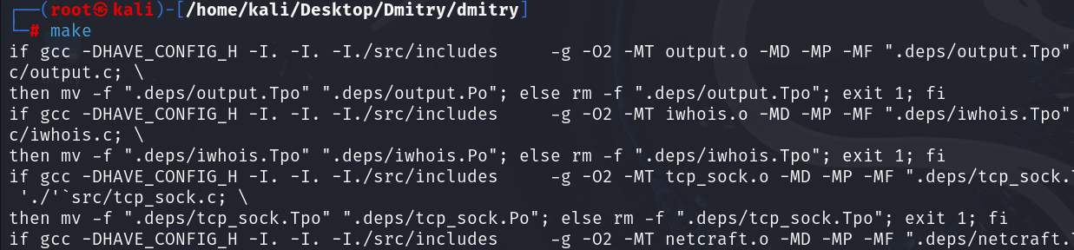

**Step 11:** Now, we can install the tool with the help of the following command.

Command: make install

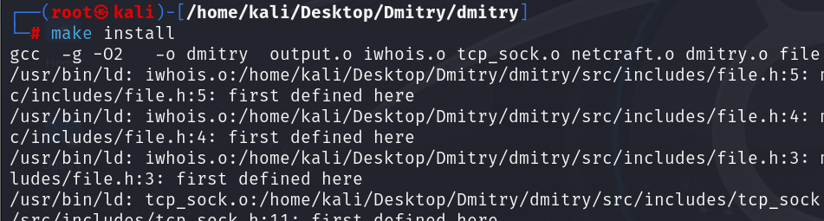

**Run the Tool and Get the Information About Any Target**

We can run the tool and enter the following command to collect any basic information.

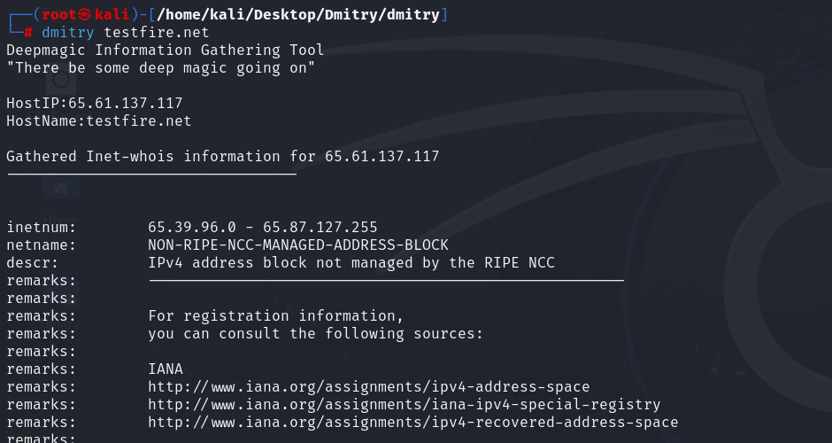

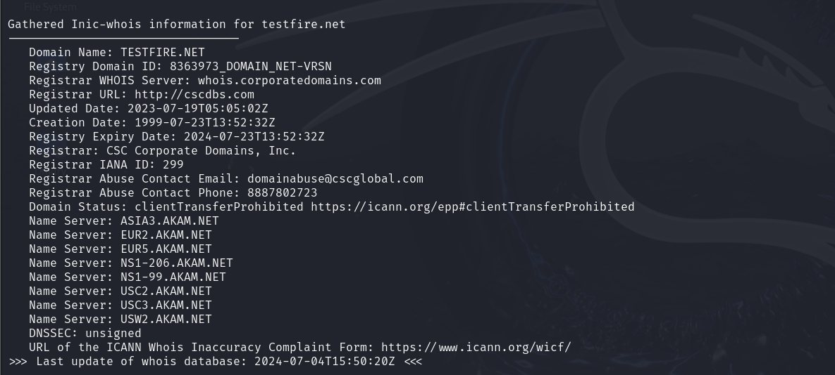

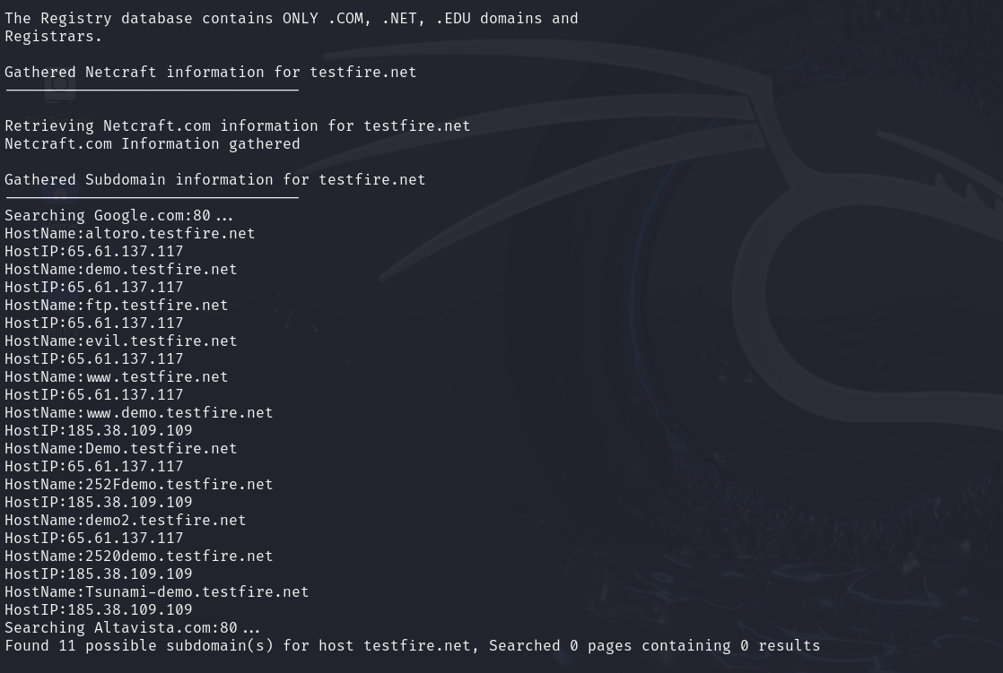

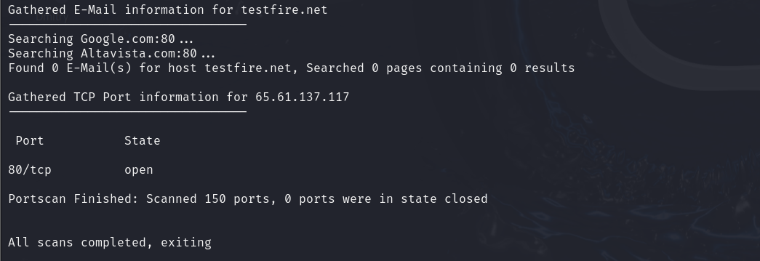

We can run the tool and get specific information about any target with the help of switches.