**EagleOSINT Tool**

EagleOSINT is a robust open-source tool designed for gathering open-source intelligence (OSINT) on specified targets. This walkthrough provides an overview of EagleOSINT, along with detailed steps for installation and usage on Kali Linux.

**Overview of EagleOSINT**

EagleOSINT is engineered to streamline the process of collecting, analyzing, and visualizing data from publicly available sources. It is particularly useful for security researchers, ethical hackers, and analysts who need to gather comprehensive information about a target for purposes such as penetration testing, threat intelligence, and digital forensics.

**Key Features of EagleOSINT**

1. **Data Collection**: Gathers information from a wide range of public sources, including social media platforms, websites, and online databases.
2. **Modular Design**: Offers a variety of modules that can be customized and extended to fit specific needs.
3. **Visualization Tools**: Provides tools to visualize data, making it easier to analyze and interpret findings.
4. **Automated Reporting**: Generates detailed reports that summarize the gathered intelligence.

**Installation steps:**

1. **Clone the Repository**: Clone the EagleOSINT repository from GitHub.

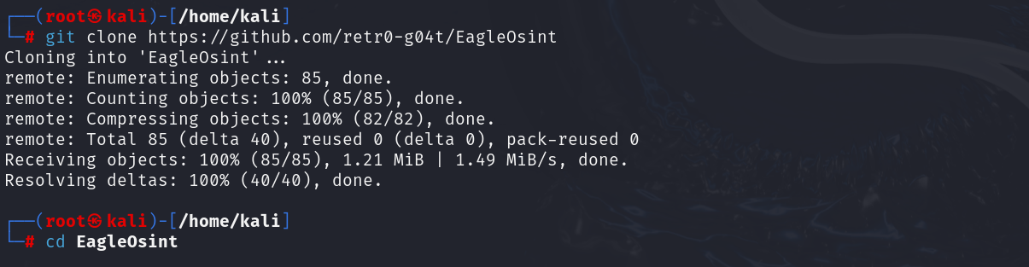

1. **Navigate to the Directory**: Change into the directory of the cloned repository.

**Running EagleOSINT:**

To start using EagleOSINT, execute the main script from the terminal:





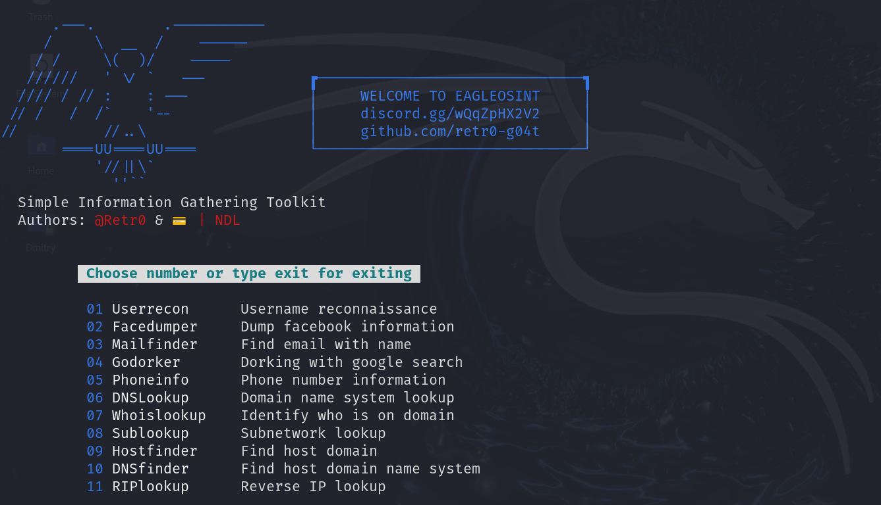

**Performing a Scan**

* **Specify the Target**: Input the target domain, IP address, or username you wish to investigate.

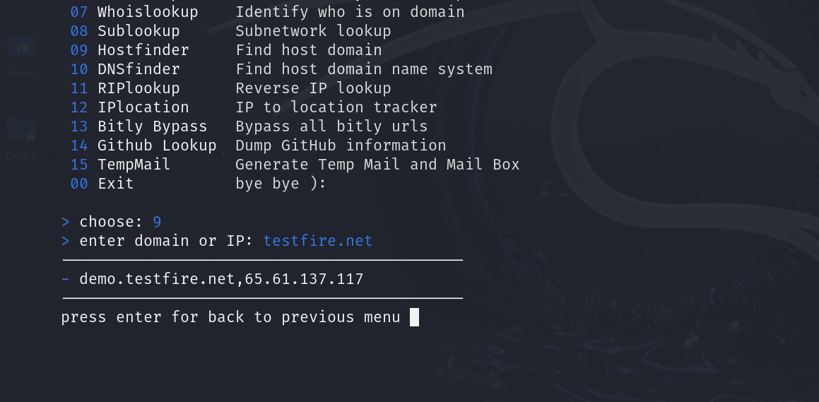



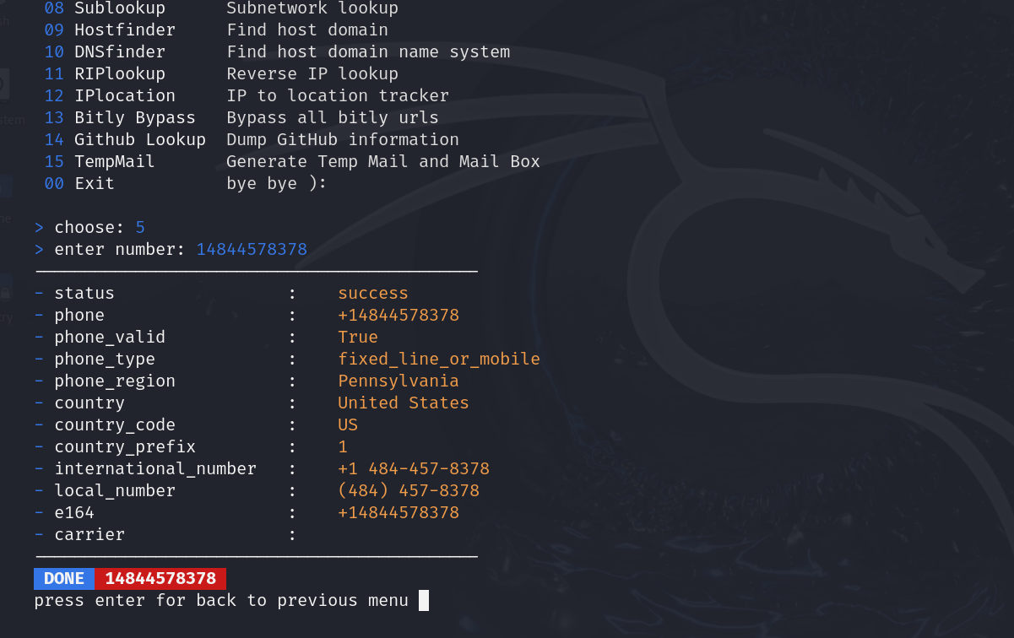

We can perform all 15 modules to gather information.

**Conclusion**

EagleOSINT is a versatile and powerful tool for conducting open-source intelligence gathering on Kali Linux. Its modular design, extensive data sources, and user-friendly features make it an essential tool for security professionals and researchers. By following the installation and usage guidelines provided in this article, you can efficiently leverage EagleOSINT to enhance your intelligence gathering capabilities.