**WebOSINT Tool**

WebOSINT is a powerful tool designed for web-based open-source intelligence gathering. This article guides you through the installation process and explain how to use WebOSINT effectively.

**Installation**

**Prerequisites**

Before installing WebOSINT, ensure you have the following prerequisites installed on your system:

* **Python**: WebOSINT is written in Python, so you need Python 3.6 or later installed. Download it from the [official Python website](https://www.python.org/).
* **Git**: To clone the repository, you need Git installed. Download it from the [official Git website](https://git-scm.com/).

**Step to Install:**

1. **Clone the Repository**: Open your terminal and clone the WebOSINT repository from GitHub.
2. **Navigate to the Directory**: Change into the directory of the cloned repository.

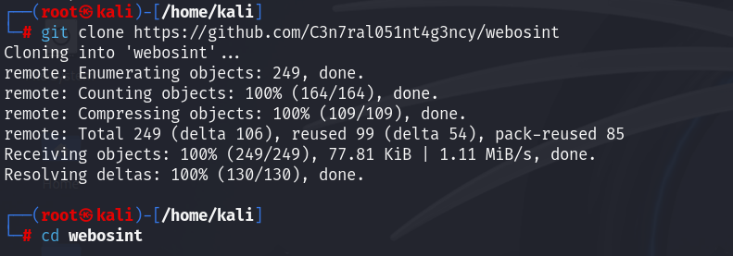

1. **Install Dependencies**: Install the required Python packages using pip.

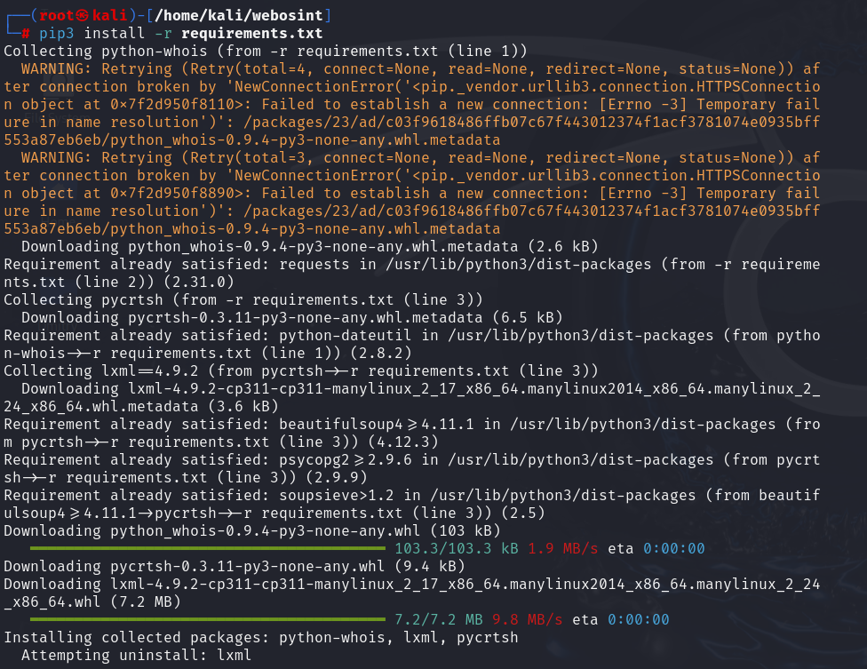

**Step 2: Running WebOSINT:**

**Command:** python3 webosint.py

**Step 3: Performing a Scan**

WebOSINT provides a range of scanning options to gather different types of information. Here’s how you can perform a basic scan:

1. **Target Specification**: Enter the target domain or IP address you want to scan. WebOSINT will gather a wide array of information from public sources.
2. **Choosing Modules**: WebOSINT allows you to select specific modules depending on the type of information you want to gather. For example, you can use modules to find subdomains, detect open ports, or retrieve WHOIS data.
3. **Executing the Scan**: Once you have specified the target and selected the modules, execute the scan. The tool will collect data from various sources and present it in a comprehensive report.

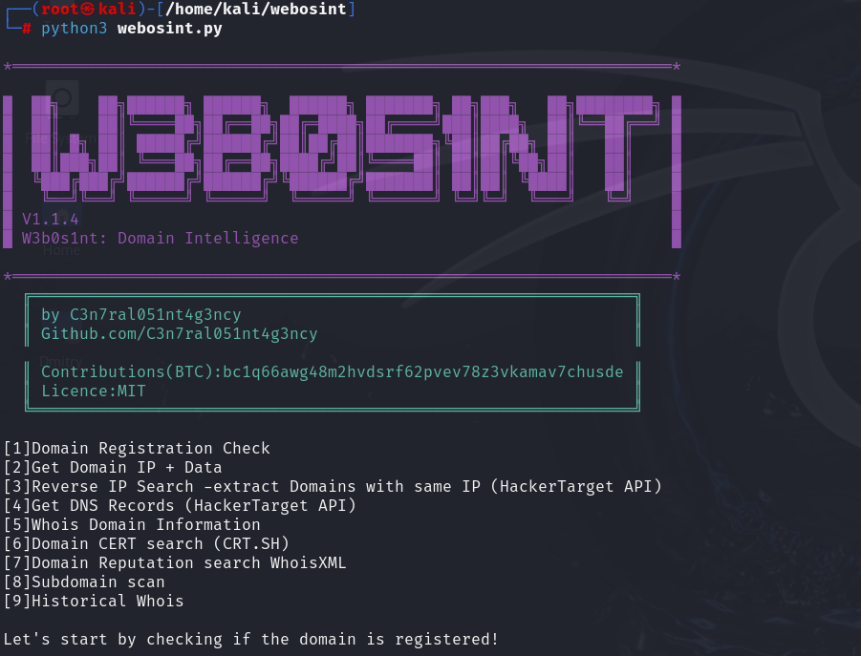

**Step 4: Analyzing the Results**

The results from WebOSINT scans are typically presented in an organized format, allowing you to analyze the gathered data effectively. This can include information such as:

* **Subdomains**: Lists all discovered subdomains of the target domain.
* **Open Ports**: Displays the open ports on the target system.
* **WHOIS Data**: Provides registration details of the target domain.
* **Email Addresses**: Identifies email addresses associated with the target domain.

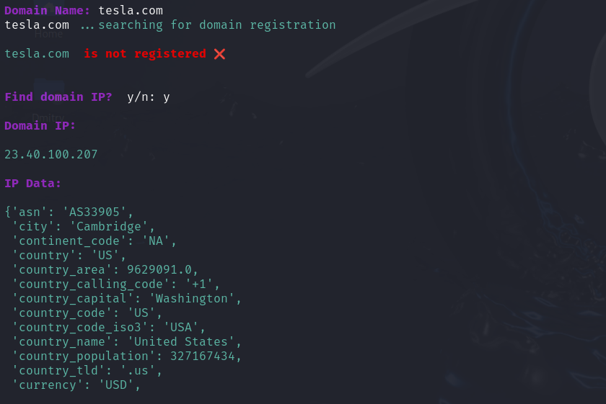

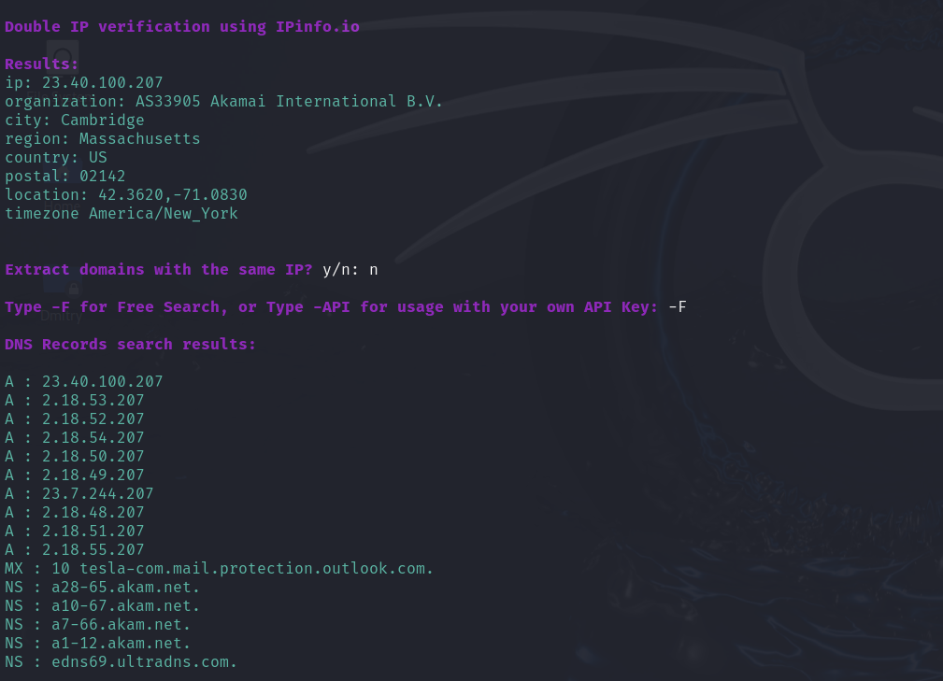

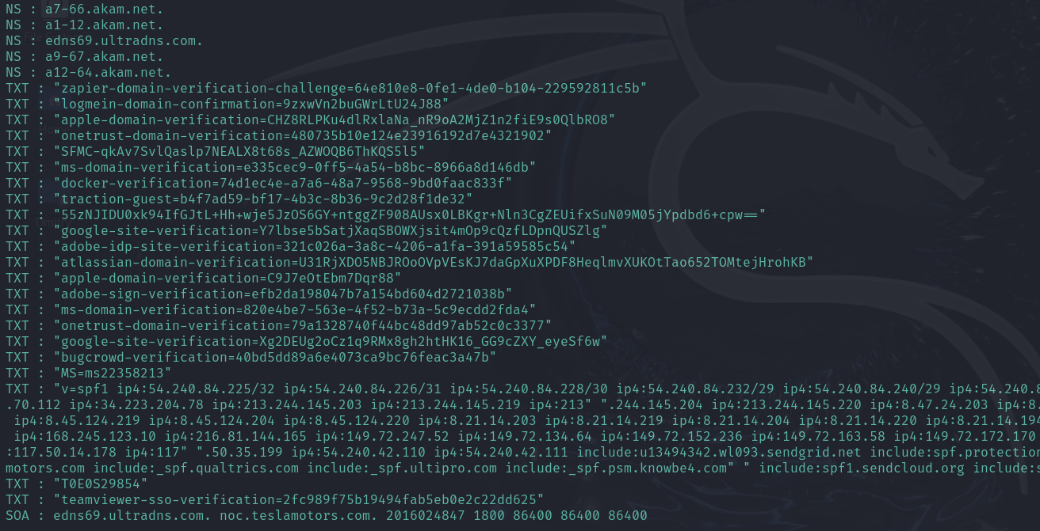

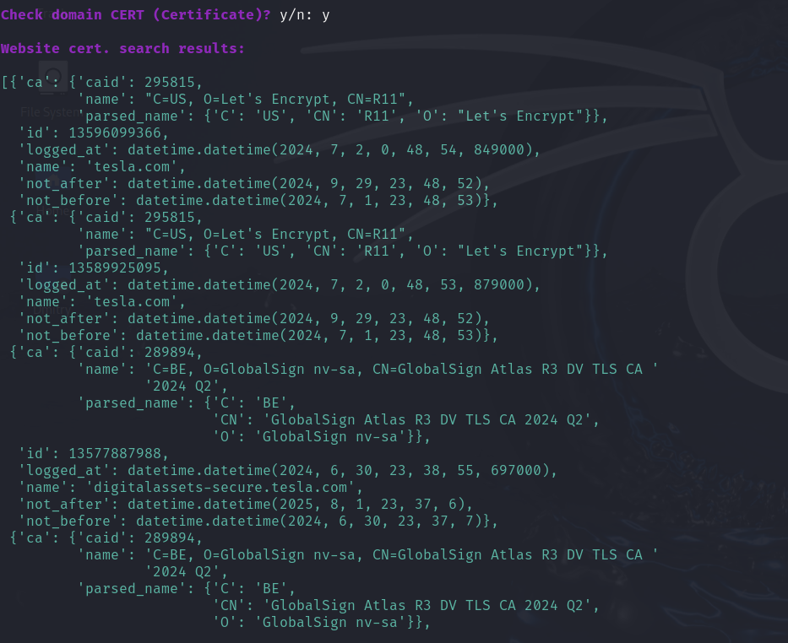

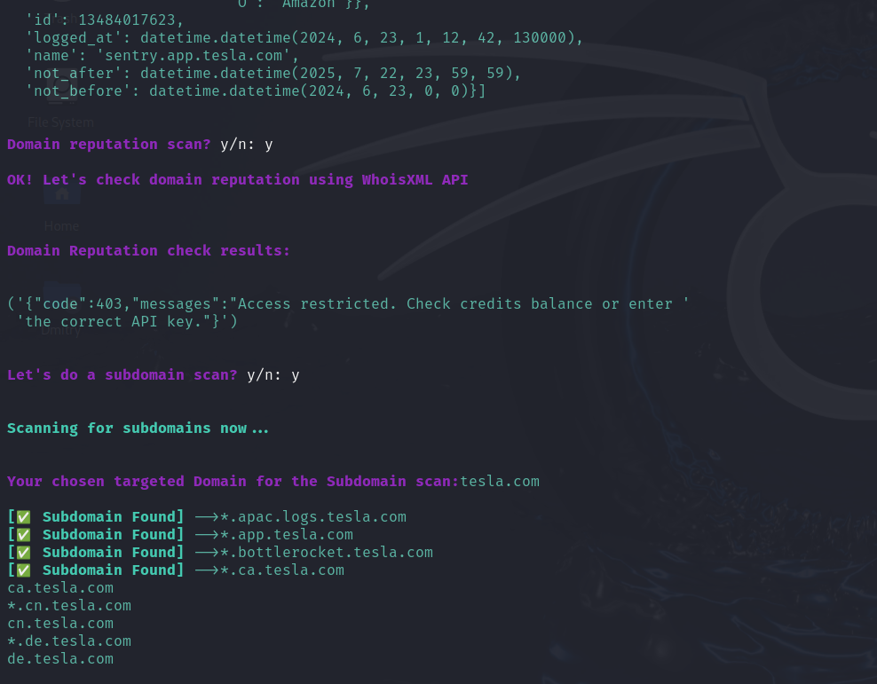

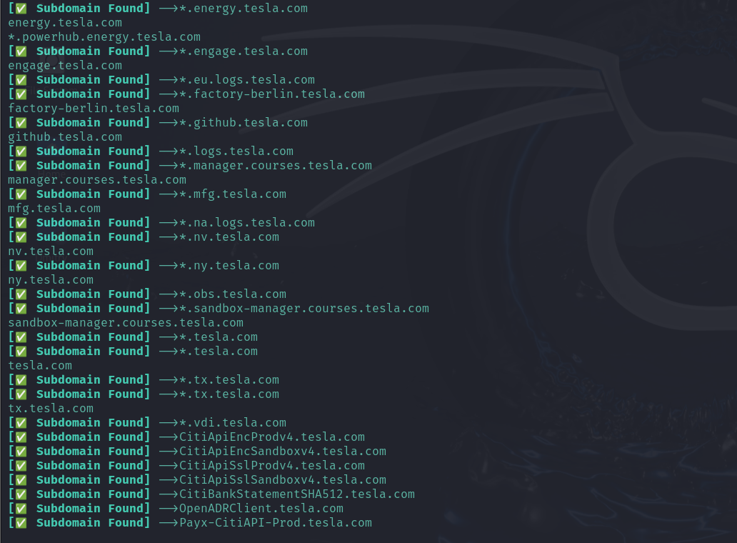

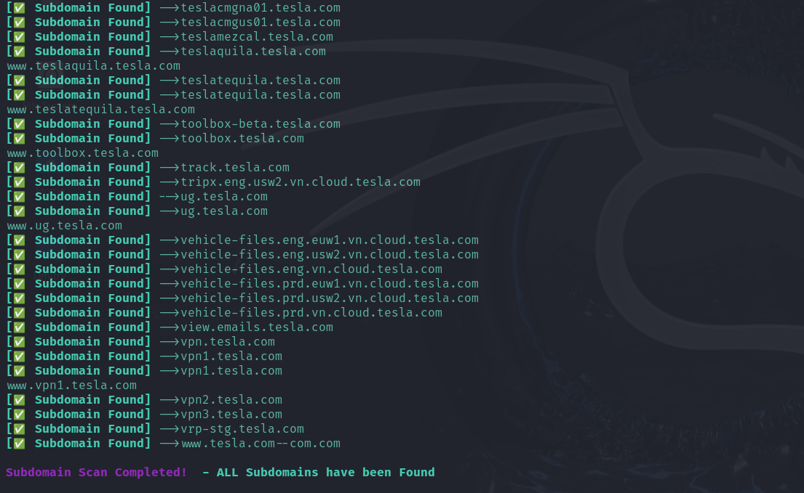

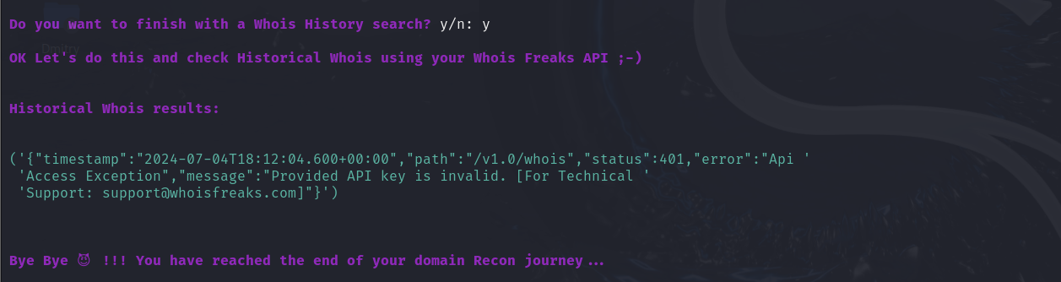

**Conclusion**

WebOSINT is a versatile tool for web-based open-source intelligence gathering, useful for both security researchers and analysts. By following the installation steps and understanding the working process, you can effectively use WebOSINT to gather critical information about your targets. Always ensure you have the necessary permissions and adhere to legal guidelines when performing intelligence gathering.