Text Synthesis:

Text synthesis is a process of combining several texts into one or in other words we can say that synthesis is the process to connect multiple sources together to make a cohesive argument. As we sythesize the information to remember it in a very sort and efficient manner and it contains the important points in the text and is written in our own words, so before get into implementation of Text synthesis lets understand how we summarize the text as it contains all main points outlined in the documents and steps to perform text synthesis.

Key Features of a Synthesis
Report information from the sources(summarized paragraphs) using different phrases.
Organize so that readers can immediately see where information from.
Make sense of the sources and help the reader understand them in greater depth.

Check if synthesis is correct:
Make sure your purpose is clear.
Make sure the language is correct.
Make sure the style is your own.
Remember to acknowledge other people's work.
Synthesizing:
Begins with a sentence or phrase that informs readers of the topic of the paragraph.
Include information from more than one source.
Clearly indicate which material comes from which source.
Each focal points(phrases) supported atleast two resources.
Primary goal is logical suport the idea and it suport our overall thesis accordingly.
After getting idea from these thesis we can move on our conclusion.
In conclution restate your thesis statement that infer confimation.
Psychologically speaking if it presented in already proper manner such that our audiance
naturally incliented to agree
Go walk through and summarize the connection between each idea, thesis statement
overall concluding statement
Go through each small thesis ad make sure that there is an evident and logic link back to the
thesis statement.
Summarization:
Summarization is the process of shortening a set of text data computationally, to create a subset (a summary) that represents the most important or relevant information within the original text document.

Steps to perform Text synthesis:

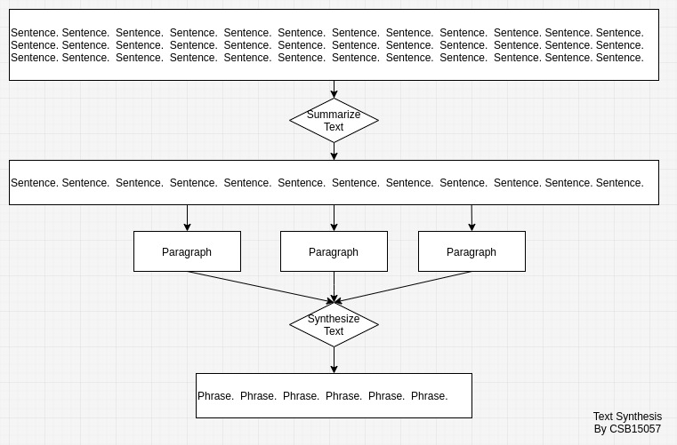
a high level idea of performing Text synthesis.

Steps:
- Text cleaning
- Word tokenization
- Word-frequency table
- Sentence Tokenization
- Summarization
- Synthesization

We can synthesis in two way:
X : Interpret information from source(paragraph) A
X : Interpret information from source(paragraph) B
Y : A new idea that came from the sources

1: Idea of both sources can be combined by stacking them
X + X = Y

2: X’s are combined new thought created
X(Y)X

How does it look like in body paragraph:
X:paragraph1
Introduce evidence
- signed phrase
Insert evidence
Analysis: What does this evidence mean in connection to our sub claim
Transition phrase(Supports, built, contradicts, illuminates)

X: paragraph2
Introduce evidence
- signed phrase
Insert evidence
Analysis: What does this evidence mean in connection to our sub claim
Transition phrase(Supports, built, contradicts, illuminates)

Y: final phrase(that make easy to remember the things/story/...)
Connection of all sources
What does the evidence all connect together to build and prove your argument?
How do i know if it flows?
Can i understand it?

Example:
Ang(2016) found that small bussiness that followed the theory of financial management
reduced bussiness cost by 12%. while Sonefield(2015) found that small bussiness that followed this theory reduced bussiness cost by 17%.

X: Ang(2016) found that small bussiness that followed the theory of financial management
reduced bussiness cost by 12%.
X: while Sonefield(2015) found that small bussiness that followed this theory reduced bussiness cost by 17%.

After Synthes:
keys: small, bussiness, theory, financial, management, reduced, bussiness, cost(Common in both)
Y: small bussiness that followed the theory of financial management reduced businesss cost.

Example 2:
Sharpe(2016) observes an increase in students ability to focus after they had recess. Similarily, Bornes(2015) observes that hands on activities also helped student focus.

X: Sharpe(2016) observes an increase in students ability to focus after they had recess.
X: Similarily,
Y: Sharpe(2016) observes an increase in students ability to focus after they had recess. Similarily,

X = Y
X: Sharpe(2016) observes an increase in students ability to focus after they had recess. Similarily
X: Bornes(2015) observes that hands on activities also helped student focus.
After Synthesis:
keys: observes, students, focus, recess.
new_key: student, focus, recess.
Y: Increase in student ability to focus after they had recess, hand on activities also helped student focus.

Example 3:
An example of a summarization problem is document summarization, which attempts to automatically produce an abstract from a given document. The first is generic summarization, which focuses on obtaining a generic summary or abstract of the collection (whether documents, or sets of images, or videos, news stories etc.). The second is query relevant summarization, sometimes called query-based summarization, which summarizes objects specific to a query. Summarization systems are able to create both query relevant text summaries and generic machine-generated summaries depending on what the user needs.

X: An example of a summarization problem is document summarization,
X: which attempts to automatically produce an abstract from a given document.
X: The first is generic summarization,
X: which focuses on obtaining a generic summary or abstract of the collection (whether documents,
X: or sets of images,
X: or videos, news stories etc.).
X: The second is query relevant summarization,
X: ometimes called query-based summarization,
X: which summarizes objects specific to a query.
X: Summarization systems are able to create both query relevant text summaries and generic
X: machine-generated summaries depending on what the user needs.

