UI:
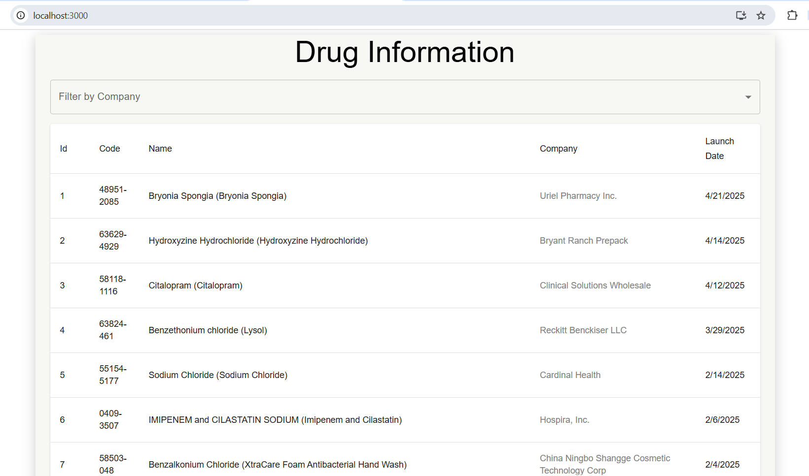

Filter by Company:
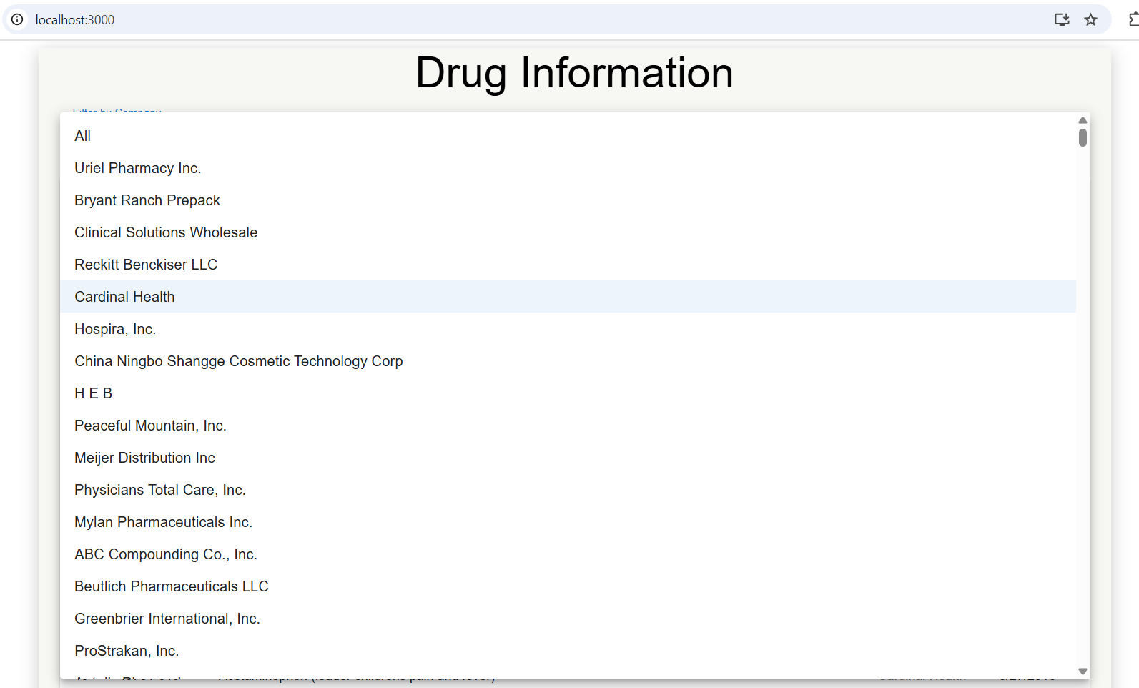

Filtered Company data showing:
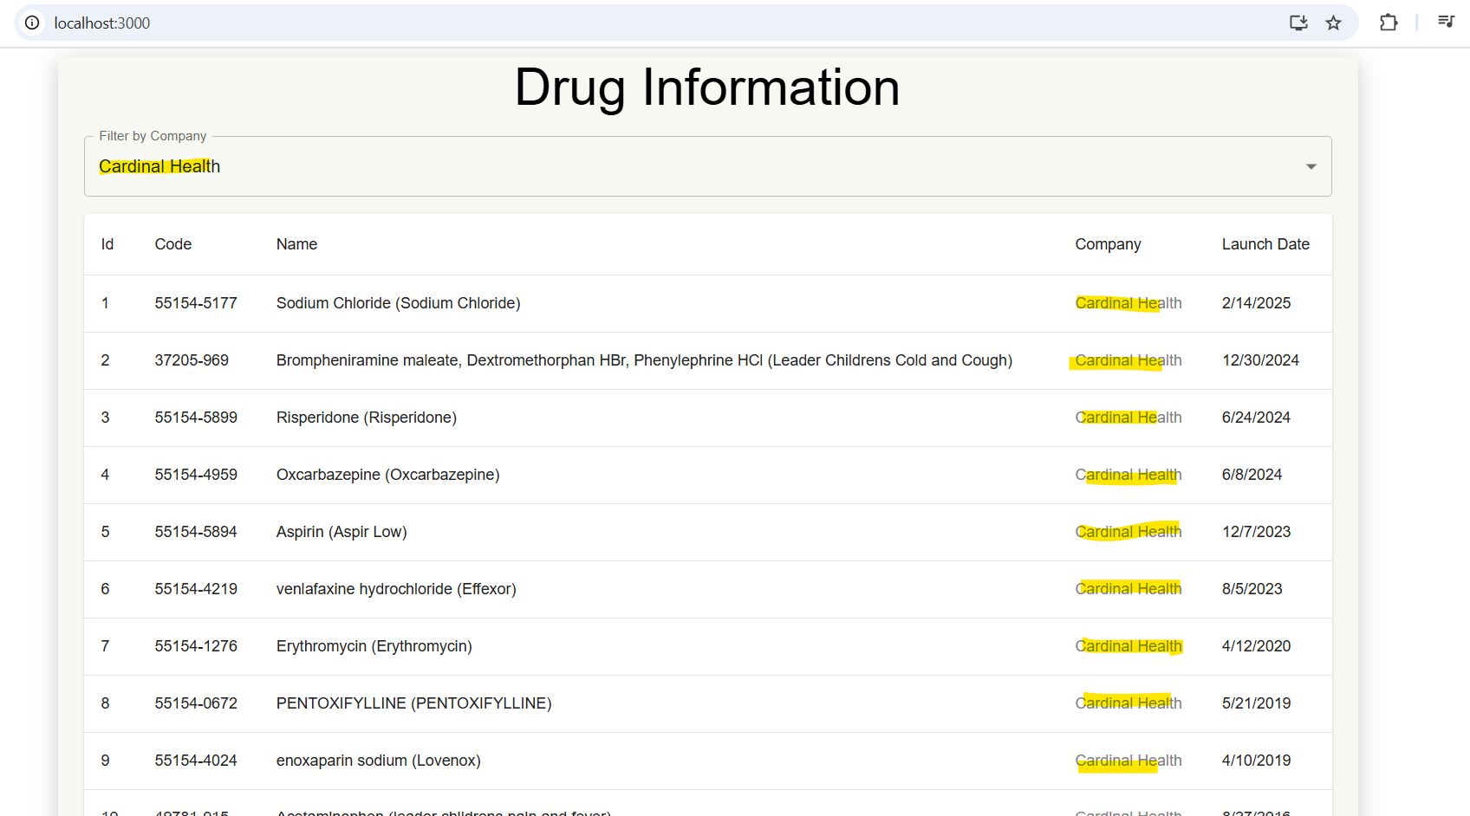

Frontend Running:
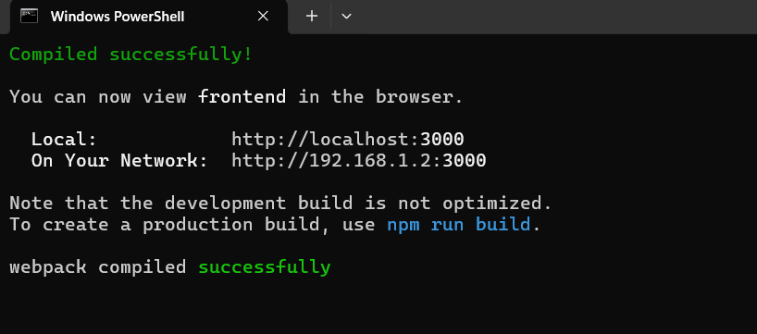
Backend running:
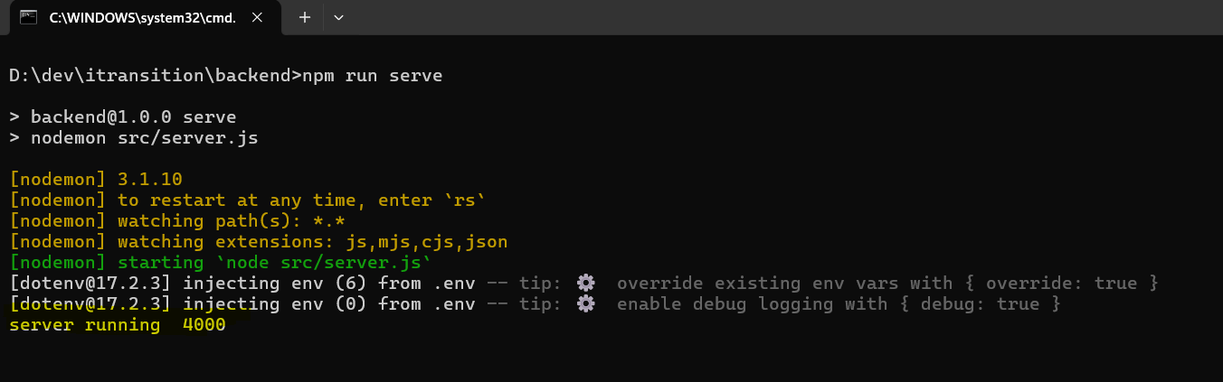
--------------------------------------------------------------------------------------------------------------------------------------
Successfully loaded data in PostgreSQL database:
