Effect of treatments on leaves

Ajay Shankar A

2023-11-11

Table of contents

## Effect of Treatments on leaves to produce roots

An experiment was conducted to find the rooting potential of the leaves mainly angiosperms to root when treated with different phyto-hormones.

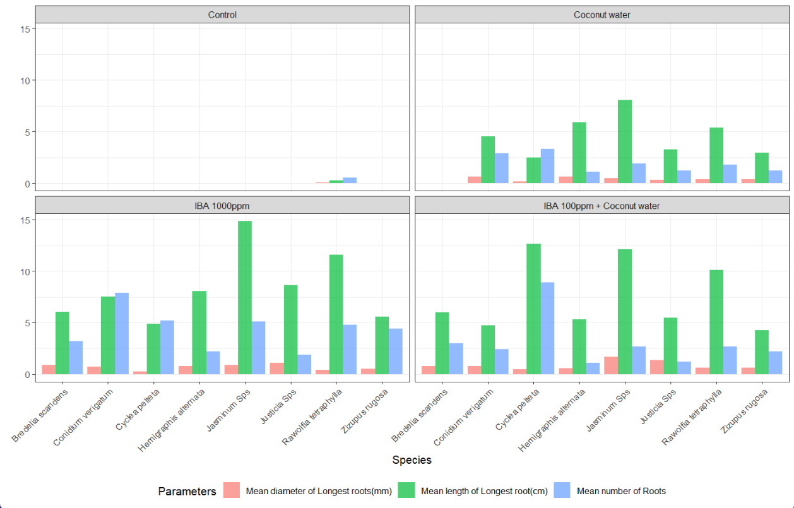

* In the experiment, 4 treatments were applied on 8 different species, and the observations included:
  + Number of roots (num_roots_n).
  + Length of the longest root in centimeters (lng_long_root_cm).
  + Diameter of the longest root in millimeters (dia_long_root_mm).

#### Loading Required packages

library(tidyverse)  
library(gt)

#### Loading the data and formatting

The data is loaded as a dataframe thesisdata and columns such as treatments(Treatment) and species(Species) are changes to factors as they are not suitable as strings.

# Loading data  
thesisdata <- read_csv("thesisdata.csv",  
 show_col_types = FALSE)  
# formating data  
ths_data <- thesisdata  
ths_data$Treatment <- as.factor(ths_data$Treatment)  
ths_data$Treatment <-   
 factor(ths_data$Treatment,levels = c("Control",  
 "Coconut water",   
 "IBA 1000ppm",  
 "IBA 100ppm + Coconut water"))  
ths_data$Species <- factor(ths_data$Species)  
  
ths_data %>% head()

# A tibble: 6 × 5  
 Species Treatment num_roots_n lng_long_root_cm dia_long_root_mm  
 <fct> <fct> <dbl> <dbl> <dbl>  
1 Conidium verigatum Control 0 0 0  
2 Conidium verigatum Control 0 0 0  
3 Conidium verigatum Control 0 0 0  
4 Conidium verigatum Control 0 0 0  
5 Conidium verigatum Control 0 0 0  
6 Conidium verigatum Control 0 0 0

* Confirming that only 8 species and 4 treatments are used in the experiment.

treatments_and_species <- list(unique(ths_data$Treatment), unique(ths_data$Species))  
  
names(treatments_and_species) <- c("Treatment", "Species")  
treatments_and_species

$Treatment  
[1] Control Coconut water   
[3] IBA 1000ppm IBA 100ppm + Coconut water  
Levels: Control Coconut water IBA 1000ppm IBA 100ppm + Coconut water  
  
$Species  
[1] Conidium verigatum Rawolfia tetraphylla Justicia Sps   
[4] Zizupus rugosa Jasminum Sps Cyclea pelteta   
[7] Bredelia scandens Hemigraphis alternata  
8 Levels: Bredelia scandens Conidium verigatum ... Zizupus rugosa

### Aggregating data and formatting the results into a table.

The data is aggregated in **?@tbl-aggregate-summary** by the average of root lengths with standard deviation(SD)

ths_data_1 <- ths_data %>% group_by(Species, Treatment) %>%   
 summarise(avg_n_roots = mean(num_roots_n),  
 SD_n_roots = sd(num_roots_n),  
 avg_lng_root = mean(lng_long_root_cm),  
 SD_lng_root = sd(lng_long_root_cm),  
 avg_dia_root = mean(dia_long_root_mm),  
 SD_dia_root = sd(dia_long_root_mm)) %>%  
 # rounding of to 2 digits   
 mutate(across(where(is.double), ~round(., digits = 2))) %>%  
 # combining means and SD into a single column  
 unite(avg_n_roots_SD, avg_n_roots, SD_n_roots, sep = " \u00b1 ") %>%  
 unite(avg_lng_root_SD, avg_lng_root, SD_lng_root, sep = " \u00b1 ") %>%   
 unite(avg_dia_root_SD, avg_dia_root, SD_dia_root, sep = " \u00b1 ") %>%  
 # using 'gt' package to get a table   
 gt(rowname_col = "Treatment") %>%   
 tab_header(  
 title = "Thesis Data of the Species",  
 subtitle = "Influence of growth regulators on the root generation"  
 ) %>%   
 opt_align_table_header(align = "center") %>%   
 cols_label( # renaming columns  
 avg_n_roots_SD = md("Mean number of roots \u00b1 SD"), #md is markdown language  
 avg_lng_root_SD = md("Mean length of longest roots \u00b1 SD (cm)"),  
 avg_dia_root_SD = md("Mean diameter of longest roots \u00b1 SD (mm)")  
 ) %>% # fixing columns width  
 cols_width(Treatment ~ px(150),  
 avg_n_roots_SD ~ px(150),  
 avg_lng_root_SD ~ px(150),  
 avg_dia_root_SD ~ px(150),  
 ) %>%   
 cols_align(align = "center")  
  
ths_data_1

Table 1: Thesis Data of the Species

Influence of growth regulators on the root generation

|  | Mean number of roots ± SD | Mean length of longest roots ± SD (cm) | Mean diameter of longest roots ± SD (mm) |
| --- | --- | --- | --- |
| Bredelia scandens | | | |
| Control | 0 ± 0 | 0 ± 0 | 0 ± 0 |
| Coconut water | 0 ± 0 | 0 ± 0 | 0 ± 0 |
| IBA 1000ppm | 3.22 ± 0.44 | 6.06 ± 2.02 | 0.89 ± 0.17 |
| IBA 100ppm + Coconut water | 3 ± 0.5 | 6.02 ± 1.26 | 0.77 ± 0.2 |
| Conidium verigatum | | | |
| Control | 0 ± 0 | 0 ± 0 | 0 ± 0 |
| Coconut water | 2.89 ± 1.05 | 4.52 ± 1.1 | 0.62 ± 0.15 |
| IBA 1000ppm | 7.89 ± 3.62 | 7.52 ± 2.55 | 0.76 ± 0.15 |
| IBA 100ppm + Coconut water | 2.44 ± 0.88 | 4.74 ± 1.09 | 0.81 ± 0.18 |
| Cyclea pelteta | | | |
| Control | 0 ± 0 | 0 ± 0 | 0 ± 0 |
| Coconut water | 3.33 ± 0.71 | 2.48 ± 0.37 | 0.18 ± 0.04 |
| IBA 1000ppm | 5.22 ± 1.39 | 4.89 ± 1.17 | 0.28 ± 0.07 |
| IBA 100ppm + Coconut water | 8.89 ± 2.03 | 12.64 ± 3.23 | 0.45 ± 0.1 |
| Hemigraphis alternata | | | |
| Control | 0 ± 0 | 0 ± 0 | 0 ± 0 |
| Coconut water | 1.11 ± 0.33 | 5.89 ± 0.84 | 0.65 ± 0.11 |
| IBA 1000ppm | 2.22 ± 0.83 | 8.06 ± 1.58 | 0.77 ± 0.11 |
| IBA 100ppm + Coconut water | 1.11 ± 0.33 | 5.33 ± 1.93 | 0.57 ± 0.09 |
| Jasminum Sps | | | |
| Control | 0 ± 0 | 0 ± 0 | 0 ± 0 |
| Coconut water | 1.89 ± 0.6 | 8.06 ± 0.88 | 0.5 ± 0.05 |
| IBA 1000ppm | 5.11 ± 1.17 | 14.82 ± 1.59 | 0.88 ± 0.19 |
| IBA 100ppm + Coconut water | 2.67 ± 1.22 | 12.12 ± 2.27 | 1.71 ± 0.25 |
| Justicia Sps | | | |
| Control | 0 ± 0 | 0 ± 0 | 0 ± 0 |
| Coconut water | 1.22 ± 0.44 | 3.28 ± 1.24 | 0.35 ± 0.21 |
| IBA 1000ppm | 1.89 ± 0.78 | 8.64 ± 2.41 | 1.08 ± 0.26 |
| IBA 100ppm + Coconut water | 1.22 ± 0.44 | 5.47 ± 1.84 | 1.35 ± 0.23 |
| Rawolfia tetraphylla | | | |
| Control | 0.56 ± 1.13 | 0.26 ± 0.51 | 0.04 ± 0.09 |
| Coconut water | 1.78 ± 0.97 | 5.4 ± 2.64 | 0.36 ± 0.1 |
| IBA 1000ppm | 4.78 ± 2.17 | 11.59 ± 4.79 | 0.4 ± 0.12 |
| IBA 100ppm + Coconut water | 2.67 ± 1.41 | 10.09 ± 2.34 | 0.61 ± 0.19 |
| Zizupus rugosa | | | |
| Control | 0 ± 0 | 0 ± 0 | 0 ± 0 |
| Coconut water | 1.22 ± 0.83 | 2.94 ± 1.34 | 0.38 ± 0.18 |
| IBA 1000ppm | 4.44 ± 1.59 | 5.56 ± 2.08 | 0.53 ± 0.15 |
| IBA 100ppm + Coconut water | 2.22 ± 0.67 | 4.26 ± 1.11 | 0.63 ± 0.17 |

**?(caption)**

### Plotting the data for better understanding.

* Plotting a bar graph Figure 1 to see how each treatment performed on each species.

ths_data |> summarise(avg_n_roots = mean(num_roots_n),  
 avg_lng_root = mean(lng_long_root_cm),  
 avg_dia_root = mean(dia_long_root_mm),  
 .by = c(Species, Treatment)) %>%  
 rename("Mean number of Roots" = avg_n_roots,  
 "Mean length of Longest root(cm)" = avg_lng_root,  
 "Mean diameter of Longest roots(mm)" = avg_dia_root) %>%   
 tidyr::pivot_longer(c("Mean number of Roots", "Mean length of Longest root(cm)",  
 "Mean diameter of Longest roots(mm)")) |>   
 ggplot(aes(x = Species, y = value, fill = name)) +   
 geom_col(alpha = 0.7, position = "dodge") +   
 facet_wrap(~Treatment, ncol = 2) +   
 theme_bw() + labs(y = " ", fill = "Parameters",  
 title = "Effect of treatments on rooting") +  
 theme(legend.position = "bottom",  
 axis.text.x = element_text(angle = 45, hjust = 1),  
 plot.title = element_text(size = 18))

|  |
| --- |
| Figure 1: Influence of pytohormone treatments on leaves of different species |

* We can clearly see that *Control* treatment is not producing any roots in majority of the species.
* **IBA 1000ppm** is clearly showing most promising results in most of the species in the graph.

### Finding correlation

We are going to filter out the control treatment as it is not significant at producing roots at all and plot Figure 2 to find which treatment has better correlation at producing roots with higher diameters.

ths_data |> filter(Treatment!= "Control") |>   
 ggplot(aes(x = lng_long_root_cm, y = dia_long_root_mm)) +   
 geom_point(aes(color = Treatment)) +   
 geom_smooth(method = "lm", aes(group = Treatment, color = Treatment)) +  
 labs(title = "Plotting Root length Vs Root Diameter",  
 x = "Length of the longest root",   
 y = "Diameter of the longest root") +  
 theme(legend.position = "bottom",  
 plot.title = element_text(size = 18))

`geom_smooth()` using formula = 'y ~ x'

|  |
| --- |
| Figure 2: Plotting a scatter plot to find correlation between root lengths and diameters |

* The graph clearly shows that the Coconut Water treatment has the highest slope but other treatments which produced higher root lengths did not have a correlation as that of Coconut Water treatment.

### Statistical Analysis

Let’s conduct a anova test on the data after filtering Control as it has not given any roots.

Let *H0* be Null hypothesis *H1* be Alternate hypothesis

# ANOVA Model  
model_anova <- ths_data %>%  
 filter(Treatment != "Control") %>%  
 aov(num_roots_n ~ Treatment, data = .)  
  
# Summary  
model_anova %>% summary()

Df Sum Sq Mean Sq F value Pr(>F)   
Treatment 2 256.0 128.00 27.43 2.51e-11 ***  
Residuals 213 993.9 4.67   
---  
Signif. codes: 0 '***' 0.001 '**' 0.01 '*' 0.05 '.' 0.1 ' ' 1

# TukeyHSD  
model_anova %>% TukeyHSD(conf.level = 0.95)

Tukey multiple comparisons of means  
 95% family-wise confidence level  
  
Fit: aov(formula = num_roots_n ~ Treatment, data = .)  
  
$Treatment  
 diff lwr upr  
IBA 1000ppm-Coconut water 2.666667 1.8169277 3.5164057  
IBA 100ppm + Coconut water-Coconut water 1.347222 0.4974832 2.1969612  
IBA 100ppm + Coconut water-IBA 1000ppm -1.319444 -2.1691835 -0.4697054  
 p adj  
IBA 1000ppm-Coconut water 0.0000000  
IBA 100ppm + Coconut water-Coconut water 0.0006848  
IBA 100ppm + Coconut water-IBA 1000ppm 0.0009086

We can see from p adj that all the treatments means are different and we can reject the *H0* hypothesis. *H1* holds at 95% confidence interval.