Palmer Penguins

Ajay Shankar A

2023-11-21

Table of contents

Building a model to predict the sex of three species of penguins of **Palmer Penguins** data.

|  |
| --- |
| Tip |
| This is my first Machine Learning project and I am still learning as of this date. This work is inspired by **Julia Silge** and you can find the original work by her in her [blog](https://juliasilge.com/blog/palmer-penguins/) and would like to thank her for the teachings in [Youtube channel](https://www.youtube.com/@JuliaSilge) |

## 1 Exploring the data

library(tidyverse)  
  
library(palmerpenguins)  
  
penguins

# A tibble: 344 × 8  
 species island bill_length_mm bill_depth_mm flipper_length_mm body_mass_g  
 <fct> <fct> <dbl> <dbl> <int> <int>  
 1 Adelie Torgersen 39.1 18.7 181 3750  
 2 Adelie Torgersen 39.5 17.4 186 3800  
 3 Adelie Torgersen 40.3 18 195 3250  
 4 Adelie Torgersen NA NA NA NA  
 5 Adelie Torgersen 36.7 19.3 193 3450  
 6 Adelie Torgersen 39.3 20.6 190 3650  
 7 Adelie Torgersen 38.9 17.8 181 3625  
 8 Adelie Torgersen 39.2 19.6 195 4675  
 9 Adelie Torgersen 34.1 18.1 193 3475  
10 Adelie Torgersen 42 20.2 190 4250  
# ℹ 334 more rows  
# ℹ 2 more variables: sex <fct>, year <int>

The data set is from *palmerpenguins* library which contains observations of Antarctic pebguins from the Palmer Archipelago. You can read more about how this dataset came to be in [this post on the RStudio Education blog](https://education.rstudio.com/blog/2020/07/palmerpenguins-cran/). Our modeling goal here is to predict [the sex of the penguins](https://github.com/rfordatascience/tidytuesday/blob/master/data/2020/2020-07-28/readme.md) using a classification model, based on other observations in the dataset.

It is easier to classify and predict species than the sex of the species as the different physical characteristics are what makes a species different from each other. But sex somewhat harder to predict.

penguins %>% filter(!is.na(sex)) %>%   
 ggplot(aes(flipper_length_mm, bill_length_mm, color = sex,  
 size = body_mass_g)) +  
 geom_point(alpha = 0.5) +  
 facet_wrap(~species) +  
 theme_minimal()

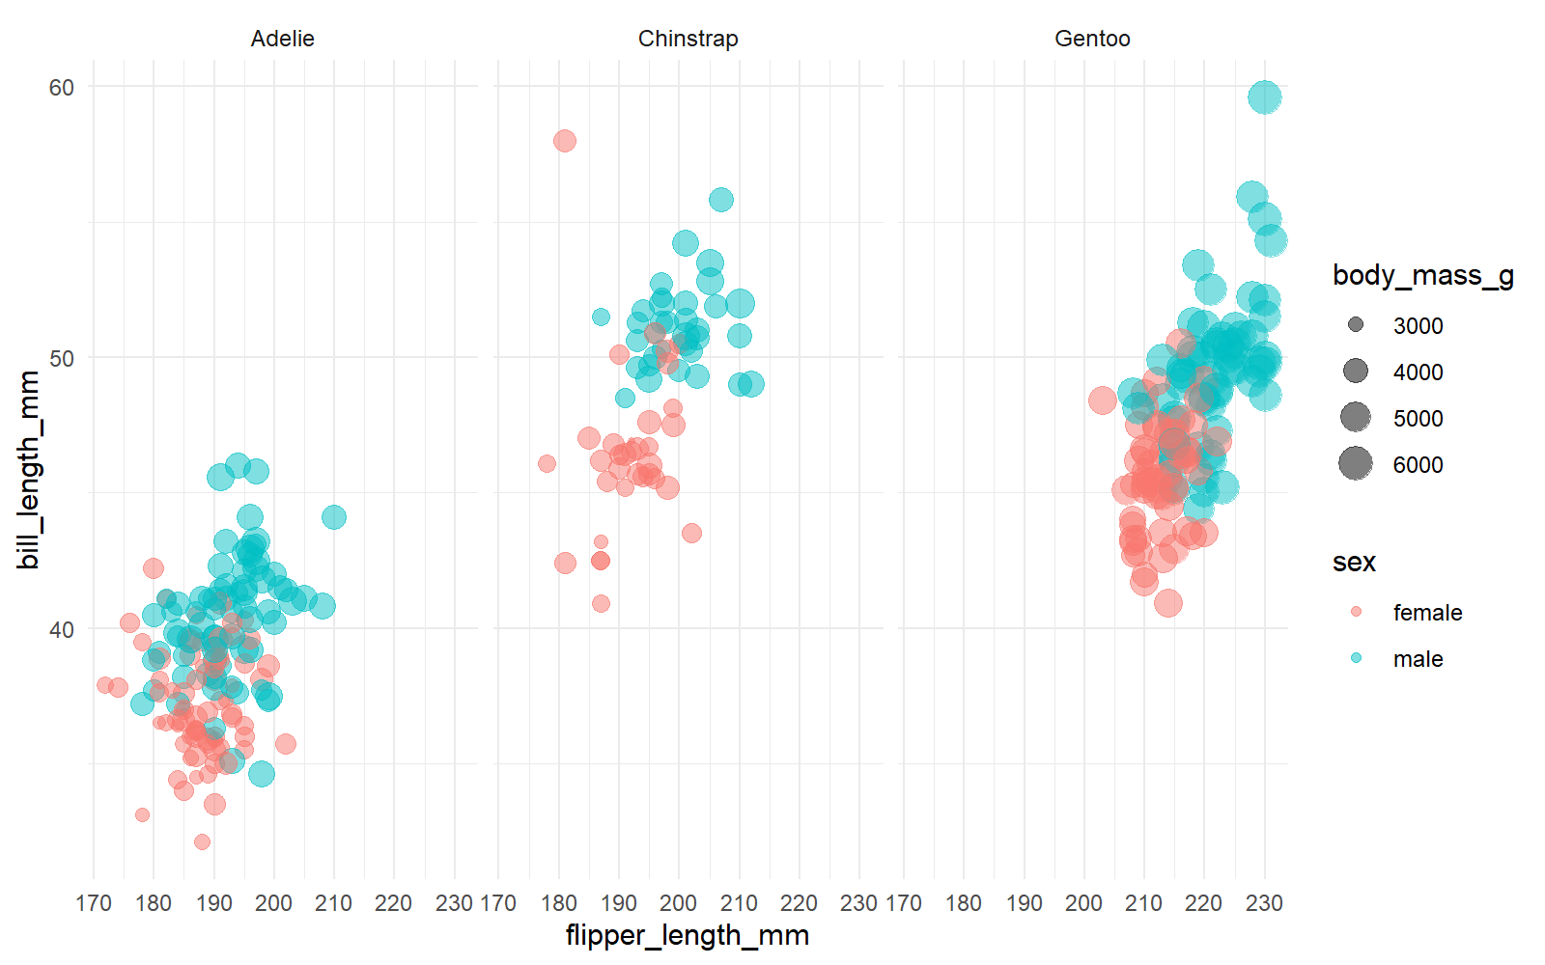

From the above graph it looks like female penguins have smaller with differet bills. Now let’s build a model but first remove year and island from the model.

penguins_df <- penguins %>% filter(!is.na(sex)) %>% select(-year, -island)  
  
penguins_df

# A tibble: 333 × 6  
 species bill_length_mm bill_depth_mm flipper_length_mm body_mass_g sex   
 <fct> <dbl> <dbl> <int> <int> <fct>   
 1 Adelie 39.1 18.7 181 3750 male   
 2 Adelie 39.5 17.4 186 3800 female  
 3 Adelie 40.3 18 195 3250 female  
 4 Adelie 36.7 19.3 193 3450 female  
 5 Adelie 39.3 20.6 190 3650 male   
 6 Adelie 38.9 17.8 181 3625 female  
 7 Adelie 39.2 19.6 195 4675 male   
 8 Adelie 41.1 17.6 182 3200 female  
 9 Adelie 38.6 21.2 191 3800 male   
10 Adelie 34.6 21.1 198 4400 male   
# ℹ 323 more rows

## 2 Building a Model

Let’s start by loading the tidymodels package and splitting our data into training and testing sets.

library(tidymodels)

── Attaching packages ────────────────────────────────────── tidymodels 1.1.1 ──

✔ broom 1.0.5 ✔ rsample 1.2.0  
✔ dials 1.2.0 ✔ tune 1.1.2  
✔ infer 1.0.5 ✔ workflows 1.1.3  
✔ modeldata 1.2.0 ✔ workflowsets 1.0.1  
✔ parsnip 1.1.1 ✔ yardstick 1.2.0  
✔ recipes 1.0.8

── Conflicts ───────────────────────────────────────── tidymodels_conflicts() ──  
✖ scales::discard() masks purrr::discard()  
✖ dplyr::filter() masks stats::filter()  
✖ recipes::fixed() masks stringr::fixed()  
✖ dplyr::lag() masks stats::lag()  
✖ yardstick::spec() masks readr::spec()  
✖ recipes::step() masks stats::step()  
• Learn how to get started at https://www.tidymodels.org/start/

set.seed(123)  
  
penguin_split <- initial_split(penguins_df, strata = sex)  
  
penguins_train <- training(penguin_split)  
penguins_test <- testing(penguin_split)

As data for building a model is not that large, let’s create resamples of training data to evaluate the model.

set.seed(123)  
penguin_boot <- bootstraps(penguins_train)  
  
penguin_boot

# Bootstrap sampling   
# A tibble: 25 × 2  
 splits id   
 <list> <chr>   
 1 <split [249/93]> Bootstrap01  
 2 <split [249/91]> Bootstrap02  
 3 <split [249/90]> Bootstrap03  
 4 <split [249/91]> Bootstrap04  
 5 <split [249/85]> Bootstrap05  
 6 <split [249/87]> Bootstrap06  
 7 <split [249/94]> Bootstrap07  
 8 <split [249/88]> Bootstrap08  
 9 <split [249/95]> Bootstrap09  
10 <split [249/89]> Bootstrap10  
# ℹ 15 more rows

Let’s build and compare two different models, a *logistic regression* model and a *random forest* model.

# logistic regression model  
glm_spec <- logistic_reg() %>%  
 set_engine("glm")  
  
glm_spec

Logistic Regression Model Specification (classification)  
  
Computational engine: glm

# random forest model  
  
rf_spec <- rand_forest() %>%  
 set_mode("classification") %>%   
 set_engine("ranger")  
  
rf_spec

Random Forest Model Specification (classification)  
  
Computational engine: ranger

Next let’s start putting together a tidymodels workflow(), a helper object to help manage modeling pipelines with pieces that fit together like Lego blocks. Notice that there is no model yet: Model: None.

penguin_wf <- workflow() %>%   
 add_formula(sex ~ .)  
  
penguin_wf

══ Workflow ════════════════════════════════════════════════════════════════════  
Preprocessor: Formula  
Model: None  
  
── Preprocessor ────────────────────────────────────────────────────────────────  
sex ~ .

Now we can add a model and fit the model to each of the resamples. First, we can fit the logistic regression model

glm_rs <- penguin_wf %>%  
 add_model(glm_spec) %>%  
 fit_resamples(  
 resamples = penguin_boot,  
 control = control_resamples(save_pred = TRUE)  
 )

→ A | warning: glm.fit: fitted probabilities numerically 0 or 1 occurred

There were issues with some computations A: x1

There were issues with some computations A: x3

glm_rs

# Resampling results  
# Bootstrap sampling   
# A tibble: 25 × 5  
 splits id .metrics .notes .predictions  
 <list> <chr> <list> <list> <list>   
 1 <split [249/93]> Bootstrap01 <tibble [2 × 4]> <tibble [0 × 3]> <tibble>   
 2 <split [249/91]> Bootstrap02 <tibble [2 × 4]> <tibble [0 × 3]> <tibble>   
 3 <split [249/90]> Bootstrap03 <tibble [2 × 4]> <tibble [0 × 3]> <tibble>   
 4 <split [249/91]> Bootstrap04 <tibble [2 × 4]> <tibble [0 × 3]> <tibble>   
 5 <split [249/85]> Bootstrap05 <tibble [2 × 4]> <tibble [1 × 3]> <tibble>   
 6 <split [249/87]> Bootstrap06 <tibble [2 × 4]> <tibble [0 × 3]> <tibble>   
 7 <split [249/94]> Bootstrap07 <tibble [2 × 4]> <tibble [0 × 3]> <tibble>   
 8 <split [249/88]> Bootstrap08 <tibble [2 × 4]> <tibble [1 × 3]> <tibble>   
 9 <split [249/95]> Bootstrap09 <tibble [2 × 4]> <tibble [0 × 3]> <tibble>   
10 <split [249/89]> Bootstrap10 <tibble [2 × 4]> <tibble [0 × 3]> <tibble>   
# ℹ 15 more rows  
  
There were issues with some computations:  
  
 - Warning(s) x3: glm.fit: fitted probabilities numerically 0 or 1 occurred  
  
Run `show_notes(.Last.tune.result)` for more information.

Second, we can fit the random forest model.

rf_rs <- penguin_wf %>%  
 add_model(rf_spec) %>%  
 fit_resamples(  
 resamples = penguin_boot,  
 control = control_resamples(save_pred = TRUE)  
 )  
  
rf_rs

# Resampling results  
# Bootstrap sampling   
# A tibble: 25 × 5  
 splits id .metrics .notes .predictions  
 <list> <chr> <list> <list> <list>   
 1 <split [249/93]> Bootstrap01 <tibble [2 × 4]> <tibble [0 × 3]> <tibble>   
 2 <split [249/91]> Bootstrap02 <tibble [2 × 4]> <tibble [0 × 3]> <tibble>   
 3 <split [249/90]> Bootstrap03 <tibble [2 × 4]> <tibble [0 × 3]> <tibble>   
 4 <split [249/91]> Bootstrap04 <tibble [2 × 4]> <tibble [0 × 3]> <tibble>   
 5 <split [249/85]> Bootstrap05 <tibble [2 × 4]> <tibble [0 × 3]> <tibble>   
 6 <split [249/87]> Bootstrap06 <tibble [2 × 4]> <tibble [0 × 3]> <tibble>   
 7 <split [249/94]> Bootstrap07 <tibble [2 × 4]> <tibble [0 × 3]> <tibble>   
 8 <split [249/88]> Bootstrap08 <tibble [2 × 4]> <tibble [0 × 3]> <tibble>   
 9 <split [249/95]> Bootstrap09 <tibble [2 × 4]> <tibble [0 × 3]> <tibble>   
10 <split [249/89]> Bootstrap10 <tibble [2 × 4]> <tibble [0 × 3]> <tibble>   
# ℹ 15 more rows

We have fit each of our candidate models to our resampled training set!

## 3 Evaluate Model

Now let’s check the results and how well they performed.

collect_metrics(glm_rs)

# A tibble: 2 × 6  
 .metric .estimator mean n std_err .config   
 <chr> <chr> <dbl> <int> <dbl> <chr>   
1 accuracy binary 0.918 25 0.00639 Preprocessor1_Model1  
2 roc_auc binary 0.979 25 0.00254 Preprocessor1_Model1

collect_notes(glm_rs)

# A tibble: 3 × 4  
 id location type note   
 <chr> <chr> <chr> <chr>   
1 Bootstrap05 preprocessor 1/1, model 1/1 warning glm.fit: fitted probabilities…  
2 Bootstrap08 preprocessor 1/1, model 1/1 warning glm.fit: fitted probabilities…  
3 Bootstrap23 preprocessor 1/1, model 1/1 warning glm.fit: fitted probabilities…

Pretty nice! The function collect_metrics() extracts and formats the .metrics column from resampling results like the ones we have here.

collect_metrics(rf_rs)

# A tibble: 2 × 6  
 .metric .estimator mean n std_err .config   
 <chr> <chr> <dbl> <int> <dbl> <chr>   
1 accuracy binary 0.912 25 0.00547 Preprocessor1_Model1  
2 roc_auc binary 0.977 25 0.00202 Preprocessor1_Model1

Let’s choose *logistic model* as it is simpler.

glm_rs %>% conf_mat_resampled()

# A tibble: 4 × 3  
 Prediction Truth Freq  
 <fct> <fct> <dbl>  
1 female female 41.1  
2 female male 3   
3 male female 4.4  
4 male male 42.3

About the same, which is good. We can also make an ROC curve.

glm_rs %>%  
 collect_predictions() %>%  
 group_by(id) %>%  
 roc_curve(sex, .pred_female) %>%  
 ggplot(aes(1 - specificity, sensitivity, color = id)) +  
 geom_abline(lty = 2, color = "gray80", size = 1.5) +  
 geom_path(show.legend = FALSE, alpha = 0.6, size = 1.2) +  
 coord_equal()

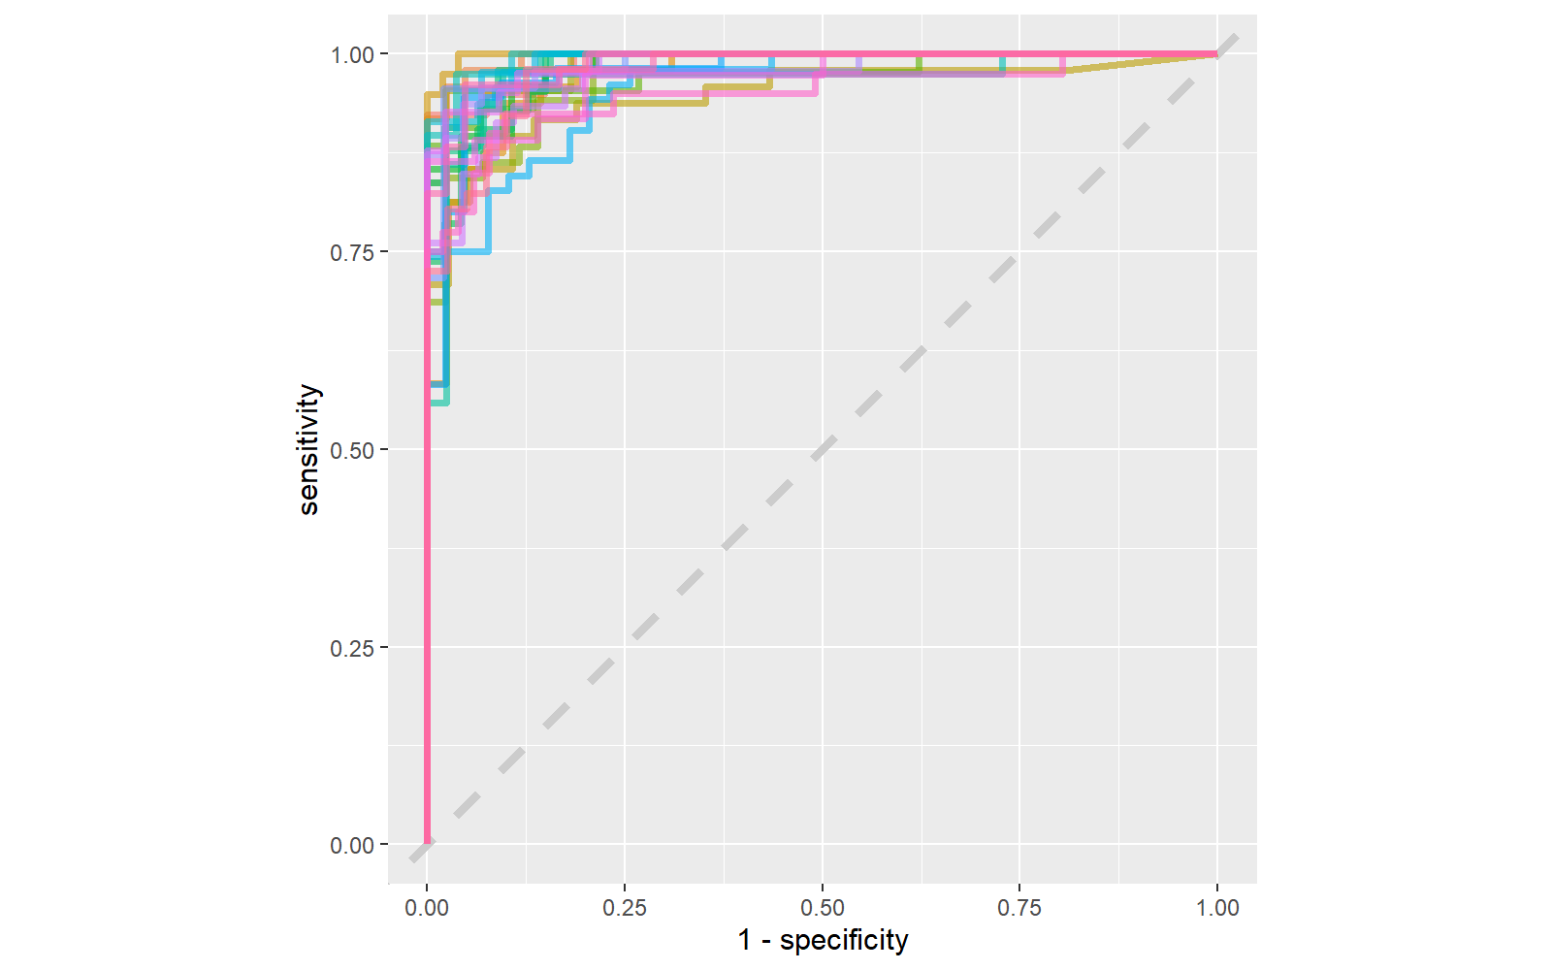

It is finally time for us to return to the testing set. Notice that we have not used the testing set yet during this whole analysis; the testing set is precious and can only be used to estimate performance on new data. Let’s fit one more time to the training data and evaluate on the testing data using the function last_fit().

penguin_final <- penguin_wf %>%  
 add_model(glm_spec) %>%  
 last_fit(penguin_split)  
  
penguin_final

# Resampling results  
# Manual resampling   
# A tibble: 1 × 6  
 splits id .metrics .notes .predictions .workflow   
 <list> <chr> <list> <list> <list> <list>   
1 <split [249/84]> train/test split <tibble> <tibble> <tibble> <workflow>

The metrics and predictions here are on the testing data.

collect_metrics(penguin_final)

# A tibble: 2 × 4  
 .metric .estimator .estimate .config   
 <chr> <chr> <dbl> <chr>   
1 accuracy binary 0.857 Preprocessor1_Model1  
2 roc_auc binary 0.938 Preprocessor1_Model1

collect_predictions(penguin_final) %>%  
 conf_mat(sex, .pred_class)

Truth  
Prediction female male  
 female 37 7  
 male 5 35

penguin_final$.workflow[[1]] %>%  
 tidy(exponentiate = TRUE)

# A tibble: 7 × 5  
 term estimate std.error statistic p.value  
 <chr> <dbl> <dbl> <dbl> <dbl>  
1 (Intercept) 5.75e-46 19.6 -5.31 0.000000110  
2 speciesChinstrap 1.37e- 4 2.34 -3.79 0.000148   
3 speciesGentoo 1.14e- 5 3.75 -3.03 0.00243   
4 bill_length_mm 1.91e+ 0 0.180 3.60 0.000321   
5 bill_depth_mm 8.36e+ 0 0.478 4.45 0.00000868   
6 flipper_length_mm 1.06e+ 0 0.0611 0.926 0.355   
7 body_mass_g 1.01e+ 0 0.00176 4.59 0.00000442

* The largest odds ratio is for bill depth, with the second largest for bill length. An increase of 1 mm in bill depth corresponds to almost 4x higher odds of being male. The characteristics of a penguin’s bill must be associated with their sex.
* We don’t have strong evidence that flipper length is different between male and female penguins, controlling for the other measures; maybe we should explore that by changing that first plot!

penguins %>% filter(!is.na(sex)) %>%   
 ggplot(aes(bill_depth_mm, bill_length_mm, color = sex,  
 size = body_mass_g)) +  
 geom_point(alpha = 0.5) +  
 facet_wrap(~species) +  
 theme_minimal()

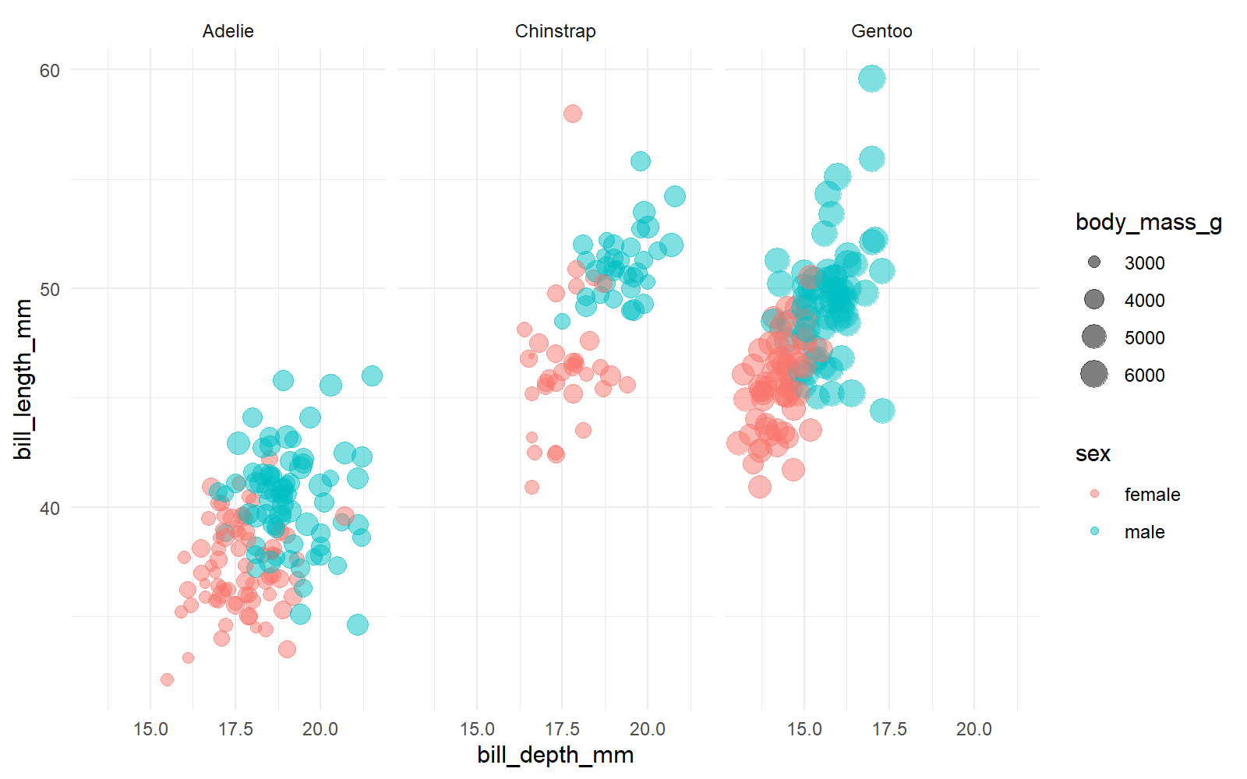

This graph shows much more separation between male and female penguins.