CS595-Interactive and Transparency in Machine Learning

Do we understand ‘fdsajfiowrjl jweiorj lwekrjoweire’ text? I don’t because I don’t know what language it is, also I don’t know what is the grammar to understand it. Likewise, Machine learning can’t understand random representation. So I see the bag of words model is not great for text classification. So we need to represent a good way such that ML can understand. So when I was doing text analysis on

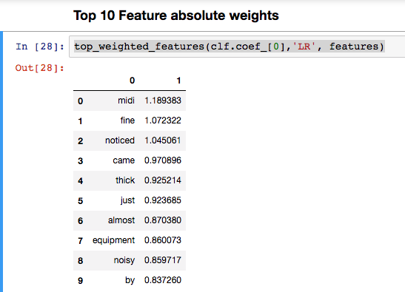

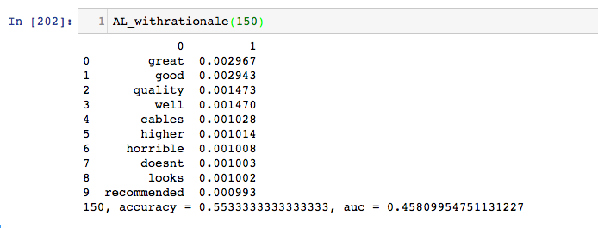

An App to Create Datasets, a by-product of IML

Create dataset(CD) which is a simple WebUI brings rationales from the human labeler in an easy way. Suited for Active Learning with Rationale using simple Web UI, so in this project I did learning with rationale using Human generated labeler(chi-square), but not satisfied(personally) it is just based on pure statistics. Even If we tweak all the way around it can’t be as good as human since complex inference in risk domain such as Medical, Self-Driving cars are still taken by Humans. So I developed an App which is a by-product of My CS595 Class Project – “Sentimental analysis on Amazon Review”. Creating a Training Datasets is not easy process, so I thought I will open-source UI which I used for myself to Label rationales on Amazon Review Dataset on Musical Instruments. This app is written in Python and HTML, so it is very easy to extend adapt to LwE models. I strongly recommended to watch the 1 min fast-tracked demo video before reading this paper. Later if you like to use this app, then please watch 10-min video which has everything you need to get run it in local machine, all code is present in https://github.com/ajayramesh23/CD