1/29/2017

­­Ajay Ramesh & Chandra Kumar

Illinois Tech

File Sharing System Design Doc-1.0

CS550AOS-Programming Assignment 1

Table of Contents

Introduction 3

Requirement 3

Central indexing server. 3

Peer. 3

Over all Program Design 4

File Registry Sequence Diagram – 4

File Lookup Sequence Diagram – 5

File Download Sequence Diagram – 5

Registry and Lookup Concurrency Flow chart 5

Evaluation and measurement : 7

Lookup 7

Registry 8

Class Diagram and its dependency - 9

Peer Server 9

Index Server 9

# Introduction

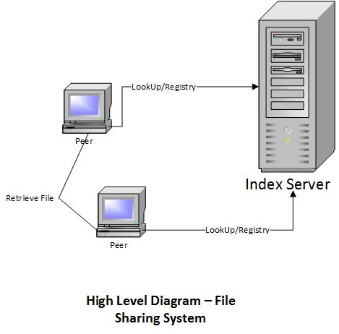

## Requirement

### Central indexing server.

This server indexes the contents of all of the peers that register with it. It also provides search facility to peers.

* *registry(peer id, file name, ...)* -- invoked by a peer to register all its files with the indexing server. The server then builds the index for the peer.
* *lookup(file name)* -- this procedure should search the index and return all the matching peers to the requestor.

### Peer.

A peer is both a client and a server. As a client, the user specifies a file name with the indexing server using "lookup". The indexing server returns a list of all other peers that hold the file. The user can pick one such peer and the client then connects to this peer and downloads the file. As a server, the peer waits for requests from other peers and sends the requested file when receiving a request. Minimally, the peer server should provide the following interface to the peer client:

* retrieve(file name) -- invoked by a peer to download a file from another peer.

# Over all Program Design

We have used the Java Sockets . The overall design overview is blow:

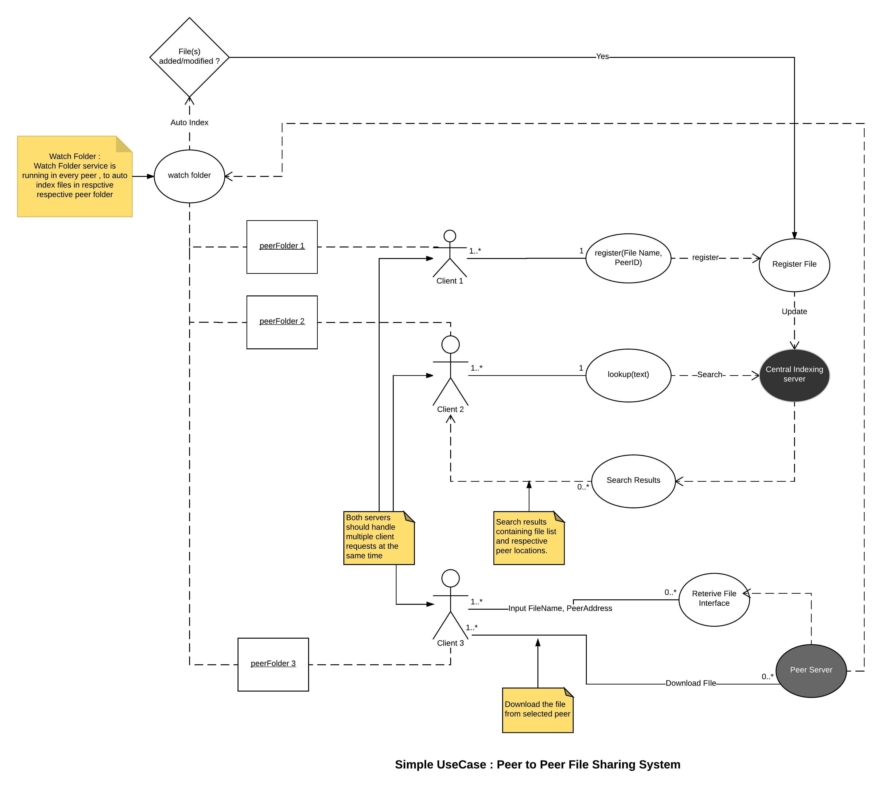

## File Registry Sequence Diagram –

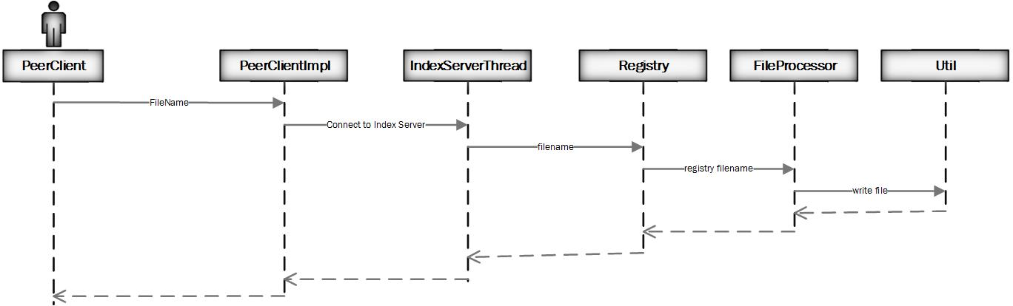

## File Lookup Sequence Diagram –

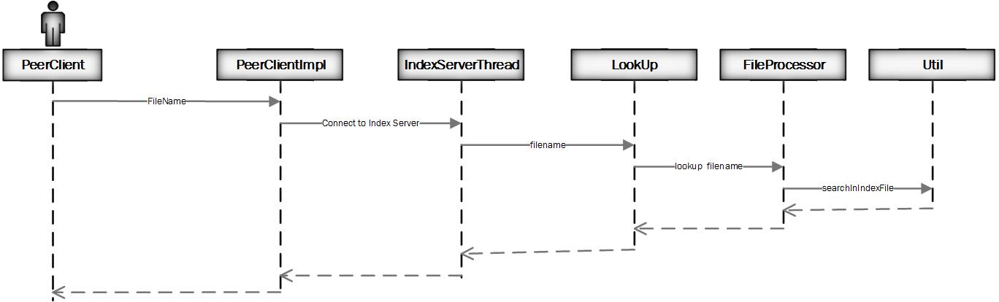

## File Download Sequence Diagram –

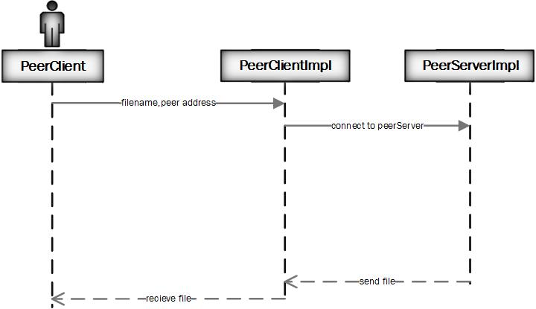

## Registry and Lookup Concurrency Flow chart

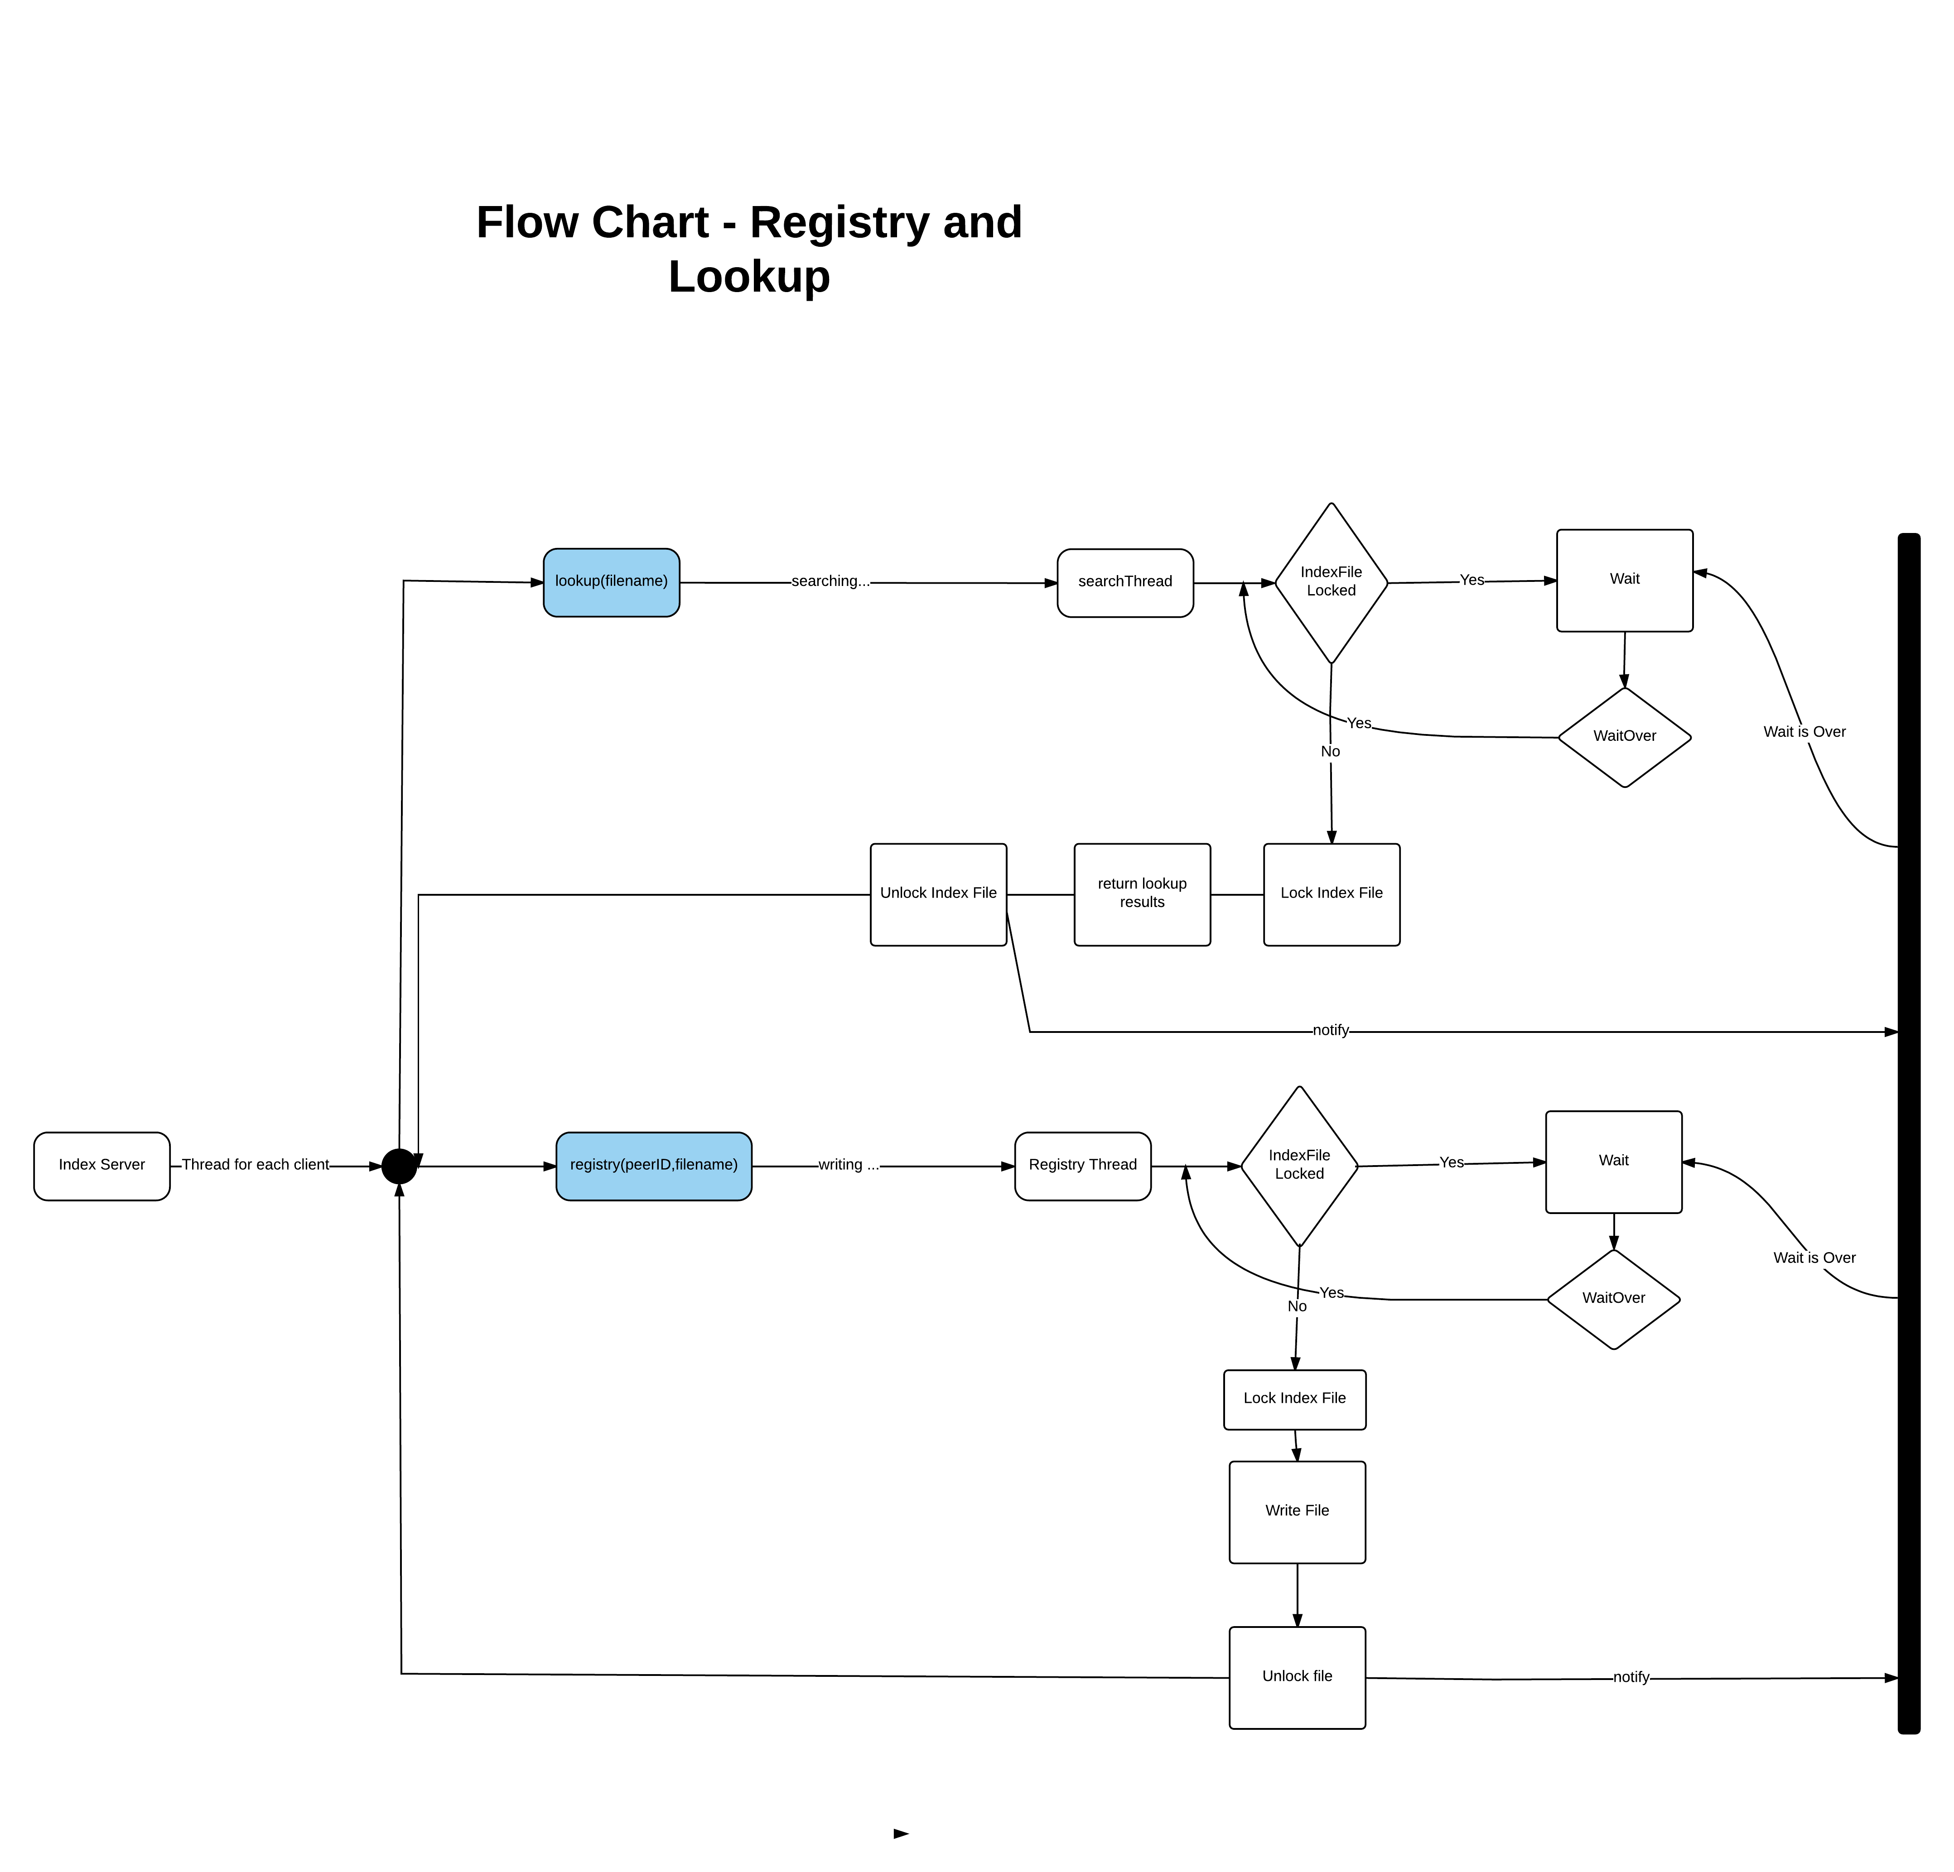

# Evaluation and measurement :

## Lookup

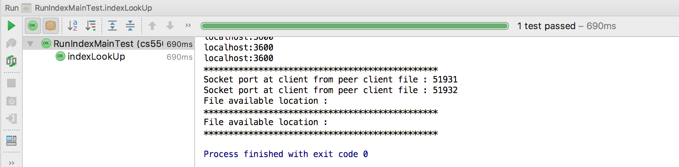

## Registry

Adding 1000 entries from 3 peers simultaneously

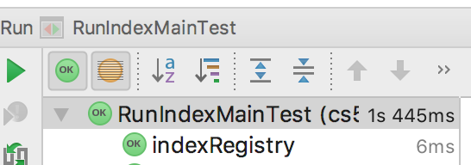

# Class Diagram and its dependency -

## Peer Server

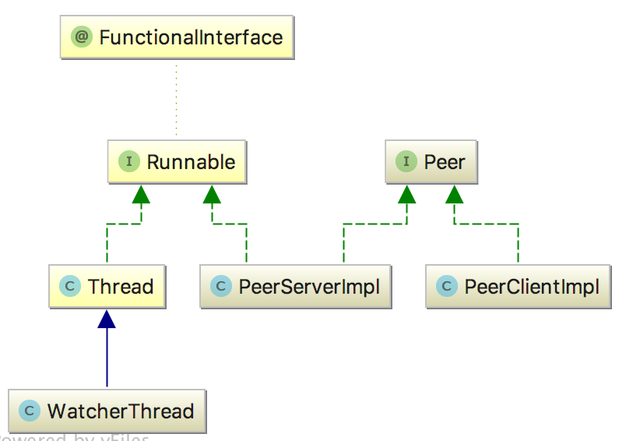

## Index Server

