PurchaOrderAgent
User Guide

Dynamics 365 Finance & Operations Purchase Order Agent
Powered by Copilot Studio · Claude Sonnet (latest) · MCP

1. What This Agent Can Do
Capability | How to trigger
Create a single purchase order | "create purchase order" or give all details at once
Bulk PO creation from Excel | "upload excel" or "bulk purchase order"
Look up a PO by number | "check PO-00001 status"
Find open POs for a vendor | "open POs for vendor US-101"
See POs you created | "show my purchase orders"

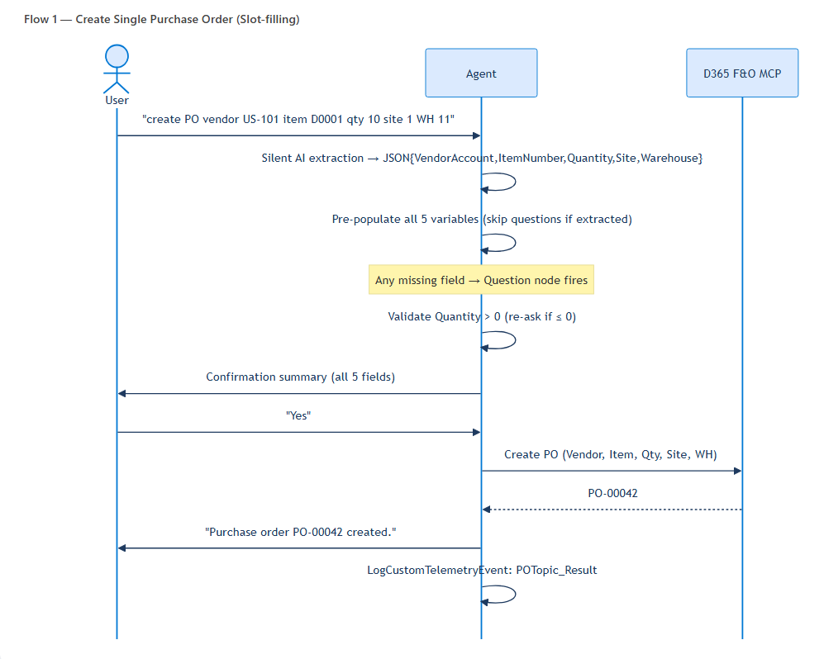
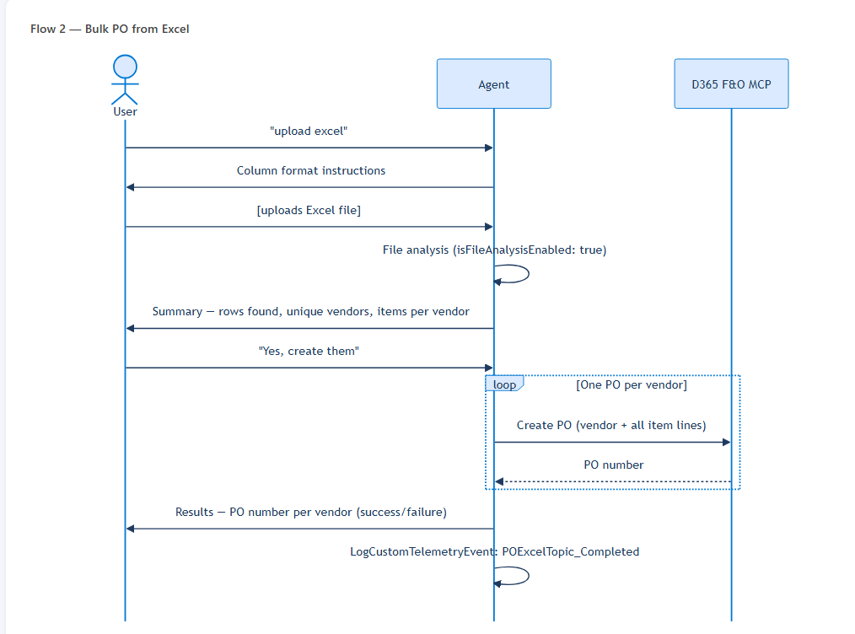
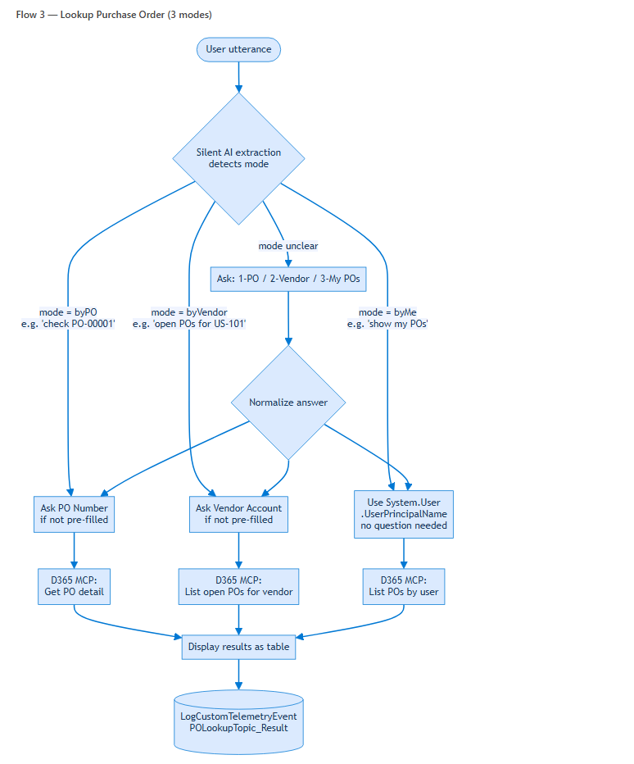

2. Creating a Single Purchase Order
2a Basic flow — agent asks each question
Say any of: create purchase order, new PO, place a purchase order, I need to order items
The agent collects 5 required fields in sequence:
- 1. Vendor Account Number — e.g., US-101
- 2. Item Number — e.g., D0001
- 3. Quantity — must be greater than 0
- 4. Site — e.g., 1
- 5. Warehouse — e.g., 11
After collecting all fields the agent shows a confirmation summary. Reply Yes to submit to D365 or No to cancel.

2b Slot-filling — give all details at once
You can skip all questions by providing every field in a single message. The agent extracts values silently and jumps straight to the confirmation summary.

Examples:
create purchase order Vendor 1001, item D0001, quantity 10, site 1, warehouse 11
create PO for vendor US-101, item A0001, qty 5, site 2, warehouse 21
new PO — vendor USMF-000001, item D0003, qty 100, site 1, WH 13

2c Quantity validation
Quantity must be a positive number greater than 0. If you provide 0 or a negative number, the agent asks you to correct it before proceeding. This check applies both when the value is extracted from your message and when you type it in reply to the question.

3. Bulk Purchase Order Creation from Excel
Step 1 — Trigger the flow
Say any of: upload excel, bulk purchase order, create POs from spreadsheet, import purchase orders from file
Step 2 — Prepare your Excel file
Your Excel file must have the following columns (header names are case-insensitive):
Column | Description | Example
VendorAccount | Vendor account code | US-101
ItemNumber | Item / product code | D0001
Quantity | Quantity to order (must be > 0) | 50
Site | Site code | 1
Warehouse | Warehouse code | 11

Grouping rule: rows with the same VendorAccount are combined into one PO with multiple lines. Each unique vendor creates one purchase order.
Step 3 — Upload and confirm
- Attach your Excel file to your next message.
- The agent analyses the file and shows a summary (row count, unique vendors, items per vendor).
- Reply Yes to confirm — the agent creates one PO per vendor and reports each PO number.
- Missing Site/Warehouse columns? The agent asks for a default value before proceeding.

4. Looking Up Purchase Orders
By PO number
Returns: PO status, vendor, all line items with quantities, delivery status, invoice status.
check PO-00001 status
what is the status of PO-00042
find purchase order PO-10023
By vendor account
Returns: Table of all open POs for that vendor — PO number, date, status, total amount.
open POs for vendor US-101
show purchase orders for vendor USMF-000001
POs created by me
Returns: Table of POs you created — PO number, vendor, date, status.
show my purchase orders
POs created by me
my open purchase orders
Tip: Including details in your trigger message skips the clarifying question entirely.
- "check PO-00001" → straight to the lookup, no question asked
- "open POs for vendor US-101" → immediate vendor query
- "my POs" → looks up by your identity (no question)

5. Field Reference
Field | Format | Example values
Vendor Account | Text code | US-101 · USMF-000001 · V-1001
Item Number | Text code | D0001 · A0001 · D0003
Quantity | Positive integer | 1 · 50 · 1000
Site | Numeric code | 1 · 2 · 3
Warehouse | Numeric code | 11 · 13 · 21
PO Number | PO-NNNNN | PO-00001 · PO-00042

6. Error Handling
Situation | What happens
D365 returns an error | Agent explains what failed and offers to correct and retry
Invalid quantity (≤ 0) | Agent re-asks with a clear validation message
Unknown / out-of-scope request | Agent lists its 3 capabilities with examples
Repeated unrecognised input (3×) | Agent escalates to a human agent

7. Activity Logging
Every key action is automatically logged to Azure Application Insights for audit and analytics.
Event name | When logged
POTopic_Started | Single PO flow triggered
POTopic_FieldsCollected | All 5 fields collected
POTopic_Submitted | User confirmed — D365 call initiated
POTopic_Result | D365 returned result
POTopic_Cancelled | User declined confirmation
POExcelTopic_Started | Excel flow triggered
POExcelTopic_FileReceived | User sent file
POExcelTopic_Completed | Excel processing complete
POLookupTopic_Started | Lookup flow triggered
POLookupTopic_ByPO | Looking up by PO number
POLookupTopic_ByVendor | Looking up by vendor
POLookupTopic_ByMe | Looking up by current user
POLookupTopic_Result | Lookup result returned

8. Quick Reference Card
CREATE SINGLE PO
"create purchase order"
"create PO vendor US-101 item D0001 qty 10 site 1 warehouse 11"

BULK FROM EXCEL
"upload excel"
"bulk purchase order"

LOOK UP PO
"check PO-00001 status" → by PO number
"open POs for vendor US-101" → by vendor
"show my purchase orders" → by me (current user)

PurchaOrderAgent · Copilot Studio · Dynamics 365 Finance & Operations · 2026

