gh manager-brief
Architecture Document
Personalized end-of-Day-3 manager briefs for workshop attendees
Version 1.0 | 2026-06-10

Table of Contents

1. Overview
gh manager-brief is a GitHub CLI extension that generates a personalized 'send this to your manager' brief for each workshop attendee at the end of Day 3. Each brief is a one-page Markdown document covering four things: what the attendee learned, what they built, what they are committing to over the next 30 days, and how their manager can help.
The design goal is behavioral, not technical: turn managers into accountability partners rather than obstacles, and save attendees an awkward follow-up conversation they would otherwise skip.

1.1 Problem
- Multi-day workshops produce excited attendees and vague intentions.
- Attendees rarely follow up with their manager - the conversation feels open-ended and high-effort.
- Managers, lacking specifics, default to 'sounds great' instead of unblocking the next step.
- Workshop ROI evaporates within two weeks.

1.2 Solution
A small CLI extension that takes a CSV of attendee responses and emits ready-to-send Markdown briefs. Each brief has a fixed shape (learned / built / committing / ask) so it reads in under two minutes. Optionally, the extension posts each brief as a GitHub issue assigned to the attendee with a 'manager-brief' label, creating a durable 30-day accountability checkpoint.

2. Architecture
The system has four stages: Capture, Generation, Output, and Outcome. The diagram below shows the flow.
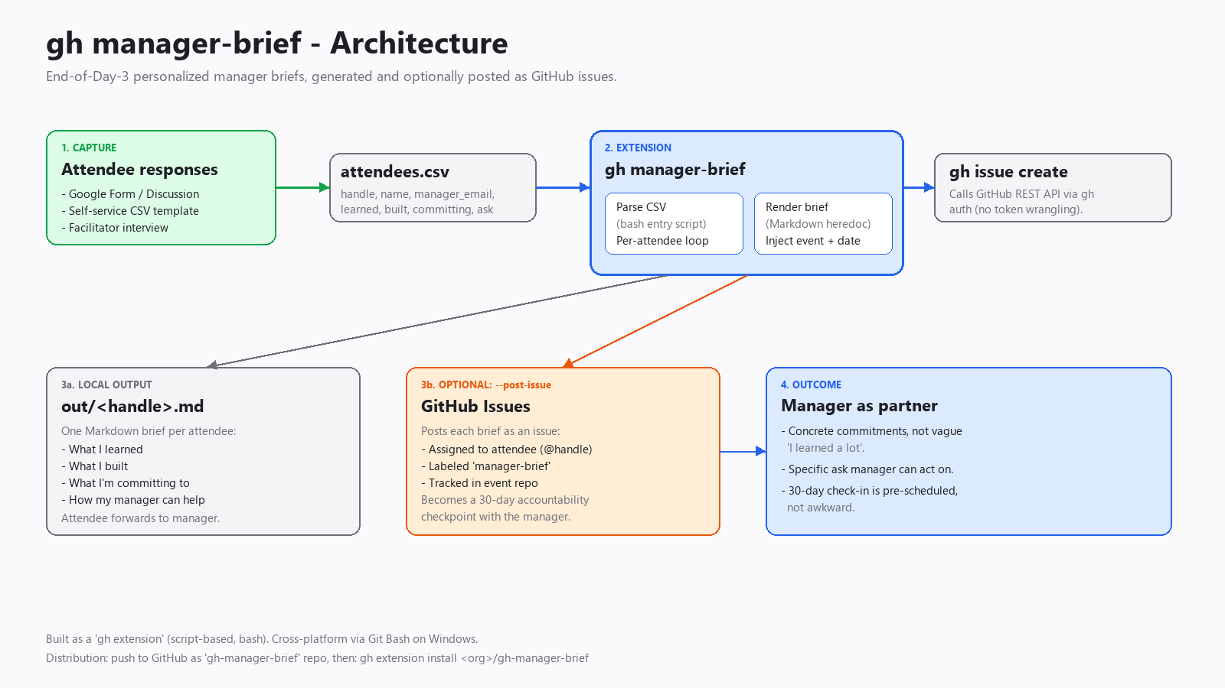
Figure 1: End-to-end flow from attendee response to manager handoff.

3. Components
Component | Type | Responsibility
gh-manager-brief (script) | Bash entry point | Parses CLI flags, reads CSV, loops attendees, renders each brief.
attendees.csv | Input | Single source of truth for attendee data. One row per attendee.
out/<handle>.md | Output | One Markdown brief per attendee. Self-contained; safe to email.
gh issue create | Optional output | Posts each brief as a GitHub issue, assigned to attendee, labeled 'manager-brief'.
GitHub CLI auth | Dependency | Reuses existing gh authentication; no token management in the extension.

4. Data flow
Step-by-step:
- Facilitator collects attendee responses via Form / GitHub Discussion / interview.
- Responses are exported to a CSV with columns: handle, name, manager_email, learned, built, committing, ask.
- Facilitator runs: gh manager-brief generate --input attendees.csv --out ./out
- The extension iterates rows, rendering one Markdown file per attendee into ./out.
- If --post-issue OWNER/REPO is supplied, each brief is also posted as an issue assigned to the attendee.
- Attendee receives the brief (file or issue notification), forwards it to their manager.
- Manager replies with concrete support; the issue (if used) becomes the 30-day checkpoint.

5. CSV schema
Column | Type | Purpose
handle | string | GitHub username (also used as output filename).
name | string | Display name for the brief header.
manager_email | string | Listed in the brief so the attendee knows who to send it to.
learned | text | Free-form: what concepts or skills the attendee absorbed.
built | text | Free-form: what artifact the attendee shipped during the workshop.
committing | text | Free-form: 30-day commitment, ideally measurable.
ask | text | Free-form: specific support needed from the manager.
Fields containing commas must be wrapped in double quotes per RFC 4180.

6. Distribution
The extension is distributed as a GitHub repository named 'gh-manager-brief'. The 'gh-' prefix is required for gh to recognize it as an extension.

6.1 Install
gh extension install <org>/gh-manager-brief

6.2 Update
gh extension upgrade manager-brief

6.3 Uninstall
gh extension remove manager-brief

7. Security and privacy
- Attendee data lives only in the CSV and the generated Markdown - no external services, no telemetry.
- When --post-issue is used, briefs become content in the target GitHub repo. Use a private repo for sensitive workshops.
- Manager email addresses are written into the brief body. If the issue path is used, this lands in GitHub - confirm attendees are OK with that.
- The extension inherits gh authentication; no additional secrets are stored.

8. Extension points (future)
- --email-via-graph: send each brief directly to manager_email via Microsoft Graph.
- --template <path>: support custom Markdown templates per organization.
- --checkin-days N: auto-create a follow-up issue at day N referencing the original brief.
- --source discussion: pull responses directly from a GitHub Discussion thread instead of CSV.

9. Operations
Concern | How it's handled
Runtime errors | Bash 'set -euo pipefail' aborts on first failure; partial output remains for inspection.
Idempotency | Re-running overwrites Markdown files. Issue posting is NOT idempotent - use a fresh label or dedicated repo per cohort.
Logging | Each generated file and posted issue is echoed to stdout.
Cross-platform | Runs natively on macOS/Linux. Windows uses Git Bash, which gh invokes automatically.

10. Glossary
- Brief: the one-page Markdown document a single attendee sends to their manager.
- Cohort: a group of attendees from a single workshop run.
- Ask: the concrete unblock or support request made of the manager.

