**Discrimination Claims Navigator**

Report for: {{ user_info().first_name }} {{ user_info().last_name }}  
Dated: {{ format_date(today(), format='MM/dd/yyyy') }}  
Number of pages in this report: 3

Summary of your claims

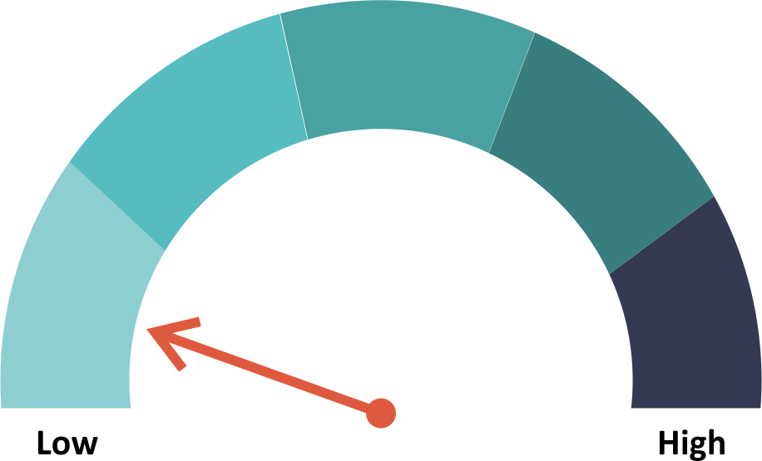

**Summary indicator of claim**

Because special protections apply under the *free exercise of religion* clause of the U.S. Constitution, your chance for a successful discrimination claim is **low**.

Your employer or potential employer is protected by the **ministerial exception** to anti-discrimination laws. The ministerial exception, sometimes known as the "ecclesiastical exception," is a legal doctrine in the United States barring the application of anti-discrimination laws to religious institutions' employment relationships with its "ministers." As explained by the Supreme Court in the landmark case *Hosanna-Tabor Evangelical Lutheran Church and School v. E.E.O.C.* , the exception is drawn from the First Amendment to the United States Constitution, and seeks to both (1) safeguard religious groups' "freedom . . . to select their own ministers," a principle rooted in the Free Exercise Clause, and (2) prevent "government involvement in ecclesiastical decisions," a prohibition stemming from the Establishment Clause. When applied, the exception operates to give religious institutions an affirmative defense when sued for discrimination by employees who qualify as "ministers;" for example, female priests cannot sue the Catholic church to force their hiring. However, exactly which types of employees should qualify as a "ministers," and thus how broadly the exception should apply, is the subject of current litigation before the Supreme Court.

**What’s next?**

Read through your individual claim(s) below. Now that you have an initial analysis of your claim(s), you will want to decide if you want to move forward. If you want to move forward, we suggest you consult with a lawyer. A lawyer can help you with several issues that are beyond the scope of this navigator, including:

* comparing your facts and circumstances to others in a similar situation;
* understanding how you would do in the court or administrative agency that would hear your claim(s);
* estimating the value of your claim(s);
* estimating how much it would cost to pursue your claim(s); and
* negotiating with your employer or filing your claim(s).

**Transcript of your responses**

Below you will find a transcript of your responses. These notes may help you using the transcript.

* If you decide to hire a lawyer, you can use this transcript to discuss your claims. Your lawyer can help you compare your facts and circumstances to others in a similar situation, and will likely be able to formulate claims other than those generated by the Discrimination Claims Navigator. A lawyer will also be able to fit your facts and circumstances within an understanding of how local courts and/or administrative agencies are likely to respond, which is an important part of understanding the value of your claims.
* The transcript does not show additional information that may have been helpful for your answers in the Help feature. Your lawyer may want to access the additional information in the Help feature in order to understand the context and meaning of the questions in the transcript.
* The transcript only shows questions that you have answered. Many questions in the interview are not shown because they are not responsive to your answers. For example, if you have not specified that your claim is in respect of a disability, then you will not be shown questions on claims for a disability. If you change your answers in the interview, you can access that content.

**1. Free exercise of religion**

1.1 Free exercise of religion

First, we need to understand if your employer benefits from special protections for religion. Is your employer or potential employer a church or religious institution?

Answer:True

1.2 Free exercise of religion, continued

Are you applying to be a minister, a priest or a role that performs the functions of a minister or priest?

Answer: True

**Important Legal Information**

You agreed to the terms and conditions of the Discrimination Claims Navigator before you were granted access. We rely on those terms to disclaim liability for the use of the Discrimination Claims Navigator. Disclaiming liability for the Discrimination Claims Navigator helps us bring you services at a cost that increases access to legal information. The mission of PartnerVine Access is to expand access to legal information, and, by doing so, expand access to justice. The terms and conditions of the Discrimination Claims Navigator govern your use of the Discrimination Claims Navigator and this report, and are incorporated here by reference.

Among other things, the terms and conditions include the following:

* PartnerVine Access excludes any warranty and liability with respect to the Discrimination Claims Navigator to the maximum extent permitted by the applicable law. The limitation of liability includes the liability for indirect or consequential damages.
* Under no circumstances is responsibility assumed for any loss or damage resulting from use of the Discrimination Claims Navigator. The Discrimination Claims Navigator is provided "as is" and as available. Any warranties and conditions of any kind are expressly disclaimed, whether express or implied, including the warranties or conditions of merchantability, fitness for a particular purpose, title, quiet enjoyment, accuracy, or non-infringement. No warranty is made that: (1) the Discrimination Claims Navigator will meet your requirements; or (2) the results that may be obtained from the use of the Discrimination Claims Navigator will be accurate, reliable and as expected by the user.
* The Discrimination Claims Navigator are drafted with care. The Discrimination Claims Navigator does not, however, claim to be complete or accurate for any purpose.
* Use of the Discrimination Claims Navigator does not free a user from a diligent and responsible assessment of the facts and circumstances of claims. The Discrimination Claims Navigator is intended as an initial assessment of claims, and is not intended to be final or definitive.
* If users need more analysis, they must seek the advice of an attorney or other legal service provider.
* For the avoidance of doubt: the Discrimination Claims Navigator does not provide legal advice, but rather organizes information on the law in a manner that is responsive in a question and answer format. Users may not rely on the content of the Discrimination Claims Navigator appropriately addressing the facts and circumstances applicable to the user. You must act for yourself in using the Discrimination Claims Navigator, and make independent decisions as to how the Discrimination Claims Navigator should be tailored to your own facts and circumstances, based upon your own judgment and upon advice from such legal and other advisers as you may deem necessary.
* Use of the Discrimination Claims Navigator does not establish an attorney-client relationship between you and PartnerVine Access, PartnerVine LLC or any of its affiliates. PartnerVine is not a law firm and does not provide legal advice.

PartnerVine Access is an initiative of PartnerVine LLC, a Delaware company with its registered office at 276 Fifth Avenue, Suite 704, New York, NY 10001. Contact details for PartnerVine LLC are below. The best way to contact us is by email.



PartnerVine LLC  
276 Fifth Avenue, Suite 704  
New York, NY 10001  
Email: [access@partnervine.com](mailto:access@partnervine.com)  
Telephone: (646) 583-0621