**Discrimination Claims Navigator**

Report for: {{ user_info().first_name }} {{ user_info().last_name }}  
Dated: {{ format_date(today(), format='MM/dd/yyyy') }}  
Number of pages in this report: 8

Summary of your claims

{%p if overall_summary <= 0.1 %}

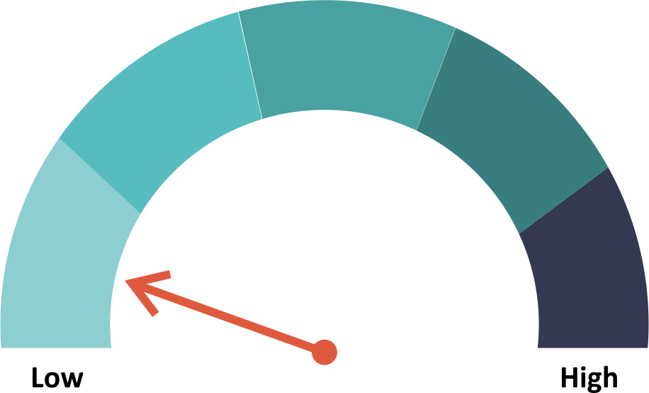

{%p endif %}

{%p if overall_summary == 0.2 %}

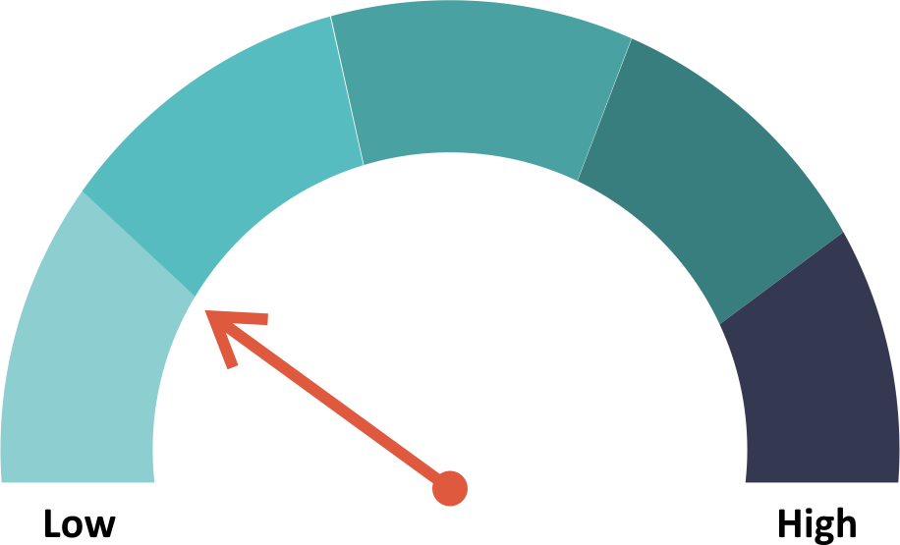

{%p endif %}

{%p if overall_summary == 0.3%}

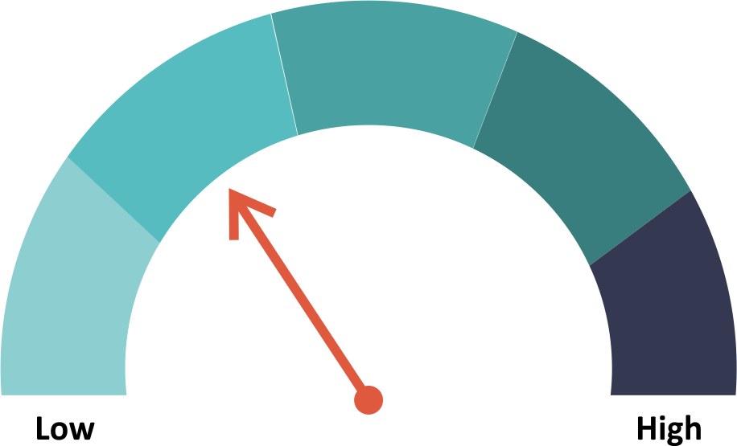

{%p endif %}

{%p if overall_summary == 0.4 %}

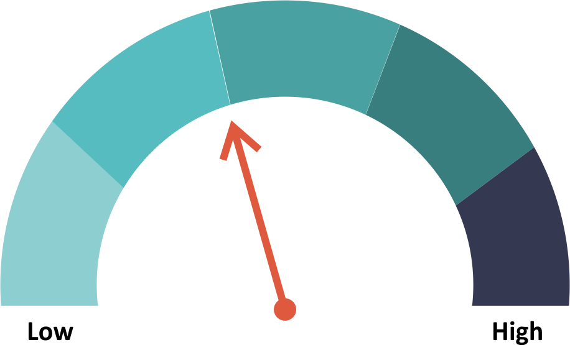

{%p endif %}

{%p if overall_summary == 0.5 %}

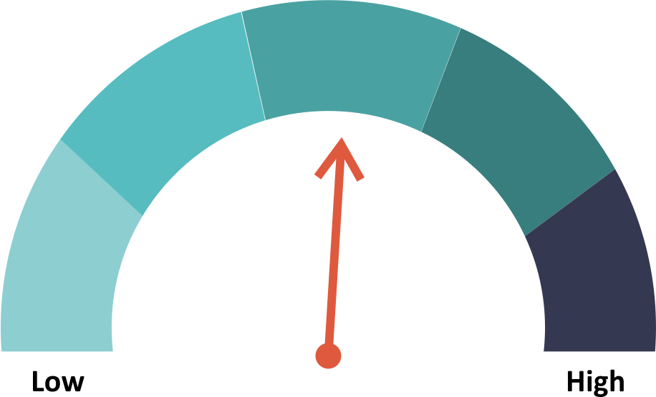

{%p endif %}

{%p if overall_summary == 0.6 %}

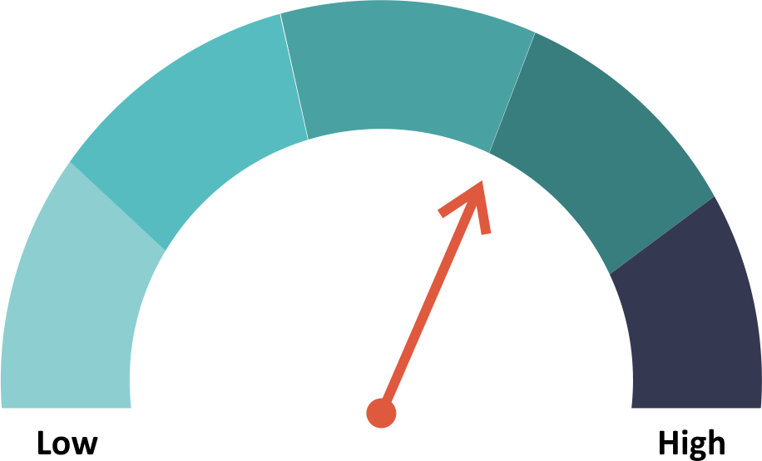

{%p endif %}

{%p if overall_summary == 0.7 %}

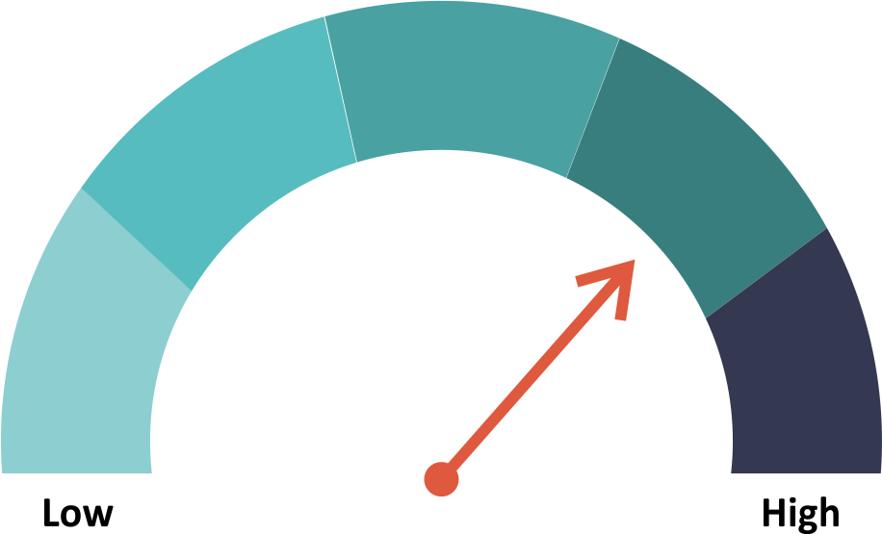

{%p endif %}

{%p if overall_summary == 0.8 %}

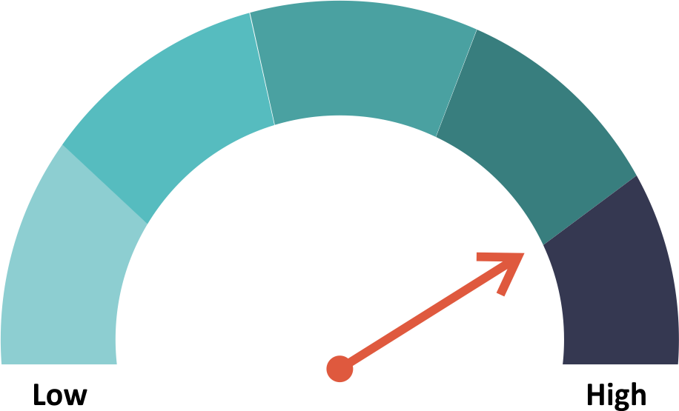

{%p endif %}

{%p if overall_summary == 0.9 %}

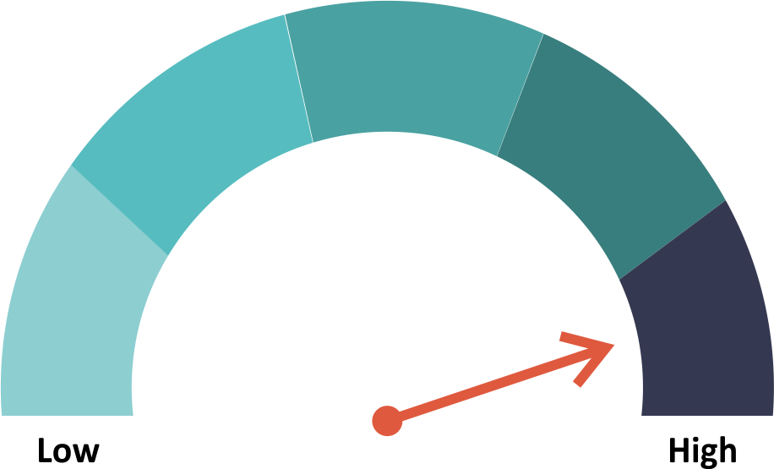

{%p endif %}

**Summary indicator of claims**

The summary indicator above reflects the value of your best claim. Since claims are considered independently, the summary doesn’t average or add up your claims. If you have more than one valid claim, there may be more of a chance that your claims are considered positively. We have not quantified that chance in this summary.

**What’s next?**

Read through your individual claim(s) below. Now that you have an initial analysis of your claim(s), you will want to decide if you want to move forward. If you want to move forward, we suggest you consult with a lawyer. A lawyer can help you with several issues that are beyond the scope of this navigator, including:

* comparing your facts and circumstances to others in a similar situation;
* understanding how you would do in the court or administrative agency that would hear your claim(s);
* estimating the value of your claim(s);
* estimating how much it would cost to pursue your claim(s); and
* negotiating with your employer or filing your claim(s).

{%p if claims %}

Your individual claims

{%p endif %}

{%p for claim in claims %}

Claim #{{loop.index}}

{{ content[claim].title }}

{%p if content[claim].dial <= 0.1 %}



{%p endif %}

{%p if content[claim].dial == 0.2 %}



{%p endif %}

{%p if content[claim].dial == 0.3%}



{%p endif %}

{%p if content[claim].dial == 0.4 %}



{%p endif %}

{%p if content[claim].dial == 0.5 %}



{%p endif %}

{%p if content[claim].dial == 0.6 %}



{%p endif %}

{%p if content[claim].dial == 0.7 %}



{%p endif %}

{%p if content[claim].dial == 0.8 %}



{%p endif %}

{%p if content[claim].dial == 0.9 %}



{%p endif %}

{%p if claim == ‘ministerial_exception’ %}

Because special protections apply under the *free exercise of religion* clause of the U.S. Constitution, your chance for a successful discrimination claim is **low**. Your employer or potential employer is protected by the ministerial exception to anti-discrimination laws. The ministerial exception, sometimes known as the "ecclesiastical exception" is a legal doctrine in the United States barring the application of anti-discrimination laws to religious institutions' employment relationships with its ministers. As explained by the Supreme Court in the landmark case *Hosanna-Tabor Evangelical Lutheran Church and School v. E.E.O.C.*, the exception is drawn from the First Amendment to the United States Constitution, and seeks to both (1) safeguard religious groups' "freedom . . . to select their own ministers," a principle rooted in the Free Exercise Clause, and (2) prevent "government involvement in ecclesiastical decisions," a prohibition stemming from the Establishment Clause. When applied, the exception operates to give religious institutions an affirmative defense when sued for discrimination by employees who qualify as "ministers;" for example, female priests cannot sue the Catholic church to force their hiring. However, exactly which types of employees should qualify as a "ministers," and thus how broadly the exception should apply, is the subject of current litigation before the Supreme Court.

{%p endif %}

{%p if claim == ‘ministerial_exception_uncertain’ %}

If you are not sure if the job you are applying for is a role that performs the function of a minister or priest, you may fall in an area of the law that has not been defined by the US Supreme Court. In some jurisdictions, the courts have considered teachers that work for religious institutions as performing enough of the role of a minister or priest that the religious institution should receive the protection of the free exercise of religion clause in hiring for that role. Other jurisdictions have proceeded differently or have not addressed the issue. If you would like to consider your discrimination claim further, we suggest that you consult qualified legal counsel in your jurisdiction.

{%p endif %}

{%p if claim == ‘strong_claim_based_on_direct_evidence_of_discriminatory_intent’ %}

Based on your responses, your chance for a successful discrimination claim under Title VII of the Civil Rights Act of 1964 is **good**.

**Background**. Based on your response that there is direct evidence of discriminatory intent from your employer or potential employer, you have a strong claim for discrimination under Title VII of the Civil Rights Act of 1964. Direct evidence of discriminatory intent is one of the strongest grounds for a discrimination claim. The strength of your evidence of discriminatory intent will likely be an important part of your claim.

{%p endif %}

{%p if claim == ‘valid_Price_Waterhouse_claim’ %}

Based on your responses, you have a valid claim under the Civil Rights Act of 1964 under a line of case law for a claim that is often referred to as a **Price Waterhouse Claim**.

**Background**. Based on your response that your protected trait actually motivated your employer's decision, you have a valid claim for discrimination. This type of claim may not be as easy to win as a claim where you can show direct evidence of discriminatory intent, which is often more clear cut. With a Price Waterhouse Claim, you are required to show that a preponderance of evidence indicates that intentional discrimination was a motivating factor at the time of your employer or potential employer's decision, even it if was mixed with other motives.

{%p endif %}

{%p if claim == ‘valid_McDonnell_Douglas_claim’ %}

Based on your responses, you have a valid claim under the Civil Rights Act of 1964 under a line of case law for a claim that is often referred to as a **McDonnell Douglas Claim**.

**Background**. Your responses indicated that you do not have direct evidence of discriminatory intent. As a result, your employer or potential employer would likely ask a court to dismiss your claim for lack of evidence. To give you a chance to make your case without direct evidence of discriminatory intent, a court in a McDonnell Douglas Claim shifts the burden of persuasion to you. To meet the burden of persuasion, you will have to provide facts that show "by a preponderance of the evidence" that your claim is true.

As an example for a rejected applicant for a job, the court would implement the burden of persuasion by following these steps:

* You would need to make a *prima facie* case, meaning that you would need to show that
* you are a member of a protected class,
* you were qualified for and applied for an available position,
* despite being qualified, you were rejected for that position, and
* the position remained available after your rejection, and your employer or potential employer continued to seek applicants with your qualifications.
* Your employer or potential employer would then be required to articulate a legitimate, non-discriminatory reason for your rejection.
* You would then need to demonstrate that your employer or potential employer's reason was a pretext for discrimination.

That framework has been used in different situations by different courts, and even extended to other claims of discrimination under different laws, like the Disabilities Act and the Age Discrimination Act. A McDonnell Douglas Claim is a harder claim to prove than a claim that includes direct evidence of discriminatory intent.

{%p endif %}

{%p if claim == ‘business_necessity_defense’ %}

Based on your responses, you have a claim that your employer's policy had a disparate impact on persons with your protected trait, but your employer has a defense to that claim on the basis that the practice is necessary for the business.

To show that the employment practice is necessary to the business, your employer or potential employer will need to show that:

* the employment practice relates to the performance of the job, and
* the employment practice relates to the job you are applying for.

{%p endif %}

{%p if claim == ‘valid_disparate_impact_claim’ %}

Your claim is that the employment practice your employer or potential employer used was discriminatory under the disparate impact theory of Title VII of the Civil Rights Act of 1964. You've indicated that your employer is not likely to prove that its employment practice is necessary for the business, and that alternative methods are available. Based on your responses, your claim is relatively strong.

In these situations, there is often a dispute over whether the employment practice is necessary for the business. You can expect your employer or potential employer to claim that the practice was necessary for the business, and the strength of your claim will be in showing that there is an alternative employment practice that does not have the discriminatory effect, serves the employer's interest, and that the employer refused to adopt that alternative employment practice.

{%p endif %}

{%p if claim == ‘disputed_disparate_impact_claim’ %}

Based on your responses, your employer or potential employer may claim that the discriminatory practice was necessary for business, and you can show that there was an alternative employment practice that serves your employer’s interest and that your employer has refused to adopt. Your Disparate Impact Claim will be disputed, but you do have a valid response to your employer or potential employer's Business Necessity Defense.

**Background**. Your claim is based on the employment practice having a disparate impact on your group protected by Title VII of the Civil Rights Act of 1964. Your employer or potential employer will likely claim that the employment practice was necessary for business (the "Business Necessity Defense"), and you will need to show that there is an alternative employment practice that does not have the discriminatory effect, serves the employer's interest, and that the employer refused to adopt that alternative employment practice.

{%p endif %}

{%p if claim == ‘hostile_work_environment_claim’ %}

Your claim is that your employer created or allowed for a hostile work environment. A Hostile Work Environment Claim is a claim under Title VII of the Civil Rights Act of 1964.

Your responses indicate that the conduct or comments that created a hostile work environment were unwelcome and abusive and pervasive. In situations like this, your employer will often argue that the conduct or comments were not unwelcome and that the hostility of the work environment could not be described as abusive and pervasive. To decide a case, a judge or jury will look at the evidence provided by both sides.

{%p endif %}

{%p if claim == ‘hostile_work_environment_claim_with_retaliation’ %}

Your claim is that your employer created or allowed for a hostile work environment and that there were threats against you that were carried out (***Retaliation***). A Hostile Work Environment Claim is a claim under Title VII of the Civil Rights Act of 1964.

Your responses indicate that the conduct or comments that created a hostile work environment were unwelcome and abusive and pervasive. In situations like this, your employer will often argue that the conduct or comments were not unwelcome and that the hostility of the work environment could not be described as abusive and pervasive. In your case, you have also indicated that there were was Retaliation, which makes your claim stronger than a Hostile Work Environment Claim without Retaliation.

{%p endif %}

{%p if claim == ‘Disabilities_Act_claim’ %}

Based on your responses, your claim is that you can perform the functions of your job without any kind of accommodation by your employer and your employer discriminated against you with no defenses. As a result, you have a valid claim for discrimination under the Disabilities Act of 1990. Since you can perform the functions of your job without any kind of accommodation by your employer, and your employer discriminated against you with no other defenses, you have a relatively strong claim.

{%p endif %}

{%p if claim == ‘Disabilities_Act_claim_reasonable_accommodation’ %}

Based on your responses, your claim is that you can perform the essential functions of your job if your employer or potential employer reasonably accommodated your disability. Your responses indicated that the reasonable accommodation would not impose undue hardship on the operation of the employer's business, so you have a valid claim under the Disabilities Act.

{%p endif %}

{%p if claim == ‘undue_hardship_or_no_reasonable_accommodation’ %}

Your responses indicate that you could not perform essential functions of the job with reasonable accommodation or that the accommodation would impose undue hardship on the operation of the employer's business. As a result, your claim is not likely to be successful under the Americans with Disabilities Act of 1990.

{%p endif %}

{%p if claim == ‘equal_pay_claim’ %}

Based on your answers, you have a claim under the Equal Pay Act of 1963 because you have not been paid equally for equal work. In these situations, the cases often revolve around the description of the situation, with employers claiming that the work was not in fact equal and therefore differences in pay were justified.

{%p endif %}

{%p if claim == ‘age_claim’ %}

Your responses indicate that you have a valid claim under the Age Discrimination in Employment Act of 1963. Your responses indicate that your employer has more than 20 employees (which is required for the application of this law), you were treated differently because of your age, you opposed the employment practice of your employer and were retaliated against. If the court agrees with your view of the facts and circumstances, then you have a good case for discrimination under the Age Discrimination in Employment Act of 1963. Cases like this one are often decided based on arguments over the facts and circumstances, and in a court a judge or jury would decide those facts and circumstances.

{%p endif %}

{%p if claim == ‘genetic_information_applicant_claim’ %}

Your responses indicate that you have a valid claim under the Genetic Information Nondiscrimination Act of 2008. You stated that:

* you were discriminated against on the basis of your genetic information,
* you weren't hired because of your genetic information, and
* your genetic information caused your failure to be hired.

Based on your responses, you have a good claim for discrimination based on genetic information as an applicant for a job.

{%p endif %}

{%p if claim == ‘genetic_information_disparate_treatment_claim’ %}

Your responses indicate that you have a valid claim under the Genetic Information Nondiscrimination Act of 2008. You stated that:

* you were discriminated against on the basis of your genetic information,
* your employer classified, segregated or limited its employees on the basis of genetic information,
* that classification, segregation or limitation adversely affected your employment status or your employment opportunities, and
* your employer made that classification, segregation or limitation because of your genetic information.

Based on your responses, you have a good claim for discrimination based on genetic information.

{%p endif %}

{%p if claim == ‘genetic_information_mistaken_request_defense’ %}

Based on your responses, you do not have a claim for discrimination under the Genetic Information Nondiscrimination Act of 2008. If your employer requested, required or purchased you or your family member's genetic information by mistake and can show that is the case, your employer has a valid defense to your discrimination claim.

{%p endif %}

{%p if claim == ‘genetic_information_health_request_consent_defense’ %}

Based on your responses, you do not have a claim for discrimination under the Genetic Information Nondiscrimination Act of 2008. Because you gave prior, knowing, voluntary and written consent to the transfer of genetic information, you do not have a claim under the Genetic Information Nondiscrimination Act of 2008.

{%p endif %}

{%p if claim == ‘genetic_information_health_request_medical_professional_exemption_defense’ %}

Based on your responses, you do not have a claim under the Genetic Information Nondiscrimination Act of 2008. Because the genetic information is being shared for health reasons and the only person receiving the information is appropriately licensed as a medical professional, your employer has a valid defense to your claim.

{%p endif %}

{%p if claim == ‘genetic_information_health_request_not_disclosed_to_employer_defense’ %}

Based on your responses, you do not have a claim under the Genetic Information Nondiscrimination Act of 2008. Because the genetic information was not disclosed to your employer and the request was for medical reasons, you do not have a claim under the Genetic Information Nondiscrimination Act of 2008.

{%p endif %}

{%p if claim == ‘genetic_information_publicly_available_defense’ %}

Based on your responses, you do not have a good claim under the Genetic Information Nondiscrimination Act of 2008. Since you stated that the genetic information purchased by your employer was publicly available, the chance of a successful discrimination claim is low.

{%p endif %}

{%p if claim == ‘genetic_information_discriminatory_comp_practice_claim’ %}

Based on your responses, you have a claim for discrimination under the Genetic Information Nondiscrimination Act of 2008. You stated that your genetic information was the cause of a discriminatory employment compensation practice, which is grounds for a discrimination claim.

{%p endif %}

{%p if claim == ‘genetic_information_no_promotion_claim’ %}

Based on your responses, you have a claim under the Genetic Information Nondiscrimination Act of 2008. You stated that your employer's refusal to promote you or denial of a promotion was based on your or your family's genetic information. As a result, you have a discrimination claim under the Genetic Information Nondiscrimination Act of 2008.

{%p endif %}

{%p if claim == ‘genetic_information_no_training_claim’ %}

Based on your responses, you have a claim under the Genetic Information Nondiscrimination Act of 2008. You stated that your employer's refusal to select you for a training program was based on your or your family's genetic information. As a result, you have a discrimination claim under the Genetic Information Nondiscrimination Act of 2008.

{%p endif %}

{%p if claim == ‘genetic_information_benefits_denial_claim’ %}

Based on your responses, you have a claim under the Genetic Information Nondiscrimination Act of 2008. You stated that your employer's denial of benefits was based on your or your family's genetic information. As a result, you have a discrimination claim under the Genetic Information Nondiscrimination Act of 2008.

{%p endif %}

{%p if claim == ‘genetic_information_termination_claim’ %}

Based on your responses, you have a claim under the Genetic Information Nondiscrimination Act of 2008. You stated that your employer fired or discharged you from employment based on your or your family's genetic information. As a result, you have a discrimination claim under the Genetic Information Nondiscrimination Act of 2008.

{%p endif %}

{%p if claim == ‘genetic_information_forced_to_quit_claim’ %}

Based on your responses, you have a claim under the Genetic Information Nondiscrimination Act of 2008. You stated that you have been forced to quit by your employer because of your or your family's genetic information. As a result, you have a discrimination claim under the Genetic Information Nondiscrimination Act of 2008.

{%p endif %}

{%p endfor %}

**Transcript of your responses**

Below you will find a transcript of your responses. These notes may help you using the transcript.

* If you decide to hire a lawyer, you can use this transcript to discuss your claims. Your lawyer can help you compare your facts and circumstances to others in a similar situation, and will likely be able to formulate claims other than those generated by the Discrimination Claims Navigator. A lawyer will also be able to fit your facts and circumstances within an understanding of how local courts and/or administrative agencies are likely to respond, which is an important part of understanding the value of your claims.
* The transcript does not show additional information that may have been helpful for your answers in the Help feature. Your lawyer may want to access the additional information in the Help feature in order to understand the context and meaning of the questions in the transcript.
* The transcript only shows questions that you have answered. Many questions in the interview are not shown because they are not responsive to your answers. For example, if you have not specified that your claim is in respect of a disability, then you will not be shown questions on claims for a disability. If you change your answers in the interview, you can access that content.

**1. Free exercise of religion** {% set index = 1 %}

{%p if defined(‘employer_religious’) %}

{{‘1.’+index|string}} Free exercise of religion {% set index = index + 1 %}

First, we need to understand if your employer benefits from special protections for religion. Is your employer or potential employer a church or religious institution?

Answer:{{value(‘employer_religious’)}}

{%p endif %}

{%p if defined(‘ministerial_job’) %}

{{‘1.’+index|string}} Free exercise of religion, continued

Are you applying to be a minister, a priest or a role that performs the functions of a minister or priest?

Answer: {{value(‘ministerial_job’)}}

{%p endif %}

**2. Civil Rights Act** {% set index = 1 %}

{%p if defined(‘employer_more_than_15’) %}

{{‘2.’+index|string}} Civil Rights Act: Coverage {% set index = index + 1 %}

Now, we will ask you questions about the Civil Rights Act of 1964, which prohibits discrimination in many circumstances. Does your employer or potential employer have 15 or more employees?

Answer:{{value(‘employer_more_than_15’)}}

{%p endif %}

{%p if defined(‘Title_VII_applies’) %}

{{‘2.’+index|string}} Civil Rights Act: Protected traits {% set index = index + 1 %}

Is your discrimination claim based on: race, color, sex (including pregnancy, childbirth and related conditions), religion or national origin?

Answer:{{value(‘Title_VII_applies’)}}

{%p endif %}

{%p if defined(‘discrimination_based_on_employer_policy’) %}

{{‘2.’+index|string}} Civil Rights Act: Disparate Treatment/Impact {% set index = index + 1 %}

Is the discrimination based on an employer’s policy?

Answer:{{value(‘discrimination_based_on_employer_policy’)}}

{%p endif %}

{%p if defined(‘direct_evidence_of_discriminatory_intent’) %}

{{‘2.’+index|string}} Civil Rights Act: Disparate Treatment {% set index = index + 1 %}

Is there direct evidence of discriminatory intent?

Answer: {{value(‘direct_evidence_of_discriminatory_intent’)}}

{%p endif %}

{%p if defined(‘Price_Waterhouse_claim’) %}

{{‘2.’+index|string}} Civil Rights Act: Disparate Treatment {% set index = index + 1 %}

This next question goes to a situation where your employer or potential employer may have had mixed motives. You do not need to know that your protected trait was the only motivating factor at the time of your employer or potential employer’s decision, only that it actually played

Answer: {{value(‘Price_Waterhouse_claim’)}}

{%p endif %}

{%p if defined(‘McDonnell_Douglas_prima_facie_case’) %}

{{‘2.’+index|string}} Civil Rights Act: Disparate Treatment {% set index = index + 1 %}

Do you have facts adequate to support the following statements: [1] Do you belong to a racial minority or other protected trait? [2] Did you apply and were qualified for a job for which the employer was seeking applicants? [3] Despite your qualifications, were you rejected? [4] After your rejection, did the position remain open and the employer continued to seek applications from others that had your qualifications?

Answer: {{value(‘McDonnell_Douglas_prima_facie_case’)}}

{%p endif %}

{%p if defined(‘McDonnell_Douglas_burden_shifting’) %}

{{‘2.’+index|string}} Civil Rights Act: Disparate Treatment {% set index = index + 1 %}

If your potential employer can articulate a legitimate, nondiscriminatory reason for your rejection, can you show that your potential employer's reason is merely a pretext for behavior actually motivated by discrimination?

Answer: {{value(‘McDonnell_Douglas_burden_shifting’)}}

{%p endif %}

{%p if defined(‘disparate_impact’) %}

{{‘2.’+index|string}} Civil Rights Act: Disparate Treatment {% set index = index + 1 %}

Does your employer's or potential employer's policy have a disparate impact on you because of your protected trait?

Answer: {{value(‘disparate_impact’)}}

{%p endif %}

{%p if defined(‘business_necessity’) %}

{{‘2.’+index|string}} Civil Rights Act: Disparate Treatment {% set index = index + 1 %}

Can your employer or potential employer show that the employment practice is necessary for the business?

Answer: {{value(‘business_necessity’)}}

{%p endif %}

{%p if defined(‘alternative_employment_practice’) %}

{{‘2.’+index|string}} Civil Rights Act: Disparate Treatment {% set index = index + 1 %}

Can you show an alternative employment practice that serves the employer's interest and that the employer has refused to adopt?

Answer: {{value(‘alternative_employment_practice’)}}

{%p endif %}

{%p if defined(‘hostile_work_environment’) %}

{{‘2.’+index|string}} Civil Rights Act: Hostile Work Environment {% set index = index + 1 %}  
  
Is your claim for discrimination based on a hostile work environment?

Answer: {{value(‘hostile_work_environment’)}}

{%p endif %}

{%p if defined(‘conduct_or_comments’) %}

{{‘2.’+index|string}} Civil Rights Act: Hostile Work Environment {% set index = index + 1 %}  
  
Have there been: sexual conduct or comments about sexual activity, or conduct or comments relating to your gender or sexual orientation?

Answer: {{value(‘conduct_or_comments’)}}

{%p endif %}

{%p if defined(‘conduct_or_comments_unwelcome’) %}

{{‘2.’+index|string}} Civil Rights Act: Hostile Work Environment {% set index = index + 1 %}  
  
Have there been: sexual conduct or comments about sexual activity, or conduct or comments relating to your gender or sexual orientation?

Answer: {{value(‘conduct_or_comments_unwelcome’)}}

{%p endif %}

{%p if defined(‘conduct_or_comments_abusive_or_pervasive’) %}

{{‘2.’+index|string}} Civil Rights Act: Hostile Work Environment {% set index = index + 1 %}  
  
Were the comments or conduct abusive or pervasive?

Answer: {{value(‘conduct_or_comments_abusive_or_pervasive’)}}

{%p endif %}

{%p if defined(‘threats_carried_out’) %}

{{‘2.’+index|string}} Civil Rights Act: Hostile Work Environment  
 Have there been threats against you at work and were they carried out? For instance, were your terms of employment altered?

Answer: {{value(‘threats_carried_out’)}}

{%p endif %}

**3. Disabilities Act** {% set index = 1 %}

{%p if defined(‘disability’) %}

{{‘3.’+index|string}} Disabilities Act {% set index = index + 1 %}

Now we will ask you questions about the Americans with Disabilities Act of 1990, which prohibits discrimination because of disabilities in many circumstances.

Is your claim of discrimination in respect of a disability?

Answer: {{value(‘disability’)}}

{%p endif %}

{%p if defined(‘disability_no_accommodation_required’) %}

{{‘3.’+index|string}} Disabilities Act, continued {% set index = index + 1 %}

Can you perform the functions of your job without any kind of accommodation by your employer?

Answer: {{value(‘disability_no_accommodation_required’)}}

{%p endif %}

{%p if defined(‘disability_no_defense’) %}

{{‘3.’+index|string}} Disabilities Act, continued {% set index = index + 1 %}

Did your employer discriminate against you on the basis of your disability and have no defenses?

Answer: {{value(‘disability_no_defense’)}}

{%p endif %}

{%p if defined(‘disability_reasonable_accommodation’) %}

{{‘3.’+index|string}} Disabilities Act, continued {% set index = index + 1 %}

Can you perform the essential functions of your job or potential job with reasonable accommodation by your employer?

Answer: {{value(‘disability_reasonable_accommodation’)}}

{%p endif %}

{%p if defined(‘disability_undue_hardship’) %}

{{‘3.’+index|string}} Disabilities Act, continued {% set index = index + 1 %}

Will the accommodation impose undue hardship on the operation of your employer or potential employer's business?

Answer: {{value(‘disability_undue_hardship’)}}

{%p endif %}

{%p if defined(‘no_accommodation’) %}

{{‘3.’+index|string}} Disabilities Act, continued

Did your employer provide the accommodation? For this question, the accommodation is the one that would be considered reasonable and would not impose undue hardship on the employer.

Answer: {{value(‘no_accommodation’)}}

{%p endif %}

**4. Equal Pay Act** {% set index = 1 %}

{%p if defined(‘unequal_pay’) %}

{{‘4.’+index|string}} Equal Pay Act

Now we will ask you questions about the Equal Pay Act of 1963, which prohibits discrimination in compensation because of your sex. Is your claim based on unequal pay for equal work performed by the opposite sex?

Answer: {{value(‘unequal_pay’)}}

{%p endif %}

**5. Age Discrimination Act** {% set index = 1 %}

{%p if defined(‘age’) %}

{{‘5.’+index|string}} Age Discrimination Act {% set index = index + 1 %}

Now we will ask you questions about the Age Discrimination in Employment Act of 1967, which prohibits age discrimination in employment. Are you 40 years of age or older and is your claim in respect of discrimination on the basis of your age?

Answer: {{value(‘age’)}}

{%p endif %}

{%p if defined(‘employer_more_than_20’) %}

{{‘5.’+index|string}} Age Discrimination Act, continued{% set index = index + 1 %}

Does your employer or potential employer have 20 or more employees?

Answer:{{value(‘employer_more_than_20’)}}

{%p endif %}

{%p if defined(‘age_disparate_treatment’) %}

{{‘5.’+index|string}} Age Discrimination Act, continued {% set index = index + 1 %}

Were you fired on the basis of your age or the status of your pension?

Answer:{{value(‘age_disparate_treatment’)}}

{%p endif %}

{%p if defined(‘opposed_employment_practice’) %}

{{‘5.’+index|string}} Age Discrimination Act, continued {% set index = index + 1 %}

Can you answer either of the two questions below affirmatively? [A] Were you opposed to an employment practice of your employer? [B] Have you participated in any proceedings or in filing charges against your employer on the basis of your employer’s employment practice?

Answer: {{value(‘opposed_employment_practice’)}}

{%p endif %}

{%p if defined(‘age_retaliation’) %}

{{‘5.’+index|string}} Age Discrimination Act, continued

Can you meet all of the requirements below? [A] Did you have a reasonable, good faith belief that the employment practice was unlawful? [B] Did you engage in statutorily protected expression? [C] Did you suffer an adverse employment action (hiring, firing or demotion)? [D] Is there any connection between the employee’s statutorily protected expression and the adverse employee action?

Answer: {{value(‘age_retaliation’)}}

{%p endif %}

**6. Genetic Information Nondiscrimination Act** {% set index = 1 %}

{%p if defined(‘genetic_information’) %}

{{‘6.’+index|string}} Genetic Information Nondiscrimination Act{% set index = index + 1 %}

Now we will ask you questions about the Genetic Information Nondiscrimination Act of 2008, which prohibits discrimination on the basis of genetic information in many circumstances. Were you discriminated against on the basis of genetic information?

Answer:{{value(‘genetic_information’)}}

{%p endif %}

{%p if defined(‘genetic_information_applicant_not_hired’) %}

{{‘6.’+index|string}} Genetic Information Nondiscrimination Act, continued{% set index = index + 1 %}

Did you apply for a job and the employer failed or refused to hire you for that specific job?

Answer:{{value(‘genetic_information_applicant_not_hired’)}}

{%p endif %}

{%p if defined(‘genetic_information_caused_not_hiring’) %}

{{‘6.’+index|string}} Genetic Information Nondiscrimination Act, continued{% set index = index + 1 %}

Was the employer's failure or refusal to hire you because of your genetic information?

Answer:{{value(‘genetic_information_caused_not_hiring’)}}

{%p endif %}

{%p if defined(‘genetic_information_disparate_treatment’) %}

{{‘6.’+index|string}} Genetic Information Nondiscrimination Act, continued{% set index = index + 1 %}

Has your employer made any classification, segregation or limitation of its employees?

Answer:{{value(‘genetic_information_disparate_treatment’)}}

{%p endif %}

{%p if defined(‘genetic_information_disparate_treatment_employment_effect’) %}

{{‘6.’+index|string}} Genetic Information Nondiscrimination Act, continued{% set index = index + 1 %}

Does the classification, segregation or limitation made by your employer adversely affect or tend to adversely affect: your status as an employee, or your employment opportunities?

Answer:{{value(‘genetic_information_disparate_treatment_employment_effect’)}}

{%p endif %}

{%p if defined(‘genetic_information_disparate_treatment_cause_is_discrimination’) %}

{{‘6.’+index|string}} Genetic Information Nondiscrimination Act, continued{% set index = index + 1 %}

Did your employer make the classification, segregation or limitation because of your genetic information?

Answer:{{value(‘genetic_information_disparate_treatment_cause_is_discrimination’)}}

{%p endif %}

{%p if defined(‘genetic_information_request’) %}

{{‘6.’+index|string}} Genetic Information Nondiscrimination Act, continued{% set index = index + 1 %}

Has you employer requested, required or purchased your or any of your family member's genetic information?

Answer:{{value(‘genetic_information_request’)}}

{%p endif %}

{%p if defined(‘genetic_information_mistaken_request’) %}

{{‘6.’+index|string}} Genetic Information Nondiscrimination Act, continued{% set index = index + 1 %}

Was your employer's request or requirement made by mistake?

Answer:{{value(‘genetic_information_mistaken_request’)}}

{%p endif %}

{%p if defined(‘genetic_information_health_request’) %}

{{‘6.’+index|string}} Genetic Information Nondiscrimination Act, continued{% set index = index + 1 %}

Does your employer offer health or genetic services whether or not as part of a wellness program?

Answer:{{value(‘genetic_information_health_request’)}}

{%p endif %}

{%p if defined(‘genetic_information_health_request_consent’) %}

{{‘6.’+index|string}} Genetic Information Nondiscrimination Act, continued{% set index = index + 1 %}

Have you given prior, knowing, voluntary and written authorization for the genetic service?

Answer:{{value(‘genetic_information_health_request_consent’)}}

{%p endif %}

{%p if defined(‘genetic_information_health_request_medical_professional_exemption’) %}

{{‘6.’+index|string}} Genetic Information Nondiscrimination Act, continued{% set index = index + 1 %}

Will it be only you (or your family member if the family member is receiving genetic services) and the licensed health care professional or board certified genetic counselor involved in providing such services who will receive individually identifiable information concerning the results of such services?

Answer:{{value(‘genetic_information_health_request_medical_professional_exemption’)}}

{%p endif %}

{%p if defined(‘genetic_information_health_request_not_disclosed_to_employer’) %}

{{‘6.’+index|string}} Genetic Information Nondiscrimination Act, continued{% set index = index + 1 %}

Will the genetic information not be disclosed to your employer?

Answer:{{value(‘genetic_information_health_request_not_disclosed_to_employer’)}}

{%p endif %}

{%p if defined(‘genetic_information_publicly_available’) %}

{{‘6.’+index|string}} Genetic Information Nondiscrimination Act, continued{% set index = index + 1 %}

Has your employer purchased documents that include your medical history which are publicly available? Publicly available records include newspapers, magazines, periodicals, and books, but do not include medical databases or court records.

Answer:{{value(‘genetic_information_publicly_available’)}}

{%p endif %}

{%p if defined(‘genetic_information_discriminatory_comp_practice’) %}

{{‘6.’+index|string}} Genetic Information Nondiscrimination Act, continued{% set index = index + 1 %}

Did your employer use your or any of your family member's genetic information to treat you differently in terms of compensation, terms, conditions or privileges of employment?

Answer:{{value(‘genetic_information_discriminatory_comp_practice’)}}

{%p endif %}

{%p if defined(‘genetic_information_no_promotion’) %}

{{‘6.’+index|string}} Genetic Information Nondiscrimination Act, continued{% set index = index + 1 %}

Has your employer refused to promote you or denied you a promotion based on your or your family's genetic information?

Answer:{{value(‘genetic_information_no_promotion’)}}

{%p endif %}

{%p if defined(‘genetic_information_no_training’) %}

{{‘6.’+index|string}} Genetic Information Nondiscrimination Act, continued{% set index = index + 1 %}

Did your employer refuse to select you for a training program and was your employer's refusal to select you for a training program based on your or any of your family member's genetic information?

Answer:{{value(‘genetic_information_no_training’)}}

{%p endif %}

{%p if defined(‘genetic_information_benefits_denial’) %}

{{‘6.’+index|string}} Genetic Information Nondiscrimination Act, continued{% set index = index + 1 %}

Has your employer denied you benefits because of your or any of your family member's genetic information?

Answer:{{value(‘genetic_information_benefits_denial’)}}

{%p endif %}

{%p if defined(‘genetic_information_termination’) %}

{{‘6.’+index|string}} Genetic Information Nondiscrimination Act, continued{% set index = index + 1 %}

Have you been fired or discharged from employment because of your or any of your family member's genetic information?

Answer:{{value(‘genetic_information_termination’)}}

{%p endif %}

{%p if defined(‘genetic_information_forced_to_quit’) %}

{{‘6.’+index|string}} Genetic Information Nondiscrimination Act, continued{% set index = index + 1 %}

Have you been forced to quit by your employer because of your or any of your family member's genetic information?

Answer:{{value(‘genetic_information_forced_to_quit’)}}

{%p endif %}

**Important Legal Information**

You agreed to the terms and conditions of the Discrimination Claims Navigator before you were granted access. We rely on those terms to disclaim liability for the use of the Discrimination Claims Navigator. Disclaiming liability for the Discrimination Claims Navigator helps us bring you services at a cost that increases access to legal information. The mission of PartnerVine Access is to expand access to legal information, and, by doing so, expand access to justice. The terms and conditions of the Discrimination Claims Navigator govern your use of the Discrimination Claims Navigator and this report, and are incorporated here by reference.

Among other things, the terms and conditions include the following:

* PartnerVine Access excludes any warranty and liability with respect to the Discrimination Claims Navigator to the maximum extent permitted by the applicable law. The limitation of liability includes the liability for indirect or consequential damages.
* Under no circumstances is responsibility assumed for any loss or damage resulting from use of the Discrimination Claims Navigator. The Discrimination Claims Navigator is provided "as is" and as available. Any warranties and conditions of any kind are expressly disclaimed, whether express or implied, including the warranties or conditions of merchantability, fitness for a particular purpose, title, quiet enjoyment, accuracy, or non-infringement. No warranty is made that: (1) the Discrimination Claims Navigator will meet your requirements; or (2) the results that may be obtained from the use of the Discrimination Claims Navigator will be accurate, reliable and as expected by the user.
* The Discrimination Claims Navigator are drafted with care. The Discrimination Claims Navigator does not, however, claim to be complete or accurate for any purpose.
* Use of the Discrimination Claims Navigator does not free a user from a diligent and responsible assessment of the facts and circumstances of claims. The Discrimination Claims Navigator is intended as an initial assessment of claims, and is not intended to be final or definitive.
* If users need more analysis, they must seek the advice of an attorney or other legal service provider.
* For the avoidance of doubt: the Discrimination Claims Navigator does not provide legal advice, but rather organizes information on the law in a manner that is responsive in a question and answer format. Users may not rely on the content of the Discrimination Claims Navigator appropriately addressing the facts and circumstances applicable to the user. You must act for yourself in using the Discrimination Claims Navigator, and make independent decisions as to how the Discrimination Claims Navigator should be tailored to your own facts and circumstances, based upon your own judgment and upon advice from such legal and other advisers as you may deem necessary.
* Use of the Discrimination Claims Navigator does not establish an attorney-client relationship between you and PartnerVine Access, PartnerVine LLC or any of its affiliates. PartnerVine is not a law firm and does not provide legal advice.

PartnerVine Access is an initiative of PartnerVine LLC, a Delaware company with its registered office at 276 Fifth Avenue, Suite 704, New York, NY 10001. Contact details for PartnerVine LLC are below. The best way to contact us is by email.



PartnerVine LLC  
276 Fifth Avenue, Suite 704  
New York, NY 10001  
Email: [access@partnervine.com](mailto:access@partnervine.com)  
Telephone: (646) 583-0621