**www.parceloncall.com**

Problems/suggestion for improvements

1. There should be a message for those categories which are currently not working viz Pan, Grocery, Medicines, Vegetables & Fruits.

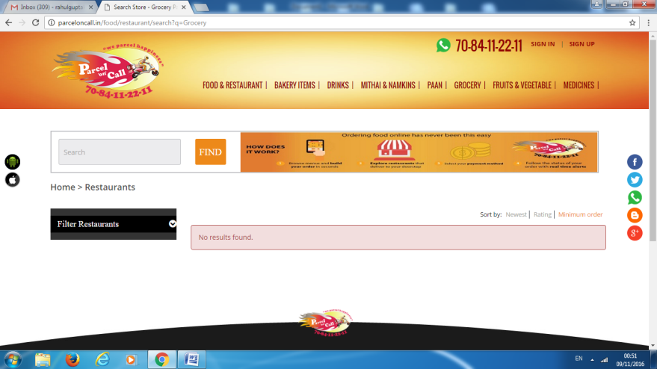

1. Filter Restaurants is the tab which is still coming in all categories … also the color is very bad.

-----------------------Suggest color-------------------------

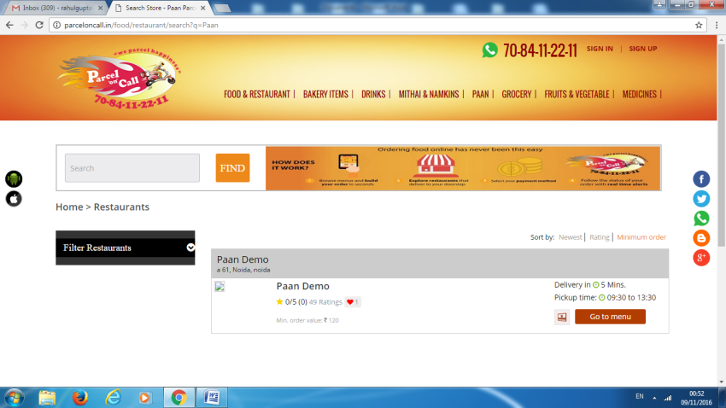

1. How does it works is not so impressive that it should be …. It is not visible properly. It should come in full screen wide

-------------------------------------provide the image and html reference-------------------------------

1. Search & Find are the same thing. Where the Filter is located Search option should also be there and the Tab is also very big in size that should be small and impressive and in place of Find there shall be Magnifier sign.
2. In place of Fruit & Vegetable or any other category there is always showing **Home>restaurants.** That should be change to respective categories.
3. Why there is always showing 49 ratings, that should be real in no otherwise show 0 there.

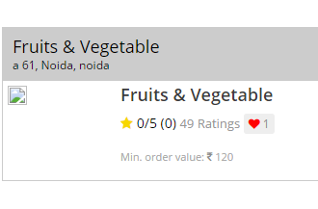

1. Remove button near the **GO TO MENU** Button

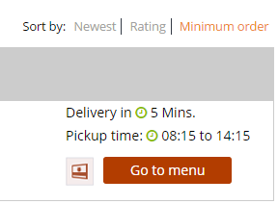

1. Spelling Mistakes are the biggest concern

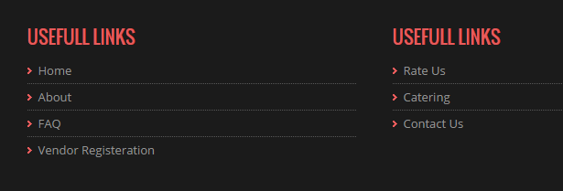

1. Contact us & Rate us page Shows this msg..

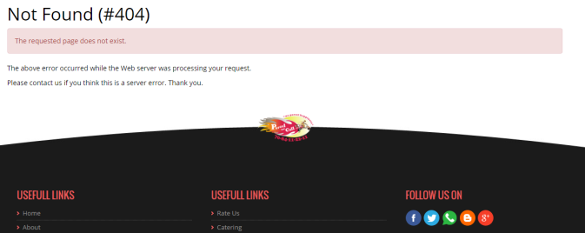

1. Vendor registration page must be changed it should also have the nature of service/supply offered

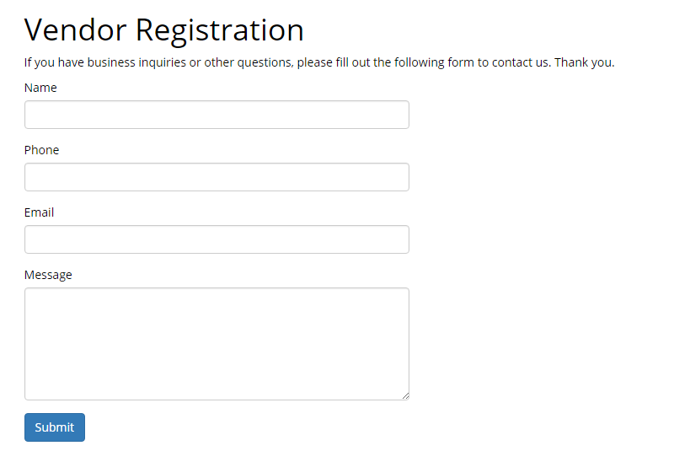

1. FAQ are empty……..



1. About us page need to change and improved.

**Suggest the changes**

1. The search bar will show the figures in middle. Food/outlets etc….. products should be there.



1. Whenever I want to restore my account and I put a wrong mail to reset or any mail which is not registered it is not responding/landed in home page. Rather it should show a message that **your mail is not registered** or say Please enter registered mailed so that the person may get info. about the site’s action.

However in case of registered mail I got the mail immediately

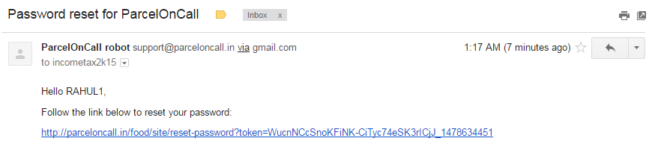

1. In case where otp has not been verified the re activation of such account??

**After login on profile page you can resend the code.**

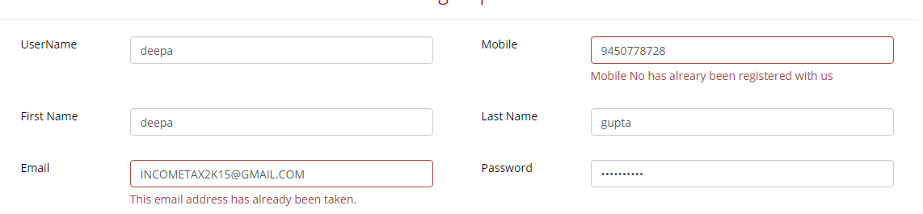

1. In above case how we justify the delivery charge since it charged for 7 kms Rs 65.00 while as per google map it is showing 6 kms max that means rs 57.00 should be charged. That will be a great task to prove such extra…. Or we also may incur loss.

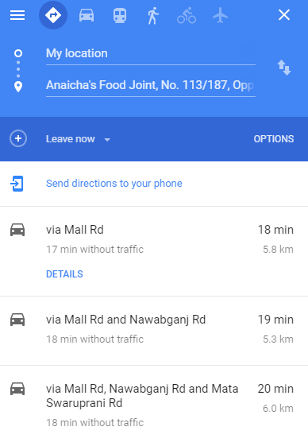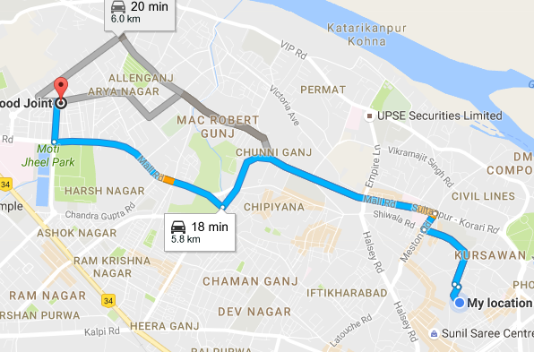

1. Still invoicing is from **KHaye Jao??**

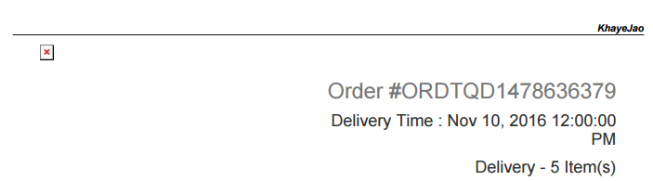

1. Taxation issues in invoice

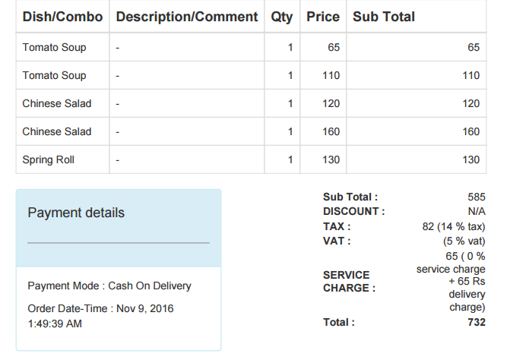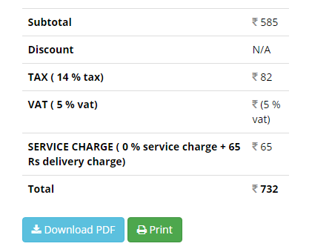

PDF Copy bill Online Site Bill

1. While booking a table online we are not able to finalinse the PAX i.e no of persons and also need for cart is beyond my imagination…. Please add smthing in the cart?? Also not able to do so ☺☹

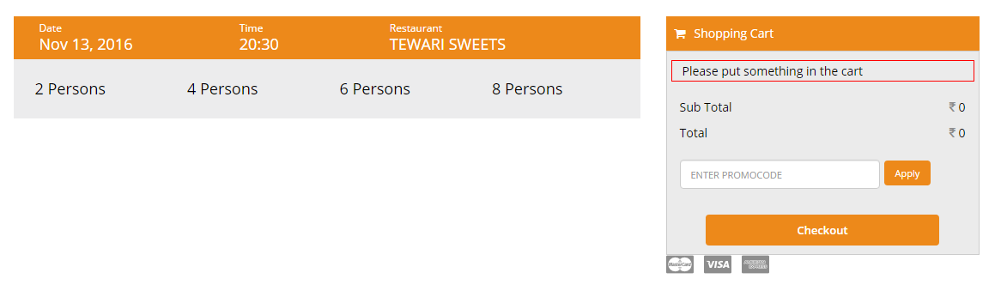

After check out showing this page:

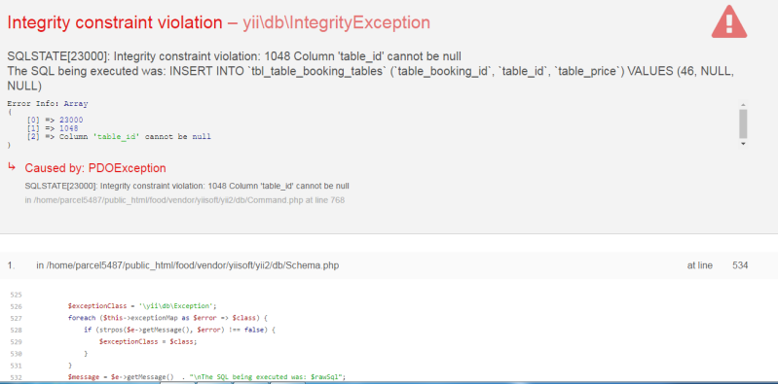

1. Testimonials page: ??



How it will luk…? and how it will go live ? How we can input?

21. When you upload the dish there is option of the quantity if i put 1 quantity so after the 1 order if person click on that it should be out of stock boss.

22.in backend when i fill up the menu listing form so all the fields is needed to fill up it should not be boss.

23. Dialogue point for time of restaurant if someone orders beyond the time of restaurant.

**Sorry. This restaurant is closed at the moment**  
pre-order for later delivery   
it will be show like i give you image in menu page top

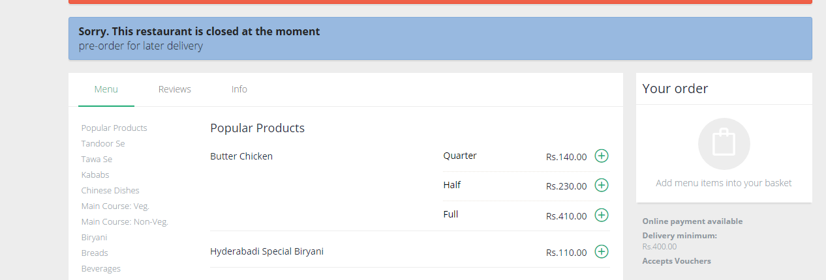

24.**Price should mentioned exclusive or inclusive of tax in top of price section -** Only tax inclusive is working if i change it to exclusive not effecting

25. Mail Notification is coming too much late.

26. Checkout pop up when the guy come on the checkout page there is should be a popup with some items.

27. Kj share will be work as per the dishes

28.When i place the order in cod way then i got this text

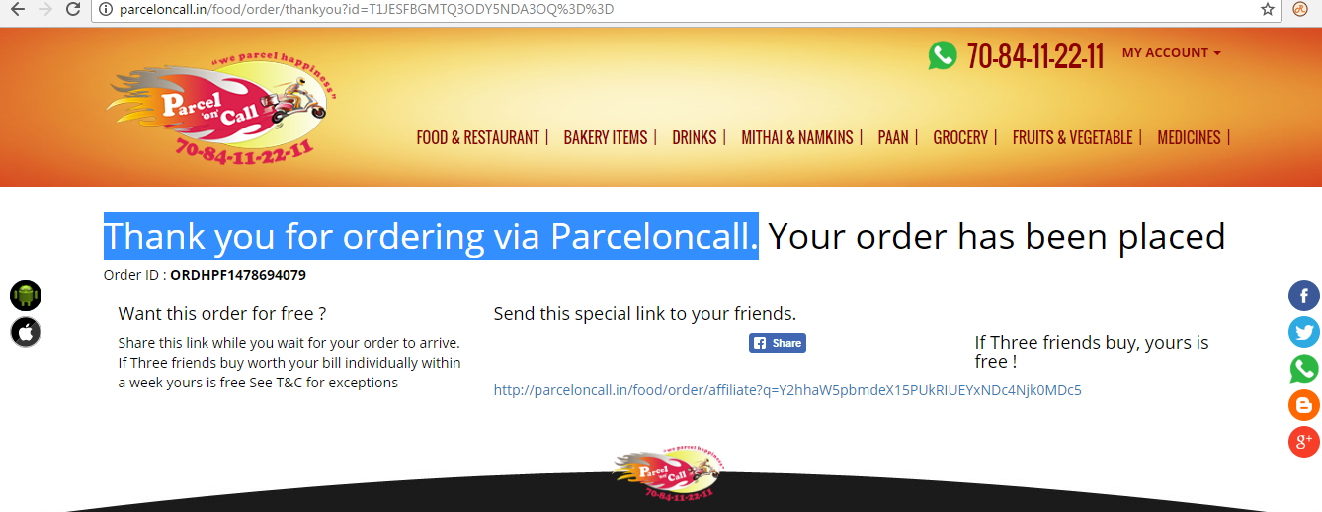

Remove the Facebook all the data make it properly text in box.

“Thank you for ordering via Parceloncall.Your order no……………………………has been booked.”

Just put this text in proper alignment sir