Curriculum Vitae

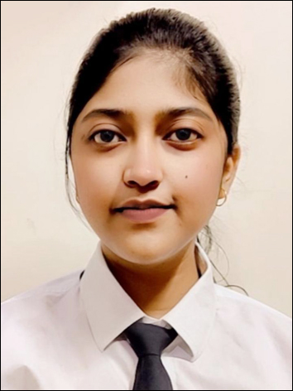
NAYANSHI SONKAR
Address:- 3/5,Khuldabad, Prayagraj (U.P), 211016
Mob No: +91-8318735351
Email Id: nayanshisonkar7@gmail.com

CAREER OBJECTIVE

- Highly motivated and dedicated with strong academic background in marketing.
- Seeking an entry-level position of relationship manager where I apply my theoretical knowledge and practical skills to contribute to the development of innovative solutions.
- Eager to learn and grow within a dynamic team environment, while leveraging my abilities, problem solving skills to make a positive impact on the organization’s success.
ACADEMIC QUALIFICATION

- Master of Business Administration. (2023-Present)
Motilal Nehru Institute of Research and business Administration (MONIRBA), University of Allahabad.
- Marketing Specialization.
- Bachelor of Commerce (2020-2023)
University of Allahabad.
- Graduated with 82% marks.
- Specialized in Income Tax (FINANCE) and achieved 95% marks
in Income Tax.

INTERNSHIP

“Marketing Intern” (1 June – 15 July 2024)
Trishaktam Collaborations private limited, Prayagraj, Uttar Pradesh.
- Assisted in developing marketing strategies to promote properties,
resulting in a 25% increase in engagement of social media.
- Created and schedule content for social media channels.
- Collaborated with the team on a project that improved Lead
Generation.

CERTIFICATION

- Certification in CCC.
- White belt certification: intro to six sigma course.
- Commercial Banking Virtual experience by JP Morgan Chase.

SKILLS

- Good Communication Skills
- Adjustable in Every Condition
- Diligent and Dedicated.
- Leadership Skills.
- Creative in Problem Solving
- Command in MS-Excel and MS-Word
- Marketing and Sales Skills

PROFESSIONAL SKILLS

- Optimistic Attitude and Punctuality towards Work.
- Effective communication and interpersonal skills.
- Flexible to adapt to a dynamic environment.
- Ability to work proactively in tem envir.
- Self motivated and result oriented.
- Public speaking.

OTHER ACTIVITIES

- Networking Events
- Attendance at marketing conferences or workshops.
- Participation in meetups focused on digital marketing trends or innovations.

- Participated in BUSINESS PLAN COMPETITION 2022 Organized by: Incubation cell,the University of Allahabad in association with Zone Startups India(a part of BSE),Mumbai.
- Gold medal in Inter School Writing Competition.
- Gold medal in Inter School Mathematics Olympiad.

INTEREST AND HOBBIES

- Hockey
- Calligraphy
- Photography
- Dance
- Reading

PERSONAL INFORMATION

Father Name : Mr. Sunil Sonkar
DOB : 08 Feb 2002
Gender : Female
Communication : English & Hindi
Nationality : Indian
Religion : Hindu
DECLARATION

I, Nayanshi Sonkar, here by declare that the above mentioned details are true
to the best of my knowledge and belief.

Place- Prayagraj (NAYANSHI SONKAR)
Signature

