LAB ASSINGMENT 2

Ajay kumar reddy Addula

16157735

I developed a Google Map Service application which takes the starting point and the destination dynamically . This application not only show the directions between the source and the destination but also give a preview of directions where to take right or left. This preview helps us to see the directions before we start which helps to have an idea of route.

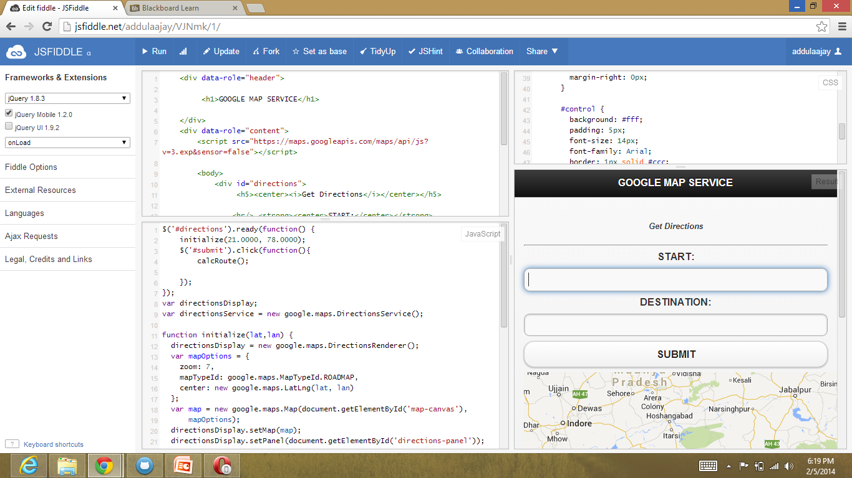

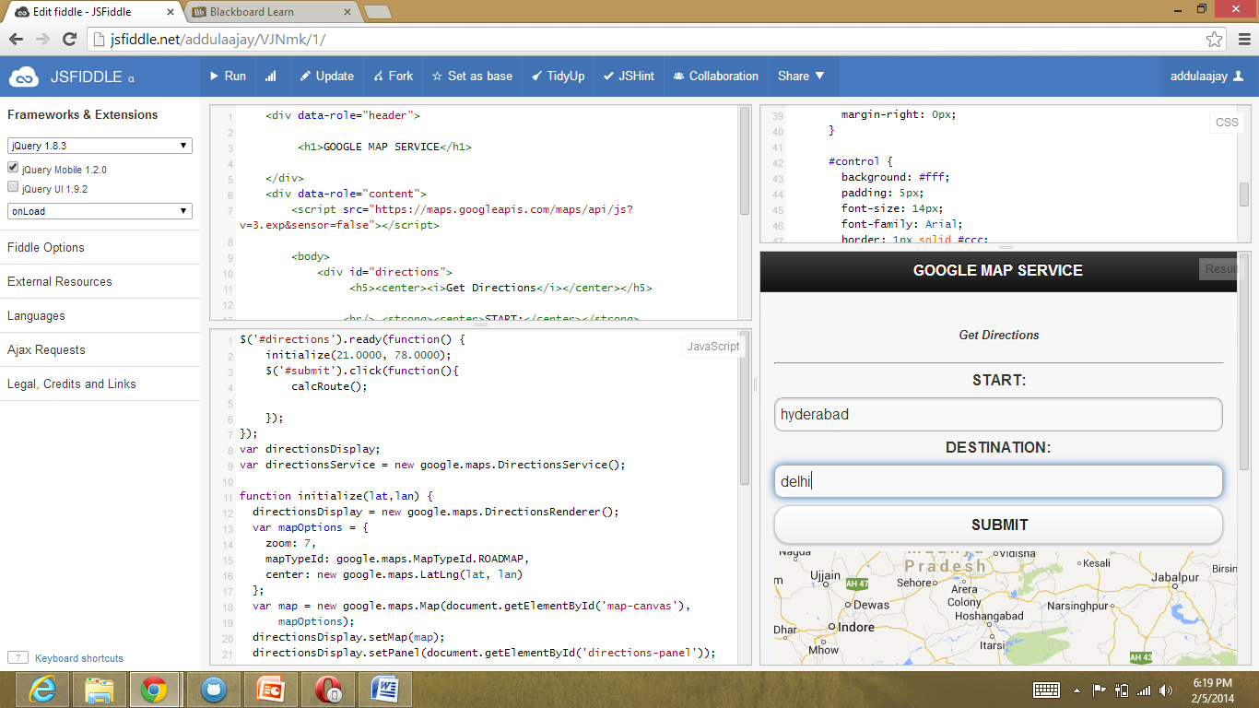

when we press "SUBMIT" we get the preview as shown below.

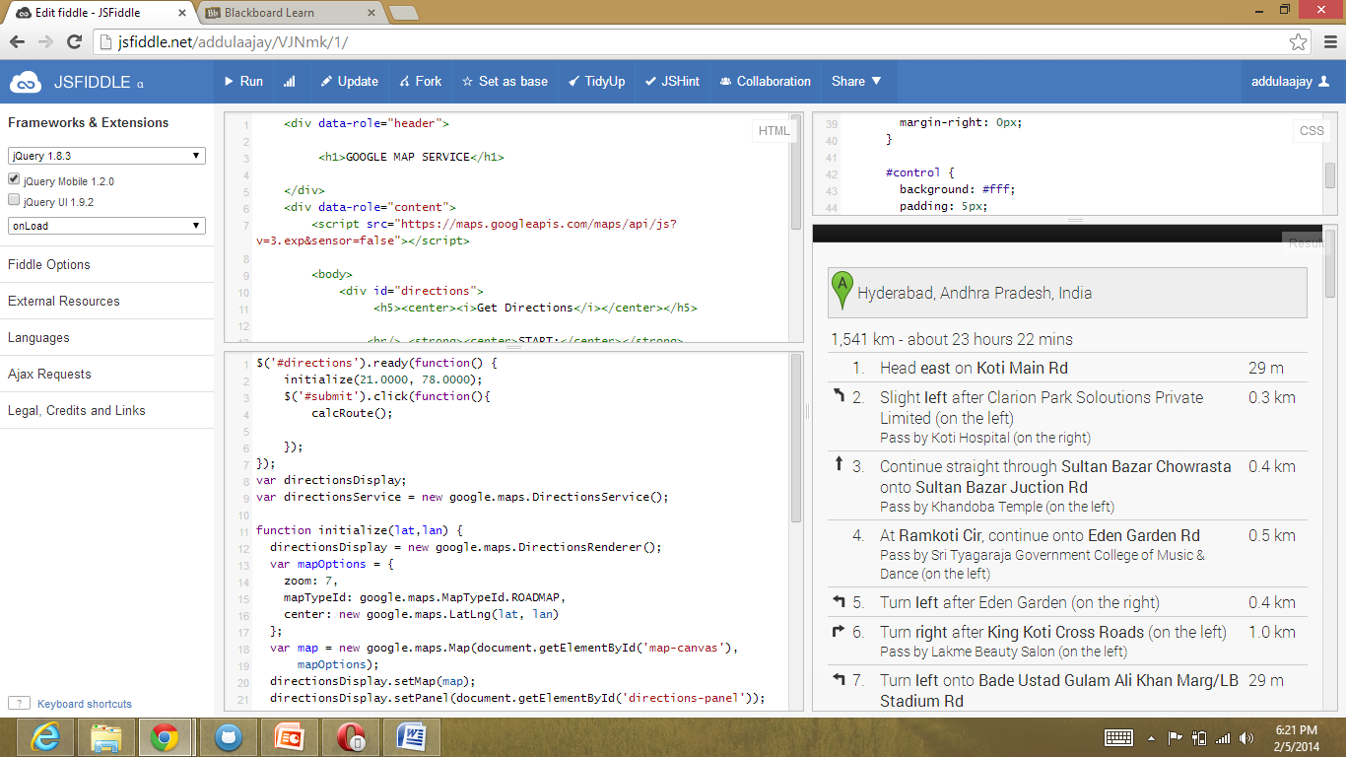

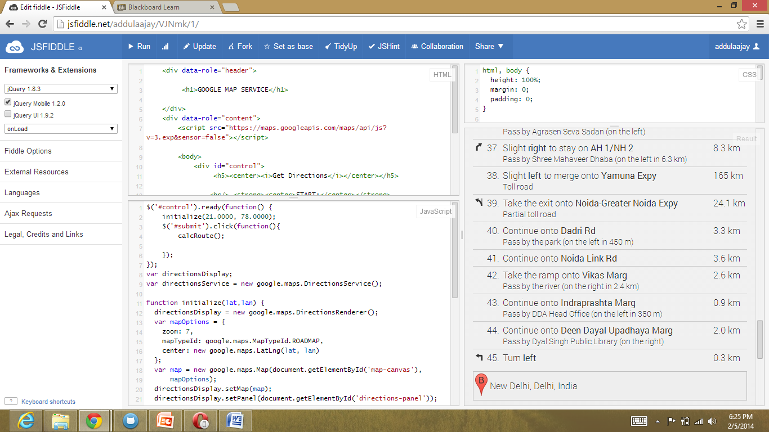

Here it shows the directions between the source and the destination.

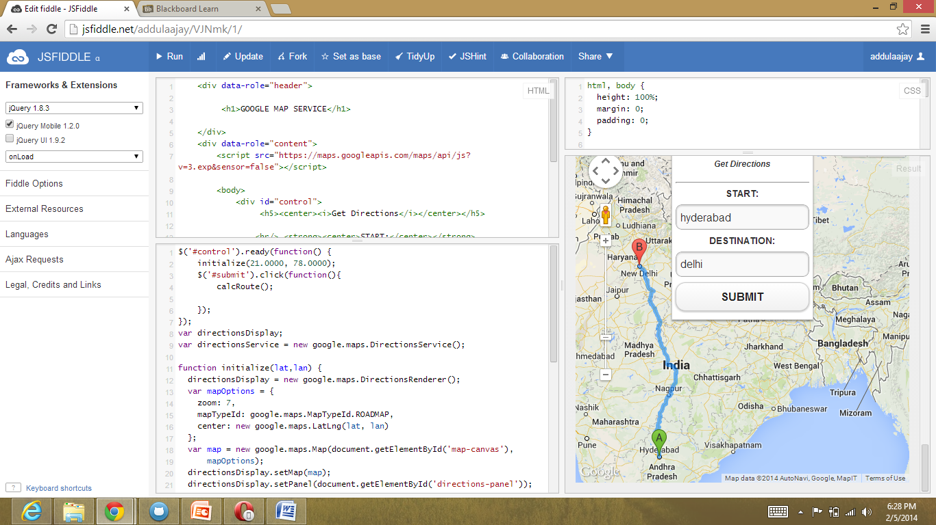

jsfiddle link: http://jsfiddle.net/addulaajay/VJNmk/6/