Freight Rate Prediction Challenge
Approach, validation, and results — Jayanta

1. Data Exploration & Key Findings
The training set (train_test.csv) has 48,000 loads from Jan 1 – Oct 31, 2025 across 64 U.S. cities, three equipment types (Dry Van, Reefer, Flatbed), with a right-skewed posted_rate (median ≈ $2,031, max ≈ $25,533).
- distance is by far the strongest single predictor of rate (correlation ≈ 0.91 with posted_rate).
- Equipment type shifts the base rate/mile meaningfully: Dry Van ≈ $2.12/mi, Flatbed ≈ $2.29/mi, Reefer ≈ $2.38/mi on average.
- Lane (pickup/delivery city) carries a real premium beyond distance and equipment: the within-lane standard deviation of rate/mile (≈0.29) is about half the overall standard deviation (≈0.58). Isolating this with a distance+equipment baseline regression and looking at the residuals revealed a clear regional pattern — Texas/South-Central pickup and delivery cities (Dallas, Houston, San Antonio, Tulsa, Oklahoma City...) carry a consistent premium (+2% to +5%), while Midwest/Northeast cities (Detroit, Buffalo, Syracuse, Grand Rapids...) carry a consistent discount, likely reflecting backhaul/demand imbalances.
- A weekly pattern (lower rates on weekends) and a seasonal pattern (rates rising into mid-year, softening toward year-end) both appear in the data — both were built into the model as separate features (day-of-week and cyclical day-of-year).
- market_index and quote_signal are weakly correlated with rate individually but were kept as inputs, since tree-based models can exploit weak non-linear interactions.

2. Data Quality Issues & How I Addressed Them
- Negative weight values: a number of rows had negative weight, which isn't physically possible — almost certainly a sign-flip data entry error. Confirmed by checking that abs(negative values) fall in the same range as normal positive weights, then corrected with weight = abs(weight).
- Missing values: weight and market_index have missing values in both train_test.csv and validation.csv. Filled with the training-set median — computed strictly from whichever data is the 'training' side at that point in the pipeline, to avoid leakage (see Section 3).
- Unseen cities in validation: validation.csv includes 8 cities (San Diego, Chicago, Norfolk, Laredo, Knoxville, Charlotte, Jackson, Allentown) that never appear in train_test.csv — about 1,447 of 12,000 rows (12%) are affected as either pickup or delivery. Rather than defaulting these to 'no lane effect,' each unseen city's effect is estimated as the distance-weighted average of its 3 nearest known cities (haversine distance on lat/lon, which is present for every row). Validated qualitatively: the estimates correctly reproduce the regional pattern found in known cities (e.g. Laredo/Jackson — South — came out positive; Chicago/Norfolk/Allentown — North — came out negative).
- December scenario file has no market_index, quote_signal, latitude, or longitude columns. Lexington and Fort Wayne are both known cities, so their coordinates and lane effects are looked up directly; the two market-condition columns use the same training-set medians applied elsewhere, since no live market signal exists for a hypothetical future date.

3. A Leakage Bug I Found and Fixed
While building the pipeline, I initially computed the missing-value medians once, from the full train_test.csv, before splitting into a fit/holdout period for evaluation. That meant the holdout period's own values were contributing to the median used to fill gaps in the training portion — a subtle form of information leaking backward from the 'future' into training preparation.
I caught this by comparing the median computed from only the pre-cutoff months against the median from the full dataset — they differed slightly (market_index: 1.12 vs ≈1.05), confirming the leak was real, not just theoretical. I fixed it so that during evaluation, medians and city-effect encodings are computed strictly from the fit period and only ever applied forward to the holdout period — never the reverse. The full-dataset versions are only used afterward, for the final model that generates the actual submission predictions, once evaluation is complete and there's no more leakage risk.

4. Validation Strategy
This is fundamentally a forecasting problem — the model must predict rates one to two months beyond the last training date. A random split would let the model 'see' data from around a future period and overstate accuracy. Instead:
- Primary evaluation: trained on Jan 1 – Aug 31, held out Sep 1 – Oct 31 (~9,523 rows) as a proxy for the real Nov/Dec forecast gap.
- Hyperparameter tuning used 3 rolling time-based folds (holdouts of Sep–Oct, Jul–Aug, and May–Jun) rather than a single split, so chosen hyperparameters aren't overfit to one particular window.
- Final model: retrained on all 10 months (Jan–Oct) before predicting validation.csv (Nov–Dec) and the December chart scenario, to use all available history for the actual deliverable.

5. Model, Tuning & Results
Model: LightGBM gradient-boosted trees on log(posted_rate), with 15 features — distance, weight, market_index, quote_signal, equipment, month, day_of_week, cyclical doy_sin/doy_cos, pickup & delivery lat/lon, and the smoothed pickup/delivery lane-effect encodings described above.
Gradient boosting was chosen over a plain linear model because the lane-effect and equipment interactions are non-linear, and it handles mixed numeric/categorical features without heavy preprocessing while remaining fast and interpretable via feature importances.
Hyperparameters were tuned with a 25-trial Optuna search (Bayesian optimization) over learning_rate, num_leaves, min_data_in_leaf, feature_fraction, bagging_fraction, and lambda_l2, evaluated across the 3 rolling folds and re-validated on the clean single holdout:
Metric (Sep–Oct 2025 holdout) | Default params | Tuned params
RMSE | $641.31 | $639.85
MAPE | 6.06% | 5.65%
Naive mean-baseline RMSE | $1,526 | $1,526
Improvement vs. baseline | 57.9% | 58.1%

Tuning gave a modest but genuine improvement — MAPE improved by about 0.4 points (≈7% relative), while RMSE barely moved. I kept the tuned parameters, since the gain is real even if not dramatic, and because MAPE (percentage error) is arguably the more relevant metric for pricing decisions across a wide range of rate magnitudes.
Top features by gain: distance dominates overwhelmingly (as expected, given the 0.91 correlation), followed by quote_signal, pickup/delivery longitude, and equipment — with pickup_effect, doy_cos, and delivery_effect contributing smaller but real amounts, confirming the engineered features add genuine signal beyond the raw inputs.

6. December 2025 Forecast (Lexington → Fort Wayne, Dry Van, 360 mi, 32,000 lb)
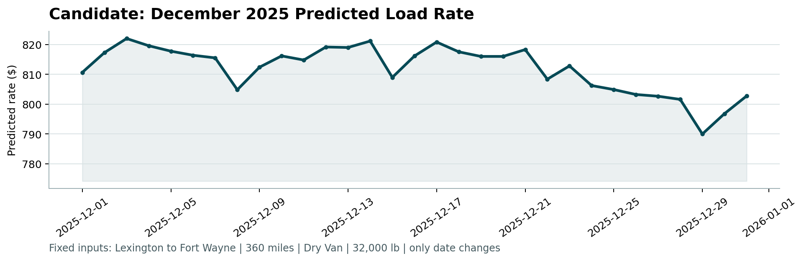
The forecast shows a weekly pattern (lower predicted rates on weekends, from the day_of_week feature) layered on a gentle year-end softening trend. The trend only appeared once I added the cyclical doy_sin/doy_cos features — an earlier version using only month and day_of_week produced a perfectly flat, mechanically repeating weekly pattern with no monthly trend at all, since month is constant (=12) for every December row and provided no usable signal for extrapolation. Because the model never saw actual December data, this trend is an extrapolation of the yearly cycle learned from Jan–Oct — a reasonable estimate, but one I'd sanity-check against real December data if it becomes available.

7. What I'd Do With More Time
- Rebuild lane-effect encodings and medians fully per-fold during hyperparameter search (the tuning stage reused full-data statistics across folds for speed — a reasonable approximation for comparing relative hyperparameter performance, but not fully leak-free in absolute terms; the final reported metric uses the clean single split, not the tuning folds).
- Quantile predictions (e.g. 10th/90th percentile) alongside the point forecast, useful for a pricing/bidding use case.
- Investigate whether the 8 unseen validation cities have region/state metadata that could make the lane-effect fallback more precise than pure geographic nearest-neighbors.

