Gujarat, India Tour Report by Stephen Dean and photos by Louise Baker
(in Suffolk, UK.)
12th – 27th February 2015

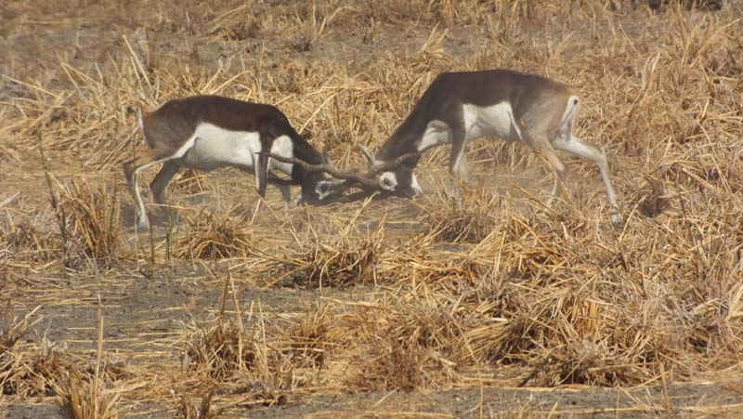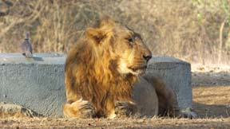

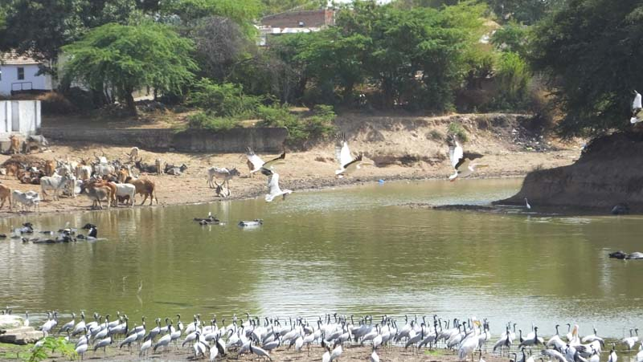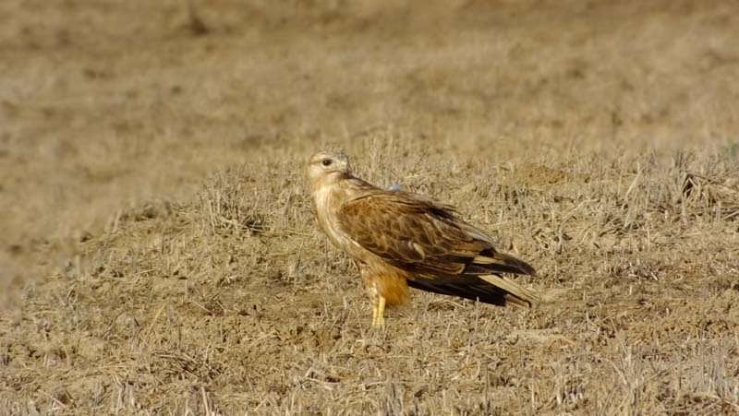

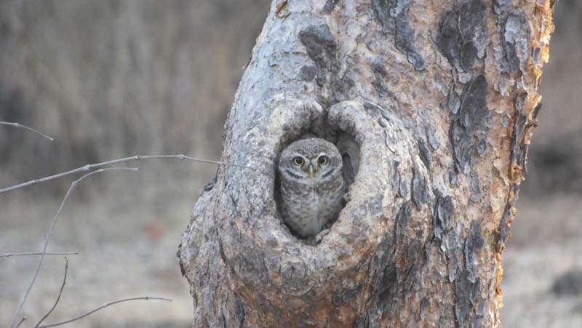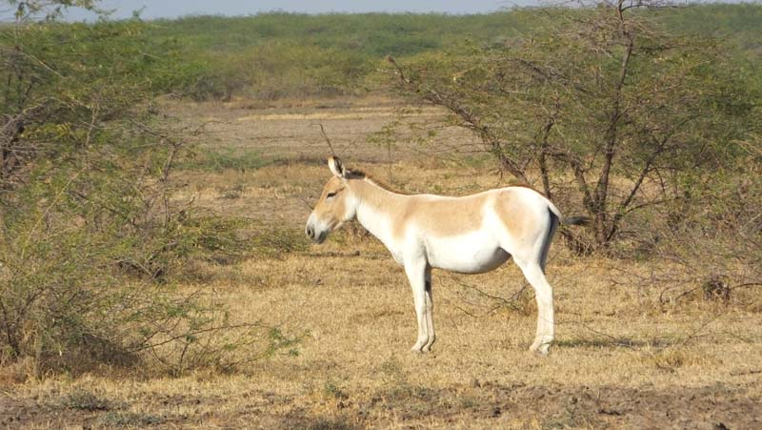

Blackbucks at Velavadar (top left), Asiatic Lion at Gir Park (top right), Demoiselle Cranes and Great White Pelicans flying (above left), Long-legged Buzzard (above right), Spotted Owlet and Wild Ass at Little Rann of Kutchh. All photos by: Louise Baker.

This trip combined birding and wildlife watching with some culture and was organized for us by Manoj Vardhan of Vardhan Individual and Group Tours, based in Jaipur.

We arrived in Ahmedabad at 3am and – considering we were on a scheduled flight – the immigration process there was chaotic; there was no organized queue and effectively there was a crowd of people edging slowly forwards to a narrow gap in the cordon. It was an hour and a half before we were able to collect our luggage and meet Manoj Vardhan (who had very kindly travelled from Jaipur to meet us) and our driver, Prakash. We stayed at the Neemrana Divans Bungalow – a comfortable, old fashioned hotel – for the rest of that day and that night, giving us a day of rest before setting off for the Little Rann of Kutch (LRK).

En route to LRK we stopped off several times and the highlights were several flocks of Rosy Starling, two Bay-backed Shrikes, twelve Sarus Cranes and about a dozen Egyptian Vultures.

In LRK we stayed at Rann Riders, where the accommodation was rather basic. This is the place to stay for the LRK but it worth pointing out that the main wildlife-viewing area is about 40 minutes from there by 'Gypsy' (the open-top, four-wheel drive vehicle of choice on safari in India). We had a good guide, “Sam”, and the first drive was very successful, yielding nine Asiatic Wild Ass, one Striped Hyaena and five Dalmatian Pelicans (three of our target species), as well as hundreds of Lesser Flamingos and small numbers of Greater Flamingos. The highlights of the following day included wonderful views of Greater Hoopoe Lark (at the nest, with two eggs), Long-legged Buzzard, Red Fox (on the edge of its range in LRK), two Striolated Buntings and a pair of Sarus Cranes.

One of my target birds – which I had somehow managed to miss on four previous trips to India – was Indian Courser and Prakash knew of a likely area, right by the road on our journey to the Great Rann of Kutch (GRK). We stopped and quickly found four together in a field. This was the first of many examples of Prakash's good local knowledge coming into play; not only did he know of likely spots for good birding, but also of places to stop to break up some of the long journeys. One of these was the extensive salt pans en route to GRK, where there were hundreds of Indian Shags and Little Cormorants, another 24 Dalmatian Pelicans and the only Western Reef-herons and Terek Sandpiper of the trip.

In GRK we stayed at the Infinity Resort at Nani Aral, which was immaculately clean and well-appointed. The next day here I had the services of Mohammed and Prakash and I set off early to meet him (the manager of the resort arranged a packed breakfast). It was about 45 minutes' drive to Mohammed's village and after a lengthy search Mohammed found one female Grey Hypocolius, which showed very well. We also saw Rufous Shrike (which has been split from Isabelline Shrike and is known as Turkestan Shrike in Europe). Both of these were new for me.

Exploration of the desert areas here yielded more new birds in the form of Rufous-tailed Lark and Red-tailed Wheatear (now split from Persian Wheatear), as well as wonderful views of Chestnut-bellied Sandgrouse and Indian Stone-curlew. A river valley on the way back to the Infinity Resort yielded Indian Bushlark and Ashy-crowned Finch-lark, both of which were new for me. Returning there after lunch we saw six Grey-necked Buntings, also new for me.
The rest of the afternoon and early evening (dusk falls quickly this far south) was spent in a vast dried out lake bed, where we had excellent views of Tawny and Steppe Eagles, three more Long-legged Buzzards, Greater Short-toed and Crested Larks and our first Golden Jackals of the trip.

We then went to Bhuj to see some of the local handicrafts (silk painting, embroidery, jewellery making and metalwork). The museum, which we had hoped to visit, was closed on both the days we were there but we did visit the stunning temple. In Bhuj we stayed at City the Village. This a new hotel and the rooms, which are 'huts', like at Rann Riders, are comfortable, but there is nowhere to sit inside and there are no cupboards, wardrobes or drawers to put anything. There are three sunbeds with parasols outside, by the pool, but there are no tables to put drinks, books or binoculars on. Like at Rann Riders, the rooms have carved wooden doors (in the Gujarat style), which look nice but can only be locked with a clasp and padlock that secures them at the top. Thus, if you're under about 5' 6” you can't reach to secure your room. Considering that this is a new hotel, the floor in our room needed re-screeding. Also here, our room wasn't serviced whilst we were out. I drew this to the attention of the manager and he did send someone, but then called him back when a party of other visitors arrived, which was very unsatisfactory, given that up until that point we were the only guests and they'd had all day to do it. We wouldn't have been able to use the swimming pool, had we wanted to, because it had algae all over the bottom. Fortunately, the food here was very good, although arrangements for breakfast were a bit chaotic.

From Bhuj we had a long journey to Jamnagar. Various roadside pools were heaving with birds, including lots of waders (Tringa sandpipers and Temminck's Stints) and a single Glossy Ibis and White-winged Tern (both new for my India list). Prakash knew of a waterway just off the road (possibly a dammed river), where there were lots of Great White Pelicans and Demoiselle Cranes, Indian Spot-billed Ducks and two Yellow-wattled Lapwings. We also stopped off at Khijadiya Bird Sanctuary but there wasn't much there because it was very dried out, although we did see about 70 Gull-billed Terns, one Eurasian Curlew and four Indian Silverbill (which were all new for my India list). In Jamnagar we stayed at the Good Fortune hotel, which was rather anonymous but well-appointed and the food was good.

Leaving Jamnagar for Gir it was foggy and so the small gulls that flew over the car (either Black-headed or Brown-headed) evaded firm identification. The countryside on this leg of the journey was surprisingly reminiscent of West Suffolk (flat and cultivated with little outcrops of Breckland-like grassland) and, unlike all the other towns and cities we passed through, Rajkot was litter-free.

The approach to Gir was markedly hillier and more wooded and we saw our first Hanuman Langurs and Chital (Spotted Deer) of the trip. At Gir we stayed at the Gateway Hotel, which is just a couple of minutes' drive from the reserve HQ. This is a well-appointed hotel, where the staff were very helpful, and we had a room with a balcony view over the river to the wooded hills beyond.

Here, we had two 'safaris' (game drives) a day (07.00) and (15.00), which entailed being picked up 45 minutes beforehand because of the length of time it takes to get the permits issued. Prakash sorted this all out for us.

For each 'safari' you have a driver and a guide and you're allocated one of a number of set routes through the 250 square kilometres of the park that is accessible to visitors. The park itself covers an area of just over 1400 square kilometres and the last population survey of the Lions, in 2010, showed there to be 411.

On our first 'safari' we were lucky: we saw Northern Palm Squirrel, Chital (the smaller, Fallow Deer-type deer), Marsh Crocodile, Hanuman Langur, Sambar (the large, Red Deer-type deer and the Lion's preferred prey), Nilgai, Wild Boar and two young male Asiatic Lions. Resting on the ground, it was remarkable how well they blended in with the dusty Teak leaf litter. On the way out of the Park we stopped to admire a well staked-out Mottled Wood-owl, perched in a tree near its nest.

The highlights of the next morning's 'safari' were two Indian Jungle Nightjars, which we were able to watch through the 'scope, Indian Pygmy Woodpecker, Yellow-fronted Pied Woodpecker, wonderful close views of a pair of White-eyed Buzzards, several Coppersmith Barbets (one of my favourite Indian birds) in a flowering “Flame of the Forest” Butea monospermum tree and what turned out to be the only pair of Plum-headed Parakeets of the trip. We heard Lions roaring but didn't see them.

Back at the hotel we saw that the Dusky Crag-martin's nest on the building was occupied by young and we had wonderful views of a Southern Coucal on the lawn as we had our breakfast. From our balcony we saw four Black-headed Ibis and two Black-winged Stilts on the river.

The afternoon 'safari' yielded close views of two adult female Lions with a cub, wonderful views of two Chameleons on the same tiny bush, right by the vehicle, two Golden Jackals and an adult Crested Hawk-eagle at its nest.

The following morning we watched the rapid sunrise from the Kamleswar Dam (constructed in the 1950s), which has created a huge lake. Driving along the top of the dam we saw our first Lion of the day, a male that was making its way in the opposite direction along the bottom of the bank. Some judicious reversing by our driver enabled us to keep up with the Lion as he made his way along and then off the track towards the reservoir. He kept going and we were able to follow him for several minutes until he wandered off into the forest. Shortly after that we saw two females with an adolescent male but they wandered away fairly quickly and then we saw two males at rest near a water trough. To have seen six Lions on one 'safari' was remarkable and these were the last ones we saw, taking our total to 11. The birding highlights included 14 Jungle Babblers foraging in the leaves close to the track, a pair of Small Minivet and further views of the Mottled Wood-owl on its usual branch and views of the top of the head of one in the nest hole. The afternoon 'safari' was comparatively uneventful but knowing that there are crocodiles in the lake made the spectacle of a female Indian Peafowl flying low over the water for several hundred metres seem rather bold.

The final 'safari' yielded a new Mottled Wood-owl, one Singing Bushlark and five Rain Quail (both new for me). Prolonged 'scope views of a perched Gyps vulture enabled us to identify it as an Indian Vulture and it was the only Gyps vulture of the trip. We also had good views of two more Golden Jackals.

It was then time to head off for our final destination, the Velavadar Blackbuck Sanctuary (VBS). En route, Prakash stopped at a broad river, choked with water hyacinth, which he knew to be good for birds and, even though it was the middle of the day when we got there, it was alive with birds: about 20 Indian Black Ibis and good numbers of Eastern Cattle Egret, Black-headed Ibis, Common Snipe, Ruff, Wood Sandpiper, Red-wattled Lapwing, Western Yellow Wagtail and one Hoopoe.

Arriving at Velavadar Blackbuck Lodge (VBL), it quickly became clear that this is a super place that is very well run. Our room was effectively a small bungalow, spotlessly clean and very well-appointed: a large bedroom, en suite bathroom (with shower), outside shower and a verandah, with comfortable seating, overlooking a small pool, which backed onto the vast semi-desert savannah that is VBS.

There is a reed-fringed pond by the reception building, which was frequented by very showy Purple Heron, Indian Pond Herons, White-throated Kingfisher, Common Kingfisher and Little Cormorant and hosted an evening roost of White Wagtails.

In the early mornings and late afternoons Pallid and Montagu's harriers passed over the lodge on their way from and to their roosting site. VBS is home to the world's largest harrier roost, numbering some 400 birds.

The restaurant here was delightful and the food was truly excellent and at our first dinner our guide, Haider Desai, came and introduced himself. We discussed the birds and mammals to be seen and made arrangements for our first 'safari' the following day.

On the first morning, in the half light, there was a male Blackbuck at the small pool behind our room. These antelope are utterly beautiful and although we had seen them on previous trips at Gajner and Tal Chappar, they are always an absolute delight.

Prakash had arranged another local guide and he and Haider teamed up for all our 'safaris' here.

On our first excursion into VBS we started in the dry grasslands, where there were lots of Blackbuck, some of which were rutting, several Nilgai, Wild Boar and a range of dry-country birds including Bay-backed, Long-tailed and Isabelline shrikes and a Grey Francolin perched in a bush, which was rather incongruous. The first new bird of the day was Sykes's Warbler and shortly after that we saw a female Striped Hyaena. Leaving the dry grassland, we crossed the road and made our way to the wetland area where, in addition to familiar European waders and wildfowl, we had good views of Steppe, Greater Spotted and Eastern Imperial eagles and a lone Dalmatian Pelican. Rather distant views of two Indian Grey Wolves and a close Jungle Cat rounded off the morning.

The afternoon 'safari' added Indian Hare to our mammal list and we saw White-browed Bushchat very well. Painted Francolin was new for me and we finished the day with two Striped Hyaena cubs near the entrance to their den and lovely views of a Short-toed Eagle perched in a bush, which was the first one I'd seen in India.

The next day we covered similar ground and again saw the female Striped Hyaena and one youngster. We saw Rufous-tailed, Crested, Greater Short-toed and Ashy-crowned Finch-larks but couldn't get onto the two Sykes's Larks before they flew. This disappointment was made up for by better views of two Indian Grey Wolves being mobbed by Red-wattled Lapwings and two Grey-necked Buntings.

After lunch, a male Black-headed Bunting was a new Indian bird for me and then we had wonderful views of nine Sykes's Larks, feeding on the ground near the Sanctuary HQ buildings, where there were two more Grey-necked Buntings on the wires and an Indian Grey Mongoose. Driving out into the grasslands, we encountered four more Sykes's Larks and two more Jungle Cats and finished the day with further views of two young Striped Hyaenas near their den.

All in all, Velavadar was wonderful. The accommodation was absolutely first class, the meals were superb and Haider's knowledge enabled us to see some remarkable birds and animals.

It was then back to Ahmedabad. En route, Common and Demoiselle cranes, c20 Painted Storks, 50+ Great White Pelicans, two Woolly-necked Storks and two Sarus Cranes livened up the journey.

Given his links to Gujarat and his significance to modern Indian history, we wanted to visit Gandhi's Ashram and so this was where we spent our last afternoon. There is a lot of information about Gandhi here, although, as a museum, the complex itself is very old fashioned. I was amused to read that Gandhi found the food in Britain to be unbearably bland, and to learn that he was 78 when he was assassinated was very sobering.

Our last night was spent at the very comfortable Taj Hotel, which was very convenient for the Airport and our flight home the next day.

This was a very successful trip and the accommodation at GRK, Gir and Velavadar is the best we've ever stayed in in India.

Below, I list the birds, mammals and reptiles that we saw.

As far as the birds are concerned, this report follows the taxonomy and nomenclature in the Birds of South Asia, The Ripley Guide (Rasmussen and Anderton) - with the exception of Siberian Stonechat, which is treated as a separate taxon from Common Stonechat by the BOU – and for the mammals I have followed the Field Guide to the Mammals of the Indian Subcontinent (Gurung and Singh). The lists comprise only those species that were seen and positively identified. Those which were new for me are shown in bold and those that I had not seen previously in India are underlined.

Little Grebe Tachybaptus ruficollis
3+, between Rann Riders and Infinity Resort, 15th February; 1 and then an adult with 2 young, on roadside pool between Bhuj and Jamnagar, 19th February.

Dalmatian Pelican Pelecanus crispus
5, LRK, 13th February; 6 and then another 18 on the salt pans between Rann Riders and Infinity Resort, 15th February; 1, in flight, GRK, 16th February; 1, VBS, 24th and 25th February.

Great White Pelican Pelecanus onocrotalus
c100, LRK, 13th February; 10, salt pans en route to Infinity Resort, 15th February; c80, waterway between Bhuj and Jamnagar, 19th February; several, Junagardh, 23rd February; 50+ between VBL and Ahmedabad, 26th February.

Indian Shag Phalacrocorax fuscicollis
Hundreds on the salt pans between Rann Riders and Infinity Resort, 15th February; several on roadside pool between Bhuj and Jamnagar, 19th February.

Great Cormorant Phalacrocorax carbo
Adult sinensis-type in full breeding plumage, in flight, GRK, 16th February; several on the river from Gandhi's Ashram, Ahmedabad, 26th February.

Little Cormorant Phalacrocorax niger
1, between Ahmedabad and Rann Riders, 13th February; 1, between Rann Riders and LRK, 14th February; 1, between Rann Riders and the salt pans en route to Infinity Resort, 15th February; many on the salt pans en route to Infinity Resort, 15th February; several on roadside pool between Bhuj and Jamnagar, 19th February; Gir, 20th February; Gir, 21st February; 10, Gir, 22nd February; 1, VBL, 23rd and 24th February.

Western Reef-heron Egretta gularis
2, salt pans en route to Infinity Resort, 15th February.

Little Egret Egretta garzetta
1, between Rann Riders and LRK, 13th February; 1, roadside pool between Bhuj and Jamnagar, 19th February; between Jamnagar and Gir, 20th February; Gir, 22nd February.

Great Egret Egretta alba
Between Ahmedabad and Rann Riders, 13th February; many, LRK, 13th February; 2, roadside pool between Bhuj and Jamnagar, 19th February; waterway between Bhuj and Jamnagar, 19th February; between Jamnagar and Gir, 20th February; several, Gir, 20th February; between Gir and VBL, 23rd February; VBS, 24th February; VBL, 25th February.

Intermediate Egret Egretta intermedia
1, Gir, 20th and 22nd February was the only one of the trip.
Eastern Cattle Egret Bubulcus coromandus
Between Ahmedabad and Rann Riders, 13th February; between Rann Riders and Infinity Resort, 15th February; between Bhuj and Jamnagar, 19th February; between Jamnagar and Gir, 20th February; several, Gir, 20th February; 2, Gir, 21st February; 4, Gir, 22nd February, 12, Gir, 23rd February; between Gir and VBL, 23rd February; between VBL and Ahmedabad, 26th February.

Grey Heron Ardea cinerea
1, between Ahmedabad and Rann Riders, 13th February; several at the salt pans, en route to Infinity Resort, 15th February; 2, between Bhuj and Jamnagar, 19th February; waterway between Bhuj and Jamnagar, 19th February; 1,VBS, 24th and 25th February.

Purple Heron Ardea purpurea
1, between Rann Riders and Infinity Resort, 15th February; adult, VBL, 23rd February; 1, VBS, 24th February; 1, VBS and one immature, VBL, 25th Feb; adult, VBL, 26th February.

Indian Pond-heron Ardeola grayii
1, between Rann Riders and LRK, 13th February; 2, between Rann Riders and LRK, 14th February; 1, between Rann Riders and Infinity Resort, 15th February; 1, between Bhuj and Jamnagar, 19th February; between Jamnagar and Gir, 20th February; 1, Gir, 22nd February; 2, VBL, 23rd February; 1, VBS, 24th February; 2, VBL, 25th February.

Striated Heron Butorides striata
1, Gir, 20th February was the only one of the trip.

Woolly-necked Stork Ciconia episcopus
2, between Ahmedabad and Rann Riders, 13th February; 2, between VBL and Ahmedabad, 26th February.

Painted Stork Mycteria leucocephala
Several, LRK, 13th February; several, salt pans, en route to Infinity Resort, 15th February; c50, Bhuj, 17th February; 2 adults and 1 immature, between Bhuj and Jamnagar, 19th February; waterway between Bhuj and Jamnagar, 19th February; KBS, 19th February; between Jamnagar and Gir, 20th February; several, Junagardh, 23rd February; 1, VBS, 24th February; c20 between VBL and Ahmedabad, 26th February.

Black Stork Ciconia nigra
1, Gir, 20th February.

Glossy Ibis Plegadis falcinellus
1, on roadside pool between Bhuj and Jamnagar, 19th February.

Black-headed Ibis Threskiornis melanocephalus
3, between Ahmedabad and Rann Riders, 13th February; several, salt pans en route to Infinity Resort, 15th February; c50, Jamnagar, 20th February; 4, Gir, 21st February; several on well-vegetated river between Gir and VBL, 23rd February; between VBL and Ahmedabad, 26th February.

Eurasian Spoonbill Platalea leucorodia
Several, LRK, 13th February; 2, roadside pool between Bhuj and Jamnagar, 19th February; between Jamnagar and Gir, 20th February; 1, VBS, 25th February; 1, VBL, 26th February.

Indian Black Ibis Pseudibis papillosa
2, between Ahmedabad and Rann Riders, 13th February; 1, between Rann Riders and Infinity Resort, 15th February; 2, between Bhuj and Jamnagar, 19th February; 3, waterway between Bhuj and Jamnagar, 19th February; 2, Gir, 20th February; 1, Gir, 21st February; 4, Gir, 22nd February; 2, Gir, 23rd February; c20 on well-vegetated river between Gir and VBL, 23rd February; 2, in the garden of the Taj Hotel, Ahmedabad, 26th February.

Lesser Flamingo Phoeniconaias minor
Hundreds, LRK, 13th February.

Greater Flamingo Phoenicopterus roseus
Few, LRK, 13th February.

Greylag Goose Anser anser
Several, LRK, 13th February.

Common Teal Anas crecca
2, waterway between Bhuj and Jamnagar, 19th February; between Jamnagar and Gir, 20th February; VBS, 24th February.

Gadwall Anas strepera
2, salt pans between Rann Riders and Infinity Resort, 15th February.

Eurasian Wigeon Anas penelope
Several, salt pans between Rann Riders and Infinity Resort, 15th February.

Northern Shoveler Anas clypeata
Several, LRK, 13th February; a few on roadside pool between Bhuj and Jamnagar, 19th February; VBS, 24th February.

Northern Pintail Anas acuta
Several, VBS, 24th February.

Indian Spot-billed Duck Anas poecilorhyncha
5 and then another 2, on roadside pools between Bhuj and Jamnagar, 19th February; c20, waterway between Bhuj and Jamnagar, 19th February.

Common Pochard Aythya ferina
Several, salt pans between Rann Riders and Infinity Resort, 15th February.

Black-winged Kite Elanus caeruleus 8, between Rann Riders and Infinity Resort, 15th February; 1, GRK, 18th February; 1, between Bhuj and Jamnagar, 19th February; 1, between Jamnagar and Gir, 20th February; 3, between Gir and VBL, 23rd February; 1, VBS, 25th February; 1, between VBL and Ahmedabad, 26th February.

Black Kite Milvus migrans
Common, Ahmedabad, 12th February; Ahmedabad and between Ahmedabad and Rann Riders, 13th February; c12, Junagardh, 20th February; several, Junagardh, 23rd February; Ahmedabad, 26th February; 1, from the taxying aircraft, Ahmedabad Airport, 27th February was the last bird of the trip.

Shikra Accipiter badius
1, GRK, 18th February; imm, KBS, 19th February; 2, Gir, 22nd February; 1, VBL, 24th February; 1, VBL, 25th February; adult, perched (dark orange iris seen), VBS, 25th February.

Long-legged Buzzard Buteo rufinus
1, seen extremely well, perched and in flight, LRK, 14th February; 3, seen very well, perched on the ground and in flight, GRK, 16th February.

Oriental Honey-buzzard Pernis ptilorhynchus
1, Gir, 21st February; 1, Gir, 22nd February; very close views of one perched, Gir 23rd February.

White-eyed Buzzard Butastur teesa
Pair seen very well, perched, Gir, 21st February; 1, Gir, 22nd February; 1, perched and being mobbed by Jungle Babblers, Gir, 23rd February.

Crested Serpent-eagle Spilornis cheela
1, seen very well, perched, Gir, 21st February.

Short-toed Eagle Circaetus gallicus
1, seen very well, perched, VBS, 24th February; 1 and then another 2, VBS, 25th February.

Crested Hawk-eagle Spizaetus cirrhatus
1, adult, at the nest, Gir, 21st February.

Greater Spotted Eagle Aquila clanga
1, immature, Gir, 22nd February; 1, adult, VBS, 24th February.

Steppe Eagle Aquila nipalensis
1, immature, between Ahmedabad and Rann Riders, 13th February; 2, GRK, 16th February; 1, immature, VBS, 24th February.

Tawny Eagle Aquila rapax
5, GRK, 16th February.

Eastern Imperial Eagle Aquila heliaca 1, immature, seen very well, VBS, 24th and 25th February.

Osprey Pandion haliaetus
1, from our hotel room balcony, Gir, 20th February.

Indian Vulture Gyps indicus
Prolonged views of one perched, Gir, 23rd February. Views through the 'scope enabled us to see its grey head, chin and throat, sparse white down from the back of the crown onto the nape, dark eye, silvery upper mandible, yellow tip to the bill, slit nostril at c10 degrees from the vertical, greyish-buff upperparts with broad pale fringes to all the wing coverts and scapulars and dark tertials with narrow pale fringes. This was the only Gyps vulture we saw.

Egyptian Vulture Neophron percnopterus
c12, in a roadside field between Ahmedabad and Rann Riders, 13th February were the only ones seen.

Montagu's Harrier Circus pygargus
Male, LRK, 14th February; female, GRK, 16th February; nice views of a male amongst several harriers going to roost, VBL, 23rd February; male, VBS, 24th February amongst c20 harriers on the ground in short grass at the roost site (17 there on 25th); female, VBS, 25th February.

Pallid Harrier Circus macrourus
2 males, VBS, 24th Feb; 1 male amongst 21 harriers seen coming out of their roost, VBL, 26th February.

Western Marsh Harrier Circus aeruginosus
1, between Rann Riders and Infinity Resort, 15th February; 2, roadside pools between Bhuj and Jamnagar, 19th February; 1, VBS, 24th February; female, VBS, 25th February.

Common Kestrel Falco tinnunculus
Female, LRK, 14th February; 1, GRK, 16th February; 2, VBS, 24th February; 3, VBS, 25th February including a perched male eating a grasshopper; 1, between VBL and Ahmedabad, 26th February.

Laggar Falcon Falco jugger
1, seen very well, perched in a bush, LRK, 14th February.

Grey Francolin Francolinus pondicerianus
3 and then another 4, GRK, 16th February; 1, Gir, 21st February; 10 (including one perched in a bush), VBS, 24th February; 3, VBS, 25th February.

Painted Francolin Francolinus pictus
Pair, VBS, 24th February; male and female seen separately, VBS, 25th February.

Rain Quail Coturnix coromandelica
A small covey of c5 birds seen very close to the track, Gir, 23rd February.

Indian Peafowl Pavo cristatus
1, between Rann Riders and LRK, 13th February; 10, between Rann Riders and LRK, 14th February; c60, Gir, 20th February; c15, Gir, 21st February; Gir, 22nd February including a female flying for a few hundred metres across the lake at Kamleswar Dam; c20, Gir, 23rd February.

Common Crane Grus grus
26 + 7 + c30, LRK, 13th February; lots flying over between Rann Riders and LRK, 14th February; c200, GRK, 16th February; several, KBS, 19th February; 45, VBS, 24th February; VBS, 25th February; several large flocks between VBL and Ahmedabad, 26th February.

Demoiselle Crane Grus virgo
26, LRK, 13th February; c200, waterway between Bhuj and Jamnagar, 19th February; 1, VBS, 24th February; between VBL and Ahmedabad, 26th February.

Sarus Crane Grus antigone
2 and then another 10, all in flight, between Ahmedabad and Rann Riders, 13th February; pair in a roadside field near Rann Riders, 14th February; 2, between VBL and Ahmedabad, 26th February.

White-breasted Waterhen Amaurornis phoenicurus
1, Gir, 21st February; 1, Gir, 23rd February; 1, VBL, 25th February.

Common Moorhen Gallinula chloropus
2, VBL, 23rd February; 2, VBL, 25th February.

Eurasian Coot Fulica atra
1, between Rann Riders and Infinity Resort, 15th February; several, salt pans en route to Infinity Resort, 15th February; 1, on roadside pool between Bhuj and Jamnagar, 19th February; 1, VBL, 23rd February; 1, VBL, 25th February.

Pied Avocet Recurvirostra avosetta
Several, VBS, 24th and 25th February.

Black-winged Stilt Himantopus himantopus
Between Rann Riders and LRK, 13th February; between LRK and Rann Riders, 14th February; several, salt pans between Rann Riders and Infinity Resort, 15th February; GRK, 18th February; roadside pools between Bhuj and Jamnagar, 19th February; 2, Gir, 21st February; 2, Gir, 22nd February; VBS, 24th and 25th February; between VBL and Ahmedabad, 26th February.

Indian Courser Cursorius coromandelicus
4, seen very well in a roadside field between Rann Riders and Infinity Resort, 15th February.

Great Thick-knee Esacus recurvirostris
2, Gir, 20th February; 1, Gir, 22nd February.

Indian Stone-curlew Burhinus indicus
2, GRK, 16th February; 2 and then another 5, Gir, 21st February; 1, VBL, 23rd February; 2, VBS, 25th February.

Red-wattled Lapwing Vanellus indicus
Between Ahmedabad and Rann Riders, 13th February; between Rann Riders and Infinity Resort, 15th February; GRK, 16th February; between Bhuj and Jamnagar, 19th February; between Jamnagar and Gir, 20th February; Gir, 20th February; 4, Gir, 21st February; 2, Gir, 22nd February; Gir, 23rd February; between Gir and VBL, 23rd February; 2, VBL, 23rd February; VBS, 24th February; 1, VBL, 24th February; 5, VBL, 26th February.

Yellow-wattled Lapwing Vanellus malabaricus
2, waterway between Bhuj and Jamnagar, 19th February; 1, Gir, 21st February.

Eurasian Curlew Numenius arquata
1, KBS, 19th February.

'Western' Black-tailed Godwit Limosa limosa
3, roadside pools between Bhuj and Jamnagar, 19th February; 1, VBS, 24th February.
Terek Sandpiper Xenus cinereus
1, salt pans en route to Infinity Resort, 15th February.

Common Greenshank Tringa nebularia
2, between Rann Riders and Infinity Resort, 15th February.

Wood Sandpiper Tringa glareola
1, roadside pool between Bhuj and Jamnagar, 19th February; several on well-vegetated river between Gir and VBL, 23rd February.

Green Sandpiper Tringa ochropus
3, roadside pools between Bhuj and Jamnagar, 19th February; 1, waterway between Bhuj and Jamnagar, 19th February; 2, Gir, 22nd February; 1, VBL, 24th February.

Common Sandpiper Actitis hypoleucos
1, salt pans en route to Infinity Resort, 15th February; 1, roadside pool between Bhuj and Jamnagar, 19th February; 1, between Jamnagar and Gir, 20th February.

Marsh Sandpiper Tringa stagnatilis
Many, LRK, 13th February; 2, roadside pools between Bhuj and Jamnagar, 19th February; VBS, 24th February.

Common Redshank Tringa totanus
1, between Rann Riders and Infinity Resort, 15th February; VBS, 24th February.

Spotted Redshank Tringa erythropus 1, between Rann Riders and Infinity Resort, 15th February; 1, GRK, 18th February; 1, roadside pool between Bhuj and Jamnagar, 19th February.

Ruff Philomachus pugnax
3, roadside pool between Bhuj and Jamnagar, 19th February; 3, waterway between Bhuj and Jamnagar, 19th February; several on well-vegetated river between Gir and VBL, 23rd February.

Dunlin Calidris alpina
Many, LRK, 13th February.

Temminck's Stint Calidris temminckii
1, c20 and another 1 on roadside pools between Bhuj and Jamnagar, 19th February.

Common Snipe Gallinago gallinago
1, waterway between Bhuj and Jamnagar, 19th February; several on well-vegetated river between Gir and VBL, 23rd February.

Heuglin's Gull Larus heuglini
2, LRK, 13th February.

Gull-billed Tern Gelochelidon nilotica
c70, KBS, 19th February.

River Tern Sterna aurantia
1, Gir, 20th February; 1, Gir, 22nd February.
White-winged Tern Childonias leucopterus
1, roadside pool between Bhuj and Jamnagar, 19th February.

Chestnut-bellied Sandgrouse Pterocles exustus
15, LRK, 14th February; 30+, 4 and then another 2, GRK, 16th February.

Rock Dove/Feral Pigeon Columba livia
Ahmedabad, 12th February; Ahmedabad,13th February; between Bhuj and Jamnagar, 19th February; between Jamnagar and Gir, 20th February; Gir, 20th February; Gir, 22nd February; 50+, Gir, 23rd February; VBL, 25th February; between VBL and Ahmedabad, 26th February; Ahmedabad Airport, 27th February.

Laughing Dove Sterptopelia senegalensis
2, LRK, 13th February; between LRK and Rann Riders, 14th February; between Rann Riders and Infinity Resort, 15th February; GRK, 16th February; 1, Gir, 20th February; 2, Gir, 21st February; 1, Gir, 23rd February; VBS, 24th February.

Red Collared Dove Streptopelia tranquebarica
1, between Ahmedabad and Rann Riders, 13th February; 1, VBS, 24th February; 1, VBS, 25th February.

Spotted Dove Streptopelia chinensis
1, Gir, 21st February.

Eurasian Collared-dove Streptopelia decaocto
Ahmedabad, 12th February; between Rann Riders and LRK, 13th February; between LRK and Rann Riders, 14th February; between Rann Riders and Infinity Resort, 15th February; GRK, 16th February; between Bhuj and Jamnagar, 19th February; between Jamnagar and Gir, 20th February; Gir, 21st February; Gir, 23rd February; VBL, 23rd February; VBS, 24th February; VBS, 25th February; VBL, 26th February.

Plum-headed Parakeet Psittacula cyanocephala
Pair, Gir, 21st February.

Rose-ringed Parakeet Psittacula krameri
Ahmedabad, 12th February; between Ahmedabad and Rann Riders, 13th February; between Rann Riders and LRK, 13th February; between LRK and Rann Riders, 14th February; between Rann Riders and Infinity Resort, 15th February; between Bhuj and Jamnagar, 19th February; between Jamnagar and Gir, 20th February; Gir, 21st February; Gir, 22nd February; Gir, 23rd February; VBL, 23rd February; VBL, 25th and 26th February.

'Southern' Coucal Centropus [sinensis] parroti
1, Gir, 21st February; 1, VBS, 24th February.

Mottled Wood-owl Strix ocellata
1, Gir, 20th February; same bird, perched in the same tree, with another nearby in the nest hole, Gir, 22nd February; 1, Gir, 23rd February (a different bird from the ones seen previously).

Spotted Owlet Athene brama
3, in the same tree, between LRK and Rann Riders, 14th February; 1, Gir, 21st February; 2, Gir, 23rd February; 1, VBS, 24th February; 1, VBS, 25th February; 2, VBS, 26th February.
Indian Jungle Nightjar Caprimulgus indicus
2 separate individuals, seen at rest, roosting on branches, Gir, 21st February.

Crested Treeswift Hemiprocne coronata
1, Gir, 20th February; 1, Gir, 21st February.

Indian Roller Coracius benghalensis
1, between Ahmedabad and Rann Riders, 13th February; 1, LRK, 14th February; I, between Bhuj and Jamnagar, 19th February; 1, VBS, 25th February.

Common Hoopoe Upupa epops
1, GRK, 16th February; 1, between Gir and VBL, 23rd February; 1, VBL, 23rd February; 2, VBS, 24th February; 1, VBS, 25th February.

White-throated Kingfisher Halcyon smyrnensis Between Ahmedabad and Rann Riders, 13th February; 1, between Rann Riders and Infinity Resort, 15th February; 1, between Bhuj and Jamnagar, 19th February; 1, between Jamnagar and Gir, 20th February; 1, VBL, 23rd February; 2, VBS and 1, VBL, 24th February; 1, VBL, 25th February.

Lesser Pied Kingfisher Ceryle rudis
1, between Ahmedabad and Rann Riders, 13th February; 1, roadside pool between Bhuj and Jamnagar, 19th February; 2, VBS, 25th February.

Common Kingfisher Alcedo atthis
1, between Rann Riders and Infinity Resort, 15th February; 1, VBL, 23rd February; 1, VBL, 25th February.

Little Green Bee-eater Merops orientalis
Between Ahmedabad and Rann Riders, 13th February; LRK and between LRK and Rann Riders, 14th February; GRK, 16th February; between Bhuj and Jamnagar, 19th February; KBS, 19th February; 2, Gir, 20th February; Gir, 21st February; Gir, 22nd February; between Gir and VBL, 23rd February; 1, VBS, 25th February.

Coppersmith Barbet Megalaima haemacephala
1, Ahmedabad, 12th February; several in a fruiting tree, Gir, 21st February.

Eurasian Wryneck Jynx torquilla
1, VBS, 24th February.

Indian Pygmy Woodpecker Dendrocopus nanus
1, Gir, 21st February.

Yellow-fronted Pied Woodpecker Dendrocopus mahrattensis
Pair, Gir, 21st February; 1, Gir, 23rd February.

Black-rumped Flameback Dinopium benghalense
1, Gir, 21st February.

Singing Bushlark Mirafra cantillans
1, Gir, 23rd February.

Indian Bushlark Mirafra erythroptera
1, GRK, 16th February.

Crested Lark Galerida cristata
1, LRK, 14th February; 2, GRK, 16th February; 4, VBS, 24th February; 1, VBS, 25th February.

Sykes's Lark Galerida deva
9 and then another 4 seen very well, VBS, 25th February.

Ashy-crowned Finch-lark Eremopterix griseus
Pair and another male, GRK, 16th February; male and two females, Gir, 21st February; 1, VBL, 23rd February; 2, VBS, 24th February; several, VBL, 24th February; several, VBS, 25th February; several, VBS, 25th February.

Greater Hoopoe Lark Alaemon alaudipes
1 seen very well and then prolonged views of another at its nest, on the ground, containing two eggs, LRK, 14th February.

Rufous-tailed Lark Ammomanes phoenicura
3, GRK, 16th February; 2, VBS, 24th February; several, VBS, 25th February.

Greater Short-toed Lark Calandrella brachydactyla
Many, LRK, 14th February; several, GRK, 16th February; 200+, VBL, 23rd February; many, VBS, 24th February; VBL, 24th February; numerous, VBS, 25th February (dark centres to the median coverts really obvious in the strong sunlight); between VBL and Ahmedabad, 26th February.

Dusky Crag-martin Ptyonoprogne concolor
Between Rann Riders and Infinity Resort, 15th February; 2, Infinity Resort, 15th February; Gir, 20th February; pair with young in the nest, Gir, 21st, 22nd and 23rd February.

Barn Swallow Hirundo rustica
Between Ahmedabad and Rann Riders, 13th February; between Rann Riders and LRK, 13th February; 1, between Rann Riders and Infinity Resort, 15th February; Gir, 22nd February; VBS, 25th February.

Red-rumped Swallow Hirundo daurica
Gir, 22nd February.

Wire-tailed Swallow Hirundo smithii
Between Ahmedabad and Rann Riders, 13th February; 2, between Rann Riders and Infinity Resort, 15th February; VBS, 24th February.

Western Yellow Wagtail Motacilla flava
20+ on well-vegetated river between Gir and VBL, 23rd February.

Citrine Wagtail Motacilla citreola
1, male, VBS, 24th February.

White Wagtail Motacilla alba
2, Infinity Resort, 15th February; 2, Bhuj, 18th February; 2, roadside pool between Bhuj and Jamnagar, 19th February; Gir, 21st February; 1, Gir, 22nd February; 1, Gir, 23rd February; sizeable roost, VBL, 23rd February; VBS, 25th February.

Tree Pipit Anthus trivialis 2, Gir, 23rd February; 1, VBS, 24th February; several, VBS, 25th February.

Paddyfield Pipit Anthus rufulus
1, KBS, 19th February; 1, Gir, 23rd February; 1, VBL, 24th February.

Long-billed Pipit Anthus similis
1, LRK, 14th February; 1 and then another 2, VBS, 24th February; 2, VBS, 25th February; 1, VBL, 26th February.

Common Woodshrike Tephrodornis pondicerianus
1, GRK, 16th February; 3, Gir, 21st February; 2, Gir, 22nd February.

Small Minivet Pericrocotus cinnamomeus
Pair and then another 2, Gir, 22nd February.

Red-vented Bulbul Pycnonotus cafer
3, Ahmedabad, 12th February; heard, Ahmedabad and 2 between there and Rann Riders, 13th February; GRK, 16th February; KBS, 19th February; Gir, 21st February; Gir 22nd February; Gir, 23rd February; 1, VBL, 26th February.

White-eared Bulbul Pycnonotus leucotis
Between Ahmedabad and Rann Riders, 13th February; Infinity Resort, 15th February; GRK, 16th February; KBS, 19th February; VBS and VBL, 24th February; VBL, 25th February; VBL, 26th February.

Common Iora Aegithina tiphia
2, Gir, 22nd February.

'Rufous-backed' Long-tailed Shrike Lanius schach erythronotus
1, Gir, 21st February; 1, Gir, 23rd February; 2, VBS, 24th February; 2, VBS, 25th February.

Rufous shrike Lanius phoenicuroides
1, GRK, 16th February.

Isabelline Shrike Lanius isabellinus
2, GRK, 16th February; 1, VBS, 24th February.

Bay-backed Shrike Lanius vittatus
2, between Ahmedabad and Rann Riders, 13th February; 1, between Rann Riders and Infinity Resort, 15th February; male, VBS, 24th February.

Grey Hypocolius Hypocolius ampelinus
Prolonged, close views of one female, GRK, 16th February.

White-browed Fantail Rhipidura aureola 2, Gir, 21st February.

Oriental Magpie-robin Copsychus saularis
1, Gir, 21st February; 2, Gir, 22nd February; male, Gir, 23rd February.

Indian Black Robin Saxicoloides fulicatus
Pair, between Ahmedabad and Rann Riders, 13th February; 1, Infinity Resort, 15th February; 1, Gir, 20th February; 1 and then another 2, Gir, 21st February; 2, Gir, 22nd February; female, Gir, 23rd February; male, VBS, 25th February.

Black Redstart Phoenicurus ochruros phoenicuroides
Male, Infinity Resort, 15th February; male, GRK, 16th February; male, Gir, 22nd February; male, Gir, 23rd February.

Isabelline Wheatear Oenanthe isabellinus
1, VBS, 24th February; 1, VBS, 25th February.

Desert Wheatear Oenanthe deserti deserti
4, LRK, 14th February; 3, GRK, 16th February.

Variable Wheatear Oenanthe picata picata
1, GRK, 16th February.

Red-tailed Wheatear Oenanthe chrysopygia
1, GRK, 16th February.

Siberian Stonechat Saxicola maurus
1, GRK, 16th February; 3, VBS, 24th February; 3, VBS, 25th February; 4, VBS, 25th February.

White-browed Bushchat Saxicola macrorhynchus
1, seen very well, VBS, 24th February.

Tickell's Blue Flycatcher Cyornis tickelliae
1, Gir, 21st February; 1, Gir, 23rd February.

Common Babbler Turdoides caudata
1, between Ahmedabad and Rann Riders, 13th February; 2, GRK, 16th February.

Jungle Babbler Turdoides striata
Several and then another 5, Gir, 21st February; 14 and then another 9, Gir, 22nd February; Gir, 23rd February.

Zitting Cisticola Cisticola juncidis
1, VBL, 24th February; 1, seen very well, perched and preening, VBS, 25th February.

Grey-breasted Prinia Prinia hodgsonii 1 seen and others heard, GRK, 16th February.

Plain Prinia Prinia inornata
1, Gir, 22nd February; 1, VBL, 23rd February; 1, VBS, 24th February.

Sykes's Warbler Hippolais rama
2, VBS, 24th February; 2, VBS, 25th February.
Common Tailorbird Orthotomus sutorius
2, Ahmedabad, 12th February; 1, Gir, 21st February; 1, VBL, 25th February.

Great Tit Parus major
1, Gir, 21st February.

Oriental White-eye Zosterops palpebrosus
1, Gir, 21st February; 1, Gir, 22nd February; 2, Gir, 23rd February.

Purple Sunbird Cinnyris asiaticus
Between Ahmedabad and Rann Riders, 13th February; Rann Riders, 13th February; GRK, 16th February; KBS, 19th February; 2, Gir, 20th February; male, Gir, 22nd February; 1, VBS, 25th February.

Striolated Bunting Emberiza striolata
2, LRK, 14th February.

Black-headed Bunting Emberiza melanocephala
Male near the Park HQ, VBS, 25th February.

Grey-necked Bunting Emberiza buchanani
6, GRK, 16th February; 2, in bushes near the wetland area, VBS, 25th February and another 2 near the Park HQ, VBS, 25th February.

Indian Silverbill Euodice malabarica
4, KBS, 19th February; 2, VBS, 24th February; 5, VBL, 26th February.

House Sparrow Passer domesticus
Ahmedabad, 12th February; between Ahmedabad and Rann Riders, 13th February; GRK, 16th February; between Bhuj and Jamnagar, 19th February; between Jamnagar and Gir, 20th February; VBS, 25th February; VBL, 26th February; Ahmedabad Airport, 27th February.

Yellow-throated Sparrow Petronia xanthocollis
2, GRK, 16th February; 3, Gir, 21st February; 3, Gir, 22nd February; 3, Gir, 23rd February.

Black Drongo Dicrurus macrocercus
Between Ahmedabad and Rann Riders, 13th February; between Rann Riders and LRK, 13th February; LRK, 14th February; between Rann Riders and Infinity Resort, 15th February; GRK, 16th February including several hawking for insects low over the ground; between Bhuj and Jamnagar, 19th February; between Jamnagar and Gir, 20th February; Gir, 22nd February; between Gir and VBL, 23rd February; 1, VBS, 24th February; VBS, 25th February; between VBL and Ahmedabad, 26th February.

Brahminy Starling Temenuchus pagodarum
2, between Ahmedabad and Rann Riders, 13th February; 1, GRK, 16th February; 9+, Gir, 21st February; 2, Gir, 22nd February; 2, Gir, 23rd February.

Rosy Starling Sturnus roseus
Small flocks between Ahmedabad and Rann Riders, 13th February.

Bank Myna Acridotheres ginginianus
Between Ahmedabad and Rann Riders, 13th February; between Jamnagar and Gir, 20th February; between VBL and Ahmedabad, 26th February.

Common Myna Acridotheres tristis
Between Ahmedabad and Rann Riders, 13th February; between Rann Riders and Infinity Resort, 15th February; between Jamnagar and Gir, 20th February; 3, Gir, 23rd February; VBS, 25th February; 2, VBL, 26th February; Ahmedabad Airport, 27th February.

House Crow Corvus splendens
Ahmedabad, 12th February; Ahmedabad, 13th February; GRK, 16th February; between Bhuj and Jamnagar, 19th February; between Jamnagar and Gir, 20th February; Gir, 20th February; Gir, 21st February; Gir, 22nd February; Gir, 23rd February; VBS, 25th February; between VBL and Ahmedabad, 26th February; Ahmedabad Airport, 27th February.

Indian Jungle Crow Corvus [macrorhynchos] culminatus
Good numbers, Gir, 20th February; good numbers including 8 together by a water trough, Gir, 21st February; Gir, 22nd February.

Rufous Treepie Dendrocitta vagabunda
2, VBS, 24th February.

LRK = Little Rann of Kutch
GRK = Great Rann of Kutch
KBS = Khijadiya Bird Sanctuary
VBL = Velavadar Blackbuck Lodge
VBS = Velavadar Blackbuck Sanctuary

Hanuman Langur Presbytis entellus
c12 seen between Junagardh and Gir and then 3 seen at Gir itself, 20th February; 10+, Gir, 21st February; c20, Gir, 22nd February; 2, Gir, 23rd February.

Golden Jackal Canis aureus
2, together (rather distant) and then one seen rather better (also heard calling), GRK, 16th February; 2 seen very well, Gir, 21st February; very good views of 2, Gir, 23rd February.

Wolf Canis lupus
2 seen distantly, VBS, 24th February; 2 (one being mobbed by two Red-wattled Lapwings) seen well, through the 'scope, VBS, 25th February.

Red Fox Vulpes vulpes
Brilliant views of one resting by the entrance to its den, in the sunshine, LRK, 14th February.

Small Indian Mongoose Herpestes auropunctatus
1, near Infinity Resort, 15th February.

Indian Grey Mongoose Herpestes edwardsii
1, VBL, 24th February; 1, seen well near the Park HQ, VBS, 25th February.

Ruddy Mongoose Herpestes smithii
1, LRK, 13th February; 1, Gir, 21st February.

Striped Hyaena Hyaena hyaena
1 adult at the entrance to its den, which was littered with bones, LRK, 13th February; female near its den, VBS, 24th February; 2 young near the den; 24th February; female near its den and at least one youngster there, VBS, on the morning of 25th February and then very good, prolonged views of two young there in the afternoon.

Jungle Cat Felis chaus
1, VBS, 24th February; 2, seen separately, VBS, 25th February.

Lion Panthera leo persica
2 young males, Gir, 20th February; heard roaring (but not seen) on the morning game drive and then excellent views of two females with a cub on the afternoon game drive, Gir, 21st February; close, prolonged views of a male on the move, then two females with a young male, which then moved off into the forest and then two males at rest near a watering trough, Gir, 22nd February. Total of 11 seen out of a global population of 411 (last count 2010 and next count due 2015).

Asiatic Wild Ass Equus hemionus
9 (out of a global population of c3500), LRK, 13th February; about a dozen, LRK, 14th February.

Wild Boar Sus scrofa
c10, Gir, 20th February; 1, Gir, 22nd February; 10, VBS, 24th February; 14, VBS, 25th February including very close views of two at rest, one of which was very dark and the other was rather pale.

Chital Cervus axis Seen between Junagardh and Gir and then c20 seen at Gir itself, 20th February; c40, Gir, 21st February; c30, Gir, 22nd February; 30+, Gir, 23rd February including two young males rutting and very good views of at least one adult male.

Sambar Cervus unicolor
3, Gir, 20th February; 3, Gir, 21st February; 3, Gir, 22nd February.

Nilgai Boselaphus tragocamelus
2, LRK, 14th February; 2, GRK, 18th February; several, KBS, 19th February; 3, Gir, 20th February; 2, Gir, 22nd February; c12, VBS, 24th February; c10, VBS, 25th February; 1, VBL, 25th February; VBS, 26th February.

Blackbuck Antilope cervicapra
1 male behind our room at VBL, lots seen at VBS and then several at VBL, 24th February; many, VBS, 25th February; c20, VBL, 25th February; VBS, 26th February.

Northern Palm Squirrel Funambulus pennantii
2, Ahmedabad, 12th February; 1, Rann Riders, 13th February; Gir, 20th February; 2, Gir, 21st February; Gir, 23rd February; 2, VBL, 25th February; Ahmedabad, 26th February.

Indian Hare Lepus nigricollis
1, VBS, 24th February.

Indian Desert Jird Meriones hurrianae
1, GRK, 16th February.

Marsh Crocodile Crocodylus palustris
1, Gir, 20th February; 1, Gir, 21st February; 2, Gir, 22nd February.

Chameleon Chamaeleo zeylanicus
2 on the same small bush, Gir, 21st February.

House Gecko Hemidactylus frenatus
1 or 2 in our room, VBL, 25th February.

Indian Flapshell Turtle Lissemys punctata
2, on roadside pool and 4, on the waterway between Bhuj and Jamnagar, 19th February.

Lizard sp
1 very pale (whitish) Agama-type lizard seen well at VBL, 25th February.
(eom)

