**Environmental Education Tour in India**

I recently spent two weeks in Jaipur, India helping to conduct a series of environmental education workshops for teachers along with Harsh Vardhan. During a break in the workshop schedule and on my last day in India, five days of sightseeing were arranged so that I could enjoy selected cultural and natural heritage sites of India. The tour included a visit to Agra’s Red Fort where all Mughal emperors lived and the Taj Mahal, considered one of the Seven Wonders of the World. In addition, I was given the opportunity to visit Keoladeo National Park, the Ranthambhor Tiger Reserve, and Jaipur.

The tour was expertly organized for me by Manoj Vardhan who manages VIGT (Vardhan’s Idividual &

Group Tours: The Tourism & Conservation Blend). Please visit his website at www.ourindiantours.com. The entire itinerary – everything – was arranged from hotels to tours to entrance fees and trains to transfers. Delightful guides met me along the way. At each stop and at each hotel, I felt like I was being greeted as a friend. The tour provided a wonderful mix of cultural and historic sites and opportunities to truly

experience the richness of India’s environment.

**Day 1** – I started my journey with a pleasant 4-5 hour car ride - driven by Mr. Ayub Khan - from Jaipur to Agra. Mr. Khan also served as my escort, arranging entrance tickets to sites. He was a delightful companion and guide.

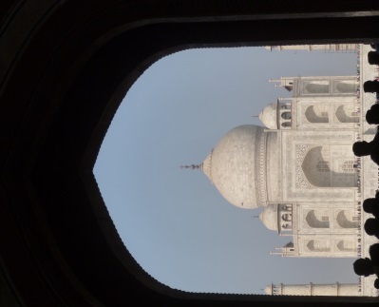We first visited the **Taj Mahal**, a white marble mausoleum. The Taj Mahal, a UNESCO World Heritage Site, was completed in 1653 after 22 years of construction. The Taj Mahal was built by Shah Jahan, a Mughal emperor, as a mausoleum for his wife Mumtaz Mahal. Built during what was considered the golden age of Mughal architecture, the Taj Mahal and its grounds are impressively intricate. The Taj Mahal beautifully reflects Islamic, Persian, Ottoman Turkish and Indian styles.

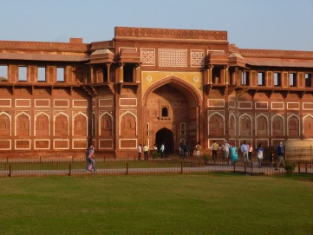We then visited the nearby **Red Fort Complex**, also known as Agra Fort. The Red Fort, an impressive and massive compound used by Mughal emperors for 200 years, spans over 250 acres. The outer structure is constructed in red sandstone andgives the fort its name. The Red Fort, also a UNESCO World Heritage Site, should not be missed. Although the white marble beauty of the Taj Mahal cannot be underestimated, in many ways, the Red Fort is perhaps even more impressive. The layers of different styles of architecture are revealed as you move from the outer fort walls into the interior palace court. The history reflected in the Red Fort is striking.

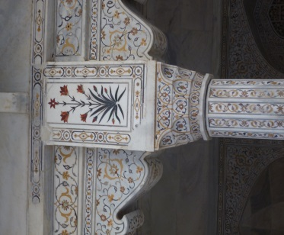

The night was spent at **Mansingh Palace Hotel** in Agra. This is a very pleasant, modern hotel. I was given a corner room with a view of the Taj Mahal. Dinner and breakfast were part of the package. Both meals were buffet style with many choices that would please most palates. A beautiful fruit basket was delivered to my room upon arrival.

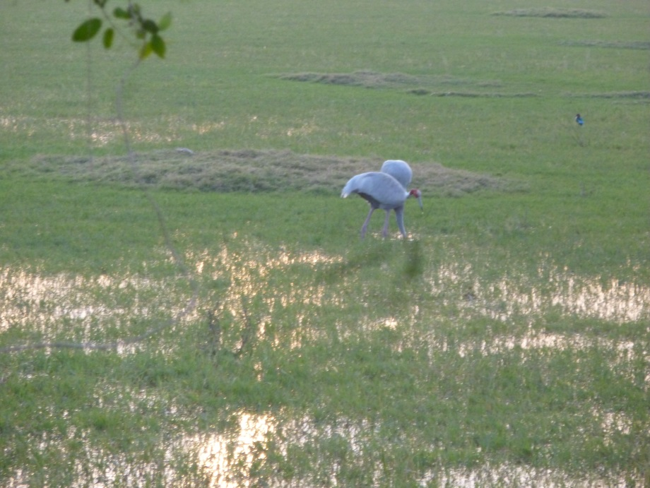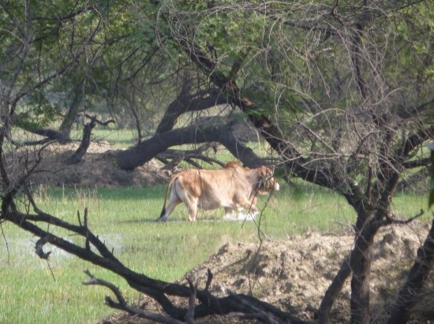**Day 2 –** Mr. Khan drove me to Bharatpur where we met Mr. Satybhan Singh. Mr. Singh served as my guide for a delightful day of birding at the **Keoladeo National Park**. I will admit that I am not an experienced birder. Mr. Singh used his intimate and vast knowledge of Keoladeo National Park to provide me with the best birding experience in my life. A bicycle rickshaw had been arranged and we spent the day rolling and strolling through the park. Known for its wetlands and wetland species, the 29 square mile Keoladeo National Park is an IUCN category II national park and UNESCO World Heritage Site. With over 230 species of birds, it is a wonderland of bird watching. Mr. Singh expertly led me to a variety of sites where I was guaranteed to see spectacular scenery as well as rare bird species. In addition to having the change to see everything from eagles and cranes to tiny bee-eaters, I was thrilled to see a python, jackal, sambar, and a jungle cat. It was a most rewarding day.

I stayed at the **Hotel Park Regency** which was very close to the park entrance. The hotel was quiet, the room was comfortable, and the restaurant food was appealing.

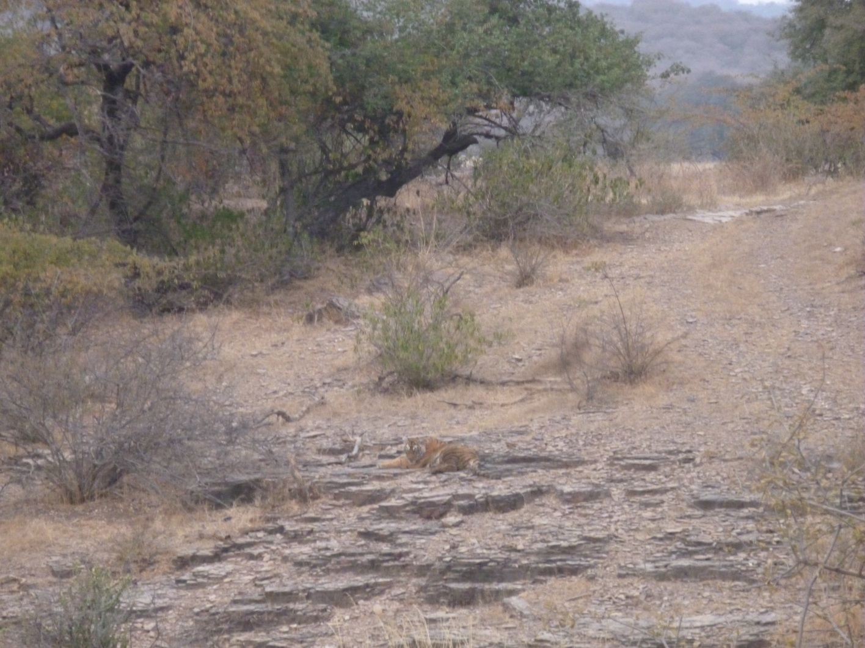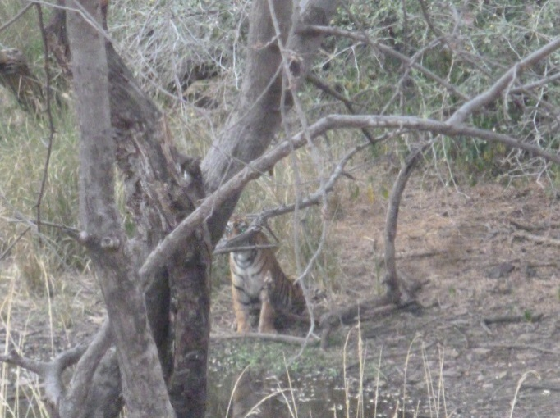**Day 3 –**Mr. Singh escorted me to the train station and made sure I boarded the correct train and car. When I arrived at my next stop, Sawai Madhopur, I was met by someone from the Tiger Home Hotel. Two safaris into **Ranthambhor Tiger Reserve** had been arranged – one for that afternoon (2:30 – 6:00pm) and one for the following morning (6:30 – 10:00 am). At the Tiger Reserve, safari vehicles are assigned specific tracts to reduce the intrusion of tourists on the wildlife. Because the staff at the Tiger Hotel had heard that tigers had been sighted that morning in a particular tract, they took it upon themselves to change my safari reservations so that I would have a better chance to see tigers. I was most grateful for their kindness, and there attentivenesspaid off. I saw four tigers. We spent over an hour watching as the family of tigers slept, drank from the pond, and wandered about. It was a magnificent afternoon.

**Tiger Home Hotel** is a wonderful and clean guest house on a quiet residential street near Ranthambhore National Park. It is relatively small, with family style meals. WiFi was available and good enough for Skyping back to the U.S. Hotel staff were very hospitable. I couldn't have asked for more. They took care of me - picked me up at the train station, made sure that I knew the schedule for my safaris, and arranged for my return trip to the train station for my onward journey. The food was simple and very good.

**Day 4 –** After my second safari – we didn’t see any tigers, but did see various other mammals and birds – I was taken back to the train station for my return trip to Jaipur. Again, I was escorted to my train and my hosts ensured that I found the appropriate car and seat.

**Day 5 –** On my final day in Jaipur and in India, my hosts arranged a full schedule of sightseeing around Jaipur. As with my original trip to Agra, Mr. Ayub Khan served as my host along with two of the teachers from the MGD Girls’ School. We spent a lovely day visiting the Amber Fort, Man Sgar Lake, Hawa Mahal, the City Palace of Jaipur, and the fascinating Jantar Mantar (observatory). 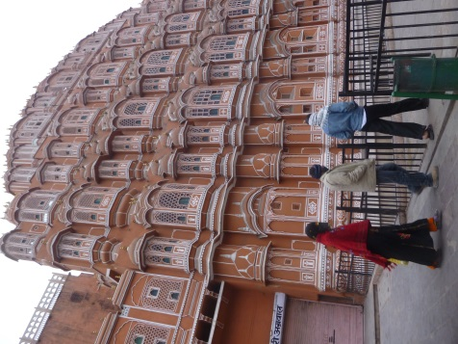

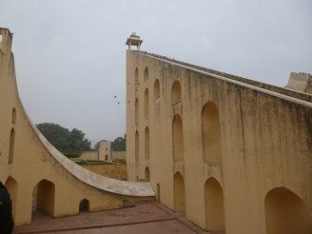The excursions planned for me were faultless. I had a wonderful time and learned a great deal. All of my needs were anticipated and I experienced some of the finest cultural and natural wonders that India has to offer. I could not have asked for more.