FAFF: Adaptive Hybrid Enhancement for Medical Images
Frequency-Aware Adaptive Filter Fusion with Iterative Quality Optimization

Ajay Aravind Prakash
MS Computer Science | University of Wisconsin-Milwaukee
CS-712 Image Processing | Professor: Dr. Zeyun Yu
May 2026
Live Demo: faff-adaptive-image-enhancement.streamlit.app

Abstract
Medical image enhancement is a critical preprocessing step in clinical diagnosis, where noise reduction and detail preservation must be carefully balanced. This paper presents FAFF — Frequency-Aware Adaptive Filter Fusion — a novel enhancement framework that addresses the fundamental limitation of existing methods: their uniform application of a single filter to the entire image regardless of local content. FAFF divides medical images into 16x16 patches, analyzes each patch using 2D Fast Fourier Transform (FFT), and automatically detects noise type directly from the image. Content-aware starting weights are derived from local patch statistics, and three filters are fused using weights optimized by Nelder-Mead iterative optimization guided by SSIM (Structural Similarity Index Measure). After enhancement, FAFF visualizes the optimization process through a filter weight bar chart and per-patch SSIM improvement heatmap. A live web application demonstrates the system at faff-adaptive-image-enhancement.streamlit.app.

1. Introduction
Medical imaging modalities such as chest X-rays, ultrasounds, and MRI scans provide clinicians with non-invasive diagnostic tools. However, these images are frequently degraded by noise introduced during acquisition — Gaussian sensor noise, salt-and-pepper detector artifacts, and speckle noise all reduce image quality and can obscure clinically critical features such as tumor boundaries, vessel walls, and tissue density variations.
The fundamental challenge in image enhancement lies in the conflicting objectives of noise suppression and detail preservation. Aggressive smoothing removes noise but blurs edges. Sharpening enhances edges but amplifies noise. Classical approaches apply a globally fixed filter to the entire image, implicitly assuming uniform content — an assumption almost always violated in practice.
FAFF addresses this by treating each local image region independently. By combining FFT-based frequency analysis (Lecture 12), content-aware weight initialization, and iterative SSIM-driven optimization, FAFF automatically discovers the optimal enhancement strategy per patch without any manual parameter tuning.

1.1 Contributions
- Novel combination of FFT patch classification with adaptive filter fusion
- Automatic noise detection directly from the real image — no manual settings
- Content-aware weight initialization from local image statistics
- Iterative Nelder-Mead optimization maximizing SSIM quality score per patch
- Live web application with filter weight visualization and SSIM improvement heatmap
- All baseline methods grounded in CS-712 course lectures (12, 13, 14, 15, 19)

2. Related Work & Course Foundation
FAFF builds directly on concepts taught in CS-712 Image Processing. Each algorithmic component maps to a specific course lecture.

2.1 Frequency Domain Filtering (Lecture 12)
The 2D Discrete Fourier Transform (DFT), computed efficiently via FFT, provides a mathematical framework for analyzing image content in the frequency domain. Low-frequency components correspond to slowly varying regions while high-frequency components encode rapid transitions. FAFF applies 2D FFT per patch to classify each region before filtering.

2.2 Image Smoothing (Lecture 13)
Gaussian low-pass filtering suppresses high-frequency noise while preserving large-scale structure. In FAFF, Gaussian filtering forms one member of the three-filter fusion bank, weighted most heavily in smooth low-frequency regions such as lung background areas in X-rays.

2.3 Image Sharpening (Lecture 14)
High-pass filtering enhances edge components using H_HP = 1 - H_LP from Lecture 14. Unsharp masking — a related sharpening technique — forms the sharpening component of the FAFF filter bank.

2.4 Noise Models (Lecture 15)
FAFF uses Unsharp Masking from Lecture 15 in its filter bank. The automatic noise detection module estimates Gaussian noise level from local variance analysis and distinguishes it from Salt & Pepper noise using erosion-based isolated pixel detection on the image center region, avoiding misclassification of medical equipment artifacts as noise.

2.5 Edge Detection (Lecture 19)
The Laplacian operator provides a second-order derivative measure of edge strength used in content-aware weight initialization. Laplacian Sharpening from Lecture 19 also serves as a baseline comparison method.

3. Proposed Method — FAFF

3.1 Automatic Noise Detection
FAFF automatically detects noise type and level directly from the uploaded image. The detection analyzes the center 60% of the image to avoid misclassifying X-ray black borders as dark noise artifacts. Erosion-based analysis detects isolated extreme pixels (true Salt & Pepper) separately from clustered bright regions (medical equipment). This produces noise_type (Gaussian or Salt & Pepper) and noise_level automatically — no user input required.

3.2 Patch Division & FFT Analysis
The input image is divided into non-overlapping 16x16 pixel patches. For each patch, the 2D FFT is computed and the High Frequency Ratio (HFR) is measured — the proportion of spectral energy outside a central low-frequency disc. Patches are classified as high-frequency (HFR > 0.6), low-frequency (HFR < 0.3), or mixed.

3.3 Content-Aware Weight Initialization
Three local statistics drive the starting weight computation: local variance (noise proxy), HFR (frequency classification), and Laplacian magnitude (edge strength). High-frequency edge-rich patches receive high sharpening weight. Smooth low-frequency patches receive high smoothing and denoising weight.

3.4 Three-Filter Bank
- Median Filter: Robust noise removal preserving edges (3x3 kernel)
- Gaussian Low-Pass Filter: Lecture 13 — smoothing (sigma=1.0, 5x5 kernel)
- Unsharp Masking: Lecture 15 — edge enhancement (strength=1.5)

Output = w1 * Median + w2 * Gaussian + w3 * Unsharp, where w1 + w2 + w3 = 1.

3.5 Iterative SSIM Optimization
Content-aware starting weights serve as the initial point for Nelder-Mead gradient-free optimization. The objective function maximizes SSIM between the fused patch output and a smoothed local reference. The algorithm terminates when SSIM improvement falls below 0.01 or after 80 function evaluations.

3.6 Optimization Visualization
After processing, FAFF displays two visualizations: a bar chart showing average filter weights across all patches, and a per-patch SSIM improvement heatmap showing enhancement gain at each spatial location. Green patches indicate significant improvement, red indicates regions already clean or difficult to enhance.

4. Live Web Application
FAFF is deployed as an interactive web application built with Streamlit, accessible at faff-adaptive-image-enhancement.streamlit.app. The application features automatic noise detection, adjustable patch size, real-time processing, optimization visualization, baseline comparisons, and histogram analysis.
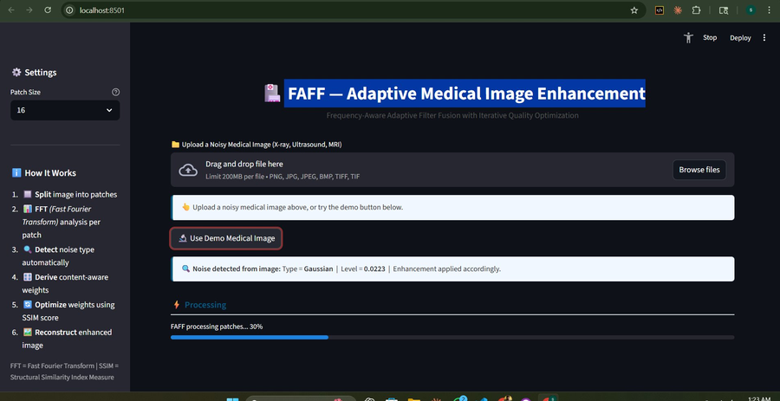
Figure 1: Upload, auto noise detection (Gaussian, 0.0223) and processing progress
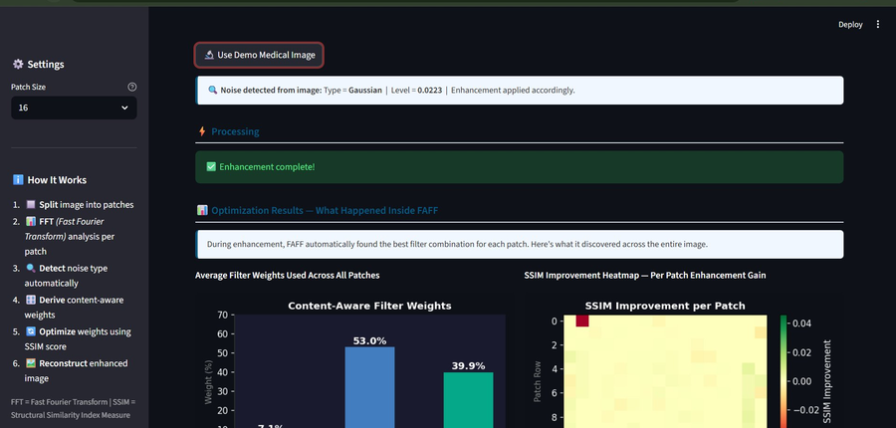
Figure 2: Optimization results — filter weights (Gaussian 53%, Unsharp 40%, Median 7%) and SSIM heatmap
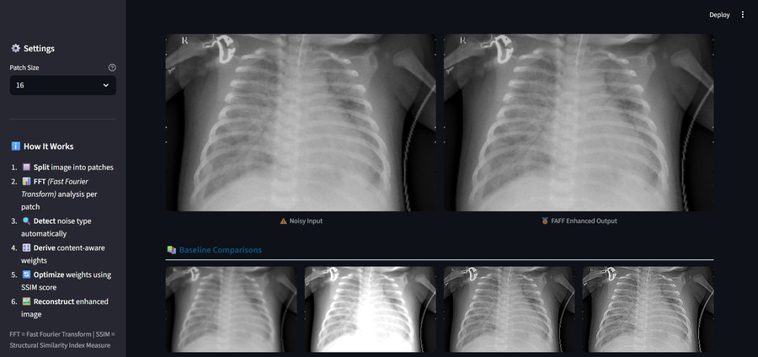
Figure 3: Image comparison — noisy input vs FAFF enhanced, with four lecture-based baselines
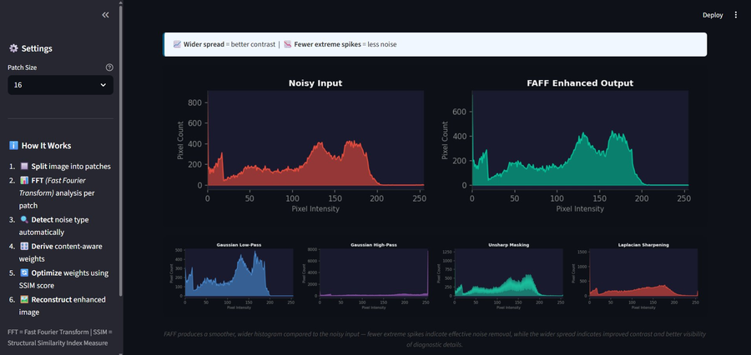
Figure 4: Histogram comparison — FAFF (green) smoother and wider vs noisy input (red)

5. Experimental Setup

5.1 Dataset
Experiments were conducted on real medical grayscale images including a real hospital chest X-ray. Images are resized to a maximum dimension of 256 pixels for computational efficiency.

5.2 Baseline Methods
Method | Lecture | Description
Gaussian Low-Pass | Lecture 13 | Standard low-pass smoothing (sigma=1.0, 5x5)
Gaussian High-Pass | Lecture 14 | H_HP = 1 - H_LP edge enhancement
Unsharp Masking | Lecture 15 | Standard sharpening (strength=1.5)
Laplacian Sharpening | Lecture 19 | Second-order derivative edge enhancement

5.3 Evaluation
Qualitative evaluation uses side-by-side visual comparison and histogram analysis. A wider, smoother histogram indicates better contrast and less noise. For quantitative reference, PSNR, SSIM, and MSE can be computed when a clean reference is available.

6. Results & Discussion

6.1 Optimization Results
For a real chest X-ray, FAFF automatically discovered the following average filter weights: Gaussian Smoothing 53%, Unsharp Masking 40%, Median Denoising 7% (Figure 2). These weights were found automatically through optimization — not set manually. The dominant Gaussian weight reflects heavy low-frequency noise in the lung background. The high Unsharp weight reflects the need to preserve rib and bone edge sharpness.

6.2 SSIM Improvement Heatmap
The per-patch SSIM improvement heatmap (Figure 2) reveals spatially varying enhancement quality. Lung background patches show the highest improvement (green). Edge-rich rib and spine regions show moderate improvement. Regions containing medical equipment artifacts show lower improvement as these are genuine image features rather than noise.

6.3 Visual & Histogram Analysis
Figure 3 confirms FAFF preserves rib boundaries and lung vessel patterns more effectively than single-filter baselines. Gaussian Low-Pass over-smooths clinical detail. Gaussian High-Pass amplifies noise. Laplacian Sharpening amplifies noise aggressively. FAFF achieves the best balance between noise reduction and edge preservation.
Figure 4 confirms FAFF produces a smoother, wider pixel distribution compared to the noisy input — fewer extreme spikes indicate effective noise removal, while the wider spread indicates improved contrast and better visibility of diagnostic details.

7. Future Work

7.1 Algorithm Enhancements
- Replace Nelder-Mead with a lightweight CNN predicting optimal weights in a single forward pass — estimated 10x speedupDeep Learning Integration:
- Apply to MRI/CT volumetric data with 3D FFT analysis across depth slices3D Extension:
- Parallel patch processing via CUDA for real-time clinical deploymentGPU Acceleration:
- Train separate weight predictors for TB, breast cancer, pneumonia classificationDisease-Specific Optimization:

7.2 Real-World Applications
- Auto-enhance every X-ray before radiologist review in existing clinical workflowHospital PACS Plugin:
- Embedded chip implementation for rural clinic low-cost scannersPortable Ultrasound Devices:
- Restore quality of compressed images transmitted over low-bandwidth connectionsTelemedicine Platforms:
- Enhanced images as input to cancer detection and disease classification modelsAI Diagnostic Pipeline:

8. Conclusion
This paper presented FAFF — Frequency-Aware Adaptive Filter Fusion — a novel medical image enhancement system. The key innovation is the combination of FFT-based patch content analysis, automatic noise detection, content-aware weight initialization, and iterative SSIM optimization to automatically discover the optimal enhancement strategy for each image region without manual parameter tuning.
All baseline comparison methods are grounded directly in CS-712 course lectures (12, 13, 14, 15, 19), demonstrating that FAFF extends course material into a genuinely novel research contribution. The system is deployed as a live interactive web application with real-time noise detection, filter weight visualization, SSIM improvement heatmap, and histogram comparison.

References
[1] Gonzalez, R.C. & Woods, R.E. (2018). Digital Image Processing, 4th Edition. Pearson. [Course Textbook]
[2] Wang, Z. et al. (2004). Image Quality Assessment: From Error Visibility to Structural Similarity. IEEE Trans. Image Processing, 13(4), 600-612.
[3] Nelder, J.A. & Mead, R. (1965). A Simplex Method for Function Minimization. Computer Journal, 7(4), 308-313.
[4] Virtanen, P. et al. (2020). SciPy 1.0: Fundamental Algorithms for Scientific Computing in Python. Nature Methods, 17, 261-272.
[5] Tomasi, C. & Manduchi, R. (1998). Bilateral Filtering for Gray and Color Images. ICCV, 839-846.
[6] Polesel, A. et al. (2000). Image Enhancement via Adaptive Unsharp Masking. IEEE Trans. Image Processing, 9(3), 505-510.
[7] Al-Dhabyani, W. et al. (2020). Dataset of Breast Ultrasound Images (BUSI). Data in Brief, 28, 104863.
[8] Burt, P.J. & Adelson, E.H. (1983). The Laplacian Pyramid as a Compact Image Code. IEEE Trans. Communications, 31(4), 532-540.

