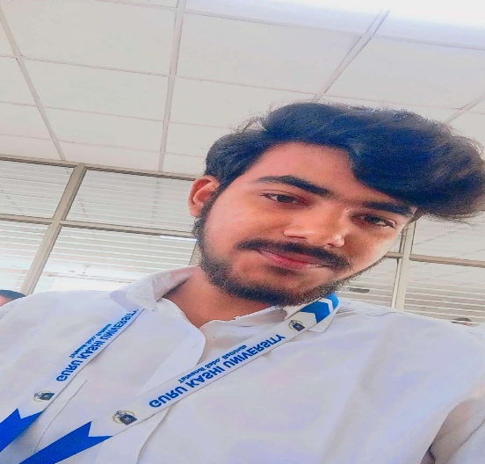

**Name:** Ajay Kumar Raut  
**Phone:** +91-7061272970   
**Email:** ajayfatki@gmail.com  
**Location:** Patna, Bihar

**🎯 Career Objective**

Motivated and enthusiastic fresher with basic knowledge of C, HTML, and Python. Eager to learn and grow in the field of software development by contributing to real-world projects in a dynamic organization.

* **Technical Skills**
* **Languages:** C (Basic), Python (Beginner), HTML (Beginner)
* **Tools:** Visual Studio Code, Git (Basic), MS Office
* **Operating Systems:** Windows (Basic)

**📜 Certifications**

**NIELIT Bootcamp on Python & Web Technologies**

* Attended a 5-day hands-on training bootcamp conducted by NIELIT
* Covered basics of Python programming, HTML structure, and web application fundamentals
* Certificate awarded on 05/05/2025

**🎓 Education**

**Bachelor of Science (B.Sc.) in Computer Science**  
Guru Kashi University, Talwandi Sabo Punjab  
2024 – 2028|

**Class 12th (Intermediate - Science)**

Lalit Narayan janta collage, BSEB  
2022 – 2024 | Percentage: 59%

**Class 10th**  
Gyan Bharti public school, CBSE  
2022 | Percentage: 59%

**🧑‍💻 Projects (Basic/Academic)**

**1. Simple Portfolio Website (HTML)**

* Created a basic personal website using HTML and CSS.
* Included sections like About Me, Skills, and Contact.

**a**.

**💡 Strengths**

* Quick learner and highly adaptable
* Good communication and teamwork skills
* Passionate about coding and self-learning

**🗣️ Languages**

* Hindi (Native)
* English (Basic to Intermediate)